Name: Merugu Sai Charan

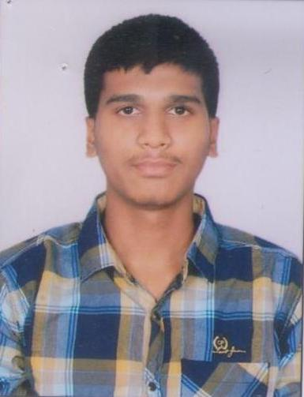

Photo

Address: H-No:7-51,Chinthakunta,Kothapally ,Karimnagar -505001,

Mobile Number: 9381431533

Email: merugusaicharan1@gmail.com

**Objective :** Secure a responsible career opportunity to fully utilize my training and

skills, while making a significant contribution to the success of the company.

**Project Experience** : Data analysis on loan prediction In bank loans are the core business of banks.The main profit comes directly from the loan’s interest. The loan companies grant a loan after an intensive process of verification and validation. By Using Machine learning we’ll develop a predictive model to predict if an applicant is able to repay the loan or not

**Highlights** :Internship in Goalstreet

Online Java Course in NPTEL.

Online Python in NPTEL

Online Linear Regression with NumPy and Python in Coursera.

## Online Ask Questions to Make Data-Driven Decisions in Coursera. Online Foundations: Data, Data, Everywhere in Coursera.

## Education :

|  |  |  |  |
| --- | --- | --- | --- |
| **Degree** | **Name of the Institution** | **Year** | **Percentage** |
| B.Tech (CSE) | Sreenidhi Institute of Science and Technology | 2022 | 71.90 |
| 12th (TS BIE) | Sri Gayatri junior College,Nizampet,Bachupally | 2018 | 96.60 |
| 10th (CBSE) | Hyderabad Public School,Ramanthapur | 2016 | 77.90 |

**Skills :**

**Technical Languages**

Python, C++, Java,R

**Languages**

Telugu, English and Hindi

**Personal Details** : Father’s Name : M.Rajamallu

Mather’s Name: M.Laxmi

Date of Birth : 26-02-2001