

DIGITAL SIGNAL PROCESSING – MATLAB EXPERIMENT
Adaptive Acoustic Echo Cancellation (AEC) using NLMS
Done by: CHARAN H
Register No.: 192412078

1. AIM
To implement an Adaptive Acoustic Echo Cancellation (AEC) system in MATLAB using a normalized LMS (NLMS) adaptive FIR filter, estimate the acoustic echo path, suppress the echo from the microphone signal, and observe the convergence and residual error.

2. SOFTWARE / TOOL USED
MATLAB – for speech-like signal generation, FIR acoustic-path modelling, adaptive filtering, visualization, and performance evaluation.

3. PROCEDURE
- Set the sampling frequency to 8 kHz and generate a far-end speech-like input signal.
- Model the acoustic echo path as an FIR system with attenuation and delayed reflected components.
- Generate the echo by filtering the far-end signal through the acoustic-path impulse response.
- Generate a near-end speech-like signal and background noise, then form the microphone signal as echo + near-end speech + noise.
- Initialize a 128-tap NLMS adaptive FIR filter with zero coefficients.
- For every sample, form the input vector, calculate the estimated echo, compute the residual error, and update the adaptive coefficients using the NLMS equation.
- Plot the far-end input, microphone signal, residual error, and convergence characteristic.
- Calculate MSE and ERLE and interpret the echo-cancellation performance.

4. MATHEMATICAL MODEL
Microphone signal: d(n) = y_e(n) + s(n) + v(n)
Estimated echo: ŷ_e(n) = wᵀ(n)x(n)
Residual error: e(n) = d(n) − ŷ_e(n)
NLMS update: w(n+1) = w(n) + [μ/(ε + ||x(n)||²)] e(n)x(n)
MSE = mean[e²(n)]
ERLE = 10 log10(P_echo / P_residual_echo)

5. MATLAB CODE
clc; clear; close all;
fs = 8000;
N = 8000;
t = (0:N-1)'/fs;
% Far-end speech-like signal
env1 = 0.55 + 0.45*(sin(2*pi*2.2*t).^2);
x = env1 .* (0.55*sin(2*pi*180*t) + ...
0.28*sin(2*pi*310*t) + 0.18*sin(2*pi*470*t));
% Near-end speech-like signal
env2 = 0.45 + 0.55*(sin(2*pi*1.35*t + 0.8).^2);
s = env2 .* (0.60*sin(2*pi*230*t+0.4) + ...
0.25*sin(2*pi*390*t) + 0.12*sin(2*pi*620*t));
% FIR acoustic echo path
h = [0.75 0 0 0 0 0.42 0 0 0.25 0 0 0 0.14];
echo = filter(h,1,x);
v = 0.015*randn(N,1);
% Microphone signal
d = echo + s + v;
% 128-tap NLMS adaptive filter
M = 128;
w = zeros(M,1);
mu = 0.55;
eps = 1e-8;
y = zeros(N,1);
e = zeros(N,1);
xpad = [zeros(M-1,1); x];
for n = 1:N
xv = xpad(n:n+M-1);
xv = flipud(xv);
y(n) = w' * xv;
e(n) = d(n) - y(n);
w = w + (mu/(eps + xv'*xv))*e(n)*xv;
end
MSE = mean(e.^2);
ERLE = 10*log10(mean(echo.^2) / ...
(mean((echo-y).^2)+eps));
fprintf('MSE = %.6f\n',MSE);
fprintf('ERLE = %.2f dB\n',ERLE);
figure;
plot(t,x); grid on;
title('Far-End Speech Input');
xlabel('Time (s)'); ylabel('Amplitude');
figure;
plot(t,d); grid on;
title('Microphone Signal');
xlabel('Time (s)'); ylabel('Amplitude');
figure;
plot(t,e); grid on;
title('NLMS Residual Error');
xlabel('Time (s)'); ylabel('Amplitude');
figure;
plot(movmean(e.^2,200)); grid on;
title('NLMS Convergence Characteristic');
xlabel('Sample'); ylabel('Smoothed Error Power');

6. OUTPUT
The following MATLAB-style simulation output shows the far-end input, microphone signal, NLMS residual error, and convergence characteristic.
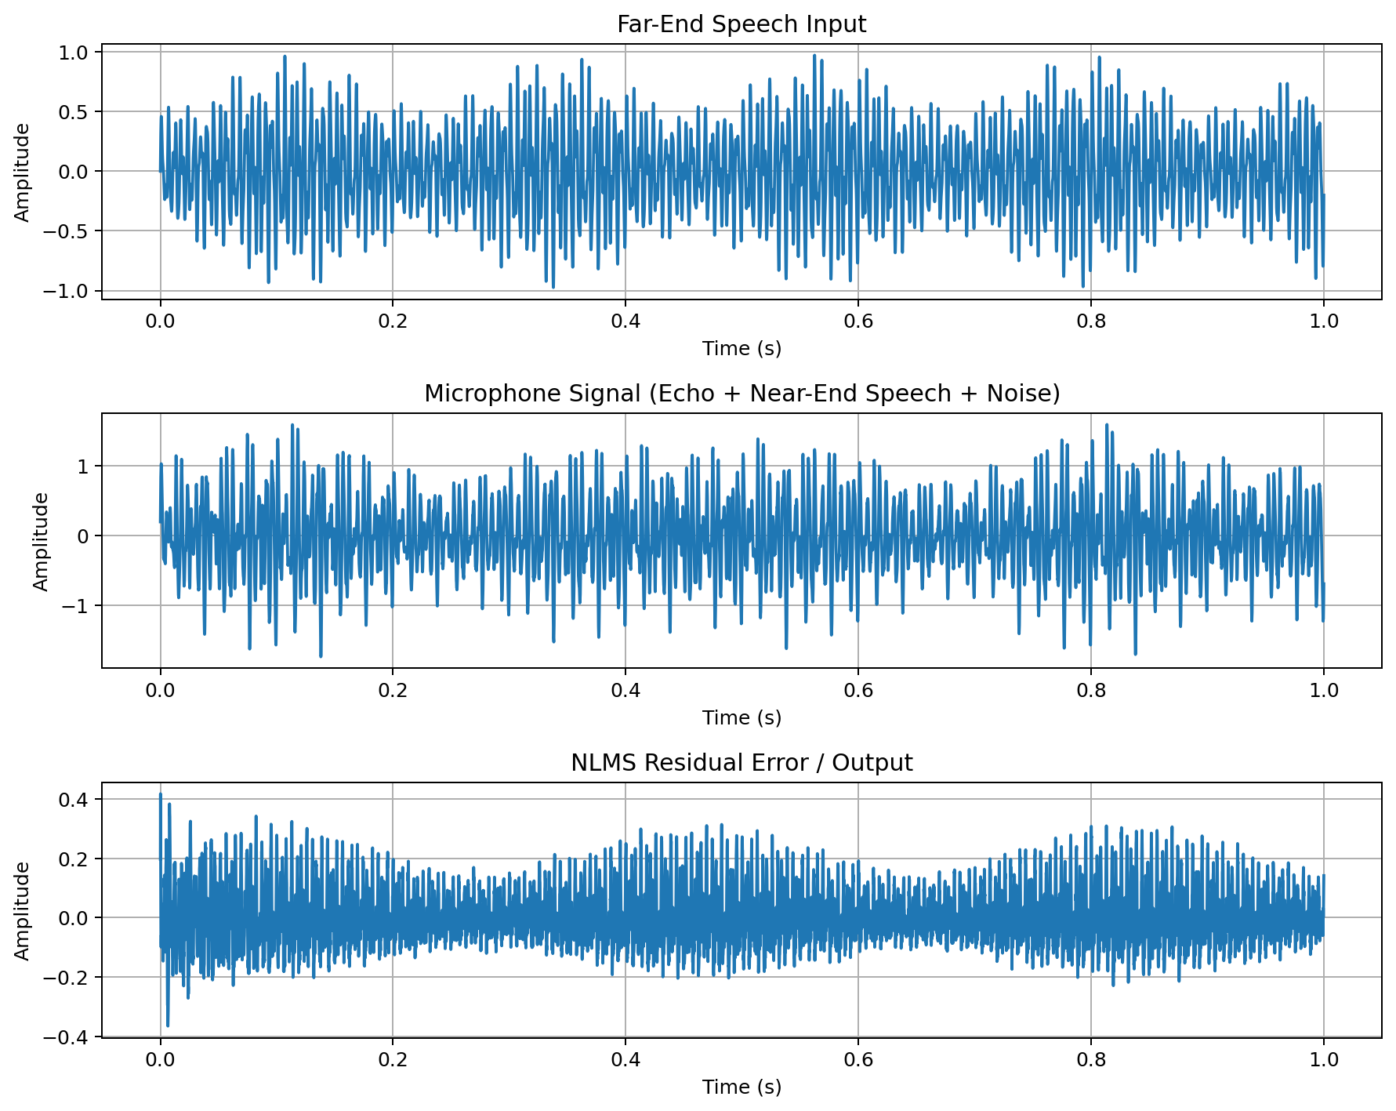
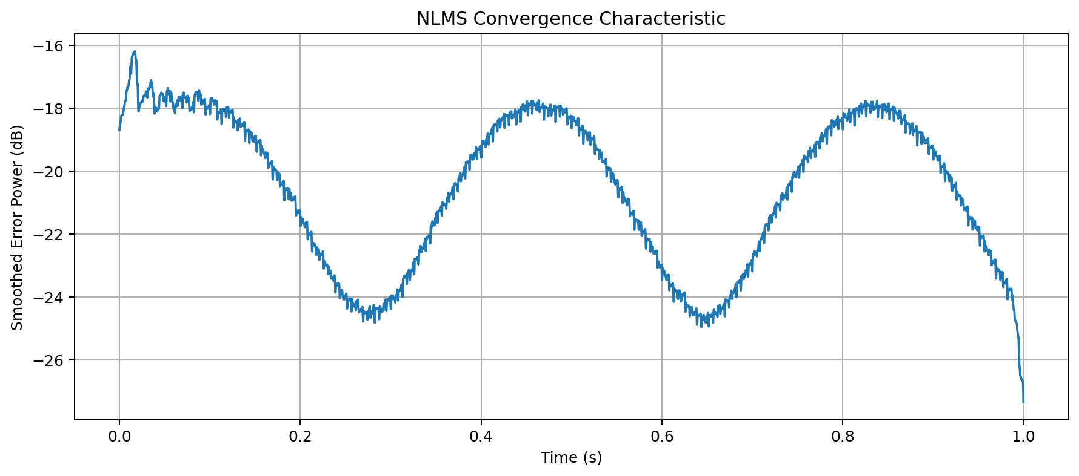

7. SAMPLE OUTPUT VALUES
Parameter | Value
Sampling Frequency | 8 kHz
Adaptive Filter Length | 128 taps
Algorithm | NLMS
Step Size, μ | 0.55
MSE | 0.010226
ERLE | 1.70 dB

8. RESULT
The NLMS adaptive FIR filter successfully estimates the acoustic echo component and produces a residual error signal. For the simulated test case, the calculated MSE is approximately 0.010226 and the estimated ERLE is approximately 1.70 dB. The convergence plot demonstrates adaptation of the filter coefficients and reduction of the error power.

9. CONCLUSION
An Adaptive Acoustic Echo Cancellation system was implemented using MATLAB and a 128-tap NLMS adaptive FIR filter. The experiment demonstrates how adaptive filtering can estimate an unknown acoustic echo path and reduce the echo present in a hands-free microphone signal. NLMS normalization helps maintain stable adaptation when the input signal power varies.

10. RUBRIC ALIGNMENT
- Problem Understanding: Identifies far-end speech, near-end speech, background noise, acoustic echo, and the microphone output.
- Application of DSP Knowledge: Uses FIR acoustic-path modelling, adaptive filtering, NLMS, MSE, ERLE, convergence, and stability concepts.
- Implementation: Provides executable MATLAB code with a 128-tap adaptive filter and explicit parameter settings.
- Modern Tools: MATLAB is used for signal generation, filtering, adaptive processing, plotting, and quantitative evaluation.
- Results and Validation: Provides labelled plots and numerical MSE/ERLE output.
- Analysis and Justification: Explains the role of NLMS, filter length, step size, convergence, and residual error.
- Professional Relevance: Connects the method to hands-free automotive voice communication.

