Prelab Programs:
- In a scratch file called warmup-1.html, write a complete page whose visible content is exactly one <h1> that says Healthy food, honest prices and one paragraph under it. Full skeleton — doctype to closing html — nothing skipped.

Source Code:

warmup-1.html
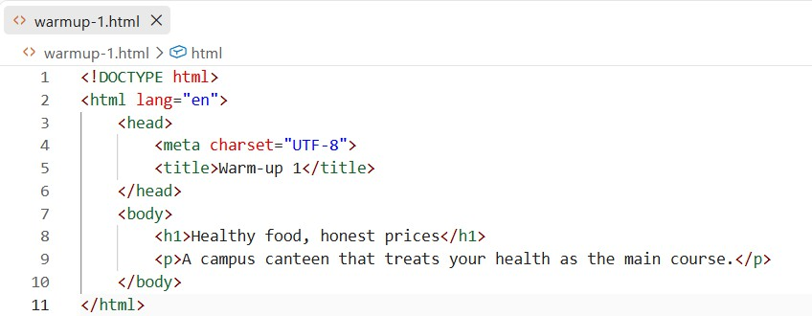

Output:
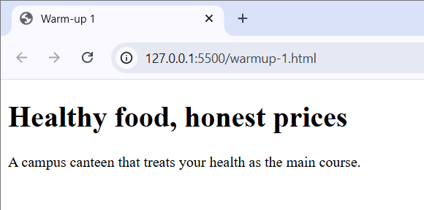

- In warmup-2.html (full skeleton again — no shortcuts), the body holds one <h2> saying Today's specials and an unordered list of any three dishes you remember from Class 4's menu.

Source Code:

warmup-2.html
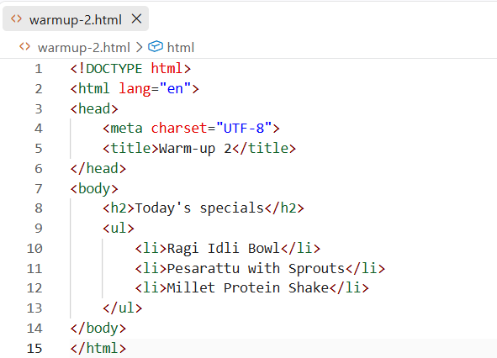

Output:
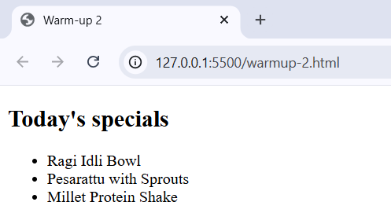

- In warmup-3.html, show a photo called ragi-idli-bowl.jpg that sits in the same folder as the file, with alt text a blind classmate

would thank you for. (No such photo on your disk? Perfect — you'll see exactly what a browser does when an image is missing, and why alt matters.)
Source Code:
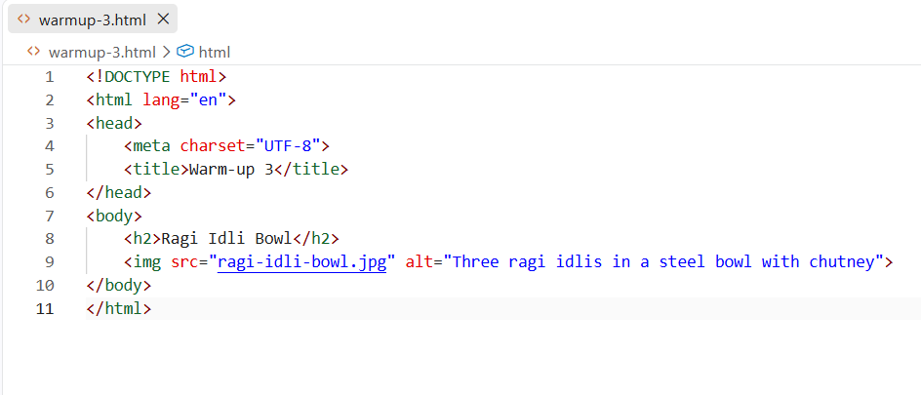
warmup-3.html

Output:
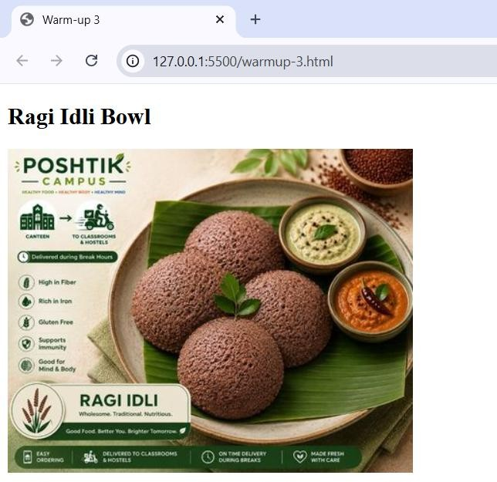

In one folder, create one.html and two.html. Page one shows a heading and a link reading Go to page two. Page two shows any heading, so you can tell you arrived. Save both, open one.html, click the link.
Source Code:

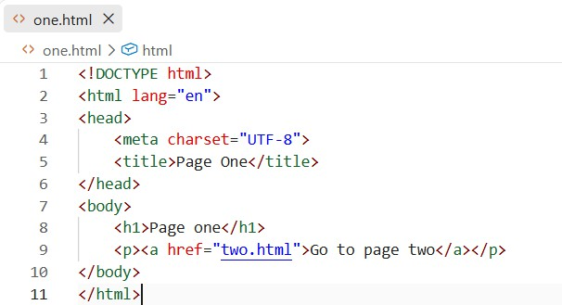
one.html

two.html
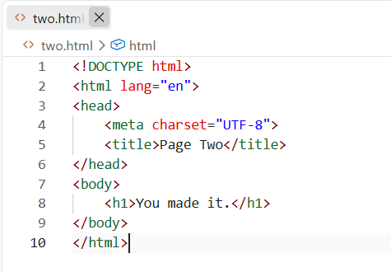

Output:
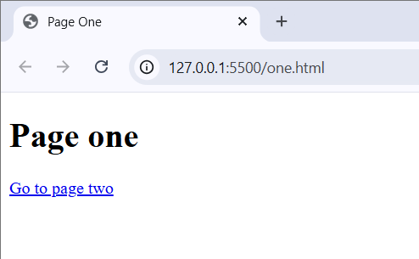

Lab Programs:

Problem: 1 Poshtik Campus needs its front door: the page a visitor lands on first, carrying the brand and the way onward.
Requirements:
- File name index.html, at the top level of poshtik-campus/.
- Browser tab must read Poshtik Campus — Home.
- One main heading with the canteen's name — exactly Poshtik Campus.
- One welcome paragraph — type exactly:
Healthy Telangana C Andhra staples at student prices — millets, sprouts and protein bowls, made fresh on campus.
- A navigation list reaching menu.html and about.html — yes, files that don't exist yet; write the nav as if they do, because in ten minutes they will.

menu.html.
- Tab reads Poshtik Campus — Menu.
- Main heading Our Menu.
- One short intro paragraph.
- An unordered list of all ten dishes, exact names, exact order from Part 6 — English only, plain text (they become fragment-linked sections in a later lab).
- The same nav list as index — but think before you paste: what should the Menu entry become on the menu page itself?

about.html.
- Tab reads Poshtik Campus — About.
- Main heading About us.
- Two short paragraphs — type exactly: “We believe campus food can be honest food: millets, sprouts and real vegetables, cooked the way home cooks.” and
“Find us beside the library block, open 8am–8pm.” — so your render matches the solution sheet's preview exactly.
- The nav, adapted the same way.

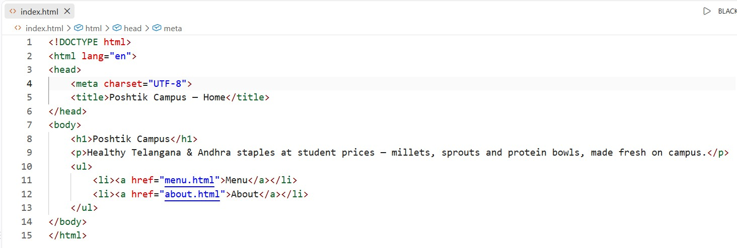
Source Code: index.html

Output:
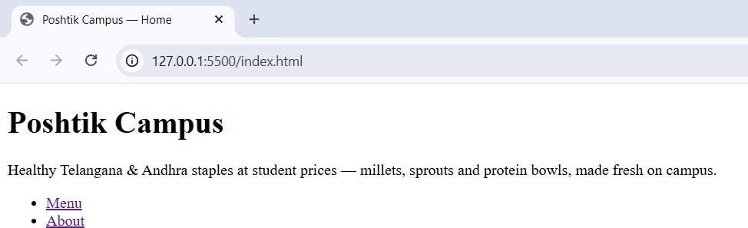

menu.html
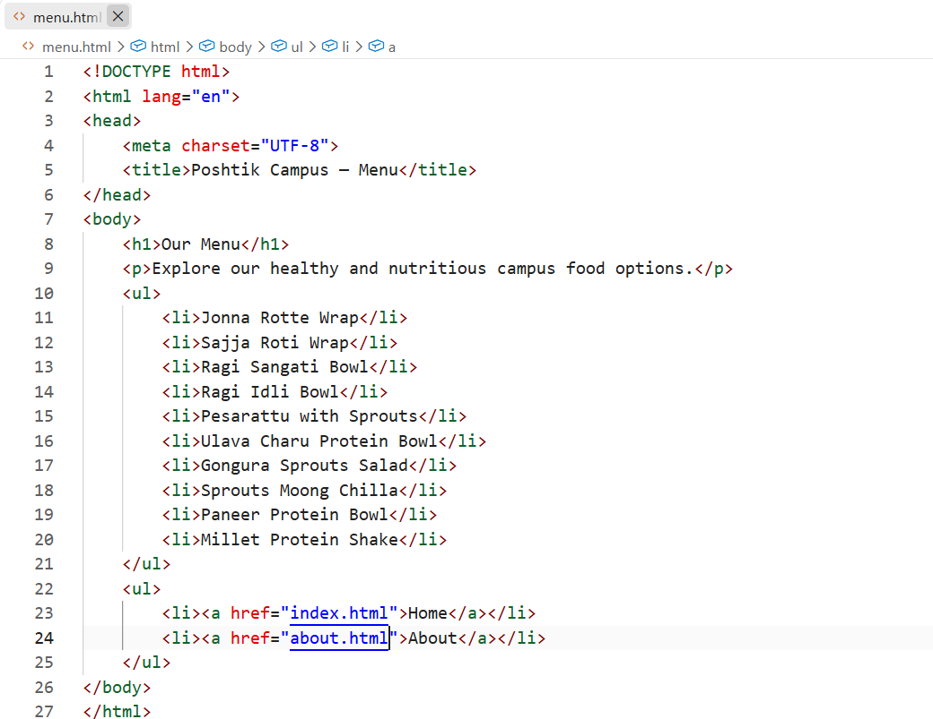

Output:
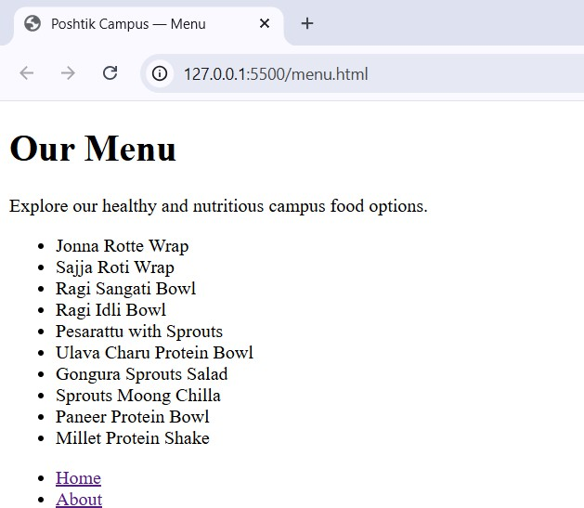

about.html
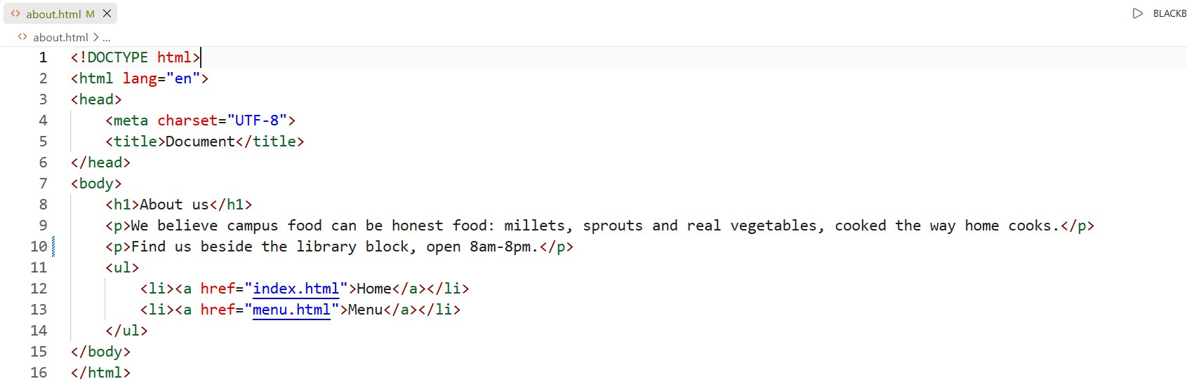

Output:

