Experiment-2
Prelab programs:
- In a scratch file called form-warmup-1.html (in your sandbox — full skeleton, as always), the body holds one containing a single labelled text input asking for the visitor's name. Nothing else.
Source code:
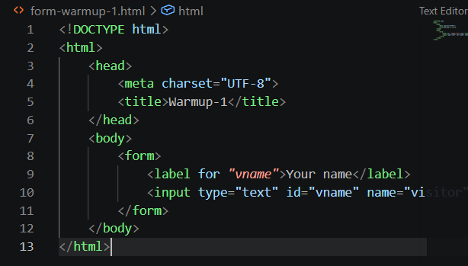
Output:
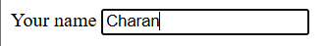

- In form-warmup-2.html, a form offers three dishes — Ragi Idli, Pesarattu, Millet Shake — as radio buttons. Each button gets its own label. Prove one-pick behaviour in the browser before you look down.
Source code:
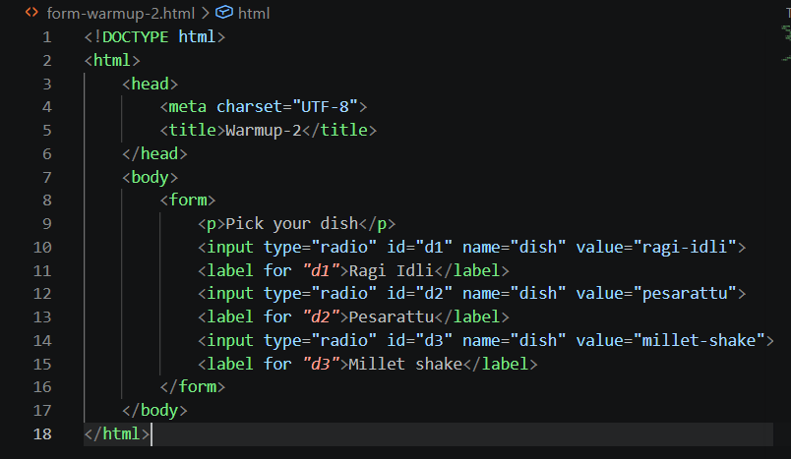
Output:
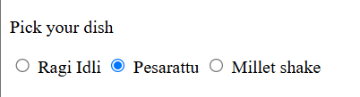

- In form-warmup-3.html, a labelled dropdown asks "When will you pick up?" with three choices: 11:00, 13:00, 17:00. Remember the shape from Class 7: <select> is the box, each <option> a row inside it.
Source code:
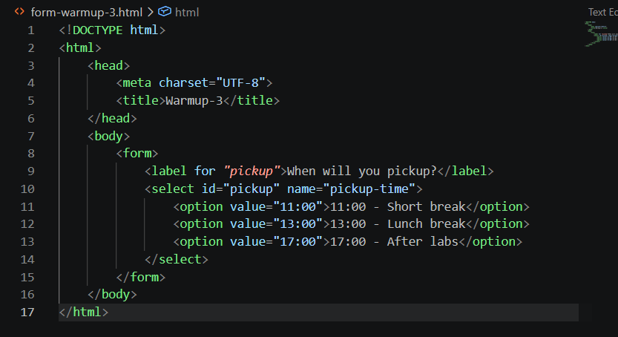
Output:
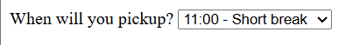

- In form-warmup-4.html, one text input named and a submit button. Save, open, type chikki into the box, press the button — then read the address bar.
Source code:
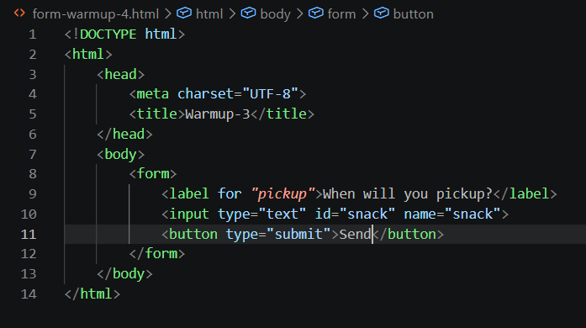
Output:
