ARTIFICIAL INTELLIGENCE ESSENTIALS
PROJECT REPORT
(Project Semester January-April 2025)

Game Strategy Advisor: “Strat Bot"



Submitted by
T. Sri Charan
Registration No. 12310418

Programme and Section- B.Tech CSE – K23FA
Course Code -INT428
Under the Guidance of
Anzar Hussain Lone (30913)
Discipline of CSE/IT
Lovely School of Computer Science and Engineering

Lovely Professional University, Phagwara

CERTIFICATE

This is to certify that Sri Charan bearing Registration no. 12310418 has completed INT428 project titled, “Game Strategy Advisor: "Strat Bot"” under my guidance and supervision. To the best of my knowledge, the present work is the result of his/her original development, effort and study.

Anzar Hussain Lone (30913)
School of Computer Science and Engineering
Lovely Professional University
Phagwara, Punjab.

Date: 12/04/2025

DECLARATION

I, Sri Charan, student of B. Tech CSE under CSE/IT Discipline at, Lovely Professional University, Punjab, hereby declare that all the information furnished in this project report is based on my own intensive work and is genuine.



Date: 12/04/2025 Signature
Registration No. 12310418 Sri Charan

Acknowledgement

I would like to convey my heartfelt thanks to all those who helped and motivated me throughout the duration of this project. I extend my sincere thanks to my guide, Anzar Hussain Lone, School of Computer Science and Engineering, for his constant guidance, feedback, and motivation throughout the project period.

I am also grateful to the department's faculty members and staff for their constant support. Special appreciation to Lovely Professional University for offering all the infrastructure, resources, and platform needed to successfully implement this Excel-based project.

Finally, I am thankful to my family and friends for their persistent support and encouragement throughout the project.

Contents

- Introduction…………………………………………………………….[6]
1.1 Background…………………………………………………… [6]
1.2 Objectives…………………………………………………….[6]
1.3 Significance…………………………………………………... [6]
- Technology Stack……………………………………………………… [6]
- System Architecture………………………………………………….[6]
- Implementation……………………………………………………….[7-8]
4.1 Backend Code………………………………………………… [7]
4.2 Frontend Interface…………………………………………… [8]
4.3 Integration…………………………………………………… [8]
- Screenshots……………………………………………………………[8-9]
- Conclusion………………………………………………………........[10]
- Future Scope………………………………………………………… [10]
- GitHub Repository…………………………………………………... [10]

INTRODUCTION

1.1 Background
Modern gamers often struggle to strategize effectively across diverse games. Many tools provide generic suggestions, but there is a lack of a dedicated intelligent chatbot that delivers context-based strategies in real-time.
1.2 Objectives
- To build an AI-powered chatbot for game strategy suggestions.
- To use Google Gemini API to generate relevant content.
- To provide an interactive and responsive web UI.
1.3 Significance
This project will serve as a helpful tool for both casual and professional gamers, enabling them to receive AI-powered strategies, enhancing their performance and engagement.

2. Technology Stack
- Frontend: HTML, CSS, JavaScript
- Backend: Flask (Python)
- AI API: Google Gemini via google.generativeai
- Environment Management: Python-dotenv (.env for API keys)
- Hosting/Version Control: GitHub (Link in Section 8)

3. System Architecture
The architecture is based on a client-server model:
- The user interface sends a request to the Flask backend.
- The Flask backend handles the request and queries Gemini API.
- Gemini generates a strategy, which is returned to the frontend.

4. Implementation
4.1 Backend Code (Python)

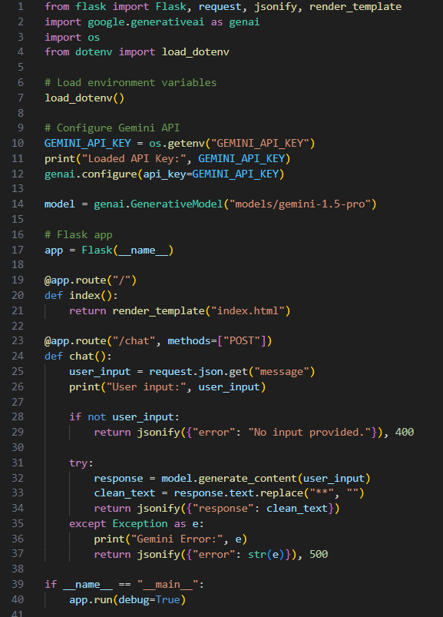

4.2 Frontend Interface (HTML + JS)
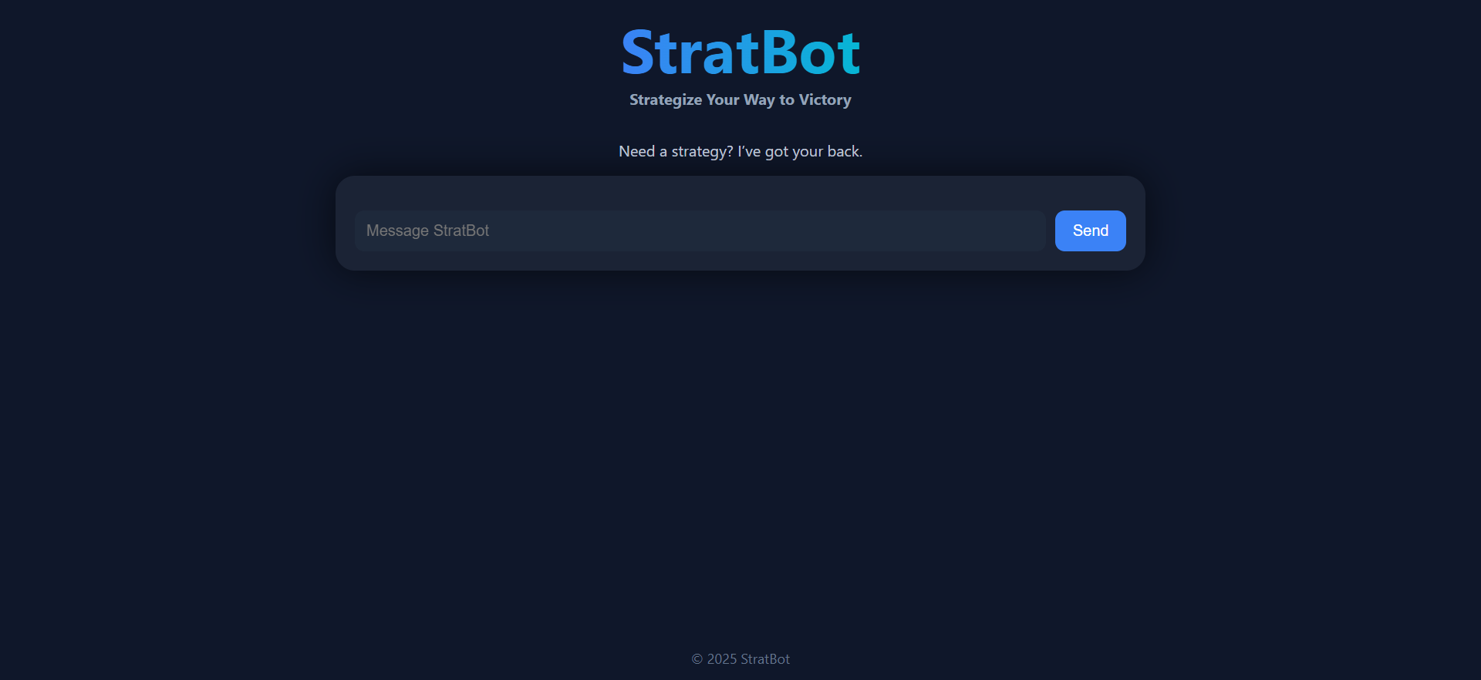
4.3 Integration
Using fetch() method in JS to call the Flask endpoint and display real-time AI responses in chat-style interface.

5. Screenshots
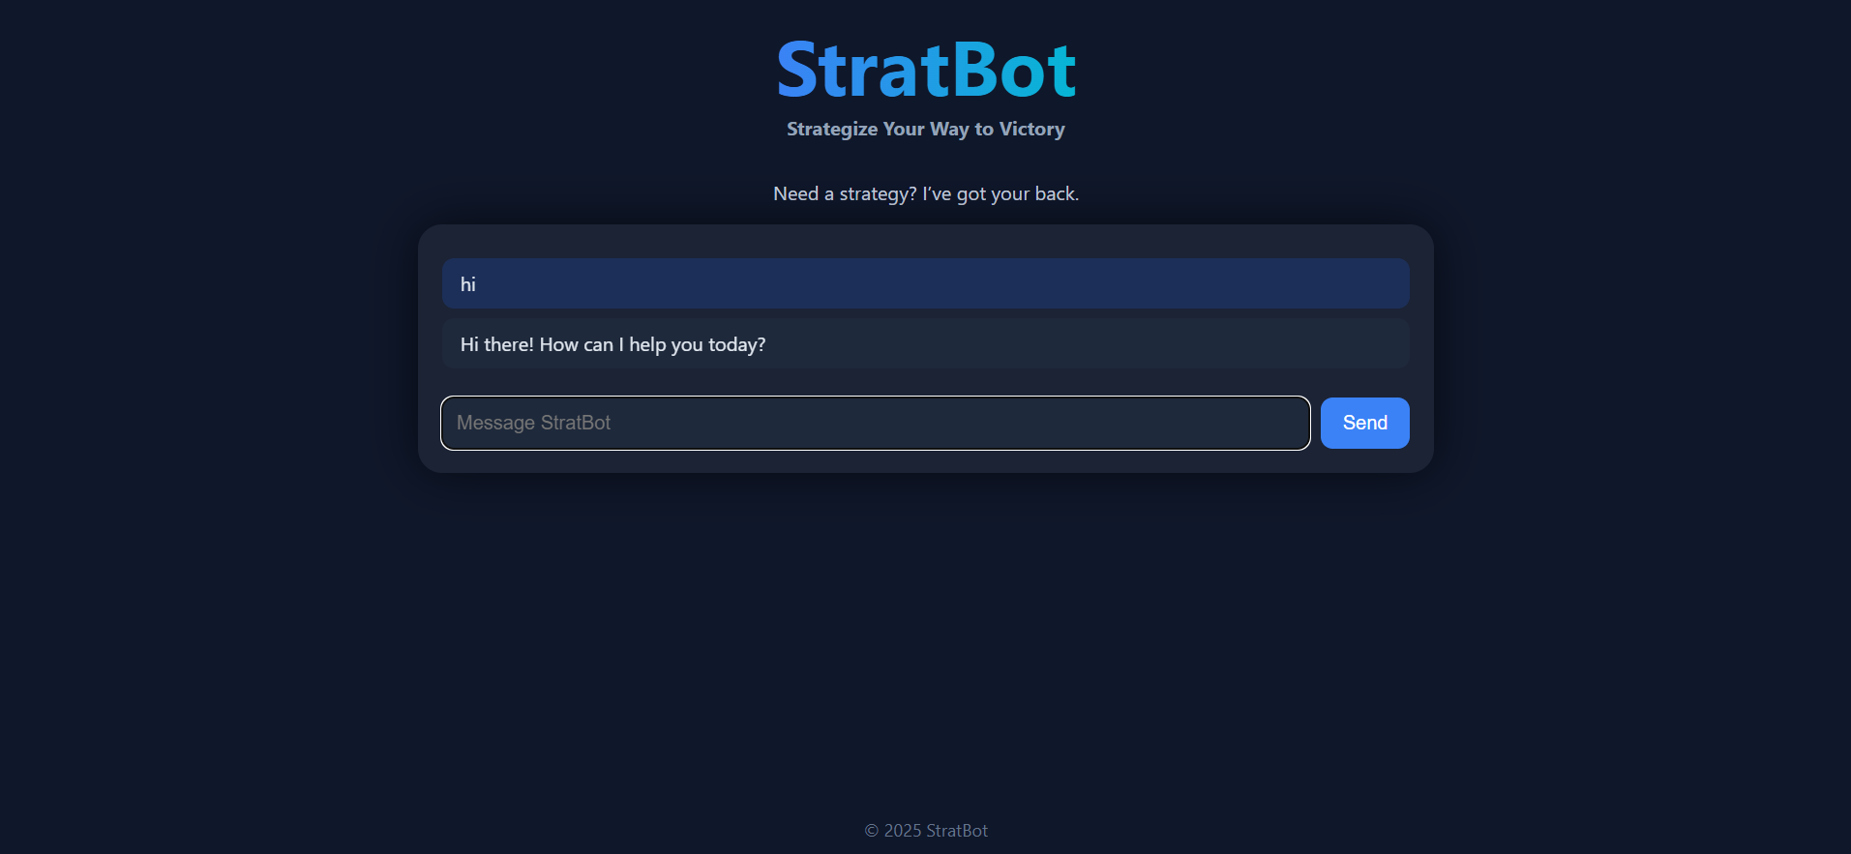
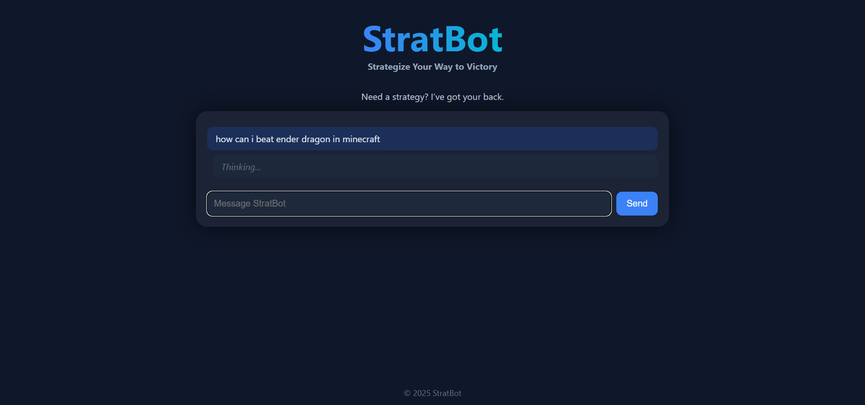

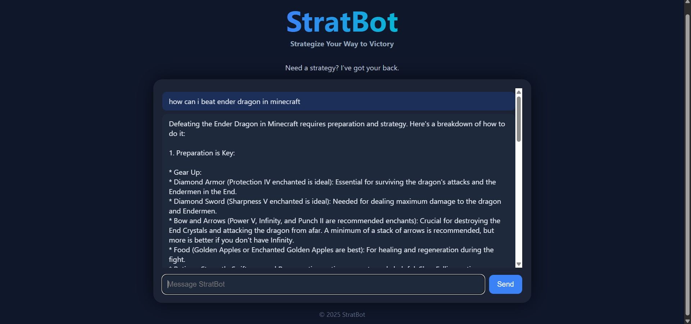
6. Conclusion
The StratBot project successfully demonstrates how generative AI models can be integrated into real-time applications to enhance user engagement and functionality. It shows potential to evolve into a larger-scale project for gaming communities.

7. Future Scope
- Integrate support for voice input.
- Add memory to retain past context in conversations.
- Allow saving strategies for future reference.
- UI enhancements with animations and icons.

8. GitHub Repository
https://github.com/SanchitSharma24/StratBot-Chatbot-AI-Project

