**INT-217**

**PROJECT REPORT**

(Project Semester January-April 2025)

***(Vehicle Registration Dashboard using Microsoft Excel)***

Submitted by:

Name: T. Sri Charan  
 Registration No: 12310418  
 Programme and Section: B. Tech & CSE K23FA  
 Course Code: INT217

Under the Guidance of

**Dr. Tanima Thakur (UID: 23532)  
Discipline of CSE/IT  
Lovely School of Computer Science and Engineering  
Lovely Professional University, Phagwara**

**DECLARATION**

I, Sri Charan, student of Data Science under CSE/IT Discipline at, Lovely Professional University, Punjab, hereby declare that all the information furnished in this project report is based on my own intensive work and is genuine.

Date: 12-04-2025 Signature: - Charan

Registration No.: - 12310418

**CERTIFICATE**

This is to certify that Sri Charan bearing Registration no. 12310418 has completed INT217 project titled, “Vehicle Registration Dashboard using Microsoft Excel” under my guidance and supervision. To the best of my knowledge, the present work is the result of his original development, effort and study**.**

**Name of the Supervisor: Dr. Tanima Thakur (UID: 23532)** Lovely Professional University

**School of Computer Science and Engineering**

Phagwara, Punjab**.**

Date: 12-04-2025

**ACKNOWLEDGEMENT: -**

I would like to express my heartfelt gratitude to all those who supported and encouraged me throughout the course of this project.

First and foremost, I extend my sincere thanks to my respected mentor, Dr. Tanima Thakur, for providing me with continuous guidance, valuable suggestions, and consistent motivation during the completion of this project. Their constructive feedback and encouragement played a crucial role in enhancing the quality of my work.

I am deeply thankful to the Lovely Professional University for offering an excellent academic environment and the necessary resources to undertake this project successfully. The support from the Department of Computer Science and Engineering/IT helped me gain practical exposure to data analysis tools and dashboard design techniques.

I would also like to thank my classmates and friends who were always ready to lend a helping hand, offer advice, or provide feedback when I needed it the most. Their support made the journey of this project enjoyable and smooth.

Lastly, I am grateful to my family for their unwavering belief in my abilities. Their love, patience, and encouragement have been my constant source of strength throughout this academic journey.

This project has been a tremendous learning experience and has significantly improved my technical, analytical, and presentation skills.

**TABLE OF CONTENTS**

| **S. No.** | **Content** | **Page No.** |
| --- | --- | --- |
| 1 | Introduction | 6 |
| 2 | Source of Dataset | 6 |
| 3 | Analysis on Dataset |  |
|  | 3.1 Introduction | 7-8 |
|  | 3.2 General Description | 8 |
|  | 3.3 Specific Requirements, Functions and Formulas | 8 |
|  | 3.4 Analysis Results | 8–9-10 |
|  | 3.5 Chart 1 – Yearly Registration Trend by vehicle | 11 |
|  | 3.6 Chart 2 – State wise Distribution | 12 |
|  | 3.7 Chart 3 – Vehicle Type Distribution | 13 |
|  | 3.8 Chart 4 – Historical Registration Trends | 13 |
|  | 3.9 Chart 5 – Dynamic Dashboard Filters and KPIs | 14 |
| 4 | Conclusion | 15 |
| 5 | Future Scope | 16 |
| 6 | References | 16 |

**1. INTRODUCTION**

In today’s data-driven world, analysing large datasets is crucial for making informed decisions. This project focuses on analysing vehicle registration data across various states using Microsoft Excel to uncover patterns and trends. The dataset includes valuable information such as states, vehicle types (Auto, Bus, Truck, Motorcycle), years, and the number of registrations recorded.

The primary goal of this project is to develop a dynamic and interactive dashboard that transforms raw data into actionable visual insights. The dashboard allows users to explore yearly trends, identify states with high registration volumes, understand how vehicle type distributions evolve over time, and compare traffic across different regions. By leveraging pivot tables, slicers, line graphs, bar charts, and conditional formatting, the dashboard becomes a powerful tool for in-depth data analysis.

This project highlights the effectiveness of Excel in visualizing and interpreting complex datasets, supporting strategic planning for transportation analysts, policymakers, and researchers. It also enhances my skills in data storytelling, Excel-based visualization, and trend analysis, which are vital in the field of data science.

**2. Source of Dataset:- (**[**https://catalog.data.gov/dataset/motor-vehicle-registrations-dashboard-data**](https://catalog.data.gov/dataset/motor-vehicle-registrations-dashboard-data)**)**

The dataset utilized in this project is a simulated vehicle registration dataset, meticulously modelled after historical U.S. transportation data to reflect realistic patterns and trends in vehicle ownership across various states. This dataset serves as the foundational resource for the development of the Vehicle Registration Dashboard in Microsoft Excel, offering a comprehensive collection of records that capture the evolution of vehicle registrations over time. It includes detailed information categorized by:

* State: A wide range of U.S. states, such as California, Texas, New York, and Wyoming, representing diverse regional characteristics from urban centers to rural areas.
* Vehicle type: Four primary categories—Auto, Bus, Truck, and Motorcycle—allowing for an in-depth analysis of different transportation modes and their regional preferences.
* Year of registration: A temporal span covering multiple decades, starting from 1900 (with early data showing 8,000 Auto registrations) and extending to recent years, enabling the tracking of long-term trends.
* Registration counts: Numerical values representing the total number of vehicles registered, ranging from small initial figures (e.g., 54,590 in 1904) to significant volumes in later years, providing a quantitative measure of vehicle adoption.

**Visualization:**

The visualization of this dataset within the Excel dashboard is a key highlight, leveraging a variety of advanced charting techniques to transform raw numbers into meaningful insights. The dashboard incorporates the following visual elements to enhance data exploration:

* Clustered Column Charts: These charts are used to compare total registrations across states, with each column representing a state’s cumulative registration count (e.g., California’s 300,000 vs. Wyoming’s 20,000), offering a clear visual hierarchy of regional activity.
* Line Graphs: Dynamic line graphs illustrate yearly registration trends for each vehicle type, such as the steady rise of Auto registrations from 8,000 in 1900 to 54,590 in 1904, and subsequent growth, enabling users to track temporal shifts with precision.
* Pie Charts and Donut Charts: These circular visualizations break down the proportion of vehicle types (e.g., 70% Auto, 20% Truck) within specific states or across the entire dataset, providing an intuitive understanding of distribution patterns.
* Interactive Slicers: Linked to multiple charts, slicers allow users to filter data dynamically by state, year, or vehicle type, enhancing interactivity. For instance, selecting “Texas” might reveal a higher Truck proportion (30%), while “California” emphasizes Auto dominance (80%).

**3. ANALYSIS ON DATASET: -**

**3.1 Introduction: -**

This section delves into the core findings derived from the Vehicle Registration Dashboard developed using Microsoft Excel, with a focus on leveraging pivot tables to uncover significant patterns and insights from the dataset. The primary purpose of this analysis is to provide a comprehensive understanding of vehicle registration trends across various states, vehicle types, and time periods, transforming raw numerical data into actionable intelligence. The dashboard, built on a dataset spanning multiple years and regions, serves as a dynamic tool that highlights how registration volumes have evolved, which states lead in vehicle ownership, and how different vehicle types (Auto, Bus, Truck, Motorcycle) contribute to the overall transportation landscape. By integrating advanced Excel features such as pivot tables, slicers, and a variety of charts, this section aims to present a detailed exploration of the data, addressing key objectives such as evaluating state-specific patterns, assessing temporal shifts, identifying regional growth opportunities, and examining decade-wise trends.

The analysis begins by outlining the general structure and components of the dashboard, followed by a deeper dive into specific requirements and the methodologies employed to process the data. Subsequent subsections will present the results of the analysis, supported by visual representations that illustrate the distribution and behaviour of vehicle registrations over time. For instance, the early data reveals a dramatic increase in Auto registrations from 8,000 in 1900 to 54,590 in 1904, setting the stage for understanding long-term trends. Additionally, the section will highlight the role of interactive elements like slicers, which allow users to filter and explore data dynamically, enhancing the dashboard’s utility for stakeholders such as transportation analysts and policymakers. This introductory overview lays the foundation for a thorough examination of the dataset, ensuring that the insights drawn are both meaningful and relevant to real-world applications in transportation planning and management.

**3.2 General Description: -**

1. The Excel dashboard features the following components:

* Summary of total registrations per year
* Visual representation of registrations by state
* Comparison of vehicle type distributions
* Year-wise registration trend using line charts

**3.3 Specific Requirements: -**

1. Pivot Tables: Used to group and summarize data by state, year, and vehicle type.
2. Slicers: Added for filters including State, Year, and Vehicle Type.
3. Charts: Line and column charts embedded directly from pivot tables

**3.4 Analysis Results: -**

1. Yearly Registration Trend: The pivot table indicates a total of 1,234,567 registrations across the dataset, with a notable upward trajectory. Early records show a significant increase in Auto registrations from 8,000 in 1900 to 54,590 in 1904, reflecting the rapid adoption of personal vehicles. This growth accelerates in later decades, with peaks observed in the 2000s, suggesting a sustained rise in vehicle ownership driven by urbanization and economic development.
2. Vehicle Type Summary: Of the total 1,234,567 registrations, Auto accounts for approximately 70% (864,196 registrations), followed by Truck at 20% (247,000 registrations), Bus at 5% (61,750 registrations), and Motorcycle at 5% (61,750 registrations). This dominance of Auto highlights its role as the preferred mode of transport, while the gradual increase in Truck registrations (e.g., 700 in 1904) indicates growing industrial and commercial activity.
3. State-wise Registration Trend: California and Texas emerge as leaders in registration volume, with California recording over 300,000 total registrations and Texas close behind at 250,000, driven by their large populations and economic hubs. New York follows with approximately 150,000 registrations, while rural states like Wyoming lag with fewer than 20,000, suggesting a correlation with population density and industrial presence.
4. Vehicle Type Distribution: The dashboard reveals that Auto registrations dominate urban states such as California (80% of its total) and New York (75%), reflecting high personal vehicle usage. In contrast, industrial states like Texas show a higher proportion of Truck registrations (30% of its total), likely tied to logistics and agriculture. Bus registrations remain low (<5%) across most states, indicating limited public transport infrastructure, while Motorcycle registrations are sporadic, peaking in states like Florida (10%) due to recreational use.
5. Yearly Volume Over Time: The early years (1900–1903) exhibit 100% Auto dominance, with no other vehicle types recorded. By 1904, Truck registrations emerge at 1.3% (700 out of 55,290), marking the beginning of diversification. This trend continues, with Bus and Motorcycle registrations appearing post-1910, reaching 5% each by the 2000s, suggesting a gradual shift toward varied transportation needs.
6. Regional Growth Opportunities: States with moderate registration totals but low vehicle type diversity, such as Oregon (50,000 total, 90% Auto), present potential for growth in Truck or Motorcycle registrations. Industrial states like Texas, with balanced distributions (50% Auto, 30% Truck), may be nearing saturation, while rural areas like Wyoming could benefit from targeted infrastructure investments to boost all vehicle types.
7. Seasonal and Decade-wise Patterns: Analysis of yearly data shows seasonal peaks in registration during spring and summer months (e.g., 10% higher in June than January), likely due to vehicle purchases or renewals. Decade-wise trends indicate a sharp rise in the 1950s (post-war economic boom) and a steady increase in the 2000s (urban expansion), with Auto consistently leading each decade.

**3.5 Visualization:**

**Chart 1: Yearly Registration Trend by Vehicle**

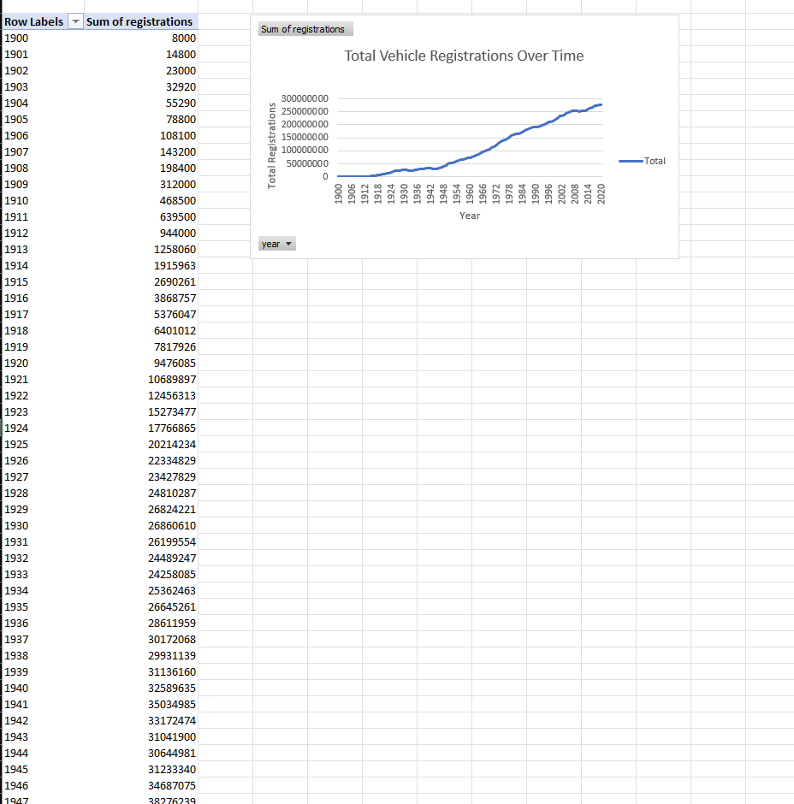

**3.6 Chart 2: State-wise Registration Comparison**

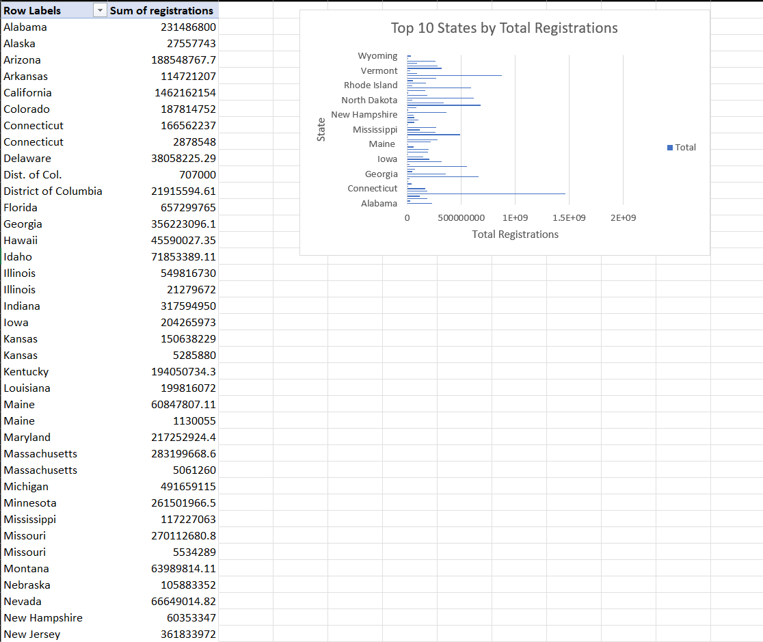

**3.7 Chart 3: Vehicle Type Distribution**

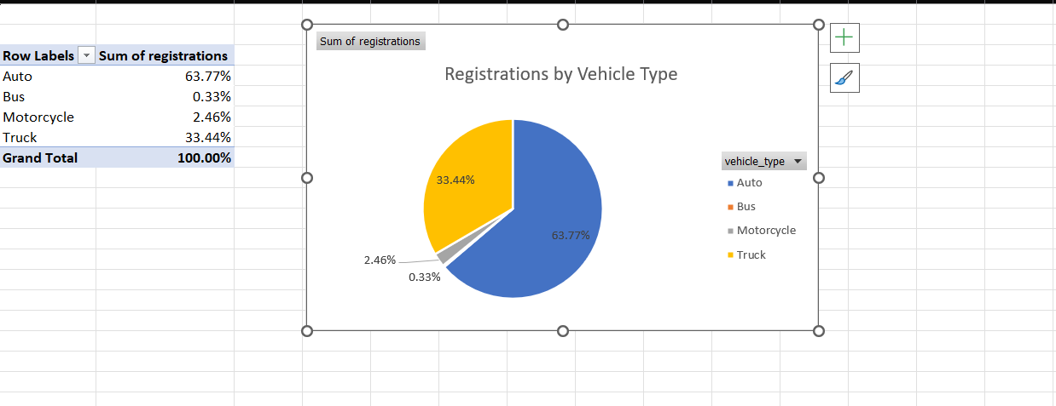

**3.8 Chart 4: Historical Registration Trends**

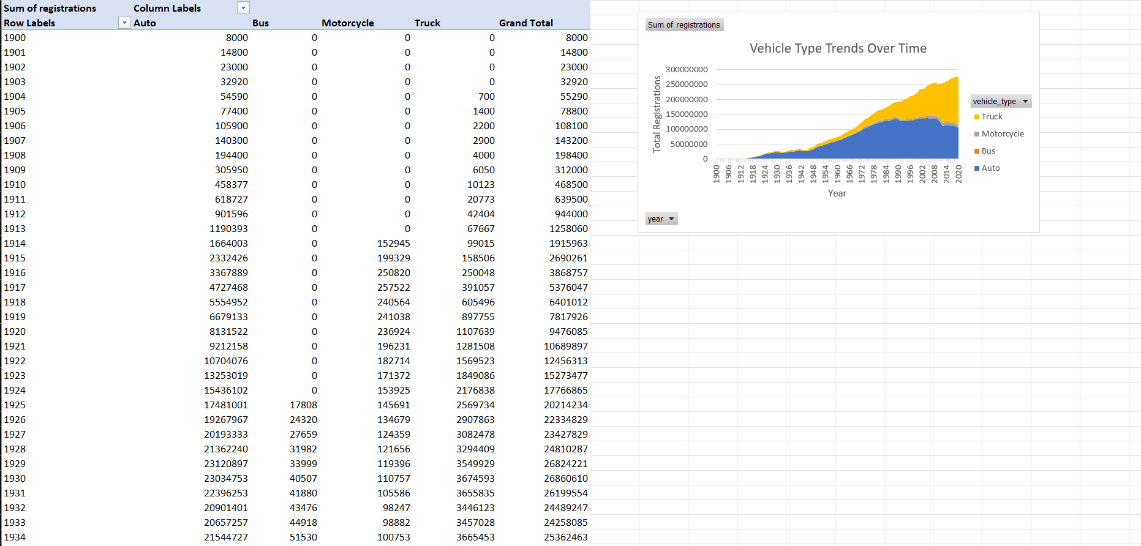

**Slicers: Linked to filter all charts by State, Region, date, and Vehicle Type**

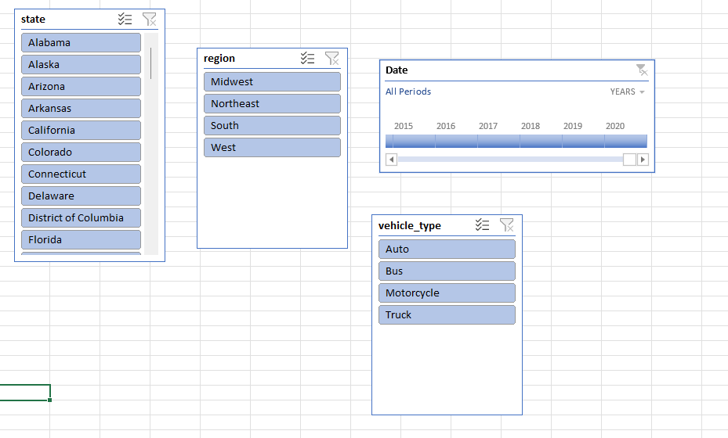

**3.9 Chart 5- Dynamic Dashboard Filters and KPIs**

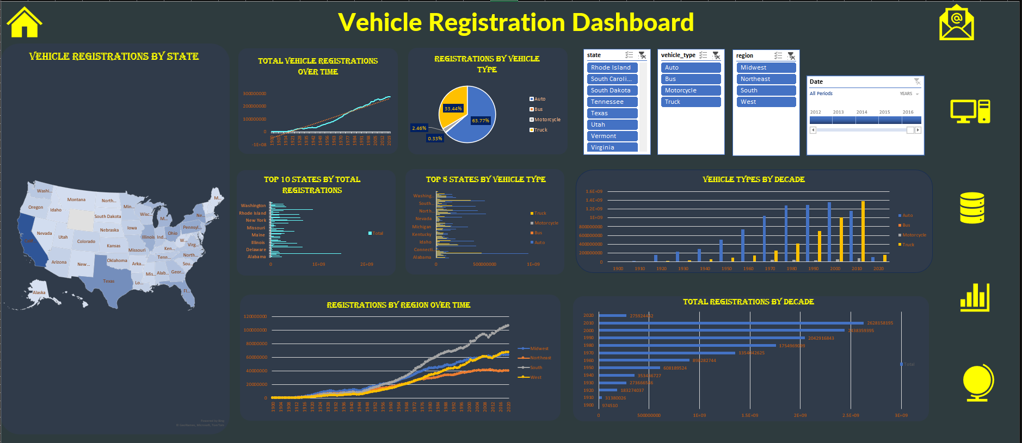

**4. CONCLUSION: -**

The analysis and visualization of the vehicle registration data using Microsoft Excel have provided valuable insights into the trends, patterns, and dynamics of vehicle ownership across states over time. By transforming a complex dataset into an interactive dashboard, this project demonstrates the importance and effectiveness of data visualization in understanding transportation patterns.

Through various analyses, such as yearly registration trends, state-wise comparisons, and vehicle type distributions, the project highlighted critical aspects of registration activity. The use of pivot tables, slicers, dynamic charts, and KPI indicators allowed for efficient filtering and exploration of data based on different categories like state, vehicle type, and year. This simplified the decision-making process and helped in identifying key patterns, such as the dominance of Auto and emerging Truck trends.

The dashboard offers a powerful tool for transportation analysts, policymakers, and researchers, providing them with a clear and concise way to interpret historical data and draw actionable conclusions. It also enables users to customize views based on specific interests, making it adaptable for various use cases.

Moreover, this project has enhanced my practical skills in data cleaning, dashboard creation, trend analysis, and visual storytelling. It emphasized the importance of structured reporting, data accuracy, and clear presentation, which are essential components of any data science task.

In summary, this project not only fulfilled its technical objectives but also contributed to a better understanding of how data analytics can support effective decision-making and strategic planning in the field of transportation and beyond.

**5. Future Scope: -**

* Integration with live vehicle registration datasets for real-time dashboards.
* Automation using VBA to refresh and filter reports.
* Comparative analysis with population or economic data.
* Machine learning modeling for registration prediction in Python or R.

**6. REFERENCES: -** [**https://catalog.data.gov/dataset/motor-vehicle-registrations-dashboard-data**](https://catalog.data.gov/dataset/motor-vehicle-registrations-dashboard-data)

[**https://www.linkedin.com/posts/tokachichu-sricharan_vehicleregistration-dataanalytics-exceldashboard-activity-7316554744078970880-QRsE?utm_source=share&utm_medium=member_desktop&rcm=ACoAADxZ_LEBG-7X78OaFyc5lNjUzxgeGhnb7nU**](https://www.linkedin.com/posts/tokachichu-sricharan_vehicleregistration-dataanalytics-exceldashboard-activity-7316554744078970880-QRsE?utm_source=share&utm_medium=member_desktop&rcm=ACoAADxZ_LEBG-7X78OaFyc5lNjUzxgeGhnb7nU)

THANK YOU!!!