1. create new group rogroup

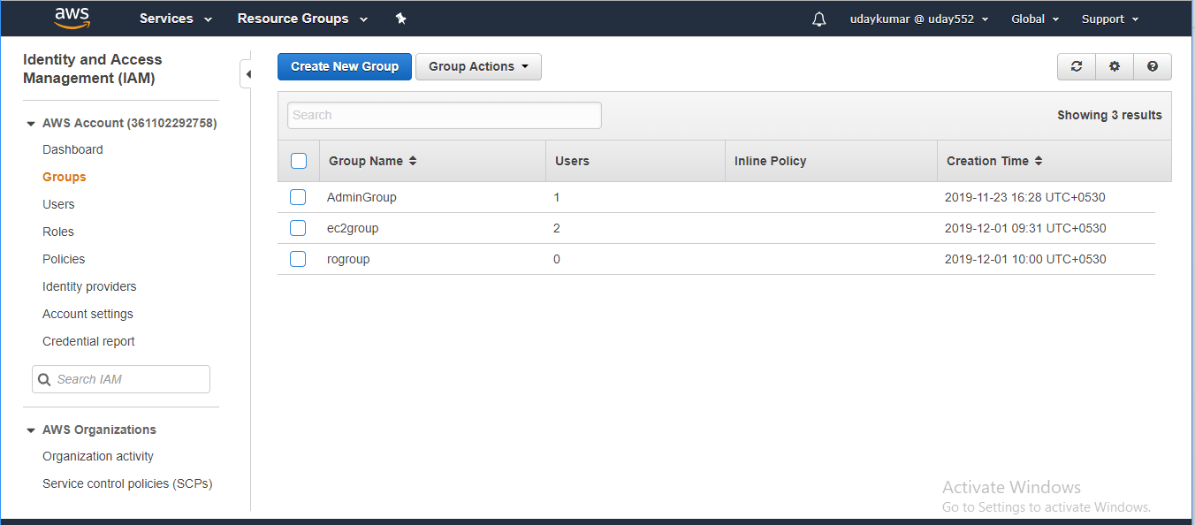

Rogroup created with readonly access

1. create two users rousera rouserb only without console access but should be able to login programmatic way

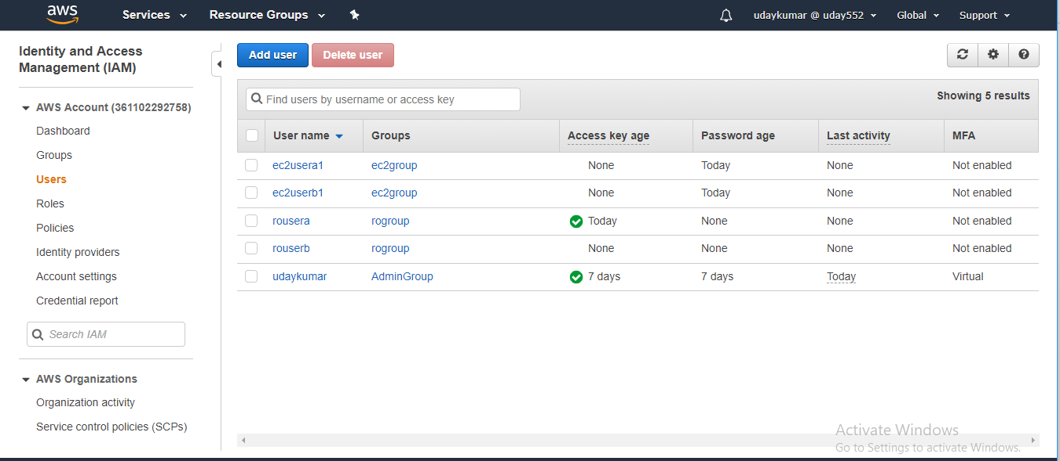

Created two users with programatic access

1. Add both users to regroup



Added both user to Rogroup

1. Provide aws full read only access to both the users in recommended method.

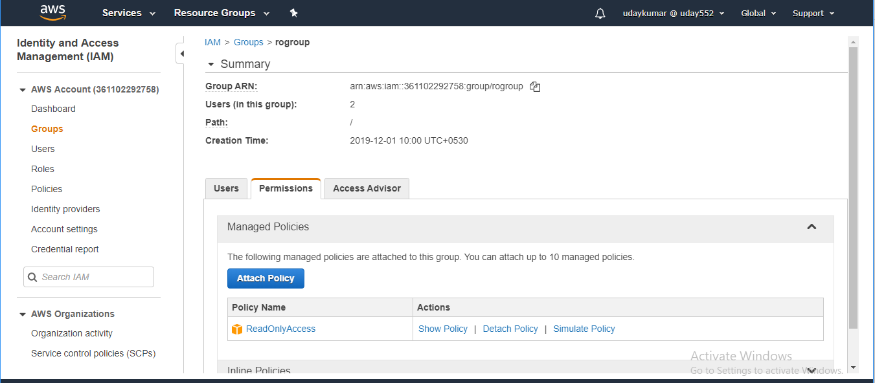

We provide the Readonly access for regroup to added the both users.