1. **Create a linux machine in Ohio region and server should be accessible from laptop.**

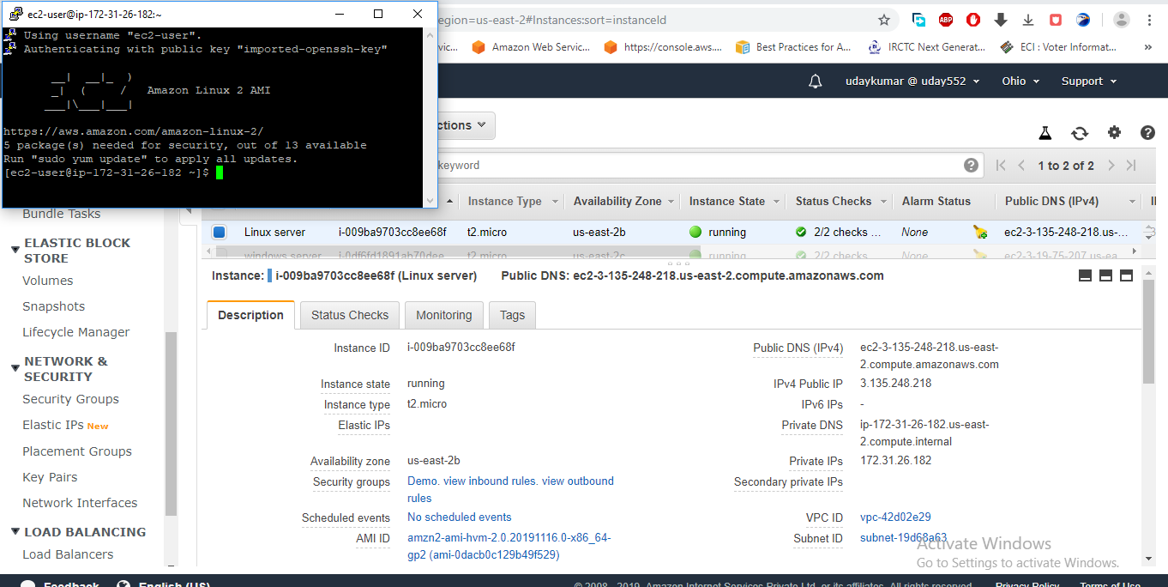

**We are created the ohio region and access to the laptop**

**2. Create a linux machine in Ohio region in second AZ which should not be accessible from internet however should be able to login from windows server**

**created in next step.**

**Linux server created in ohio in second AZ not accesing from local system**

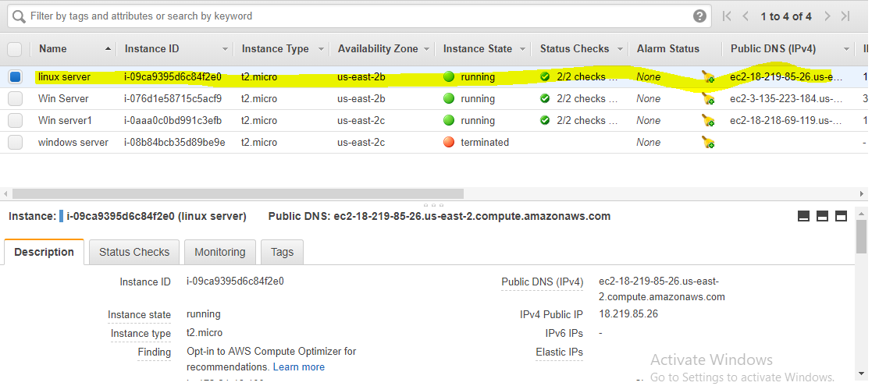

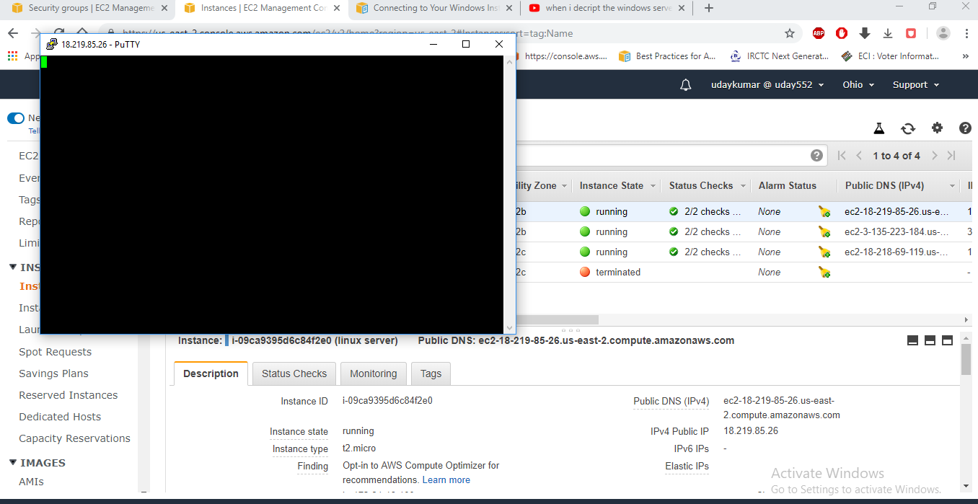

**I can able to access to windows server**

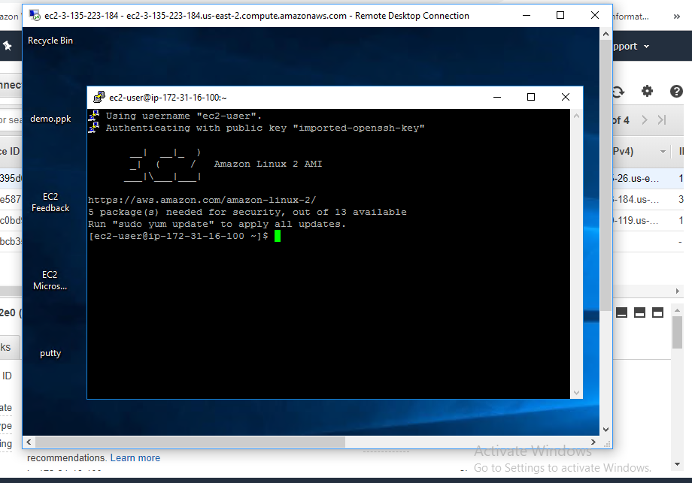

**3. Create a windows server in the last az which should be accessible from internet and using this server login to second server.**

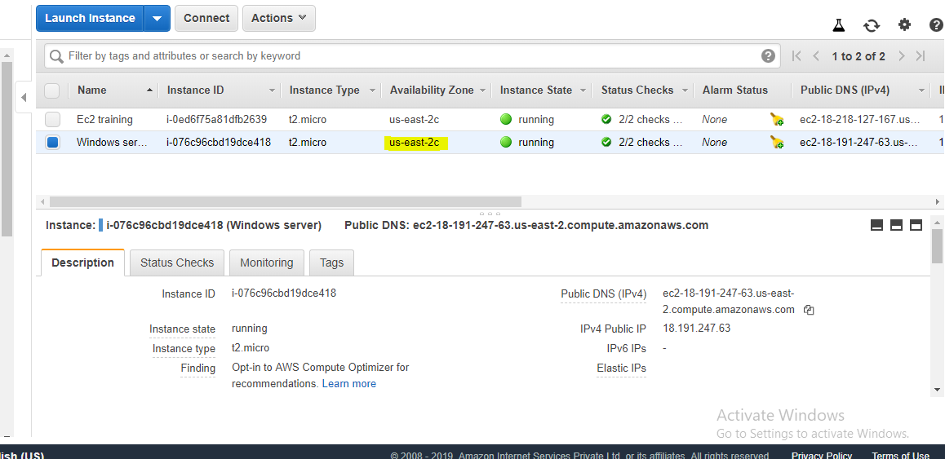

**Windows server created in last AZ**

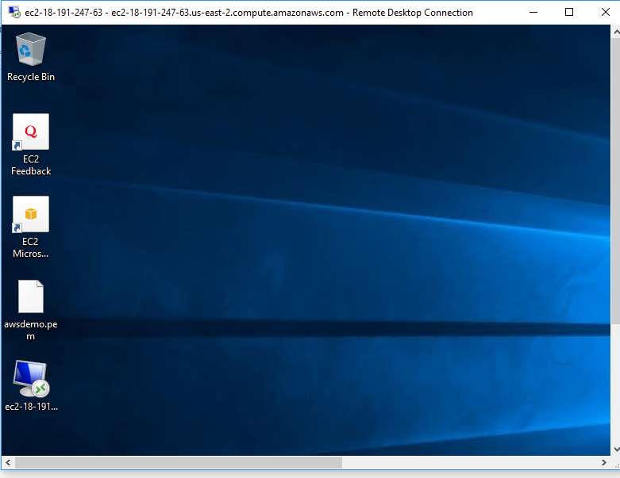

**We are able to access from internet**

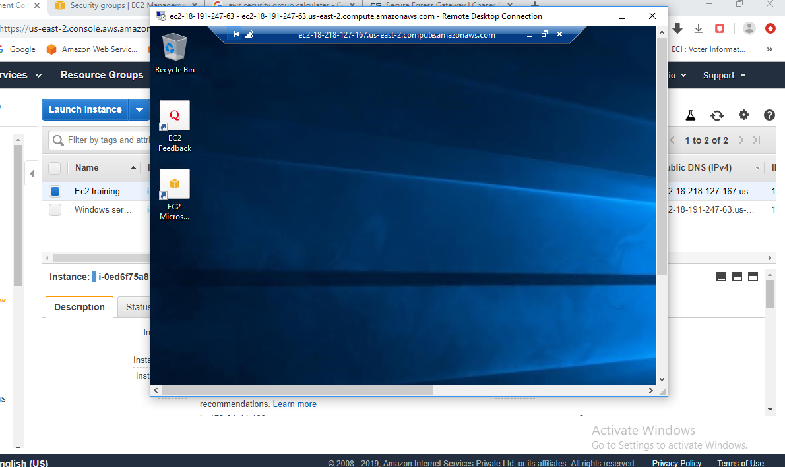

**I can able to login server 2 in server 1**

**4. Create a new image of the server1 with name ec2training.**

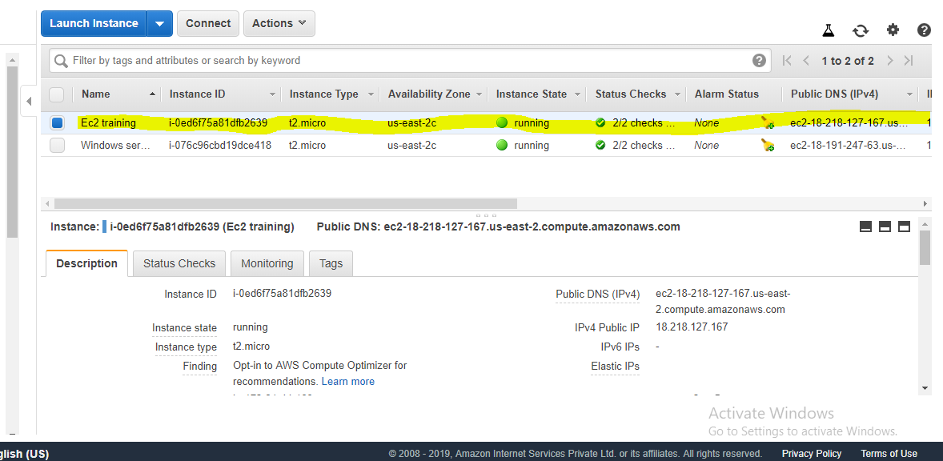

**5. Each of the above machine should allow only their respective remote login protocol/port from required source and with webserver ports [both secure and not secured]**

**from internet.**

**In above instance we allow their respective remote login protocol/port from required source.**