1. **create new group ec2group**

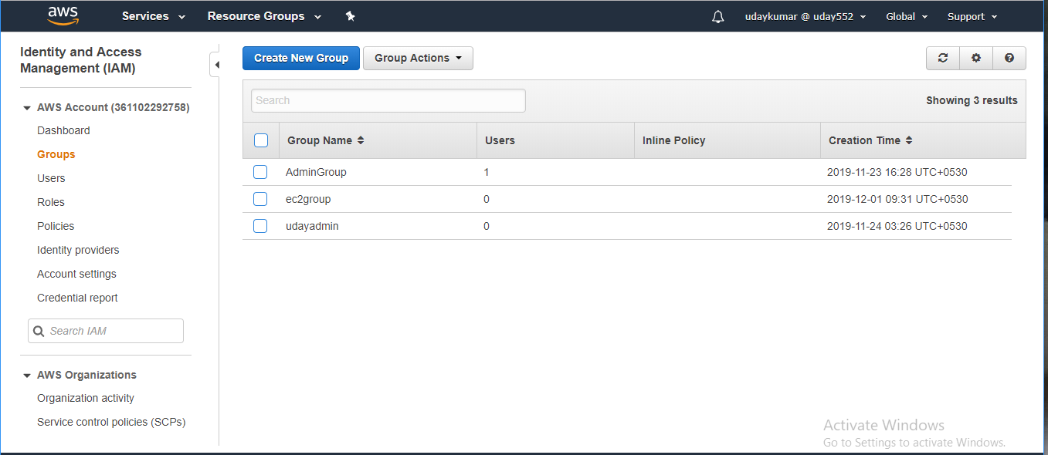

**Created ec2group with ec2full access**

1. **create two users ec2usera1 ec2userb1 only with console access**

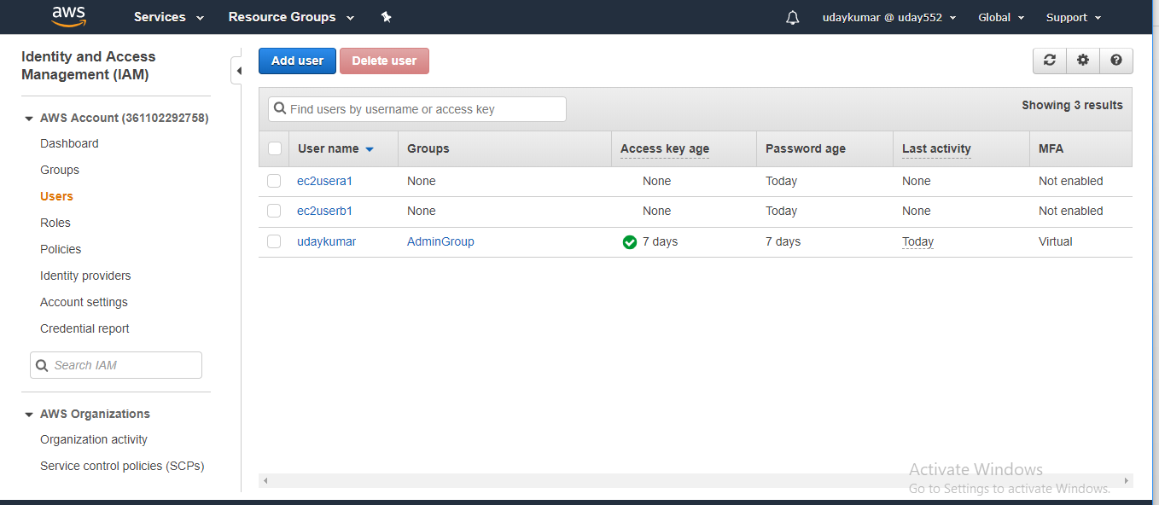

**Created two users with console access**

1. **Add both users to ec2group**

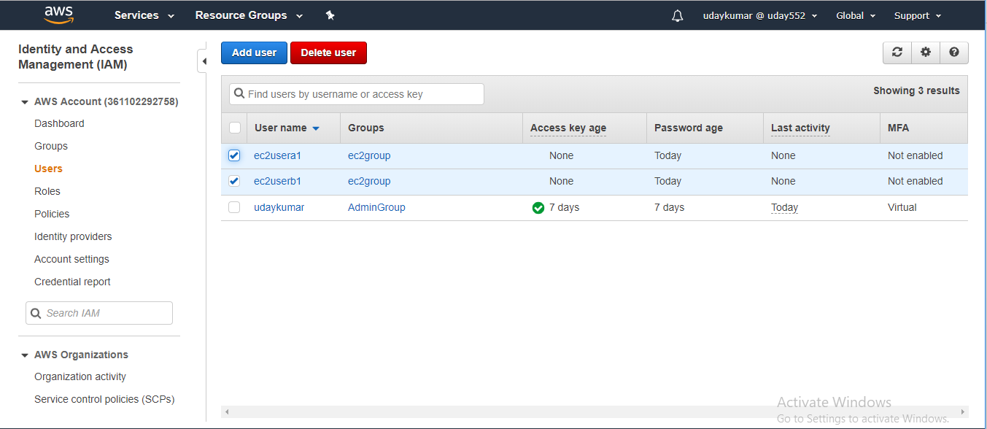

**Added both users ec2 group**

1. **Provide ec2full access to both the users in recommended method.**

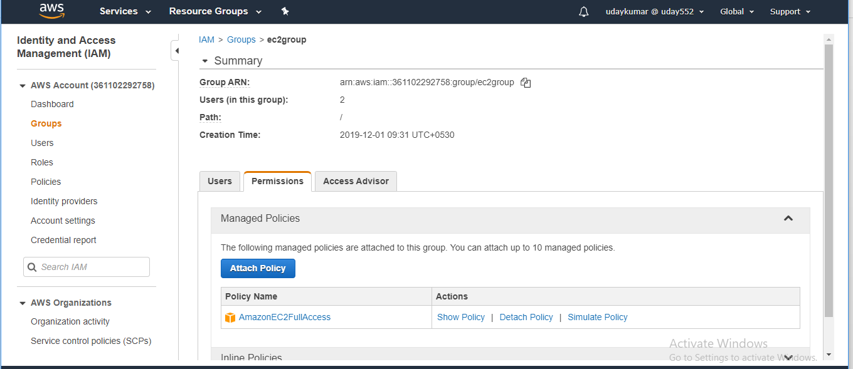

**Already ec2group have ec2full access ,just we added this group to both users.**