**Lab: CloudFront Distribution Creation**

**Services Used: S3, CloudFront**

For cloudfront configuration for this exercise verify S3 bucket hosting is setup and working fine.

1. Verify S3 bucket and static website hosting status.

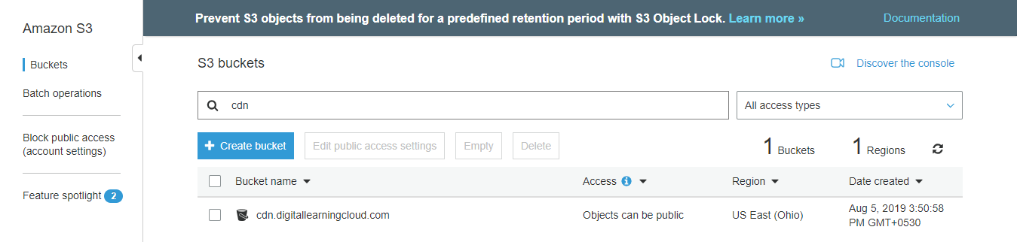

1. Take note of current bucket policy as later in the exercise we will be updating it to restrict only to be accessible from cloudfront. Currently no bucket policy is defined.

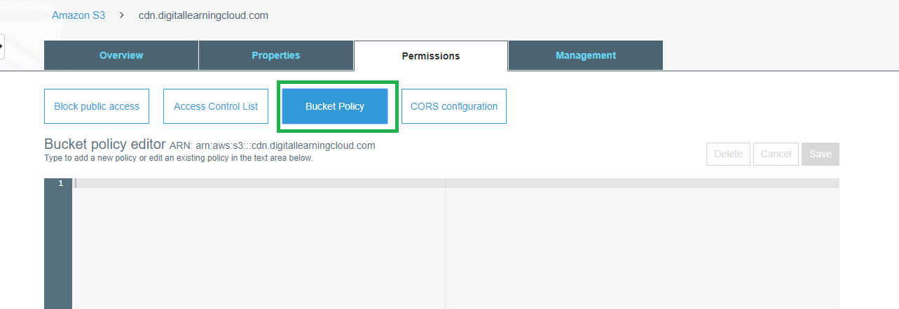

1. Check the s3 accessibility and ensure we are good to proceed with cloudfront configuration.

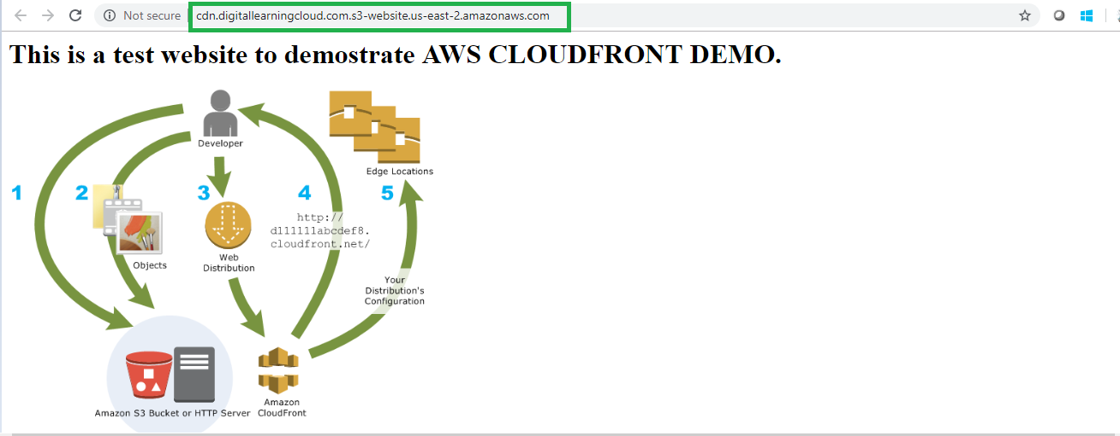

1. Go to cloudfront service in AWS console
2. Cloudfront 🡪 Create Distribution.

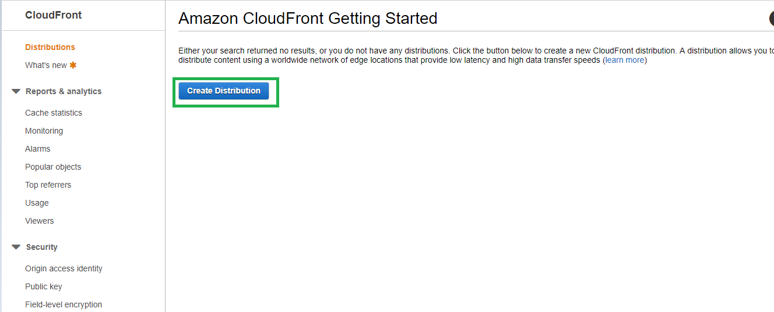

1. Select as web delivery method.

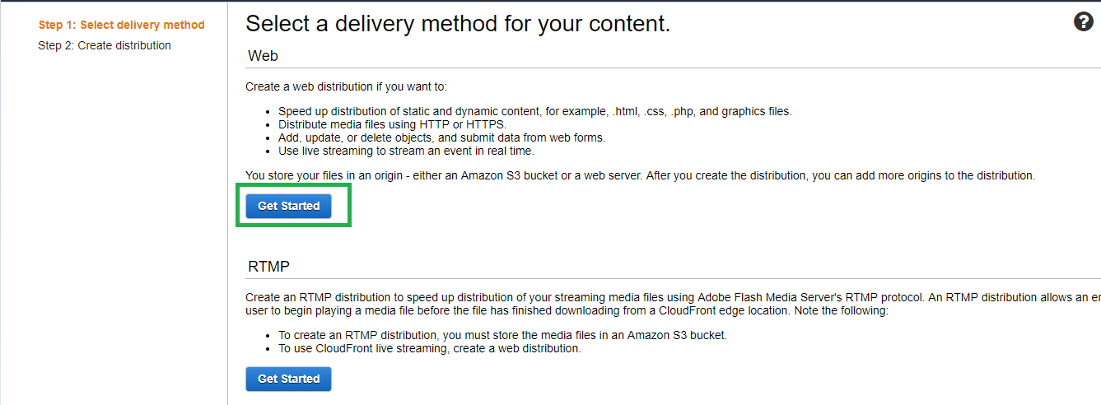

1. Select the S3 Bucket as our distribution origin is S3.

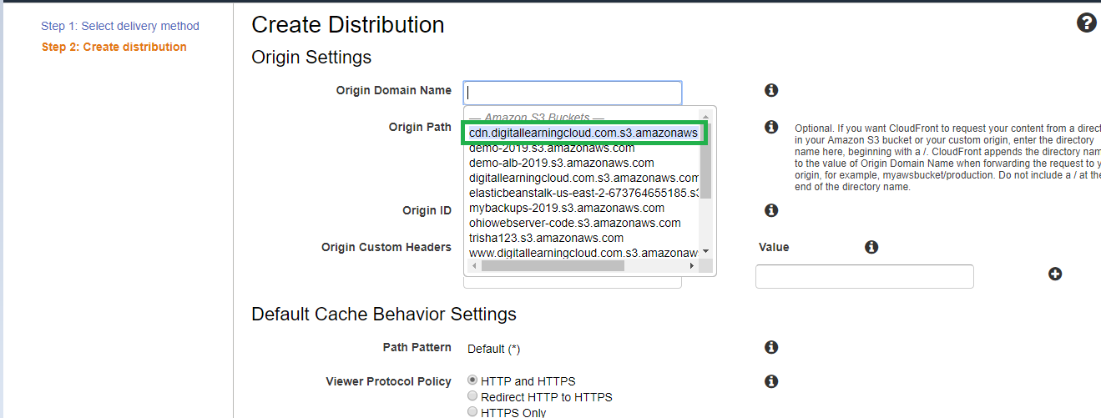

1. In the restrict bucket access settings click yes and create new identity. Also select yes update bucket policy to get the S3 bucket policy updated automatically with this origin access identity.

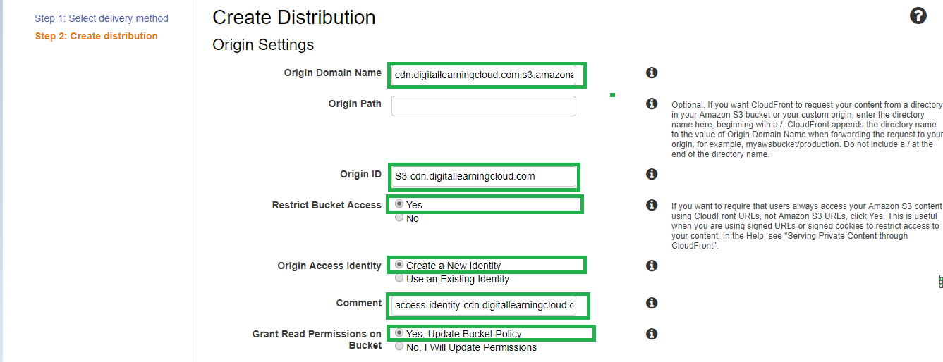

1. Keep index.html as the default root object and click create to get the distribution created.

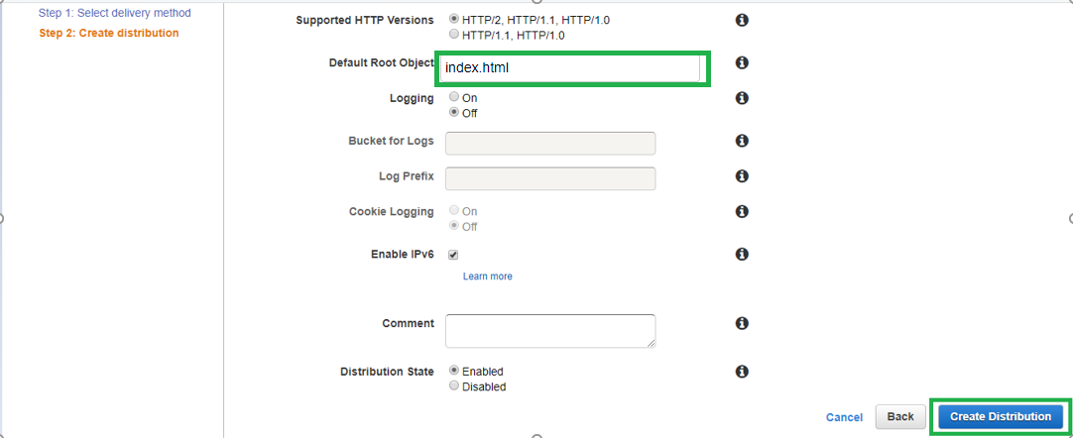

1. The distribution is now enabled and deployment in progress.

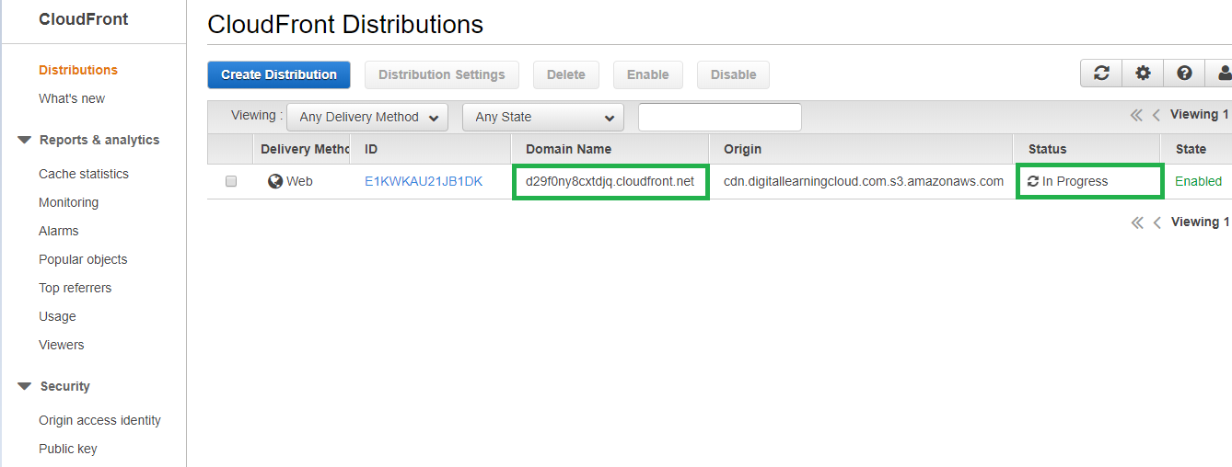

1. Meanwhile check the S3 bucket policy now as it is updated with the cloudfront distribution’s OAI.

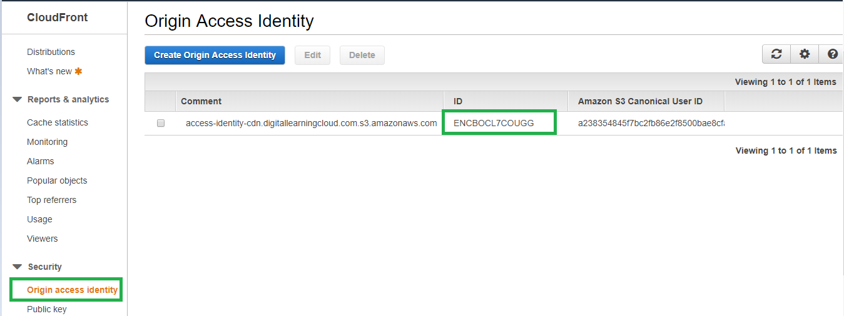

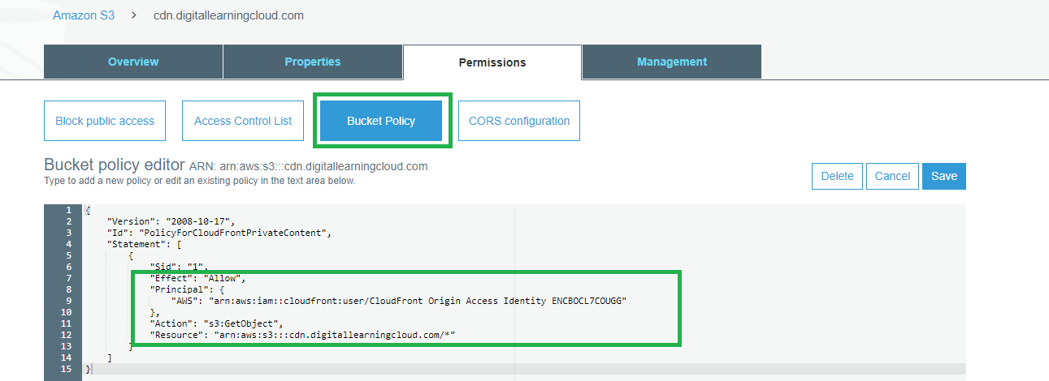

1. Remove the public access on the bucket as it will now only be accessed by cloudfront and not directly.

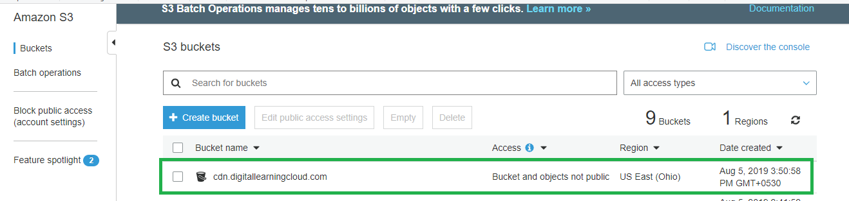

1. Check public access by directly accessing the S3 URL which should return Access Denied as the Bucket and objects are no more public.

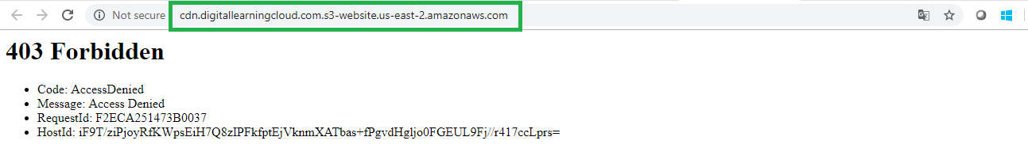

1. Now the cloudfront distribution is deployed and ready for use. Take the domain name and access in browser to verify it is working as expected.

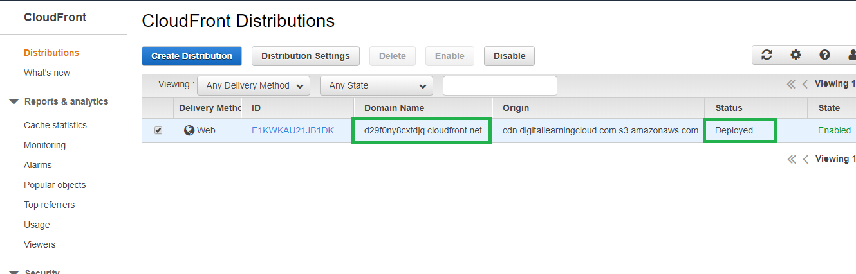

1. The cloudfront distribution is working as expected.

