SIMATS ENGINEERING
Assessment Tool 1 – Short Answer Test (Annexure A)
Course Code: CSA16 | Course Name: Data Warehousing and Data Mining
CO1: Design data warehouse architectures with appropriate dimensional models | Total Marks: 20
Name : G Charan Teja
Reg No : 192372301

Question 1 (5 Marks)

(a) Three classes of schemas used for modeling data warehouses
- Star schema – a single central fact table connected directly to one denormalized dimension table per dimension. The diagram looks like a star; queries need few joins.
- Snowflake schema – a variant of the star schema where the dimension tables are normalized into several related tables, forming a snowflake-like shape. It saves space but needs more joins.
- Fact constellation (galaxy) schema – several fact tables share common dimension tables, i.e. a collection of star schemas.

(b) Schema diagram (Star schema)
The fact table holds the two measures (count, charge) and a foreign key to each of the three dimensions: time, doctor and patient.
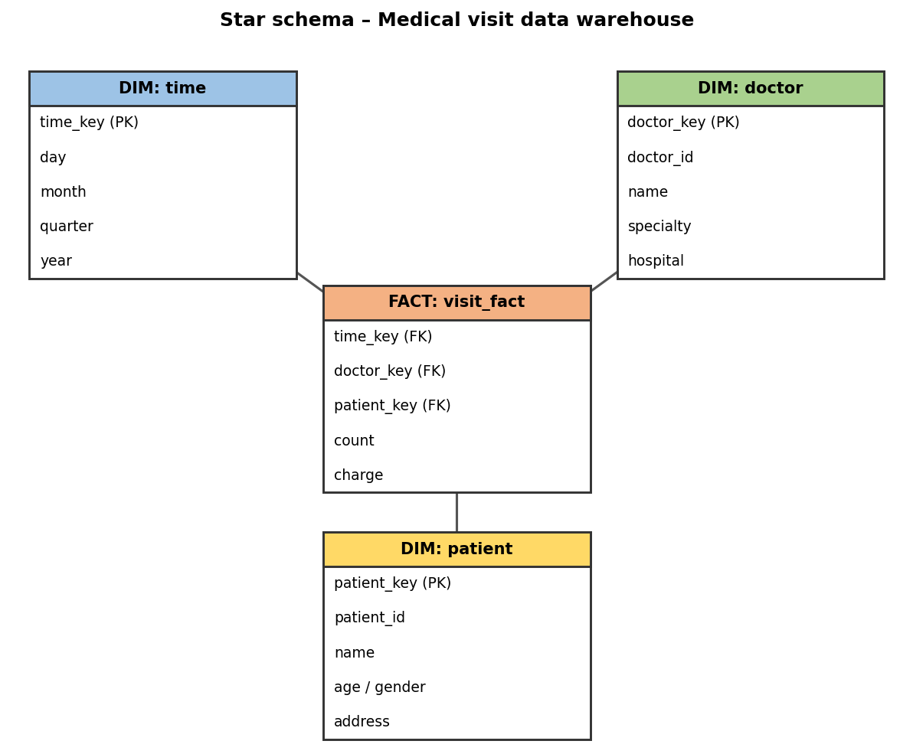

(c) SQL query
Assumption: the “list” asked for is the total fee collected by each doctor in a given year (e.g. 2010) from the relation fee(day, month, year, doctor, hospital, patient, count, charge).
SELECT doctor,
SUM(count) AS total_visits,
SUM(charge) AS total_fee
FROM fee
WHERE year = 2010
GROUP BY doctor
ORDER BY total_fee DESC;

To list it per doctor and hospital, add hospital to the SELECT and GROUP BY clauses.

Question 2 (5 Marks)

(a) Snowflake schema diagram
The fact table grade_fact stores the measures count and avg_grade. The dimension tables are normalized along their concept hierarchies: student < major < status < university; course < department; semester < year; instructor < department.
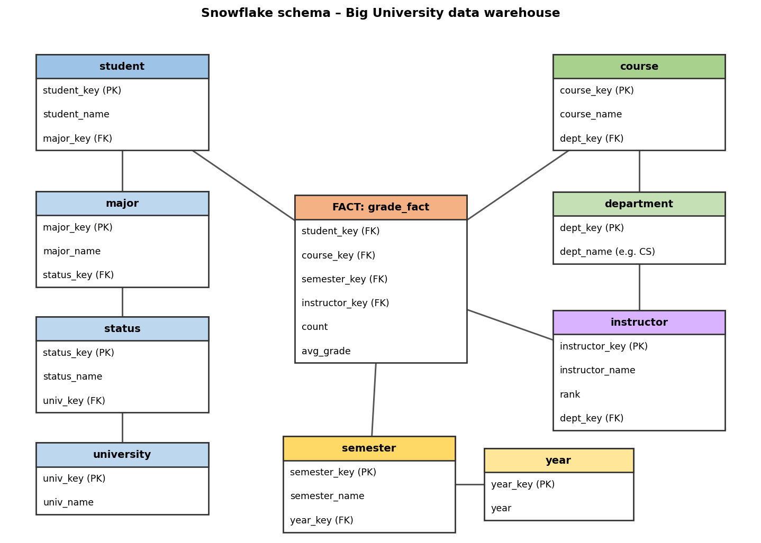

(b) OLAP operations to list the average grade of CS courses for each student
Start from the base cuboid [student, course, semester, instructor] and perform:
- Roll-up on course, from course_id to department.
- Dice (select) on course (now at the department level) with department = “CS”.
- Roll-up on semester, from semester to all (aggregate over all semesters).
- Roll-up on instructor, from instructor to all (aggregate over all instructors).
- Keep student at the individual student level (no roll-up).
Result: the cuboid [student, department = CS, all, all], whose avg_grade cells give the average grade of CS courses for each Big University student.

(c) Number of cuboids
A data cube with n dimensions, where dimension i has Lᵢ levels (including “all”), has Π Lᵢ cuboids. Here there are 4 dimensions with 5 levels each (including all):
Total cuboids = 5 × 5 × 5 × 5 = 5⁴ = 625
This count includes the base cuboid (lowest level of every dimension) and the apex cuboid (all, all, all, all).

Question 3 (5 Marks)

Data warehouse design for a regional weather bureau

Step 1 – Business requirement and granularity
About 1,000 probes send air pressure, temperature and precipitation every hour to a central station, which holds more than 10 years of history. The grain of the fact table is therefore one reading per probe per hour.
- Approximate size: 1,000 probes × 24 hours × 365 days × 10 years ≈ 87.6 million fact rows.
- Goals: efficient querying, OLAP, and discovery of general weather patterns in multidimensional space.

Step 2 – Choice of schema
A star schema is chosen: it needs the fewest joins, which suits fast OLAP queries on a large fact table.
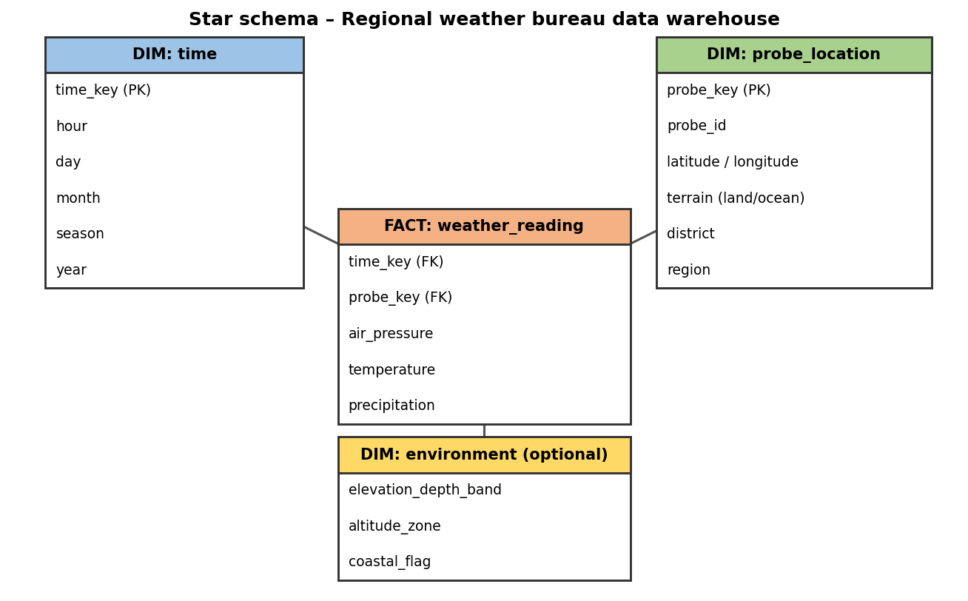

Step 3 – Dimensions and concept hierarchies
Dimension | Attributes | Concept hierarchy
Time | hour, day, month, season, year | hour < day < month < season < year < all
Probe / Location | probe_id, latitude, longitude, terrain (land/ocean), district, region | probe < district < region < all; terrain: land / ocean
Environment (optional) | altitude or depth band, coastal flag | band < all

Step 4 – Measures
- Base measures (per hourly reading): air_pressure, temperature, precipitation.
- Aggregated measures: avg / max / min temperature, avg air_pressure, sum of precipitation, and count of readings (a distributive/algebraic mix, so they roll up easily).

Step 5 – Efficient querying and OLAP support
- Materialize selected cuboids rather than the full cube, e.g. [day, district], [month, region], [year, all locations], and the base cuboid. Higher-level queries then read small pre-aggregated tables.
- Partition the fact table by year/month and index the foreign keys (bitmap indexes on low-cardinality attributes like terrain and season).
- Use an ETL process to clean the hourly feeds (handle probe failures, missing values and outliers) before loading.
- Keep the full history online for 10+ years, loading new data incrementally every hour or day.

Step 6 – OLAP operations and pattern discovery
- Roll-up / drill-down: hour → day → month → year; probe → district → region.
- Slice / dice: e.g. only ocean probes in monsoon season; or only year = 2020.
- Pivot: rotate to compare regions against months.
- Pattern derivation: seasonal trends, regional climate profiles, correlation between pressure drops and rainfall, clustering of similar-weather regions, and detection of abnormal events (storms, heat waves) using OLAP together with data mining.

Question 4 (5 Marks)
Data cube C has n dimensions; each dimension has exactly p distinct values in the base cuboid and no concept hierarchies.

(a) Maximum number of cells in the base cuboid
pⁿ – every combination of one value from each of the n dimensions can be a non-empty cell (p × p × … × p, n times).

(b) Minimum number of cells in the base cuboid
p – each of the p values of every dimension must appear at least once. One cell can cover one value in each dimension at the same time, so p cells (for example the “diagonal” cells (vᵢ, vᵢ, …, vᵢ) for i = 1…p) are enough.

(c) Maximum number of cells in the whole cube
(p + 1)ⁿ – with no hierarchies, each dimension has p values plus the aggregated value “*” (all), so every cell is a choice of one of p + 1 values in each of the n dimensions.

(d) Minimum number of cells in the whole cube
(2ⁿ − 1) × p + 1
Reasoning: with the minimum p base cells arranged as in (b), a base cell generates 2ⁿ cells in total (itself plus its 2ⁿ − 1 aggregates, obtained by replacing any subset of its coordinates by “*”). Because the p base cells have different values in every dimension, none of their aggregates coincide except the apex cell (*, *, …, *), which is shared by all. So the total is p × (2ⁿ − 1) non-apex cells (the base cell and its aggregates) + 1 apex cell.
Check: for n = 1 the formula gives p + 1 (p base cells and one apex cell), which is correct.
Summary of results: Q2(c) = 625 cuboids; Q4(a) = pⁿ; Q4(b) = p; Q4(c) = (p+1)ⁿ; Q4(d) = (2ⁿ − 1)p + 1.

