Setup

# GitLab

Access the above url and login using your Mindtree credentials.

URL - <https://glcgitlab.southindia.cloudapp.azure.com/playground/dotnet-july-2018/yashaswini/projects/apsis>

After logging in, to work on the code that is to clone/commit/pull/push, you need first generate SSH key and a personal access token.

#### Generating SSH key

1. Open Git Bash command prompt.
2. Run this command

*ssh-keygen -t rsa -C "your_mid@mindtree.com" -b 4096*

1. You will be asked to “*Enter the file in which to save the key*”. Press ENTER without typing anything. By doing so the key will be save at the default location which is *C:\Users\your_mid\.ssh* folder.
2. Similarly just press ENTER for the passphrase questions without typing anything.

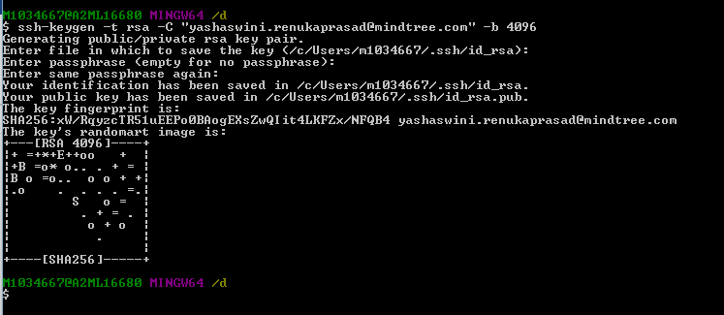

1. Now go to the folder *C:\Users\your_mid\.ssh*. You should be able to see 2 files - *id_rsa and id_rsa.pub.*
2. Open the *id_rsa.pub* file in notepad and copy the entire content of that file.

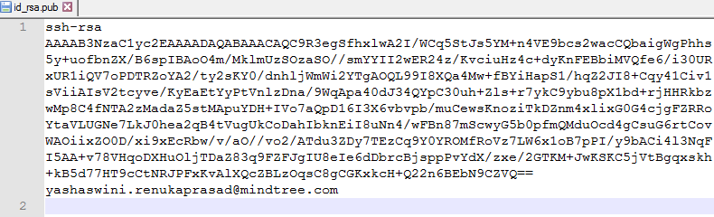

1. Open <https://glcgitlab.southindia.cloudapp.azure.com/profile/keys>
2. Paste the copied key and press Add key. You should be able to see a key added under “Your SSH keys” section.

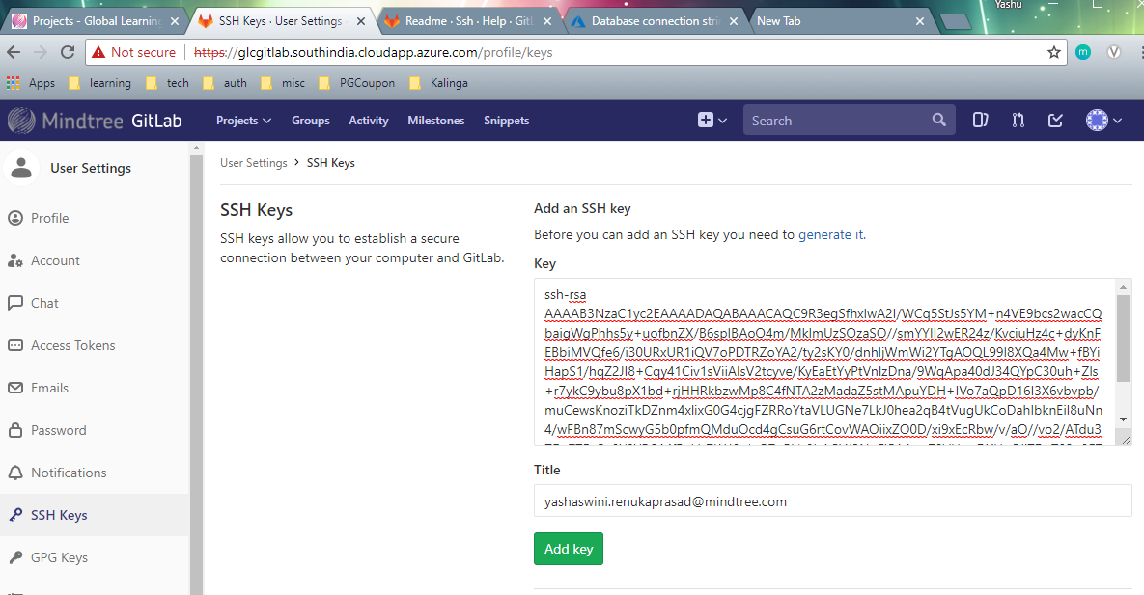

#### Generating personal access token

1. Log in to your GitLab account.
2. Go to your Profile settings.
3. Go to Access tokens.
4. Choose a name and optionally an expiry date for the token.
5. Click on both *api* and *read_user* checkboxes.
6. Click on Create personal access token.
7. Save the personal access token somewhere safe. Once you leave or refresh the page, you won't be able to access it again.

Use this token as the password to clone the repository. Username would be your [MID@mindtree.com](mailto:MID@mindtree.com).

# Database

Connect to the SQL Azure database using the below credentials. You can either use SQL Server Management studio or Visual Studio’s SQL Server Object Explorer for this.

* Server - orchardsqlserver.database.windows.net
* Database Name – Orchard8
* Username - sqluser8
* Password - pwd#Login8