**Title**: **KISAN STORE**

**Name**: Chandra Siva Charan Daggubati

**Github link**: <https://github.com/charanD09/KisanStore.git>

**Date**: 22-March-2022

**INTRODUCTION**

* 1. Project Description

I have created a web development application called Kisan Store. I'm trying to come up with a database system that keeps track of customer, product, and employee information. This web application will help farmers sell their products online, namely vegetables, fruits, and grains. The Kisan store will act as a bridge between farmers and customers. I’m interested in helping farmers' products sell online, which makes farmers profit as well as customers happy by providing them with organic products. I’m interested in getting data because I need to keep track of my business operations to make sure that I have the right components. I will manually enter employee data. My customers generate data when they produce orders. I will also manually add data from suppliers (farmers). I want to store my data in a database and do all kinds of operations whenever required. All kinds of records can be fetched from the database without any loss of data.

Week 2

For my business, I will have the following entities:

1. Product_Info – product_name, product_id, Cost,brand_id,customer_id
2. Customer_Info – cutomer_Phone,customer_id, first_name, last_name,address, zipcode,product_Info_product_id,order_id
3. Supplier_Info – supplier_ID,supplier_Fname, supplier_Lname, company_name, address,Product_Info_product_id
4. Sales_Info – Item sold, date, price, profit,supplier_Id

5. Store_Info –store_id, store_name,phone,email,address,zipcode ,sales_Id,sales_Info_sales_Id

6. Order_Info – order_id, cutomer_id, order_status, order_date,store_id ,store_Info_store_id

Tables:

|  |  |
| --- | --- |
| **Product Info** |  |
| product_name | varChar[25] |
| product_id | Integer |
| Cost | Float |
| brand_id | Integer |
| Customer_id | Integer |

|  |  |
| --- | --- |
| **Customer Info** |  |
| cutomer_Phone | varChar[25] |
| customer_id | Integer |
| first_name | varChar[25] |
| last_name | varChar[25] |
| address | varChar[50] |
| zipcode | Integer |
| Product_Info_product_id | integer |

|  |  |
| --- | --- |
| **Supplier Info** |  |
| supplier_ID | Integer |
| supplier_Fname | varChar[25] |
| supplier_Lname | varChar[25] |
| company_name | varChar[20] |
| address | varChar[50] |
| Product_Info_product_id | integer |

|  |  |
| --- | --- |
| **Sales Info** |  |
| Item sold | varChar[20] |
| date | DateTime |
| price | Float |
| profit | Float |
| Supplier_ID | Integer |
| Sales_Id | Integer |

|  |  |
| --- | --- |
| **Store Info** |  |
| store_id | integer |
| store_name | varChar[25] |
| phone | varChar[15] |
| email | varChar[25] |
| address | varChar[50] |
| zipcode | Integer |
| Sales_id | integer |
| Sales_Info_Sales_Id | integer |

|  |  |
| --- | --- |
| **Order Info** |  |
| order_id | Integer |
| cutomer_id | Integer |
| order_status | varChar[10] |
| order_date | DateTime |
| store_id | Integer |
| Store_info_sales_id | integer |

Also pushed files containing records of my data required for project in my github repository

FileNames:

* Products_Info.csv
* Customer_Info.csv
* order_Info.csv
* supplier_Info.csv
* store_Info.csv
* sales_Info.csv

Week3

ER Diagrams

1. Umlet Free Utility Diagram

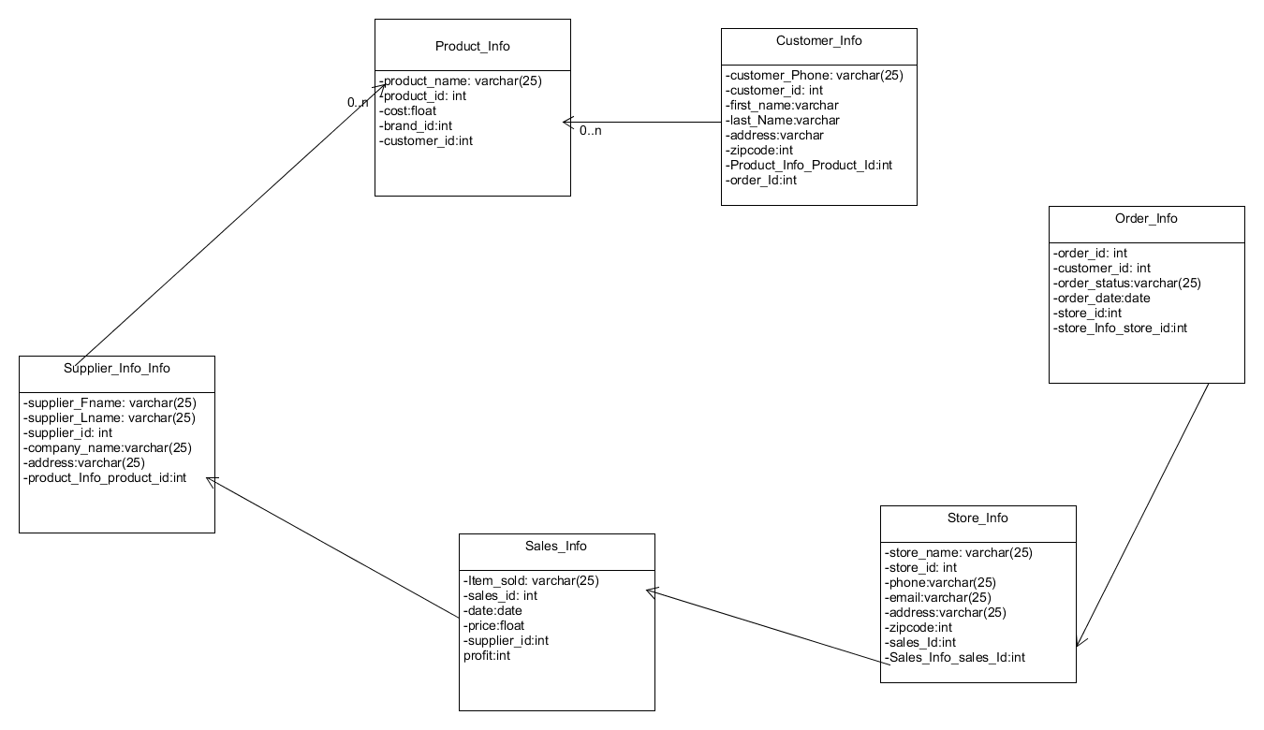

1. Crow’s foot model

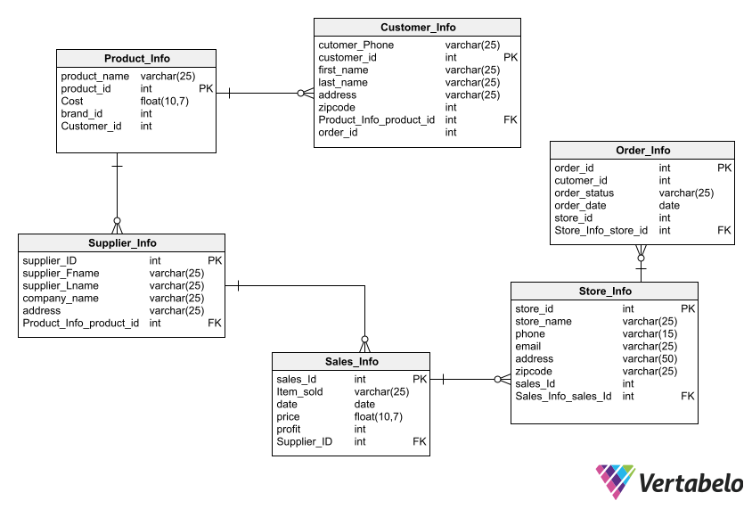

**Week4:**

Scripts and Outputs:

1. **Create tables commands**
2. Customer_Info

CREATE TABLE Customer_Info (

cutomer_Phone varchar(25) NOT NULL,

customer_id int NOT NULL,

first_name varchar(25) NOT NULL,

last_name varchar(25) NOT NULL,

address varchar(25) NOT NULL,

zipcode int NOT NULL,

Product_Info_product_id int NOT NULL,

order_id int NOT NULL,

CONSTRAINT Customer_Info_pk PRIMARY KEY (customer_id)

);

1. Product_Info

CREATE TABLE Product_Info (

product_name varchar(25) NOT NULL,

product_id int NOT NULL,

Cost float(10,7) NOT NULL,

brand_id int NOT NULL,

Customer_id int NOT NULL,

CONSTRAINT Product_Info_pk PRIMARY KEY (product_id)

);

1. Supplier_Info

CREATE TABLE Supplier_Info (

supplier_ID int NOT NULL,

supplier_Fname varchar(25) NOT NULL,

supplier_Lname varchar(25) NOT NULL,

company_name varchar(25) NOT NULL,

address varchar(25) NOT NULL,

Product_Info_product_id int NOT NULL,

CONSTRAINT Supplier_Info_pk PRIMARY KEY (supplier_ID)

);

D)Sales_Info

CREATE TABLE Sales_Info (

sales_Id int NOT NULL,

Item_sold varchar(25) NOT NULL,

date date NOT NULL,

price float(10,7) NOT NULL,

profit int NOT NULL,

Supplier_ID int NOT NULL,

CONSTRAINT Sales_Info_pk PRIMARY KEY (sales_Id)

);

E)Store_Info

CREATE TABLE Store_Info (

store_id int NOT NULL,

store_name varchar(25) NOT NULL,

phone varchar(15) NOT NULL,

email varchar(25) NOT NULL,

address varchar(50) NOT NULL,

zipcode varchar(25) NOT NULL,

sales_Id int NOT NULL,

Sales_Info_sales_Id int NOT NULL,

CONSTRAINT Store_Info_pk PRIMARY KEY (store_id)

);

1. Order_Info

CREATE TABLE Order_Info (

order_id int NOT NULL,

cutomer_id int NOT NULL,

order_status varchar(25) NOT NULL,

order_date date NOT NULL,

store_id int NOT NULL,

Store_Info_store_id int NOT NULL,

CONSTRAINT Order_Info_pk PRIMARY KEY (order_id)

);

**OUTPUTS:**

1. Create Customer_Info table

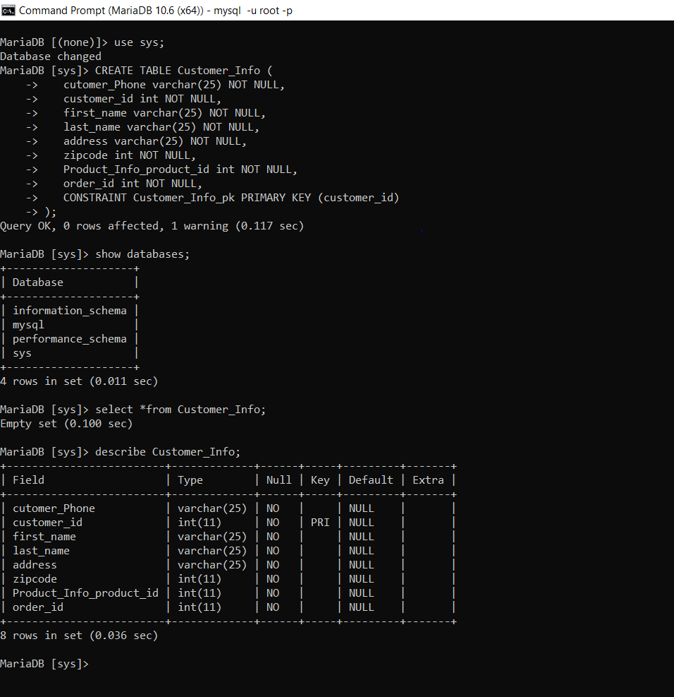

2)Create Product_Info table

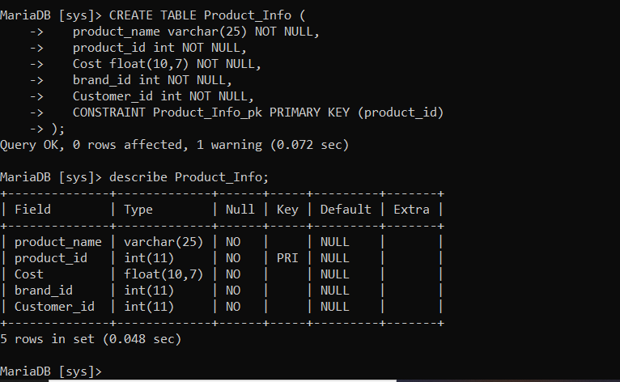

3)Create Supplier_Info table

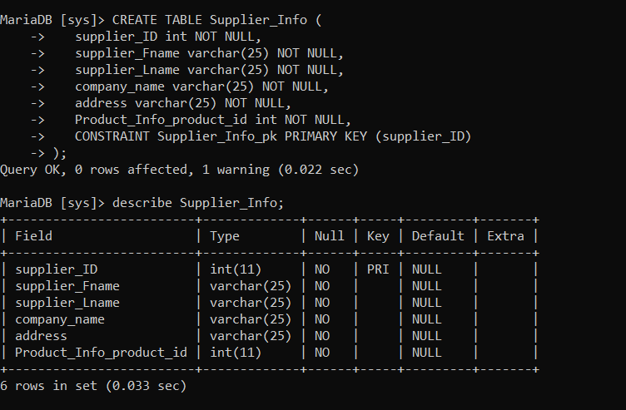

4)Create Sales_Info table

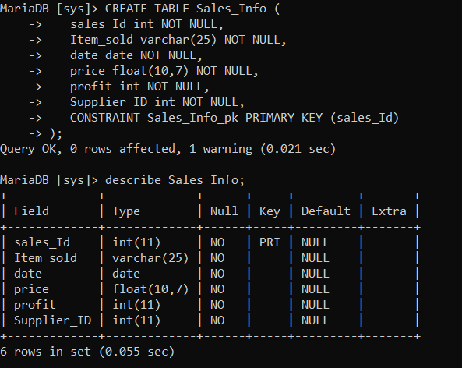

5)Create Store_Info table

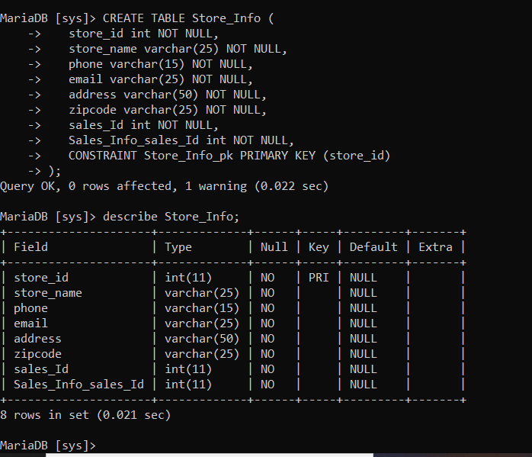

6)Create Order_Info table

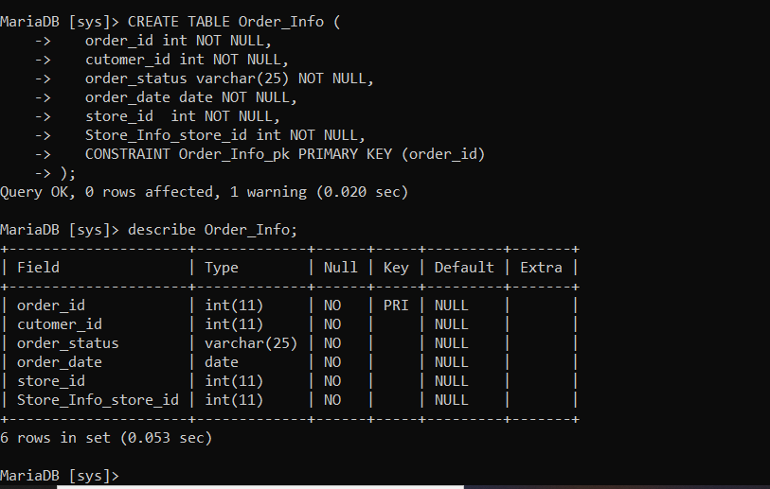

1. **Loading the data files into tables**

**Scripts:**

1. LOAD DATA LOCAL INFILE 'c:/temp/Customer_Info.csv'

-> INTO TABLE Customer_Info

-> FIELDS TERMINATED BY ','

-> LINES TERMINATED BY '\r\n'

-> IGNORE 1 LINES

-> (cutomer_Phone,customer_id,first_name,last_name,address,zipcode,Product_Info_product_id,order_id);

1. LOAD DATA LOCAL INFILE 'c:/temp/Product_Info.csv'

-> INTO TABLE Product_Info

-> FIELDS TERMINATED BY ','

-> LINES TERMINATED BY '\r\n'

-> IGNORE 1 LINES

-> (product_name,product_id,Cost,brand_id,customer_id);

1. LOAD DATA LOCAL INFILE 'c:/temp/Supplier_Info.csv'

-> INTO TABLE Supplier_Info

-> FIELDS TERMINATED BY ','

-> LINES TERMINATED BY '\r\n'

-> IGNORE 1 LINES

-> (supplier_ID,supplier_Fname,supplier_Lname,company_name,address,Product_Info_product_id);

1. LOAD DATA LOCAL INFILE 'c:/temp/Sales_Info.csv'

-> INTO TABLE Sales_Info

-> FIELDS TERMINATED BY ','

-> LINES TERMINATED BY '\r\n'

-> IGNORE 1 LINES

-> (sales_Id,Item_sold, date,price,profit,Supplier_ID);

1. LOAD DATA LOCAL INFILE 'c:/temp/Store_Info.csv'

-> INTO TABLE Store_Info

-> FIELDS TERMINATED BY ','

-> LINES TERMINATED BY '\r\n'

-> IGNORE 1 LINES

-> (store_id,store_name,phone,email,address,zipcode,sales_Id,Sales_Info_sales_Id);

1. LOAD DATA LOCAL INFILE 'c:/temp/Order_Info.csv'

-> INTO TABLE Order_Info

-> FIELDS TERMINATED BY ','

-> LINES TERMINATED BY '\r\n'

-> IGNORE 1 LINES

-> (order_id,cutomer_id,order_status,order_date,store_id,store_info_store_id);

**OUTPUTS:**

A)Loaded data present in Customer_Info.csv( local to db)

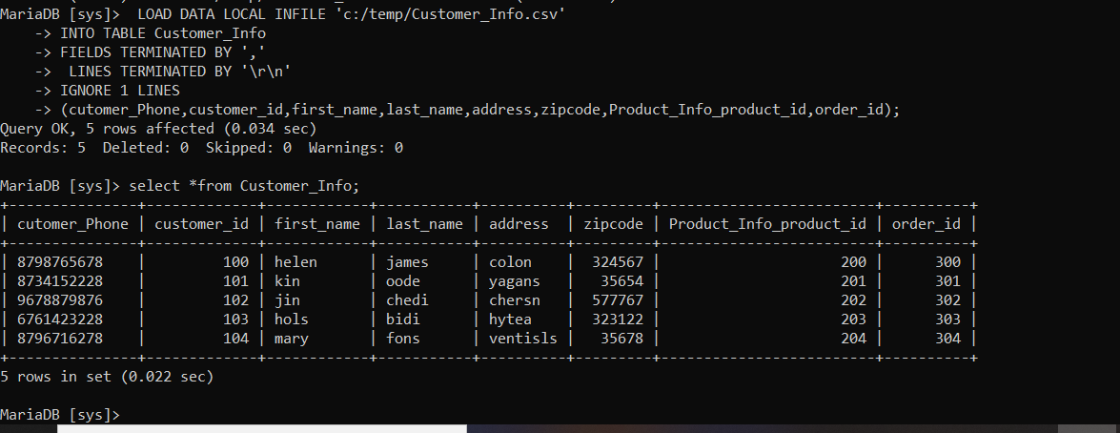

B)Loaded data present in Product_Info.csv( local to db)

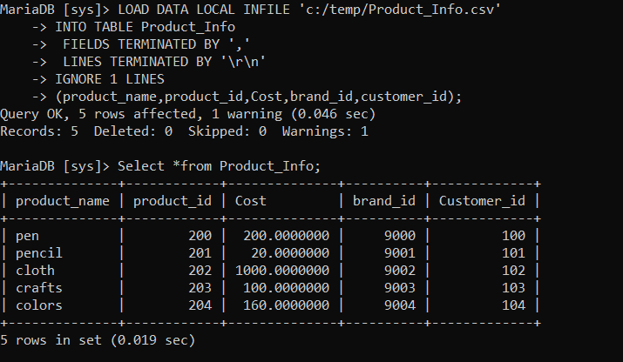

C)Loaded data present in Supplier_Info.csv( local to db)

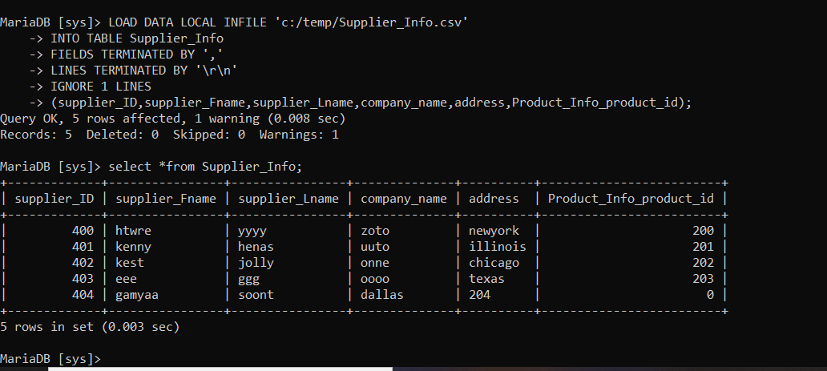

D)Loaded data present in Sales_Info.csv( local to db)

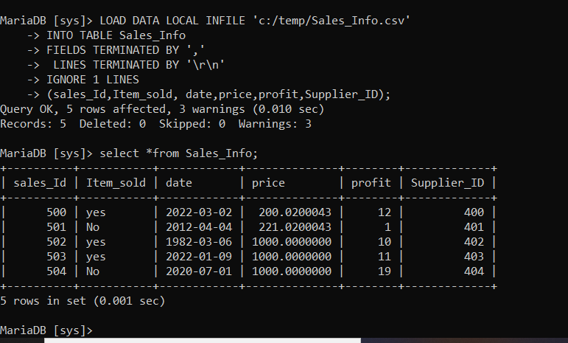

E)Loaded data present in Store_Info.csv( local to db)

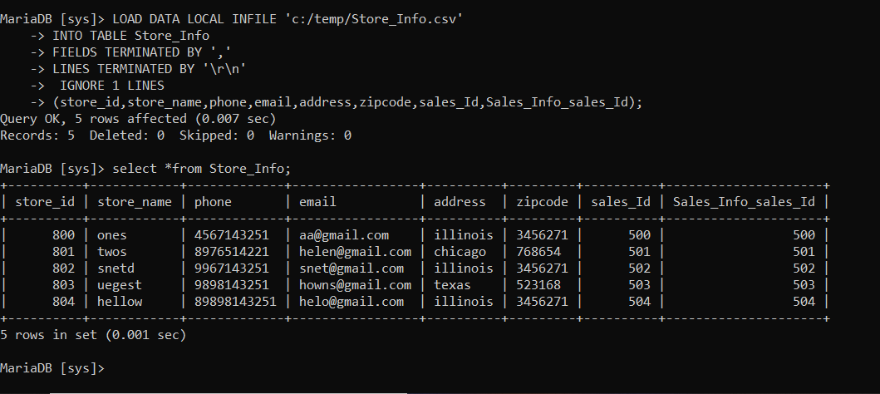

F)Loaded data present in Order_Info.csv( local to db)

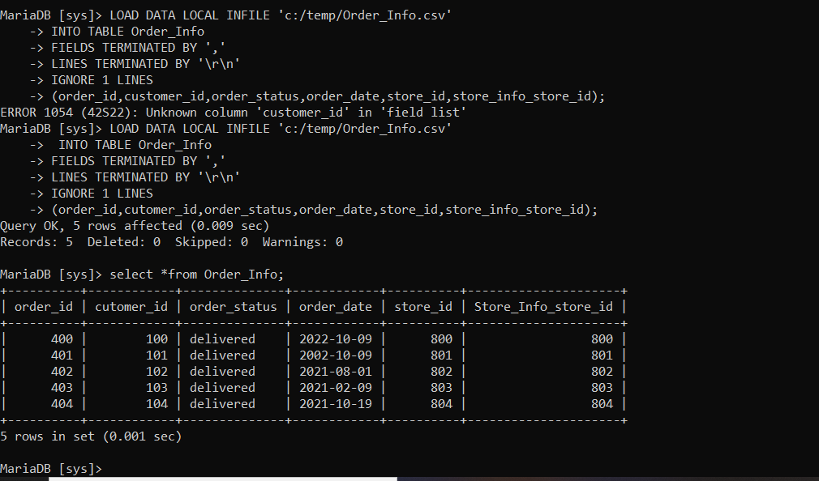

1. **DML Scripts:**
2. **Insert statements**

* Inserted a row in Order_Info table which are related to orders data.

**Script:**

INSERT INTO Order_Info values(405,1005,'delivered','2022-01-01',805,805);

**Output:**

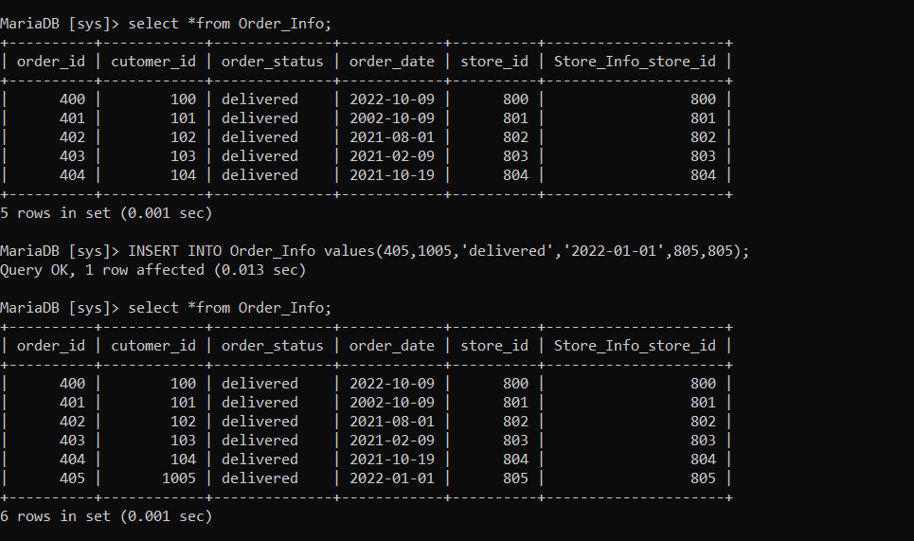

* Inserts a row in Store_Info table related to stores information.

**Script:**

INSERT INTO Store_Info values(805,'hallimi','56763534322','bbb@gmail.com','illinois',78787,505,505);

**Output:**

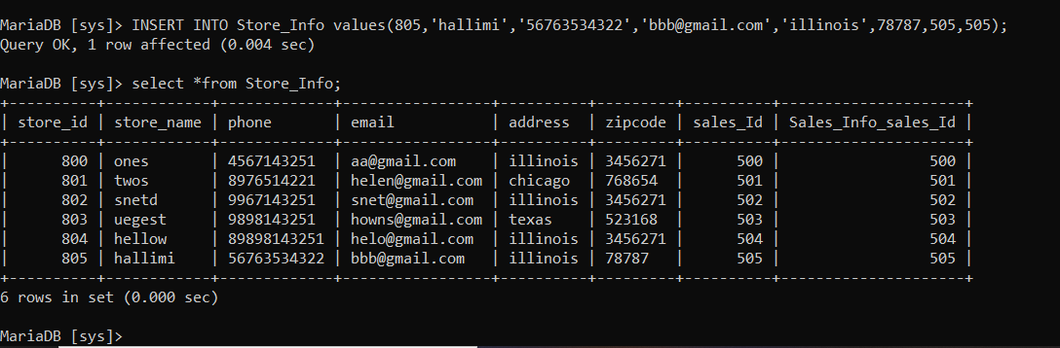

1. **Updation**

* Updates the store_name from hallini to newone whose store_id=805;

**Script:**

UPDATE Store_Info SET store_name='newone' WHERE store_id=805;

**Output:**

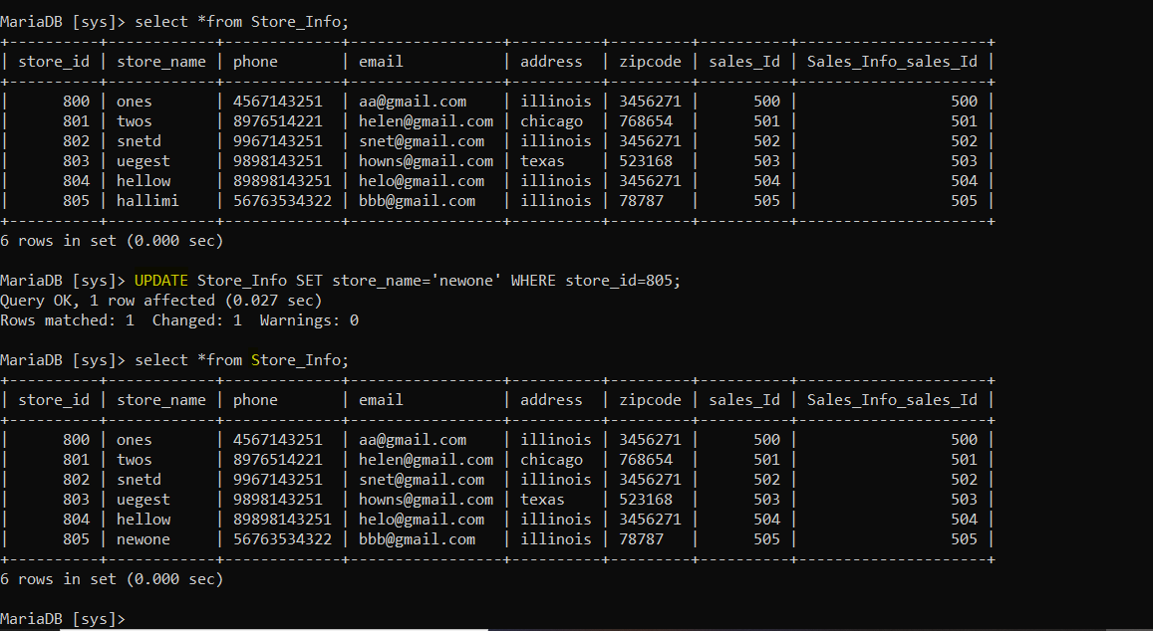

* Updates the phone and email from [4567143251,aa@gmail.com](mailto:4567143251,aa@gmail.com) to 666666666, [yyyy@gmail.com](mailto:yyyy@gmail.com) whose store_id=800;

**Script:**

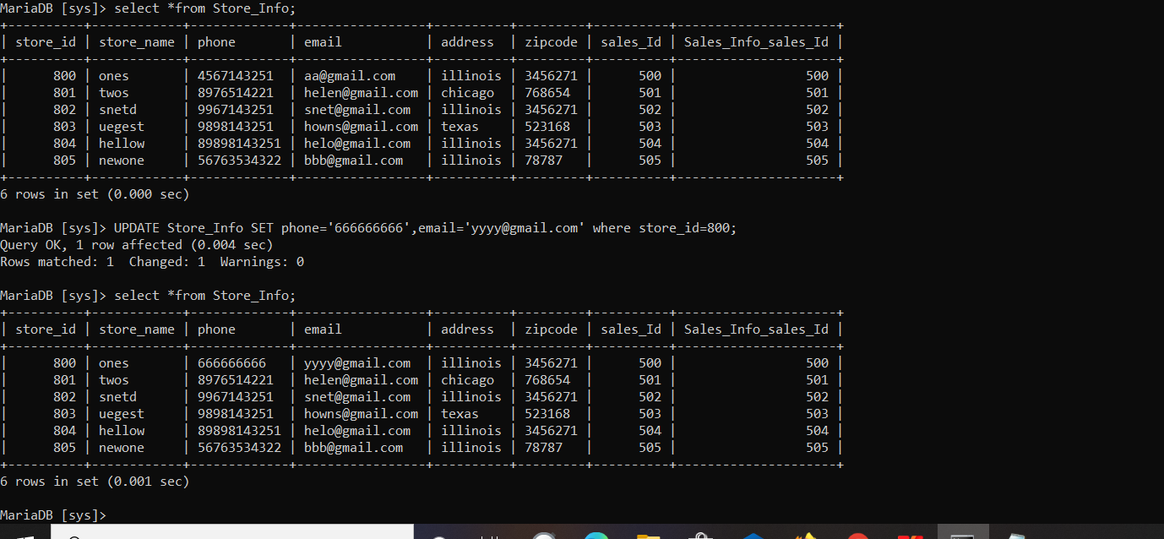

**C)Deletion**

* Delete statement in customer table. It deleted the record whose customer_id=101;

**Script:**

Delete from Customer_Info where customer_id=101;

**Output:**

Before:



After:

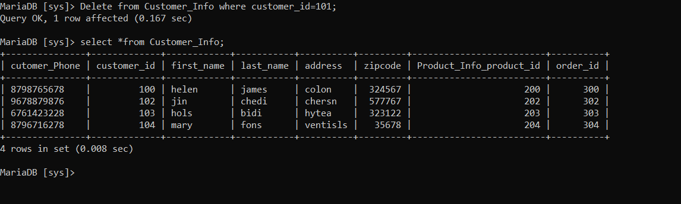

* Delete statement in store_Infotable. It deleted the record whose store Id is in 801,802;

**Script:**

Delete from store_Info where store_id in (801,802);

**Output:**

Before:

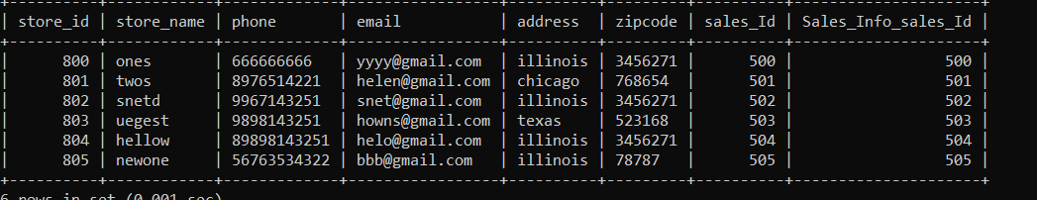

After:

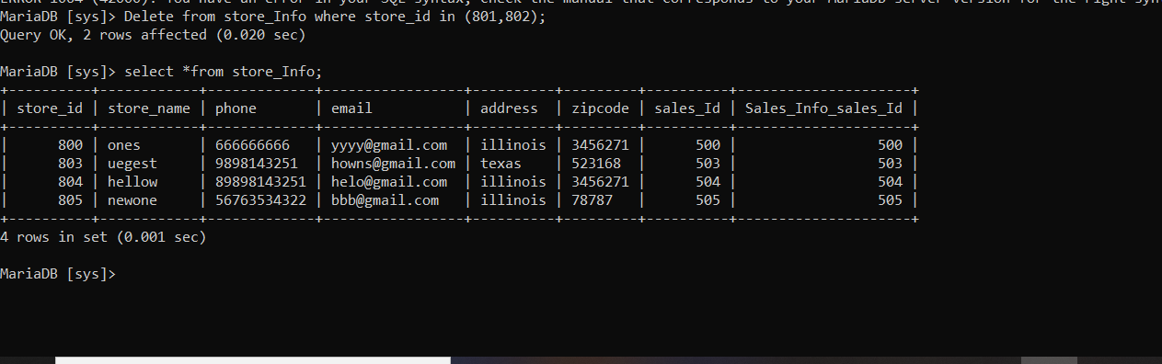

1. **Select statement**

* Selects the order_id,order_status of a customer having customer_id=100;

**Script:**

Select order_id,order_status from order_info where customer_id=100;

**Output:**

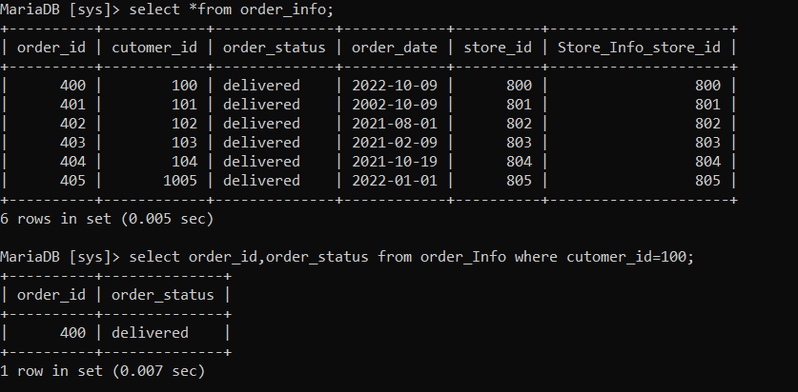

1. **Join statements**

* Used to get the columns ( order_info,customer_info ) after joining two different table.

**Script:**

select o.order_id,order_status,customer_id from order_info o join customer_info c where o.cutomer_id=c.customer_id;

**Output:**

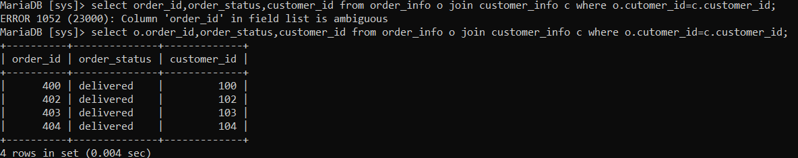

* Used to get the columns after joining product_info,customer_info table

**Script:**

select p.product_name,p.product_id,p.brand_id,c.customer_id from product_info p join customer_info c where p.customer_id=c.customer_id;

**Output:**

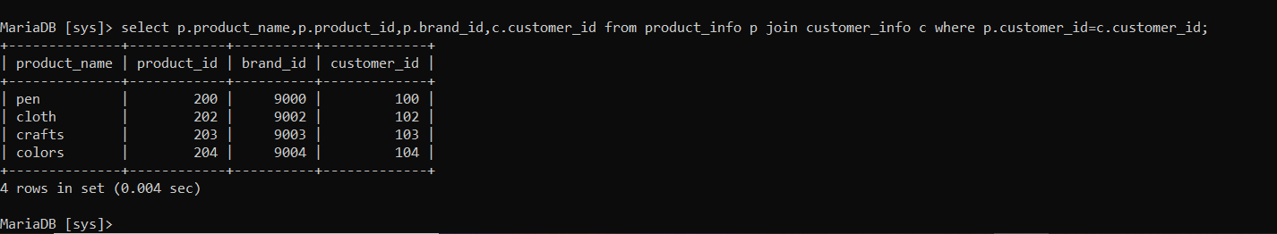

1. **Summary statements**

* Summary Query to get based on condition on table in descending order.

**Script:**

select order_id,order_status as STATUS from order_info where order_status='delivered' group by order_id order by order_id desc;

**Output:**

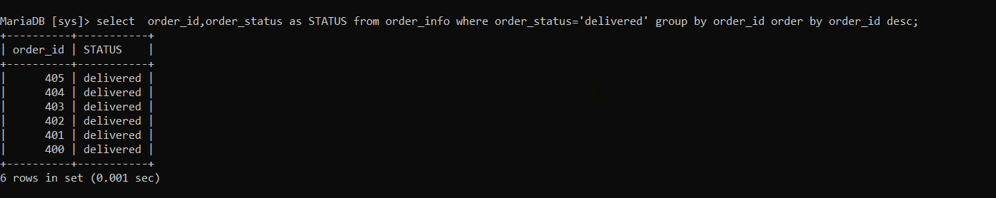

* Summary query to get information of products,customers

**Script:**

select p.product_name,p.product_id,p.brand_id,c.customer_id,sum(p.cost) from product_info p join customer_info c where p.customer_id=c.customer_id group by c.customer_id having sum(p.cost)>4;

Output:

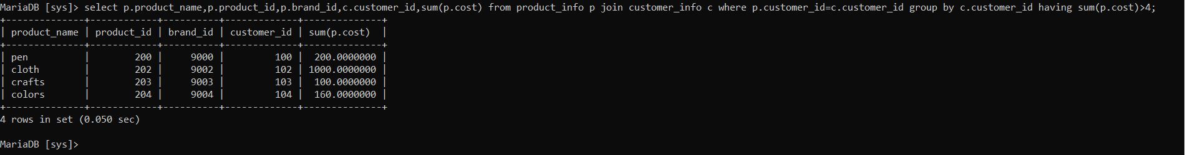

* Summary query to get information of products,customers in ascending order.

**Script:**

select p.product_name,p.product_id,p.brand_id from product_info p join customer_info c where p.customer_id=c.customer_id group by p.brand_id order by p.brand_id asc;

**Output:**

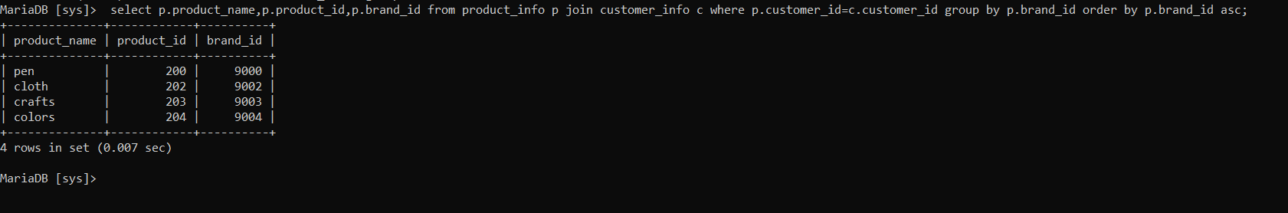

1. **Multi query**

* Query which gives required columns from 3 tables namely customer_info,products_info,order_info in descending order

**Script:**

select c.cutomer_phone,c.zipcode,o.order_status,o.order_date,p.brand_id,p.product_name from customer_info c join order_info o on c.customer_id=o.cutomer_id join product_info p on o.cutomer_id=p.customer_id order by c.customer_id desc;

**Output:**

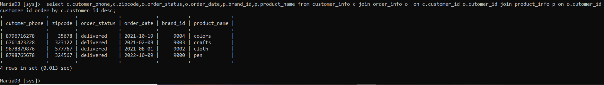

**Overall Scripts For Reference**

CREATE TABLE Customer_Info (

cutomer_Phone varchar(25) NOT NULL,

customer_id int NOT NULL,

first_name varchar(25) NOT NULL,

last_name varchar(25) NOT NULL,

address varchar(25) NOT NULL,

zipcode int NOT NULL,

Product_Info_product_id int NOT NULL,

order_id int NOT NULL,

CONSTRAINT Customer_Info_pk PRIMARY KEY (customer_id)

);

CREATE TABLE Product_Info (

product_name varchar(25) NOT NULL,

product_id int NOT NULL,

Cost float(10,7) NOT NULL,

brand_id int NOT NULL,

Customer_id int NOT NULL,

CONSTRAINT Product_Info_pk PRIMARY KEY (product_id)

);

CREATE TABLE Supplier_Info (

supplier_ID int NOT NULL,

supplier_Fname varchar(25) NOT NULL,

supplier_Lname varchar(25) NOT NULL,

company_name varchar(25) NOT NULL,

address varchar(25) NOT NULL,

Product_Info_product_id int NOT NULL,

CONSTRAINT Supplier_Info_pk PRIMARY KEY (supplier_ID)

);

CREATE TABLE Sales_Info (

sales_Id int NOT NULL,

Item_sold varchar(25) NOT NULL,

date date NOT NULL,

price float(10,7) NOT NULL,

profit int NOT NULL,

Supplier_ID int NOT NULL,

CONSTRAINT Sales_Info_pk PRIMARY KEY (sales_Id)

);

CREATE TABLE Store_Info (

store_id int NOT NULL,

store_name varchar(25) NOT NULL,

phone varchar(15) NOT NULL,

email varchar(25) NOT NULL,

address varchar(50) NOT NULL,

zipcode varchar(25) NOT NULL,

sales_Id int NOT NULL,

Sales_Info_sales_Id int NOT NULL,

CONSTRAINT Store_Info_pk PRIMARY KEY (store_id)

);

CREATE TABLE Order_Info (

order_id int NOT NULL,

cutomer_id int NOT NULL,

order_status varchar(25) NOT NULL,

order_date date NOT NULL,

store_id int NOT NULL,

Store_Info_store_id int NOT NULL,

CONSTRAINT Order_Info_pk PRIMARY KEY (order_id)

);

LOAD DATA LOCAL INFILE 'c:/temp/Customer_Info.csv'

-> INTO TABLE Customer_Info

-> FIELDS TERMINATED BY ','

-> LINES TERMINATED BY '\r\n'

-> IGNORE 1 LINES

-> (cutomer_Phone,customer_id,first_name,last_name,address,zipcode,Product_Info_product_id,order_id);

LOAD DATA LOCAL INFILE 'c:/temp/Product_Info.csv'

-> INTO TABLE Product_Info

-> FIELDS TERMINATED BY ','

-> LINES TERMINATED BY '\r\n'

-> IGNORE 1 LINES

-> (product_name,product_id,Cost,brand_id,customer_id);

LOAD DATA LOCAL INFILE 'c:/temp/Supplier_Info.csv'

-> INTO TABLE Supplier_Info

-> FIELDS TERMINATED BY ','

-> LINES TERMINATED BY '\r\n'

-> IGNORE 1 LINES

-> (supplier_ID,supplier_Fname,supplier_Lname,company_name,address,Product_Info_product_id);

LOAD DATA LOCAL INFILE 'c:/temp/Sales_Info.csv'

-> INTO TABLE Sales_Info

-> FIELDS TERMINATED BY ','

-> LINES TERMINATED BY '\r\n'

-> IGNORE 1 LINES

-> (sales_Id,Item_sold, date,price,profit,Supplier_ID);

LOAD DATA LOCAL INFILE 'c:/temp/Store_Info.csv'

-> INTO TABLE Store_Info

-> FIELDS TERMINATED BY ','

-> LINES TERMINATED BY '\r\n'

-> IGNORE 1 LINES

-> (store_id,store_name,phone,email,address,zipcode,sales_Id,Sales_Info_sales_Id);

LOAD DATA LOCAL INFILE 'c:/temp/Order_Info.csv'

-> INTO TABLE Order_Info

-> FIELDS TERMINATED BY ','

-> LINES TERMINATED BY '\r\n'

-> IGNORE 1 LINES

-> (order_id,cutomer_id,order_status,order_date,store_id,store_info_store_id);

INSERT INTO Order_Info values(405,1005,'delivered','2022-01-01',805,805);

INSERT INTO Store_Info values(805,'hallimi','56763534322','bbb@gmail.com','illinois',78787,505,505);

UPDATE Store_Info SET store_name='newone' WHERE store_id=805;

Updates the phone and email from 4567143251,aa@gmail.com to 666666666, yyyy@gmail.com whose store_id=800;

Delete from Customer_Info where customer_id=101;

Delete from store_Info where store_id in (801,802);

Select order_id,order_status from order_info where customer_id=100;

select o.order_id,order_status,customer_id from order_info o join customer_info c where o.cutomer_id=c.customer_id;

select p.product_name,p.product_id,p.brand_id,c.customer_id from product_info p join customer_info c where p.customer_id=c.customer_id;

select order_id,order_status as STATUS from order_info where order_status='delivered' group by order_id order by order_id desc;

select p.product_name,p.product_id,p.brand_id,c.customer_id,sum(p.cost) from product_info p join customer_info c where p.customer_id=c.customer_id group by c.customer_id having sum(p.cost)>4;

select p.product_name,p.product_id,p.brand_id from product_info p join customer_info c where p.customer_id=c.customer_id group by p.brand_id order by p.brand_id asc;

select c.cutomer_phone,c.zipcode,o.order_status,o.order_date,p.brand_id,p.product_name from customer_info c join order_info o on c.customer_id=o.cutomer_id join product_info p on o.cutomer_id=p.customer_id order by c.customer_id desc;