User Acknowledgment Flow
The grievance ticket system enforces a strict compliance workflow where a staff member cannot prematurely close a ticket without the explicit confirmation of the data principal (the user). The process operates in the following phases:

1. Staff Resolution (DPO Action)
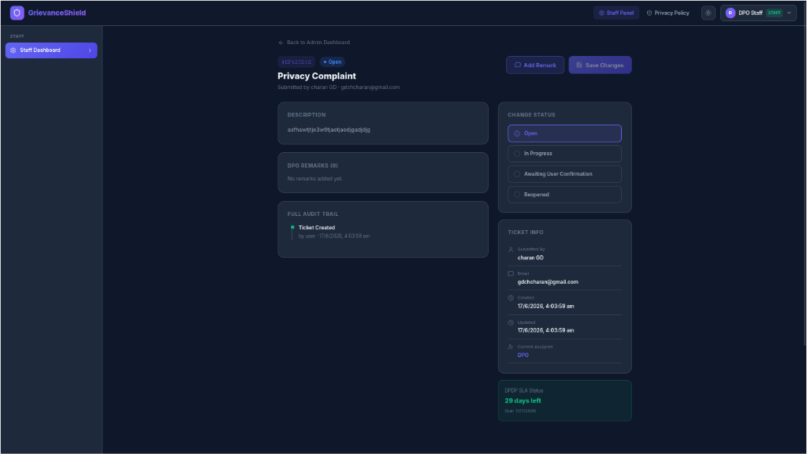
When a Data Protection Officer (DPO) or staff member finishes resolving an issue, they navigate to the ticket details. Instead of closing the ticket directly (which is restricted), they select the Awaiting User Confirmation status. Upon selecting this, the system mandates that they enter a Resolution Message explaining exactly how the grievance was addressed.

2. User Review and Action
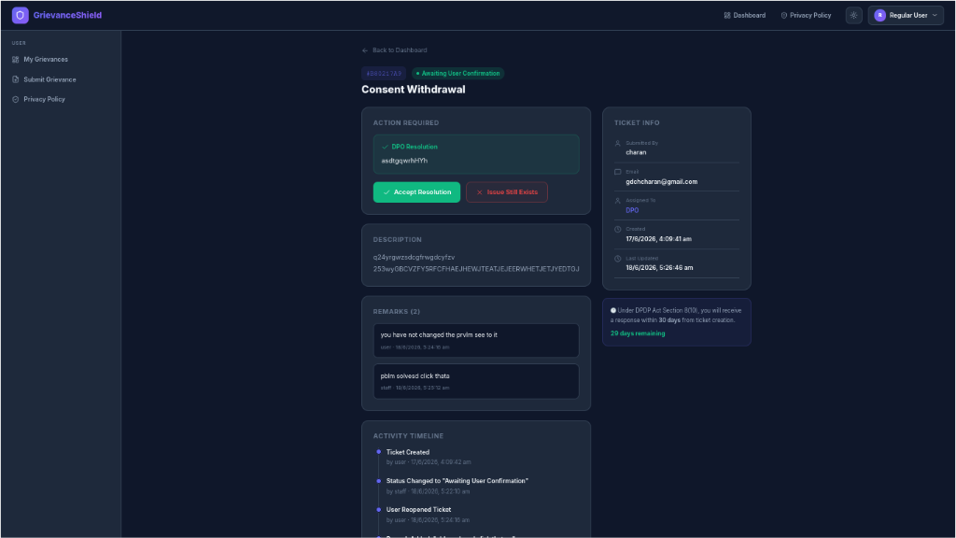
Once the staff updates the status, the data principal logs into their portal and sees the ticket marked with a distinct Awaiting User Confirmation badge.
Inside the ticket details, they are presented with a prominent Action Required panel. This panel displays the DPO's specific resolution message and provides two explicit choices:
- ✅ Accept Resolution
- ❌ Issue Still Exists

3. Final Outcomes
The user holds the final authority over the ticket's lifecycle:
- Acceptance (Closure): If the user is satisfied and clicks Accept Resolution, the system officially transitions the ticket to the Closed status. The resolution is recorded as acknowledged by the user, and the timestamp is logged.
- Rejection (Reopened): If the issue was not satisfactorily resolved, the user can click Issue Still Exists. They are then prompted to optionally enter a reason. The ticket status instantly changes to Reopened, sending it back to the DPO's queue for further investigation.

4. Comprehensive Audit Trail
Every interaction within this flow—from the DPO changing the status to "Awaiting User Confirmation", to the user choosing to Reopen or Close the ticket—is meticulously recorded in the Activity Timeline / Full Audit Trail. This ensures transparent tracking of service-level agreements and regulatory compliance under the DPDP Act.

