AI Compliance Scanner
The AI Compliance Scanner allows Administrators to rapidly verify DPDP Act compliance for any website or source code. This powerful tool uses AI to detect critical privacy indicators.
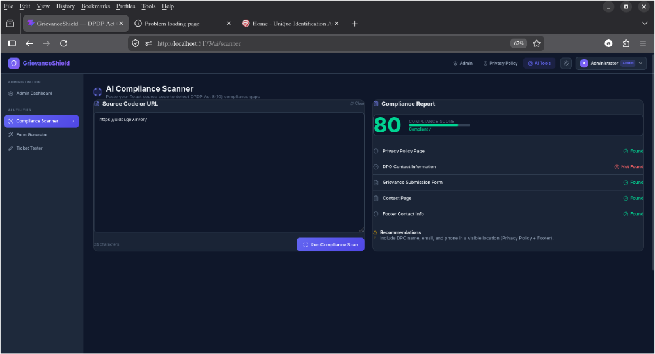
- Live URL Scanning: Administrators can paste a live website URL (e.g., https://uidai.gov.in/en/). The system automatically fetches the HTML content and passes it to the AI for analysis.
- Source Code Analysis: Alternatively, developers can paste raw React/HTML source code directly into the scanner.
- Comprehensive Reporting: The AI generates a Compliance Report, assigning a score (0-100) and explicitly checking for DPDP requirements such as:
  - Privacy Policy Page
  - DPO (Data Protection Officer) Contact Information
  - Grievance Submission Form
  - Contact Page
  - Footer Contact Info
- Actionable Recommendations: If a site fails a check, the AI provides specific recommendations (e.g., "Include DPO name, email, and phone in a visible location").

