DPDP Grievance Shield - Ticket System Workflow
This document explains the end-to-end workflow of the DPDP Grievance Redressal System, based on the platform's user interfaces. The system is designed to handle privacy grievances in compliance with the DPDP Act 2023.

1. User Submission (Data Principal)
The workflow begins when a user (Data Principal) submits a privacy grievance through the Submit Privacy Grievance portal.
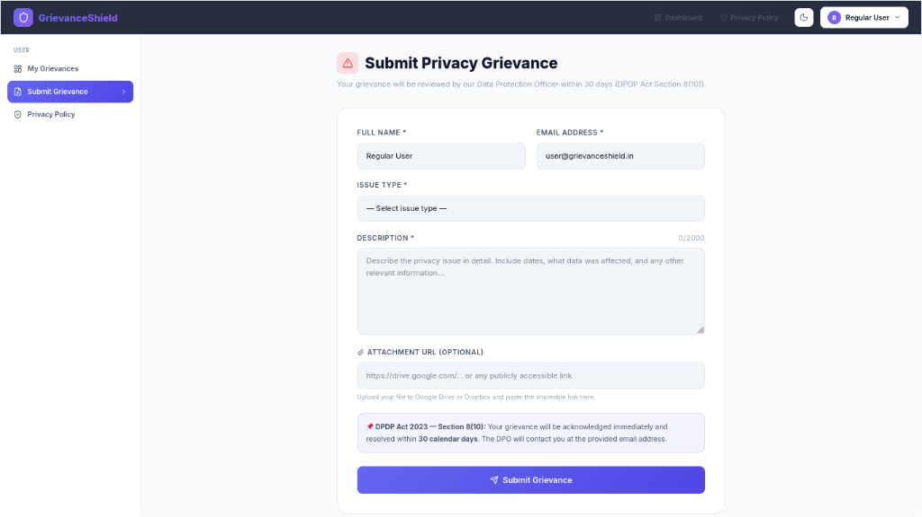
- Information Collected: The user provides their Full Name, Email Address, Issue Type (e.g., Privacy Complaint, Consent Withdrawal, Data Deletion Request), a detailed Description, and an optional Attachment URL.
- DPDP Compliance: The form explicitly notes that the grievance will be acknowledged and resolved within 30 calendar days, directly adhering to DPDP Act Section 8(10).
- Confirmation: Upon submission, the system generates a unique Ticket ID and sends an automated confirmation email to the user.

2. Administration
The Administrator has a bird's-eye view of the entire system via the Admin Dashboard.

Admin Dashboard Overview
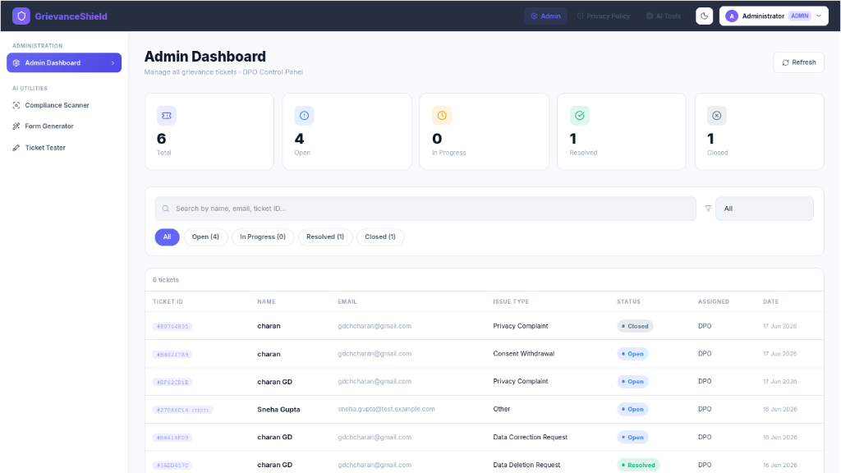
- Metrics & Navigation: The Admin panel displays key metrics (Total, Open, In Progress, Resolved, Closed tickets) at the top, along with a filterable list of all submitted grievances.
- Ticket Tracking: The table clearly outlines the Ticket ID, User Name, Email, Issue Type, Status, Assignee, and Date for rapid scanning.

Admin Ticket Management
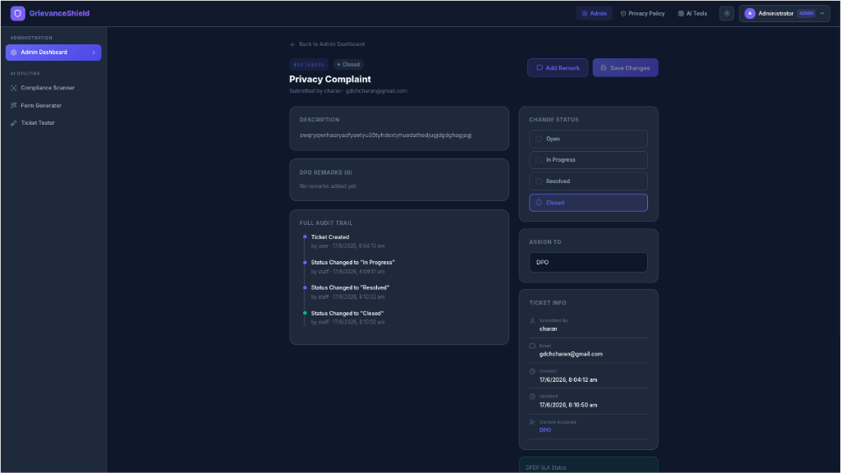
When viewing a specific ticket, the Administrator has full operational control:
- Change Status: They can update the ticket's lifecycle status (Open → In Progress → Resolved → Closed).
- Assign To (Admin Exclusive): Admins have the explicit authority to assign the ticket to specific staff members or the general DPO queue using the dropdown on the right.
- Add Remarks: They can leave internal notes or official responses.

3. Processing & Resolution (Staff / DPO)
Staff members (like DPO Staff) access the system through the Staff Dashboard, which focuses on the day-to-day handling of assigned tickets.

Staff Dashboard Overview
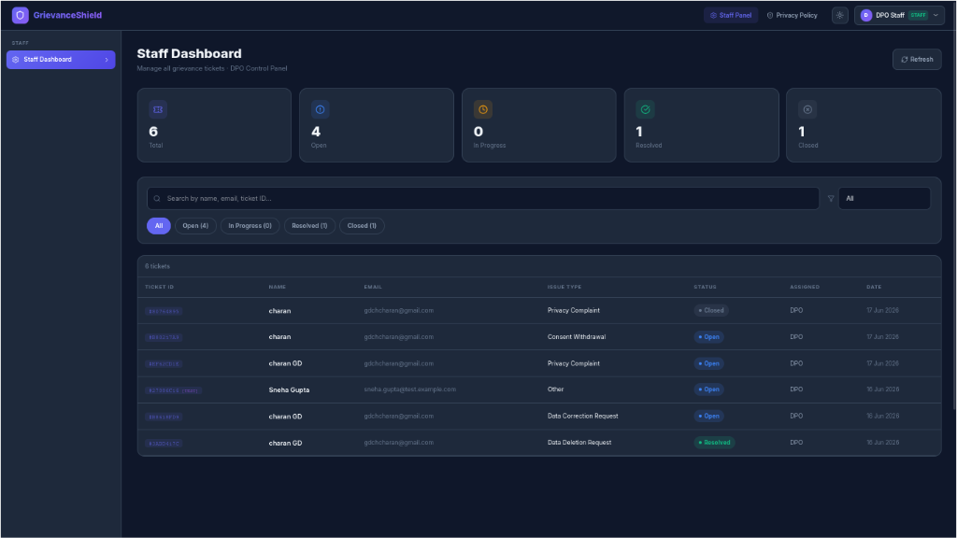
- Ticket Queue: Similar to the Admin view, Staff can see the tickets that need their attention, but their view is focused strictly on resolving issues rather than delegating them.

Staff Ticket Management
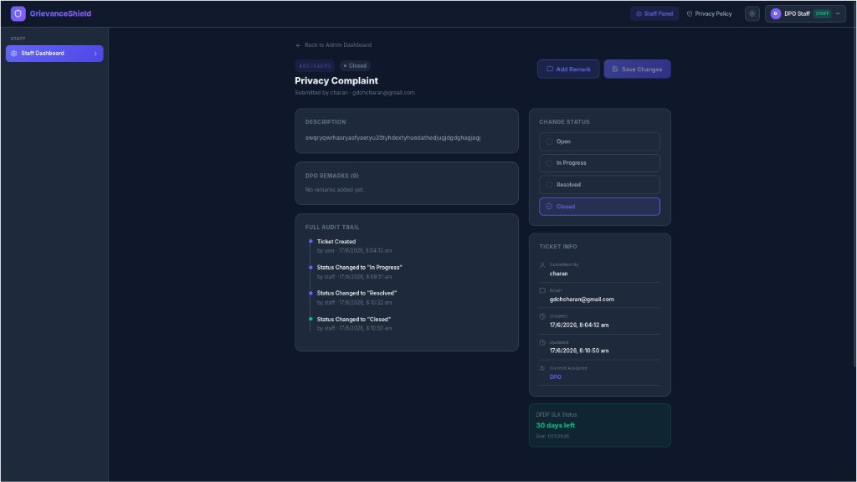
- Operational Control: In the detailed ticket view, Staff can read the user's description, change the ticket's status, and add remarks.
- Role Limitations: Noticeably, the "Assign To" module is absent. Unlike Administrators, Staff members cannot re-delegate tickets to other staff members once they are assigned.
- Email Notifications: Updating the "Change Status" block triggers an automated email update to the user, keeping them informed of progress.

