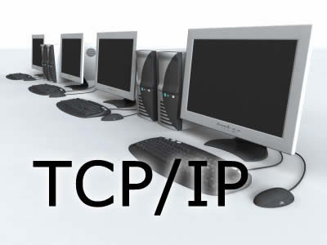

Introduction TCP/IP

■ The **Internet Protocol Suite** (commonly known as **TCP/IP**) is the set of communications protocols used for the Internet and other similar networks.

■ It is named from two of the most important protocols in it:

❑ the Transmission Control Protocol (TCP) and

❑ the Internet Protocol (IP), which were the first two networking protocols defined in this standard.

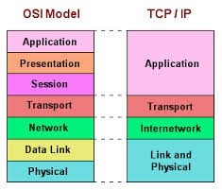

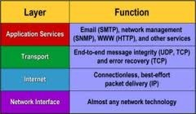

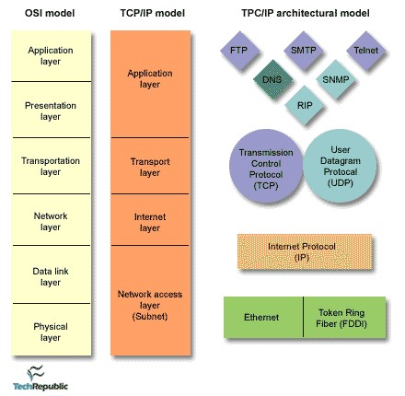

# APPLICATION

• The Application Layer is the topmost layer in the TCP/IP model.

• It provides standardized data exchange services to user applications.

• Key protocols at this layer include:

1. HTTP (Hypertext Transfer Protocol) for web browsing.
2. FTP (File Transfer Protocol) for file transfers.
3. POP3 (Post Office Protocol 3) for retrieving email messages.
4. SMTP (Simple Mail Transfer Protocol) for sending email messages.
5. SNMP (Simple Network Management Protocol) for managing network devices.

* The Application Layer handles the payload, which is the actual data generated by applications.

• Payload examples include HTML content in web browsing, email messages in SMTP/POP3, and files in FTP.

• The layer ensures data is properly formatted, encoded, and delivered to the correct application on the receiving end.

• It abstracts lower network layers, allowing applications to focus on their functions without network intricacies.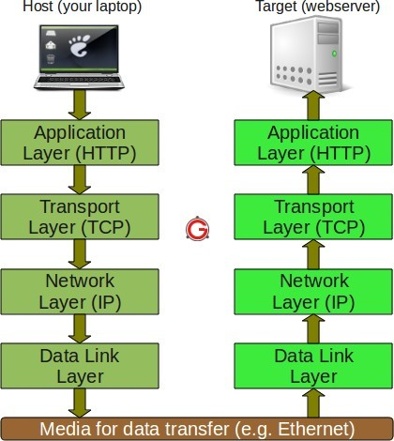

# TRANSPORT

*  The Transport Layer is responsible for maintaining end-to-end communications across the network.
* TCP (Transmission Control Protocol) is one of the primary protocols at the Transport Layer. It handles communications between hosts and provides several critical functions:
* Flow Control: TCP ensures that data is sent at a rate that the receiving host can handle, preventing congestion and data loss.
* Multiplexing: It allows multiple applications or processes on a host to use the network simultaneously by using port numbers to identify different services.
* Reliability: TCP ensures the reliable delivery of data by using acknowledgment mechanisms, retransmissions, and sequence numbers to guarantee that data arrives in the correct order without errors.
* Another protocol at the Transport Layer is UDP (User Datagram Protocol), which is sometimes used instead of TCP for special purposes:

# INTERNET

* The layer is known as the Internet Layer, is responsible for packet handling and routing. It connects independent networks and facilitates the transport of data packets across network boundaries.
* The primary protocol at the Network Layer is IP (Internet Protocol). IP assigns unique IP addresses to devices and is responsible for addressing and routing packets across networks. It is essential for enabling communication between devices on different networks, making the internet a reality.
* Internet Control Message Protocol (ICMP) is another protocol at the Network Layer. ICMP is used primarily for error reporting and diagnostic functions. It allows network devices to send error and control messages, such as "ping" requests and responses, which help identify and troubleshoot network issues.

# NETWORK

* The Physical Layer, also known as the Network Interface Layer or Data Link Layer, is the lowest layer in the TCP/IP model.
* It deals with protocols that operate at the level of individual links, which are the components that connect nodes or hosts within a network.
* Some of the protocols in this layer include:
* Ethernet: Ethernet is a widely used protocol for local area networks (LANs). It defines how data is physically transmitted over network cables, including the use of Ethernet frames and MAC (Media Access Control) addresses to address devices on the same network segment.
* Address Resolution Protocol (ARP): ARP is used to map an IP address to a physical MAC address on a local network. It is crucial for devices to determine how to send data to other devices within the same local network.
* The Physical Layer is responsible for the actual transmission and reception of raw binary data over the physical medium, such as electrical signals over copper wires or optical signals over fiber optic cables. It ensures that bits are transmitted reliably and appropriately encoded for the specific medium in use.

