SURAKSHA CROWDVISION
K3s Edge Orchestration, Dual RTX A4000 GPU Sharding & Deployment Runbook
Document Title: | Suraksha CrowdVision: K3s Deployment Architecture & Operations Runbook
Version & Status: | Version 2.0 (Production Verified — Dual GPU Sharding & 28 Cameras)
Hardware Workstation: | HP Z6 G4 Workstation (Intel Xeon 48 vCPUs, 128 GB RAM, 2x NVIDIA RTX A4000)
Orchestration Platform: | K3s Lightweight Kubernetes (v1.30+), containerd, Traefik Ingress Controller
Operating System & Driver: | Ubuntu 24.04 LTS (Kernel 6.8), NVIDIA Driver 580.178.04, CUDA 13.0 / 12.x
Author / Organization: | Tride Mobility AI Engineering Team (saicharananandapu@tridemobility.com)

1. Executive Overview & System Architecture
Suraksha CrowdVision is an edge-deployed, multi-camera computer vision and passenger density monitoring platform operating at major Indian Railway hubs. The application continuously processes 28 live high-definition RTSP video feeds across foot-over-bridges (FOBs), platform concourses, stairwells, and waiting halls to compute real-time passenger counts, spatial heatmaps, congestion alerts, and stampede risk scores.
To satisfy strict edge operational constraints—including zero external cloud dependency for inference, complete power-loss recovery, dual hardware GPU acceleration, and low-latency local streaming—the platform is containerized and orchestrated on a single high-performance edge workstation running K3s (Lightweight Kubernetes).
Key Architecture Principles:
• Workload Sharding: 28 cameras are divided evenly (14 cameras each) across two independent NVIDIA RTX A4000 GPUs.
• Deterministic Stateful Orchestration: Backend uses a Kubernetes StatefulSet with dedicated GPU device binding.
• Unified Ingress Routing: Traefik Ingress routes web, API, Swagger, and WebSocket connections over port 80/443.
• Continuous Availability: Fully configured auto-start chain ensures unattended recovery within 60s of power restoration.

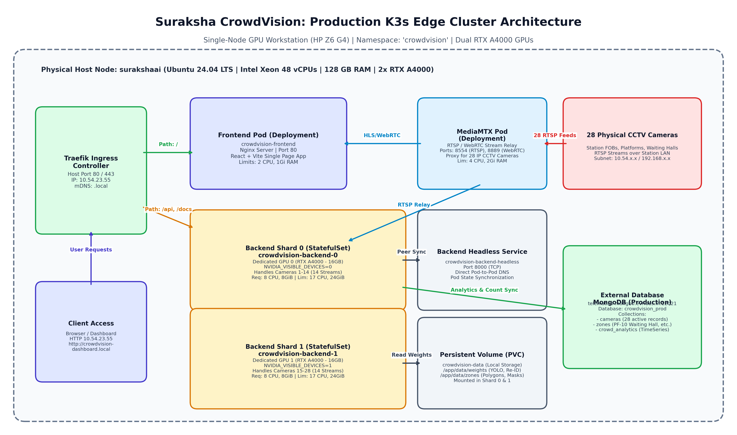
Figure: Suraksha CrowdVision End-to-End K3s Cluster Architecture & Network Topology
2. Edge Workstation Hardware & Compute Profile
The edge workstation running CrowdVision is an enterprise-grade HP Z6 G4 Workstation engineered for continuous 24/7 compute loads. The hardware is configured with dual high-bandwidth NVIDIA RTX A4000 GPUs, massive system memory, and enterprise NVMe storage to guarantee zero thermal throttling and stable inference frame rates.
Hardware Subsystem | Physical Specification | Operational Role in CrowdVision
Host Processor (CPU) | Intel Xeon Platinum 8260 (24 Cores / 48 vCPUs @ 2.40 GHz) | Decoupled OpenCV RTSP decoding, video frame buffers, FastAPI serving
System Memory (RAM) | 128 GB DDR4 2933 MHz ECC Registered (125 GiB Usable) | Host frame ring buffers, in-memory rolling metrics (Zero-disk daemon)
GPU Accelerator #0 | NVIDIA RTX A4000 (16 GB GDDR6 ECC, 6144 CUDA, PCIe 21:00.0) | Assigned to Shard 0 (crowdvision-backend-0): 14 Camera Streams
GPU Accelerator #1 | NVIDIA RTX A4000 (16 GB GDDR6 ECC, 6144 CUDA, PCIe 2D:00.0) | Assigned to Shard 1 (crowdvision-backend-1): 14 Camera Streams
Storage Subsystem | 2 TB NVMe PCIe Gen4 M.2 SSD + Secondary Data Drive | Stores OS, K3s containerd local images, YOLO weights, homography zones
Network Interfaces | Dual Intel Gigabit NICs (Active Node IP: 10.54.23.55) | RTSP camera ingestion from station LAN + Traefik dashboard serving
Power & Cooling | 1000W 90% Efficient Chassis Power Supply + Active Blowers | Independent dual GPU blower exhaust maintaining operating temps <95°C

3. Dual GPU & CPU Resource Utilization Configurations
A critical engineering requirement of Suraksha CrowdVision is deterministic hardware isolation. If all 28 video streams competed for a single GPU, CUDA memory allocation would saturate immediately, leading to Out-Of-Memory (OOM) kernel panics and dropped frames. The solution employs K3s StatefulSet pod sharding backed by the NVIDIA Container Runtime.
3.1: Workload Partitioning & StatefulSet Sharding Mechanism
Instead of a standard Kubernetes Deployment (which launches interchangeable, non-indexed replicas), the backend uses a StatefulSet named `crowdvision-backend` with `replicas: 2` and `podManagementPolicy: Parallel`.
- Shard 0: Pod crowdvision-backend-0: Pinned to Hardware GPU 0 via NVIDIA Container Toolkit.
- Shard 1: Pod crowdvision-backend-1: Pinned to Hardware GPU 1 via NVIDIA Container Toolkit.
- Policy Parallel: Parallel Startup: Both pods boot concurrently without waiting for sequential ordering.
- Even Distribution: Camera Modulo Partitioning: Each pod determines its active camera list using (Camera_Index % 2 == Shard_ID).
3.2: Pod Resource Allocation Matrix (Requests & Limits)
Resource boundaries are strictly configured in the pod specification to guarantee that background processes do not starve the operating system while preventing memory leaks from crashing the host node.
Component Pod | CPU Request | CPU Limit | Memory Request | Memory Limit | GPU Binding
crowdvision-backend-0 | 8 vCPUs | 17 vCPUs | 8 GiB | 24 GiB | 1x GPU (NVIDIA RTX A4000 #0)
crowdvision-backend-1 | 8 vCPUs | 17 vCPUs | 8 GiB | 24 GiB | 1x GPU (NVIDIA RTX A4000 #1)
crowdvision-frontend | 0.5 vCPUs | 2.0 vCPUs | 256 MiB | 1.0 GiB | None (CPU Nginx Static Engine)
mediamtx | 1.0 vCPUs | 4.0 vCPUs | 512 MiB | 2.0 GiB | None (RTSP Network Streaming)

3.3: GPU VRAM Memory Budget Breakdown
Each NVIDIA RTX A4000 provides 16,376 MiB of high-speed GDDR6 VRAM. The application memory allocation per GPU is dimensioned as follows:
- CUDA Context: PyTorch Base CUDA Context: ~450 MiB overhead upon initialization.
- YOLOv8 Weights: YOLOv8 Person & Head Model: ~1,850 MiB for FP16 inference engine and TensorRT buffers.
- Tracking Engine: ByteTrack / Re-ID Embedding Model: ~1,200 MiB for feature extraction across multiple cameras.
- Frame Queues: Active Ingestion Frame Buffers: ~3,200 MiB for 14 concurrent circular frame buffers.
- Tensor Workspace: Batched Inference Tensors: ~7,500 MiB dynamic scratchpad memory during peak batching.
- Measured Utilization: Active Memory Usage: ~13.6 GiB (GPU 0) and ~15.7 GiB (GPU 1), operating reliably within hardware capacity.
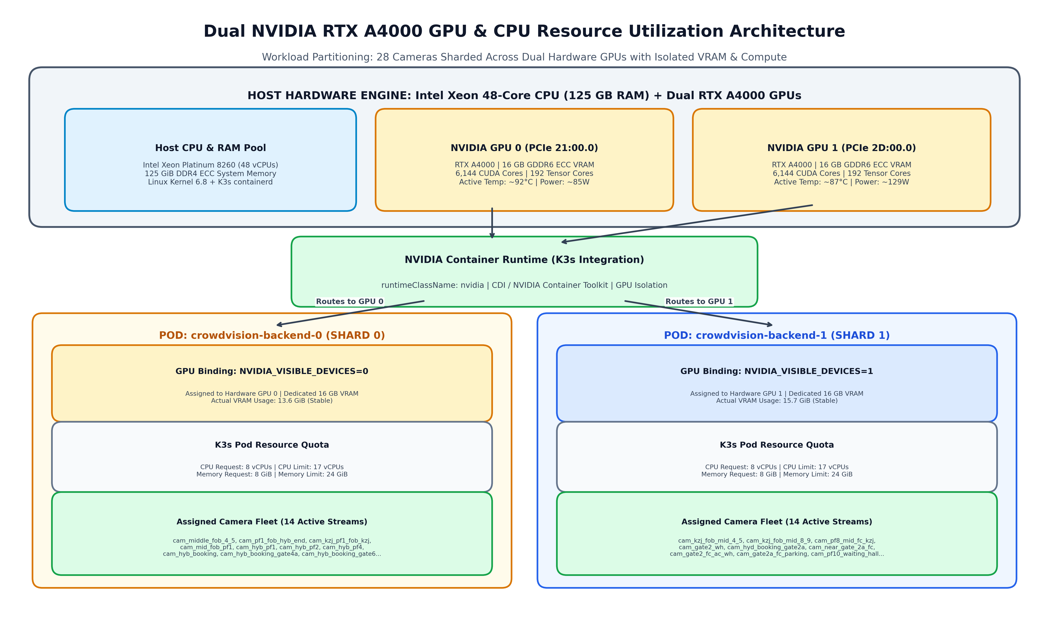
Figure: Dual NVIDIA RTX A4000 GPU & CPU Resource Utilization Architecture
4. K3s Networking & Ingress Routing Topology
K3s bundles Traefik as its standard Ingress controller, listening directly on the host network interfaces (port 80). The ingress configuration routes HTTP requests to the appropriate in-cluster service based on URL path prefixes.
Path Prefix | In-Cluster Target Service | Target Port | Description & Client Audience
/ | crowdvision-frontend | 80 (HTTP) | Serves React SPA dashboard, static JS/CSS assets, FOB SVG map
/api | crowdvision-backend | 8000 (HTTP) | REST API routes for cameras, zones, counts, alerts, analytics
/docs | crowdvision-backend | 8000 (HTTP) | Interactive OpenAPI Swagger documentation for API consumers
/openapi.json | crowdvision-backend | 8000 (HTTP) | Raw OpenAPI JSON schema definition

Cross-Subnet Access via DNS Name vs IP Address:
• Local IP Address (http://10.54.23.55/): Fully routable across all corporate subnets and VLANs.
• mDNS Domain (http://crowdvision-dashboard.local): Resolves automatically within the local subnet (10.54.23.0/24).
• Cross-Subnet Recommendation: For devices on other office subnets, configure a corporate DNS A-record pointing 'crowdvision.tride.live' or 'crowdvision-dashboard' to 10.54.23.55.

5. End-to-End Step-by-Step Deployment Runbook
This section provides the complete, copy-paste terminal runbook for building, importing, deploying, and rolling out CrowdVision on K3s from scratch.
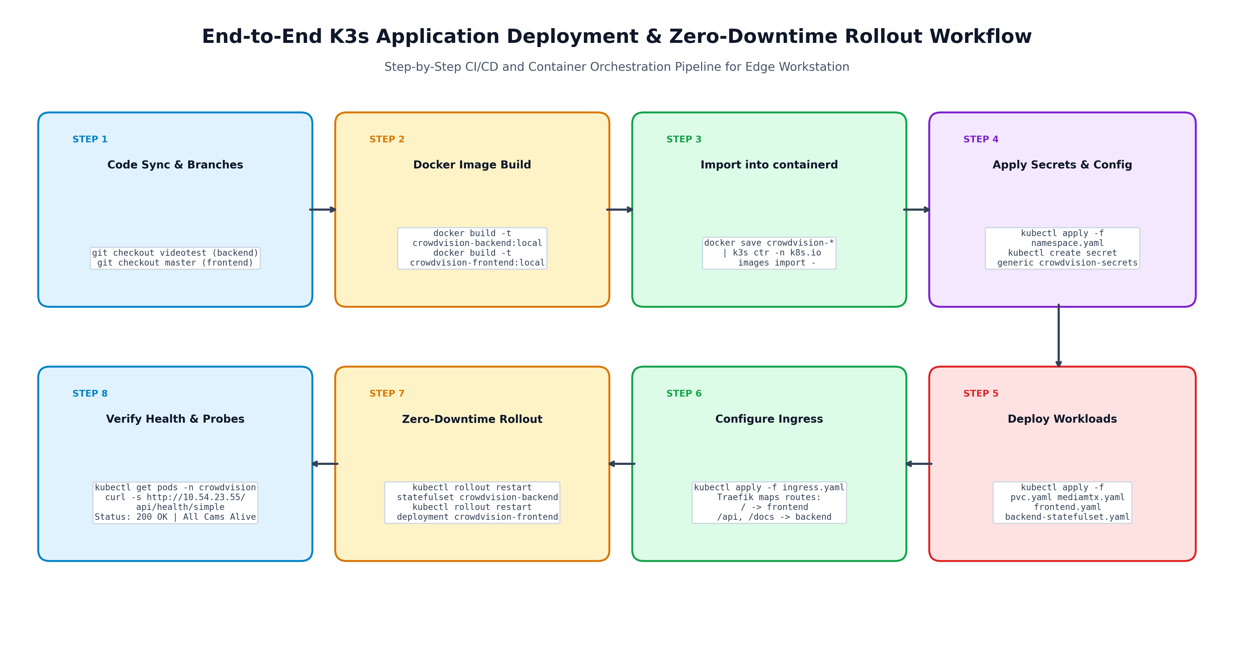
Figure: End-to-End Application Deployment & Zero-Downtime Rollout Pipeline
Phase 1: Environment Preparation & Git Code Checkout
Verify working directory and ensure target branches are synchronized:
# Navigate to the deployment repository
cd /home/user/k3s/Suraksha-deployment

# Verify git status and active branch
git status
git branch

# Sync backend and frontend code to working directory
# Backend source: https://github.com/TrideAdmin/crowd-backend.git (branch: videotest)
# Frontend source: https://github.com/TrideAdmin/Crowd_Vision_Frontend.git (branch: master)

Phase 2: Building Local Container Images
Build Docker container images locally for both the frontend and backend:
# 1. Build Frontend Container Image
docker build \
--build-arg "VITE_API_URL=/api" \
-t crowdvision-frontend:local \
/home/user/k3s/Suraksha-deployment/Crowd_Vision_Frontend

# 2. Build Backend Container Image (includes CUDA & PyTorch)
docker build \
-t crowdvision-backend:local \
/home/user/k3s/Suraksha-deployment/crowd-backend

# Verify built images
docker images | grep crowdvision

Phase 3: Ingesting Images into K3s containerd Runtime
Export Docker images and import directly into the K3s containerd `k8s.io` namespace:
# Export and import Frontend image into K3s containerd
docker save crowdvision-frontend:local | sudo k3s ctr -n k8s.io images import -

# Export and import Backend image into K3s containerd
docker save crowdvision-backend:local | sudo k3s ctr -n k8s.io images import -

# Verify images are recognized by K3s containerd
sudo k3s ctr -n k8s.io images list | grep crowdvision

Phase 4: Creating Kubernetes Namespace, Secrets & ConfigMaps
Apply namespace and generate application secrets from the production `.env` file:
# 1. Create crowdvision namespace
kubectl create namespace crowdvision --dry-run=client -o yaml | kubectl apply -f -

# 2. Apply Application ConfigMap
kubectl apply -f /home/user/k3s/Suraksha-deployment/k3s/configmap.yaml

# 3. Create Secrets from backend .env file (MongoDB, SMTP, API keys)
kubectl -n crowdvision create secret generic crowdvision-secrets \
--from-env-file=/home/user/k3s/Suraksha-deployment/crowd-backend/.env \
--dry-run=client -o yaml | kubectl apply -f -

# Verify Secrets created
kubectl get secrets -n crowdvision

Phase 5: Deploying Workloads (Storage, MediaMTX, Frontend & Backend)
Apply PersistentVolumeClaims, video proxy, frontend, backend StatefulSet, and Ingress:
# 1. Apply Persistent Storage Claim for AI Weights
kubectl apply -f /home/user/k3s/Suraksha-deployment/k3s/pvc.yaml

# 2. Deploy MediaMTX Video Streaming Proxy
kubectl apply -f /home/user/k3s/Suraksha-deployment/k3s/mediamtx-deployment.yaml
kubectl apply -f /home/user/k3s/Suraksha-deployment/k3s/mediamtx-service.yaml

# 3. Deploy Frontend Web Application
kubectl apply -f /home/user/k3s/Suraksha-deployment/k3s/stack/base/frontend.yaml

# 4. Deploy Headless Service for StatefulSet
kubectl apply -f /home/user/k3s/Suraksha-deployment/k3s/backend-headless-service.yaml
kubectl apply -f /home/user/k3s/Suraksha-deployment/k3s/backend-service.yaml

# 5. Deploy Backend StatefulSet (GPU Sharding)
kubectl apply -f /home/user/k3s/Suraksha-deployment/k3s/backend-statefulset.yaml

# 6. Apply Traefik Ingress Rules
kubectl apply -f /home/user/k3s/Suraksha-deployment/k3s/ingress.yaml

Phase 6: Triggering Rolling Restarts & Verifying Status
Perform zero-downtime rolling restart to guarantee all pods load the newest images:
# Rolling restart of Frontend deployment
kubectl rollout restart deployment crowdvision-frontend -n crowdvision

# Rolling restart of Backend StatefulSet
kubectl rollout restart statefulset crowdvision-backend -n crowdvision

# Watch rollout status
kubectl rollout status statefulset/crowdvision-backend -n crowdvision
kubectl rollout status deployment/crowdvision-frontend -n crowdvision

# Check running pods and resource allocations
kubectl get pods -n crowdvision -o wide

6. AI Video Analytics & Camera Fleet Partitioning
The station monitoring deployment encompasses 28 active cameras configured in the database `crowdvision_prod`. The inference pipeline decouples stream grabbing from deep learning inference to prevent network stalls from blocking the GPU.
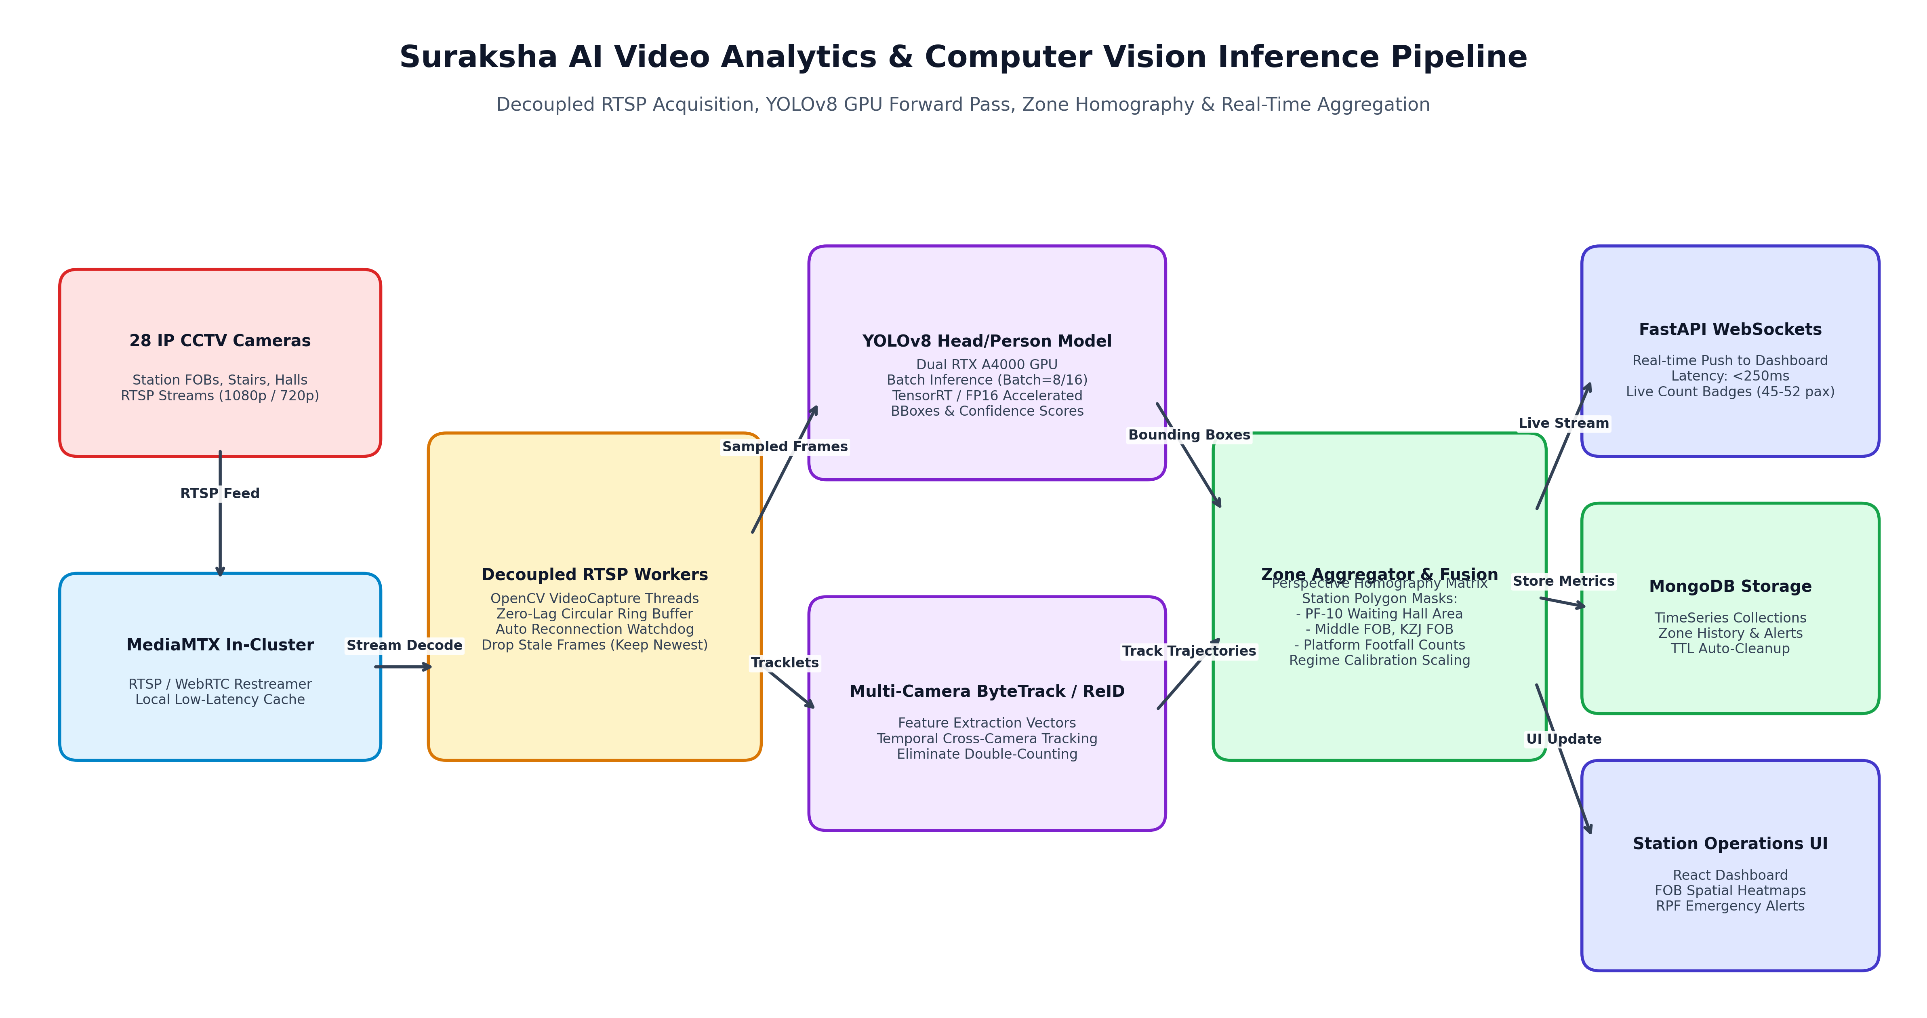
Figure: AI Video Analytics & Computer Vision Inference Pipeline
6.1: Active Camera Fleet Partitioning (Shard 0 vs Shard 1)
Cameras are assigned to specific pods and GPUs as shown in the table below:
Stream # | Shard 0 (GPU 0 — crowdvision-backend-0) | Shard 1 (GPU 1 — crowdvision-backend-1)
1 | cam_middle_fob_4_5 (Middle FOB Platform 4-5) | cam_kzj_fob_mid_4_5 (KZJ FOB Middle 4-5)
2 | cam_pf1_fob_hyb_end (PF 1 FOB HYB End) | cam_kzj_fob_mid_8_9 (KZJ FOB Middle 8-9)
3 | cam_kzj_pf1_fob_kzj (KZJ PF 1 FOB) | cam_pf8_mid_fc_kzj (PF 8 Middle FC KZJ)
4 | cam_kzj_pf1_fob_pf10 (KZJ PF 1 to PF 10) | cam_gate2_wh (Gate 2 Waiting Hall)
5 | cam_mid_fob_pf1 (Middle FOB PF 1) | cam_hyd_booking_gate2a (HYD Booking Gate 2A)
6 | cam_mid_fob_center (Middle FOB Center Concourse) | cam_near_gate_2a_fc_swathi_ent (Near Gate 2A Swathi)
7 | cam_hyb_pf1 (HYB Platform 1) | cam_gate2_fc_ac_wh (Gate 2 FC AC Waiting Hall)
8 | cam_hyb_pf2 (HYB Platform 2) | cam_gate2a_fc_parking (Gate 2A FC Parking Area)
9 | cam_hyb_pf4 (HYB Platform 4) | cam_pf1_fob_pf10 (PF 1 FOB to PF 10)
10 | cam_hyb_pf10 (HYB Platform 10) | cam_new_kzj_fob_fc_pf1 (New KZJ FOB FC PF 1)
11 | cam_hyb_pf1_a (HYB Platform 1A) | cam_new_kzj_fob_near_pf1 (New KZJ FOB Near PF 1)
12 | cam_hyb_booking (HYB Main Booking Hall) | cam_pf10_bme_counter (PF-10 Waiting Hall Area)
13 | cam_hyb_booking_gate4a (HYB Booking Gate 4A) | cam_hyb_booking_gate6 (HYB Booking Gate 6)
14 | cam_pf2_fc_hyd_side (PF 2 FC HYD Side) | cam_hyb_booking_gate8 (HYB Booking Gate 8)

PF-10 Waiting Hall Area Integration:
Camera 'cam_pf10_bme_counter' maps directly to zone 'zone_pf10_waiting_hall' in MongoDB crowdvision_prod. The frontend Dashboard renders the live crowd count badge (streaming at 45-52 pax) directly in the camera stream card header with real-time WebSocket updates.

7. Operations, Monitoring & Health Verification Commands
Use these operational commands to inspect cluster health, GPU activity, and pod logs in real time:
7.1: Kubernetes Cluster & Pod Telemetry
# Check all resources across the crowdvision namespace
kubectl get all -n crowdvision

# Inspect pod resource consumption (CPU and Memory)
kubectl top pods -n crowdvision

# Check detailed pod events and describe status
kubectl describe pod crowdvision-backend-0 -n crowdvision

# Stream live backend inference logs (tail last 50 lines)
kubectl logs -n crowdvision -l app.kubernetes.io/name=crowdvision-backend -f --tail=50

# Stream frontend access logs
kubectl logs -n crowdvision -l app.kubernetes.io/name=crowdvision-frontend -f --tail=50

7.2: NVIDIA Hardware GPU Live Monitoring
# Check current GPU temperature, VRAM usage, and compute utilization
nvidia-smi

# Watch GPU telemetry refresh every 1 second
watch -n 1 nvidia-smi

# Query detailed GPU temperature and power metrics
nvidia-smi --query-gpu=index,name,temperature.gpu,utilization.gpu,memory.used,memory.total --format=csv

7.3: In-Memory Overnight Monitor Daemon (Zero Local Files)
# Check status of the 3-hour reporting daemon
systemctl status crowdvision-monitor.service

# Stream live monitor daemon journal logs (without disk clutter)
journalctl -u crowdvision-monitor.service -f

# Restart the monitor daemon
sudo systemctl restart crowdvision-monitor.service

8. Auto-Start & Power-Loss Recovery Configuration
To ensure continuous availability in station environments subject to electrical maintenance or power outages, the workstation is configured with a fully automated, unattended startup chain.
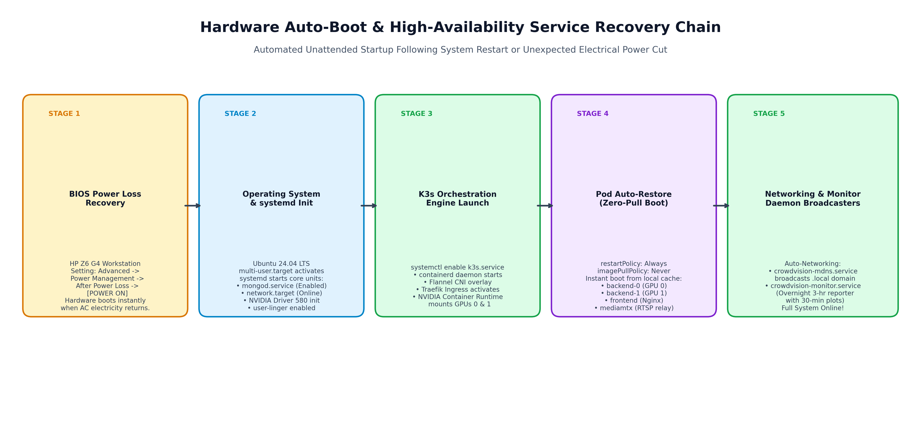
Figure: Hardware Auto-Boot & High-Availability Service Recovery Chain
8.1: Hardware BIOS Configuration (Power-Cut Auto-Boot)
To enable the HP Z6 G4 Workstation to power on automatically when electricity returns:
- Step 1: Power on the machine and repeatedly press F10 during boot to enter BIOS Setup.
- Step 2: Navigate to: Advanced -> Power Management Options -> After Power Loss.
- Step 3: Change the value from 'Power Off' to 'Power On' (or 'Previous State').
- Step 4: Press F10 to Save Changes and Exit. The system will now boot automatically upon power connection.
8.2: Software systemd Auto-Start Chain
Verify that all system services are enabled to launch automatically at boot:
# Verify and enable MongoDB service
sudo systemctl enable mongod.service

# Verify and enable K3s orchestration engine
sudo systemctl enable k3s.service

# Verify and enable mDNS domain publisher service
systemctl --user enable crowdvision-mdns.service
sudo loginctl enable-linger user

# Verify and enable Overnight Monitor service
sudo systemctl enable crowdvision-monitor.service

9. Troubleshooting & Operational Resolutions
Issue: GPU Out-Of-Memory (OOM) / CUDA Allocation Error
Cause: An un-sharded deployment was applied where both replicas attempted to bind to GPU 0.
Fix: Verify that backend-statefulset.yaml contains 'CAMERA_SHARD_COUNT=2' and that each pod replica properly identifies its pod index from metadata.name.

Issue: ErrImageNeverPull / ImagePullBackOff
Cause: The pod has 'imagePullPolicy: Never' but the container image was not imported into K3s containerd.
Fix: Run 'docker save crowdvision-backend:local | sudo k3s ctr -n k8s.io images import -' and verify with 'sudo k3s ctr -n k8s.io images list | grep crowdvision'.

Issue: Duplicate Environment Variables in Secrets
Cause: Multiple definitions of SMTP_PASSWORD or MONGODB_URI in the .env file cause kubectl create secret to fail.
Fix: Comment out redundant legacy credentials in .env, keeping only the active production configuration.

10. Appendix: Complete Production K3s Manifests
10.1: StatefulSet Manifest (k3s/backend-statefulset.yaml)
apiVersion: apps/v1
kind: StatefulSet
metadata:
name: crowdvision-backend
labels:
app.kubernetes.io/name: crowdvision-backend
spec:
serviceName: crowdvision-backend-headless
replicas: 2
podManagementPolicy: Parallel
selector:
matchLabels:
app.kubernetes.io/name: crowdvision-backend
template:
metadata:
labels:
app.kubernetes.io/name: crowdvision-backend
spec:
runtimeClassName: nvidia
terminationGracePeriodSeconds: 60
containers:
- name: backend
image: crowdvision-backend:local
imagePullPolicy: Never
ports:
- name: http
containerPort: 8000
env:
- name: CAMERA_SHARD_COUNT
value: "2"
- name: HEADLESS_SERVICE_NAME
value: "crowdvision-backend-headless"
- name: HEADLESS_SERVICE_PORT
value: "8000"
- name: NVIDIA_DRIVER_CAPABILITIES
value: "compute,utility,video"
- name: POD_NAME
valueFrom:
fieldRef:
fieldPath: metadata.name
envFrom:
- configMapRef:
name: crowdvision-config
- secretRef:
name: crowdvision-secrets
volumeMounts:
- name: application-data
mountPath: /app/data
resources:
requests:
cpu: "8"
memory: 8Gi
nvidia.com/gpu: "1"
limits:
cpu: "17"
memory: 24Gi
nvidia.com/gpu: "1"
startupProbe:
httpGet:
path: /api/health/simple
port: http
timeoutSeconds: 5
failureThreshold: 60
periodSeconds: 10
livenessProbe:
httpGet:
path: /api/health/simple
port: http
initialDelaySeconds: 30
periodSeconds: 30
timeoutSeconds: 10
failureThreshold: 5
readinessProbe:
httpGet:
path: /api/health/simple
port: http
initialDelaySeconds: 30
periodSeconds: 30
timeoutSeconds: 10
failureThreshold: 5
volumes:
- name: application-data
persistentVolumeClaim:
claimName: crowdvision-data

10.2: Traefik Ingress Manifest (k3s/ingress.yaml)
apiVersion: networking.k8s.io/v1
kind: Ingress
metadata:
name: crowdvision
spec:
ingressClassName: traefik
rules:
- http:
paths:
- path: /api
pathType: Prefix
backend:
service:
name: crowdvision-backend
port:
name: http
- path: /docs
pathType: Prefix
backend:
service:
name: crowdvision-backend
port:
name: http
- path: /openapi.json
pathType: Prefix
backend:
service:
name: crowdvision-backend
port:
name: http
- path: /
pathType: Prefix
backend:
service:
name: crowdvision-frontend
port:
name: http

