OFFICIAL TECHNICAL & OPERATIONAL DOCUMENTATION
Suraksha AI / CrowdVision Platform
End-to-End Architecture, Application Flow & Operational Documentation
Real-Time Footfall Analytics, Multi-Regime Deep Learning Inference, Stampede Early Warning, Automated Incident Response, and Production K3s Edge Deployment
Deployment Sites | Secunderabad Junction (SC), Kazipet (KZJ), Sanchalan Bhavan Control Room
System Release | v1.0.0 Production Baseline (GPU-Accelerated Hybrid Edge/Cloud)
Core Models | YOLOv8m (Head Detection) + PET Transformer (Density & Point Queries)
Orchestration & Ingress | K3s Lightweight Kubernetes, Traefik Ingress, MediaMTX RTSP Proxy
Target Stakeholders | Station Directors, Railway Protection Force (RPF), Commercial Ops, DevOps & AI Engineers

Table of Contents
1. Executive Summary & Operational Scope
2. End-to-End System Architecture (Logical & Physical)
3. High-Throughput Video Ingestion & Stream Decoupling
4. Deep Learning & Computer Vision Core (YOLOv8 + PET Transformer)
5. Adaptive Regime-Based Fusion & Count Calibration
6. Optical Flow, Crowd Dynamics & Stampede Early Warning
7. Zone-Level Spatial Aggregation & Conservative Risk Modeling
8. Automated Notification & Operational Actioning Engines
9. Real-Time Frontend Experience & Interactive SVG Floor Plan
10. Database Schema, Storage Lifecycle & TTL Data Retention
11. Production Infrastructure Topology, K3s & NVIDIA GPU Toolkit
12. Production Runbook, Health Verification & Maintenance Procedures

1. Executive Summary & Operational Scope
The Suraksha AI (CrowdVision) platform is a high-availability, mission-critical computer vision and spatial crowd intelligence system engineered specifically for major Indian Railway transit hubs, including Secunderabad Junction (SC), Hyderabad, and Kazipet (KZJ). Designed to operate in high-density, rapidly fluctuating transit environments, the system continuously ingests dozens of live CCTV/RTSP camera feeds across critical Foot Over Bridges (FOBs), island platforms, station stairways, concourses, and ticket counters.
The primary mission of the platform is the prevention of crowd surges, dangerous bottlenecks, and stampede risks, while providing station masters, commercial controllers, and Railway Protection Force (RPF) personnel with real-time situational awareness and automated incident actioning. Suraksha replaces subjective, error-prone visual inspection with sub-second quantitative intelligence: continuous head detection, deep spatial density mapping, crowd velocity tracking, and multi-camera zone fusion.
[MISSION OBJECTIVE & HARDWARE FOOTPRINT]
Suraksha AI processes up to 40 concurrent HD RTSP streams per edge workstation with sub-500ms latency. Through centralized GPU batching and model pooling, GPU VRAM requirements are reduced by over 95%, allowing full production deployment on a single NVIDIA workstation GPU (RTX 3080/4090 or A4000).

Key Operational Capabilities
• Sub-Second Crowd Counting & Density Estimation: Simultaneous multi-stream detection using YOLOv8m for sparse-to-medium heads and Point-query Efficient Transformer (PET) for extreme crowd clustering.
• Adaptive Regime-Based Blending: Dynamically arbitrates model weights across SPARSE (<15 pax), LOW (15-50 pax), MEDIUM (50-120 pax), and HIGH (>120 pax) regimes to eliminate systematic bias.
• Stampede & Compression Warning: Computes negative spatial divergence of dense optical flow fields to detect physical crowd compression up to minutes before stampede initiation.
• Interactive SVG Floor Plan Maps: Visualizes real-time crowd distribution across Hyderabad and Kazipet FOB spans with percentage-based responsive bounding geometries.
• Island Platform Congestion Forecast: Evaluates multi-train arrival schedules to predict footfall spikes on narrow island platforms 90 minutes before arrival.
• Automated Multi-Channel Notifications: Dispatches instant WhatsApp alerts via MSG91 to railway authorities and synthesizes automated multilingual voice announcements (Hindi/Telugu/English) stored on AWS S3.

2. End-to-End System Architecture
The architecture is organized as a decoupled, multi-tier distributed pipeline spanning Edge Hardware (on-premise CCTV cameras and GPU compute node at Sanchalan Bhavan/Station), Operational Persistence (MongoDB), and External Cloud Communication Gateways (MSG91, AWS S3, RapidAPI). The application flow eliminates bottlenecks by isolating real-time video capture from compute-intensive deep learning forward passes.

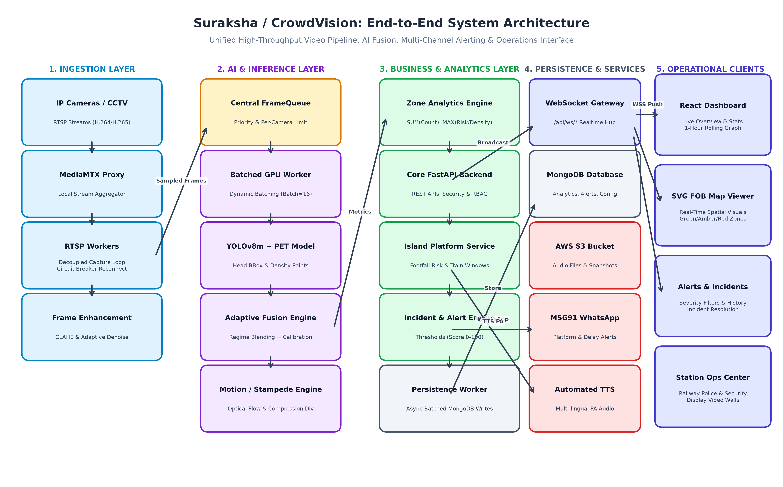
Figure 1: Suraksha / CrowdVision High-Level End-to-End System Architecture
Communication between components is strictly standardized across environments:
Layer | Primary Technology | Protocol / Ingress | Responsibilities
Edge Ingestion | MediaMTX / OpenCV Decoupled Loops | RTSP over TCP/UDP (Port 8554) | Pulls H.264/H.265 CCTV feeds; maintains zero-backlog latest frame buffer; auto-reconnect.
GPU Inference | PyTorch, CUDA 11.8+, TensorRT | BatchedInferenceService (IPC/Queue) | Dynamic micro-batching (batch=16); YOLOv8m forward pass + PET Transformer density point queries.
Business & Fusion | FastAPI (Python 3.11+) | Internal In-Memory Async Queues | Regime arbitration, count calibration, optical flow divergence, zone-level aggregation.
Real-Time Gateway | FastAPI WebSockets / Starlette | WSS (/api/ws/analytics, /api/ws/zones/*) | Sub-second broadcast of live zone metrics, alert triggers, and upcoming train schedules.
Persistence | MongoDB (Motor Async Driver) | TCP Port 27017 (Batched Worker) | Micro-batched flush every 5s; stores time-series metrics, alert incidents, and user metadata.
External Gateways | MSG91, AWS S3, RapidAPI | HTTPS REST APIs (TLS 1.3) | WhatsApp alert dispatch, multi-lingual TTS MP3 storage, and real-time live train schedule synchronization.
Operations UI | React 18, TypeScript, Vite, Tailwind | HTTPS (Port 443) + WSS | Responsive SVG FOB map rendering, 1-hour rolling footfall chart with LocalStorage cache, alert console.

3. High-Throughput Video Ingestion & Stream Decoupling
A critical vulnerability in traditional computer vision deployments is frame backlog: when deep learning models run slower than incoming camera frame rates (e.g. 25-30 FPS), buffer queues build up in memory, introducing fatal multi-minute delays in alert generation. Suraksha solves this through a completely decoupled, dual-threaded architecture within the RTSPWorker service.

Decoupled Capture vs. Inference Architecture
Each active RTSP camera feed is allocated an independent, long-running worker consisting of two decoupled concurrent threads:
1. High-Speed Frame Capture Thread (_connect_and_process): Continuously reads raw frames from the RTSP source at the camera's native speed (25-30 FPS). Upon decoding a valid frame, it immediately updates an atomic, thread-safe memory pointer (_latest_raw_frame) and timestamp (_latest_capture_timestamp). Older frames are overwritten instantly without queueing. This guarantees zero frame lag under all operating loads.
2. Cadenced AI Sampling Loop (_ai_loop): Executes at the configured target cadence (default 1.0 FPS). On each interval, it peeks at the freshest raw frame using get_latest_frame_with_metadata(). It validates frame freshness (age < 500ms) and dispatches the frame to the central batched inference queue without stalling the capture loop.

Resilience: Circuit Breaker & Exponential Backoff
Station network conditions can suffer from temporary packet drops, power interruptions, or switch reboots. RTSPWorker incorporates an enterprise-grade CircuitBreaker utility:
State | Trigger Condition | Worker Behavior | Recovery Strategy
CLOSED | Normal stream operation | Reads frames continuously; resets failure counters. | Transitions to OPEN if consecutive failures exceed threshold (default 5).
OPEN | Consecutive camera decode failures | Halts capture loop; releases OpenCV VideoCapture descriptors; prevents CPU thrashing. | Enters cooldown window; applies ExponentialBackoff (2s, 4s, 8s... up to 60s).
HALF-OPEN | Cooldown interval expired | Attempts a single test probe to reopen RTSP socket. | If test frame is successfully decoded, state reverts to CLOSED; otherwise backoff doubles.

4. Deep Learning & Computer Vision Core
Traditional single-model crowd analytics platforms fail in real-world railway environments because crowd densities vary radically by location and time—from sparse midnight platforms to crush-load festival peaks during Sabarimala or Diwali. Suraksha employs a synergistic dual-model architecture combining YOLOv8m object detection with the Point-query Efficient Transformer (PET).

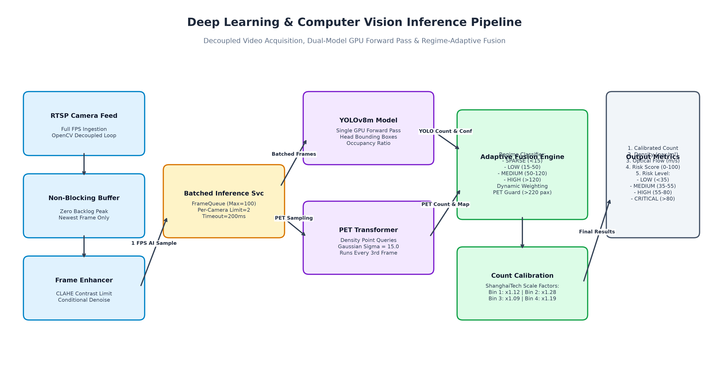
Figure 2: Computer Vision Inference Pipeline (YOLOv8 + PET Dual-Model Fusion)

YOLOv8m: Object Detection & Spatial Occupancy
YOLOv8m (You Only Look Once, medium variant) is optimized for head and upper-body detection. In sparse-to-medium crowd scenes, individual passengers exhibit distinct boundaries. YOLO generates discrete bounding boxes with bounding box coordinates, confidence scores, and computes the frame's total Spatial Occupancy Ratio (the percentage of active pedestrian ROI covered by detected human bounding boxes). Occupancy ratio serves as a critical gating factor for regime switching.

PET: Point-Query Efficient Transformer
Under extreme congestion (over 100-200 passengers per camera view), severe occlusions prevent YOLO from isolating individual heads. Earlier iterations attempted using CSRNet (Congested Scene Recognition Network), but production testing demonstrated unacceptable blurriness and false positives around luggage and platform infrastructure. The system was upgraded to the PET (Point-query Efficient Transformer) model.
PET models crowd density as direct point queries, generating sharp, localized coordinate predictions and high-fidelity density maps. A 2D Gaussian kernel (sigma=15.0) is applied over point predictions to render density maps. To balance GPU load, PET inference is cadenced to run every 3rd frame (pet_inference_interval=3) while intermediate frames utilize YOLO forward passes coupled with cached PET spatial baselines.

5. Adaptive Regime-Based Fusion & Count Calibration
The core mathematical innovation in Suraksha is its adaptive fusion algorithm (compute_fusion in utils/fusion.py). Rather than relying strictly on a single detector or static averaging, the system dynamically classifies each frame into one of four density regimes based on combined headcount estimates and YOLO spatial occupancy:
Regime | Max Count Range | Occupancy Ratio | PET Weight | YOLO Weight | Fusion Logic Rationale
SPARSE | < 15 pax | < 5% (<0.05) | 0.50 | 0.50 | Balanced blend; YOLO floor guard active to prevent undercounting.
LOW | 15 - 50 pax | < 5% (<0.05) | 0.60 | 0.40 | PET begins taking precedence; handles mild overlapping boundaries.
MEDIUM | 50 - 120 pax | 5% - 15% (0.05-0.15) | 0.75 | 0.25 | PET dominates; YOLO provides boundary stabilization.
HIGH | > 120 pax | 15% - 30% (0.15-0.30) | 0.95 | 0.05 | Extreme occlusion; PET provides 95% of prediction weight.

Dense-Scene PET Guard
In severe surge conditions (e.g. general compartment boarding), blending with YOLO can cause an artificial downward drag on the count due to head occlusion. When the PET headcount exceeds 220 people and YOLO occupancy surpasses 18% (0.18), the fusion_pet_guard triggers automatically, forcing 100% PET-direct counting (PET_GUARD_DIRECT) and bypassing the YOLO blend entirely.

Piecewise ShanghaiTech Count Calibration
Extensive benchmarking against the ShanghaiTech Crowd Dataset demonstrated a slight systematic negative bias in standard neural density integration. Suraksha implements a piecewise calibration function (calibrate_fused_count in utils/count_calibration.py) that applies fine-grained multipliers according to headcount bins:
Headcount Bin | Count Range | Calibration Multiplier | Correction Purpose
Bin 1 | < 50 pax | x1.12 (+12%) | Compensates for subtle edge clipping and partial head crops.
Bin 2 | 50 - 200 pax | x1.28 (+28%) | Addresses medium-density inter-person occlusion in platform corridors.
Bin 3 | 200 - 500 pax | x1.09 (+9%) | Fine-tunes high-density transformer query saturation.
Bin 4 | > 500 pax | x1.19 (+19%) | Extreme surge calibration; capped at a strict x1.40 safety ceiling.

6. Optical Flow, Crowd Dynamics & Stampede Early Warning
Headcount alone does not determine physical danger: 300 passengers walking smoothly at 1.2 m/s represent normal operation, whereas 150 passengers compressed into a bottleneck with opposing velocity vectors can trigger a fatal stampede within seconds. Suraksha integrates a real-time crowd dynamics module that computes velocity vectors and spatial divergence.

Farneback Dense Optical Flow & Real-World Velocity
The system executes two-frame Farneback Optical Flow on grayscale downsampled frames (every 3 frames on CPU, or every frame on GPU). Pixel displacement is mapped to real-world velocity (m/s) using calibrated homography ratios (meters_per_pixel). Motion classifications follow the Fruin/Weidmann transit standards:
Motion Classification | Velocity Range (m/s) | Real-World Interpretation | Risk Implication
STATIC | < 0.10 m/s | Stationary crowd or stationary queue | Evaluated for static queue dampening.
SLOW | 0.10 - 0.50 m/s | Dense shuffling; constrained movement | Indicates beginning of transit friction.
NORMAL | 0.50 - 1.30 m/s | Standard pedestrian walking pace | Normal transit flow; low operational risk.
FAST | 1.30 - 2.50 m/s | Brisk walking or rapid boarding | Elevated transit activity.
RUNNING | > 2.50 m/s | Running, panic, or rapid evacuation | Immediate operational trigger; flags potential panic.

Stampede Detection: Negative Divergence (Compression)
Stampedes are physically preceded by crowd compression—regions where pedestrians enter faster than they can exit. Mathematically, this corresponds to negative divergence in the optical flow vector field (div V = dVx/dx + dVy/dy). When spatial divergence falls below -4.0 (compression_threshold = -4.0), it indicates severe pedestrian pinch-points. The system immediately injects a heavy risk penalty (+10.0 points to the risk score) and triggers a stampede warning.

Static Queue Risk Dampening
A common false positive in transit stations is long, orderly queues at ticket counters or IRCTC catering stalls. Although density is high (>3.0 pax/m²), motion is near zero (<0.15 m/s) and orderly. Suraksha detects static queues and applies a 60% risk dampening factor (static_queue_risk_dampening = 0.4), preventing spurious alerts while keeping active monitoring engaged.

7. Zone-Level Spatial Aggregation & Conservative Risk Modeling
Individual camera views cover limited physical sectors. To provide actionable intelligence for railway operations, camera metrics must be synthesized into physical railway zones (e.g., 'Zone PF 1-2 Kazipet FOB', 'North Stairs Escalator', 'Island Platform 4/5 Central').

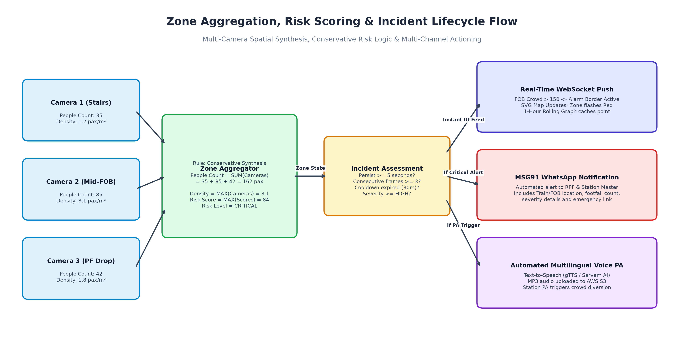
Figure 3: Zone Aggregation, Risk Scoring & Multi-Channel Alert Flow

Conservative Aggregation Rules
To ensure passenger safety, the Zone Analytics Engine (services/zone_analytics.py) applies strictly conservative synthesis rules:
• Total Headcount: SUM(Camera Headcounts). The total estimated number of people occupying the entire contiguous zone.
• Average Density: MAX(Camera Densities). If one camera covering a narrow stairway exhibits critical density (4.5 pax/m²) while another over a landing is empty, the zone is classified by the localized danger point (4.5 pax/m²).
• Risk Score & Level: MAX(Camera Risk Scores). High-risk pinch points are never diluted by adjacent empty areas.
• Motion Intensity: MAX(Camera Motion Intensities). Detects localized running or panic anywhere within the zone.

Unified Risk Level Matrix (Fruin Level of Service)
Risk scores (0 - 100) and density classifications are standardized across all stations according to transit safety research:
Risk Level | Score Range | Density Threshold | Visual UI Styling | Operational Incident Action
LOW | 0 - 35 | < 0.5 pax/m² | Solid Green Badge | Normal operational state. Free passenger movement.
MEDIUM | 35 - 55 | 0.5 - 1.5 pax/m² | Amber / Yellow Badge | Elevated monitoring. Normal peak boarding.
HIGH | 55 - 80 | 1.5 - 2.5 pax/m² | Orange Border & Icon | Station master notified. Monitor stairs for spillback.
CRITICAL | > 80 | > 2.5 pax/m² (>4.0 crush) | Flashing Red + Dark Background | Emergency alert. WhatsApp notification sent to RPF; automated voice announcement triggered.

8. Automated Notification & Operational Actioning Engines
Suraksha is not merely an observational tool; it is an active operational control system that initiates automated remediation workflows upon detecting critical conditions.

MSG91 WhatsApp Notification Engine
When high or critical risks persist for at least 5 seconds across 3 consecutive frames, the notification service (services/whatsapp_alert_service.py) formats a structured WhatsApp message using approved MSG91 templates. Alerts are dispatched directly to the Railway Protection Force duty officer, Station Superintendent, and commercial inspectors. Alerts contain the exact platform/FOB location, headcount, risk level, and emergency SOP links.

Automated Multilingual Voice Announcements
Under overcrowding or platform reassignments, the Announcement Engine (train_announcement.py) dynamically composes natural language audio notices. Audio is synthesized using gTTS or Sarvam AI Bulbul neural models in three languages: English, Hindi, and Telugu. The synthesized MP3 audio files are automatically uploaded to AWS S3 and their URLs are broadcast to station audio distribution units to direct passengers away from congested FOBs.

Island Platform Risk Engine
Island platforms (e.g. Platform 4/5 or 6/7 at Secunderabad) serve tracks on both sides. A unique transit hazard occurs when two heavy trains arrive simultaneously, causing dual passenger egress onto a narrow platform. The Island Alert Service (services/island_alert_service.py) links train schedules with spatial footfall risk algorithms, evaluating a 90-minute predictive window to warn controllers of dangerous concurrent dwell times before the trains even enter the station yard.

9. Real-Time Frontend Experience & Interactive SVG Floor Plan
The frontend application (Crowd_Vision_Frontend) is an enterprise single-page application built with React 18, TypeScript, Vite, and Tailwind CSS. It communicates with the backend via WebSocket channels (/api/ws/analytics, /api/ws/zones/analytics, /api/ws/trains) with an automatic 3-second reconnection loop and fallback to REST polling.

Interactive SVG Map Viewer (FOBMapViewer.tsx)
Rather than forcing operators to inspect disconnected camera tiles, the FOB Map Viewer displays an overhead architectural schematic of the Secunderabad Foot Over Bridge. Key implementation highlights include:
• Percentage-Based Spatial Mapping: Zone polygons and data overlay boxes are positioned using percentage coordinates (ZONE_POSITIONS), ensuring flawless scaling across 1080p, 4K video walls, and tablet screens.
• Dynamic Risk-Responsive Styling: As WebSocket updates arrive, zone sectors dynamically transition between emerald green, golden amber, vibrant orange, and pulsing crimson according to live risk levels.
• Interactive Spatial Telemetry: Clicking any FOB sector immediately opens an inspector displaying active camera sources, individual camera densities, motion velocity vectors, and historical trends.

1-Hour Rolling Footfall Chart with LocalStorage Caching
A critical production requirement addressed in FOBPeopleCountChart.tsx was the elimination of data loss upon browser refresh. The chart maintains a continuous 1-hour rolling window of footfall samples (5-second intervals). All incoming data points are automatically synchronized to the browser's localStorage cache (fob_chart_data_HYB_1h). Upon page reload or network hiccup, the historical trend curve re-renders instantly without requesting heavy historical aggregates from the database.

10. Database Schema, Storage Lifecycle & TTL Data Retention
MongoDB serves as the operational and time-series document store. All write operations are routed through the asynchronous PersistenceWorker (services/persistence_worker.py) to prevent disk I/O latency from degrading the real-time processing loop.
Collection Name | Record Contents | Indexing Strategy | Automated Retention Policy (TTL)
analytics | Per-camera/zone footfall samples (people count, density, motion, risk). | compound: [camera_id, timestamp], [zone_id, timestamp] | Auto-purged after 30 days via MongoDB TTL index.
alerts | Incident records (severity, trigger reason, zone, status, resolution). | compound: [status, severity, timestamp] | Retained for 90 days for statutory safety compliance.
cameras | RTSP URLs, calibration homography, zone mappings, stream status. | unique: [camera_id] | Permanent operational configuration.
zones | SVG coordinates, display orders, parent station IDs, thresholds. | unique: [zone_id] | Permanent spatial layout metadata.
train_schedules | Train numbers, names, arrival/departure schedules, platforms. | compound: [train_number, scheduled_arrival] | Rolling 7-day schedule window.
island_alerts | Concurrent multi-train footfall surge projections. | compound: [island_id, window_start] | Retained for 30 days.
images | File paths and metadata for critical incident snapshots. | compound: [alert_id, camera_id] | Retained for 90 days (10 GB max storage cap).
detections | Raw YOLO bounding box coordinates (debug/verification mode). | index: [timestamp] | Strict 7-day TTL cleanup to prevent storage exhaustion.

11. Production Infrastructure Topology, K3s & NVIDIA GPU Toolkit
The production deployment utilizes K3s—a lightweight, highly efficient Kubernetes distribution optimized for edge workstations and IoT appliances. The cluster topology is orchestrated using Kustomize manifests located in k3s/stack/.

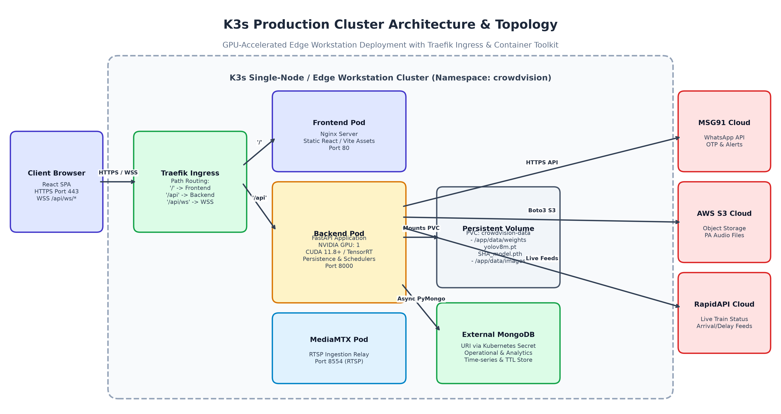
Figure 4: K3s Edge Workstation Cluster Architecture & Container Topology

K3s Kubernetes Manifest Architecture
The cluster operates under the isolated crowdvision namespace. Key architectural components include:
• Traefik Ingress Controller: Acts as the unified gateway. Routes / to the React frontend Nginx pod, /api to the FastAPI backend pod, and /api/ws/* to the WebSocket cluster, providing clean TLS termination and CORS isolation.
• GPU Workstation Acceleration (NVIDIA Container Toolkit): The backend deployment utilizes runtimeClassName: nvidia and requests nvidia.com/gpu: 1. Model weights (yolov8m.pt and SHA_model.pth) are mounted from a high-throughput PersistentVolumeClaim (crowdvision-data) at /app/data/weights.
• MediaMTX Pod: An in-cluster RTSP proxy that ingests external camera feeds and serves high-efficiency internal RTSP endpoints (rtsp://mediamtx:8554/cam_01), decoupling external network flaps from backend workers.

Deterministic Sharding Across Pods
When expanding beyond single-workstation capacity (e.g., monitoring 100+ cameras across multiple GPU nodes), the backend supports deterministic sharding (services/sharding.py). Camera IDs are hashed via CRC32 modulo the total pod count (CRC32(camera_id) % CAMERA_SHARD_COUNT). Each StatefulSet pod (crowdvision-backend-0, crowdvision-backend-1) automatically binds to its designated camera shard, ensuring balanced GPU distribution without cross-pod locks.

12. Production Runbook, Health Verification & Maintenance
This section details standard operational runbooks, daily health verification commands, and emergency troubleshooting procedures for railway IT and on-site engineering staff.

Health Check API Endpoints
The backend exposes tiered health check probes designed for Kubernetes liveness and readiness monitoring:
Endpoint | Probe Type | Evaluation Criteria | HTTP Response
GET /api/health/simple | K3s Liveness Probe | Validates FastAPI process responsiveness. | 200 OK: {"status": "alive"}
GET /api/health | K3s Readiness Probe | Validates MongoDB connectivity, GPU availability, and active RTSP workers. | 200 OK: {"status": "healthy", "database": "connected", "gpu": true}
GET /api/rtsp/list | Operator Stream Audit | Reports active frame rates, buffer lag, and circuit breaker status per camera. | 200 OK: List of stream health objects.

Standard Operating Commands (K3s Runbook)
• Deploy Entire Stack:
kubectl apply -k k3s/stack/overlays/workstation
• Monitor Cluster Rollout:
kubectl -n crowdvision rollout status deploy/crowdvision-backend --timeout=10m
• Inspect Real-Time Logs:
kubectl -n crowdvision logs deploy/crowdvision-backend -f --tail=100
• Verify Pods & GPU Binding:
kubectl -n crowdvision get pods -o wide
• Emergency Restart Backend:
kubectl -n crowdvision rollout restart deploy/crowdvision-backend
• Local Port-Forward Testing:
kubectl -n crowdvision port-forward svc/crowdvision-backend 8000:80

Troubleshooting Common Operational Issues
Issue: GPU Out of Memory (OOM)
Symptom: CUDA error: out of memory during initialization.
Resolution: Ensure SharedModelPool or BatchedInferenceService is active. Check that use_shared_model_pool=True in config.py. Verify no orphaned python processes hold the GPU using 'nvidia-smi'.
Issue: RTSP Frame Freezing
Symptom: Camera status stays 'running' but headcount is static.
Resolution: The decoupled capture thread detects bad frames and trips the CircuitBreaker. Check camera network ping. Restart stream via UI 'Restart' button or verify MediaMTX RTSP ingress.
Issue: WhatsApp Alert Not Delivered
Symptom: Alert logged in MongoDB but no WhatsApp message received.
Resolution: Verify MSG91_AUTH_KEY in secret.yaml. Confirm recipient numbers include international country code (e.g. 919876543210). Inspect logs with 'grep -i whatsapp'.
Issue: Chart Flatlining on UI
Symptom: 1-hour graph stops rendering new points.
Resolution: Inspect WebSocket connection badge in UI header. If red, verify port 443/WSS route in Traefik ingress. Confirm client local time matches Indian Standard Time (IST).

