1. Explain the Medium Access Control (MAC) problem of receiving various signals from exposed and hidden terminals and near and far terminals.

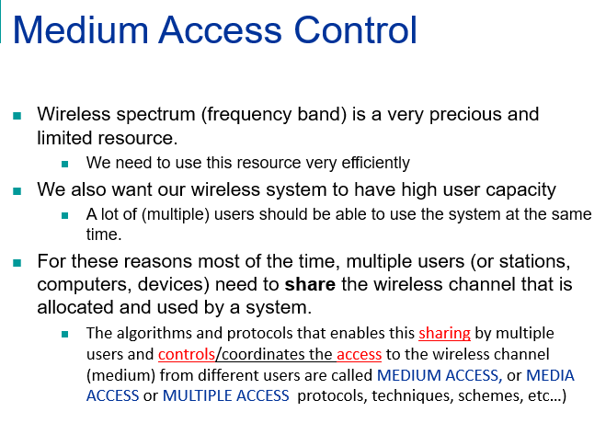

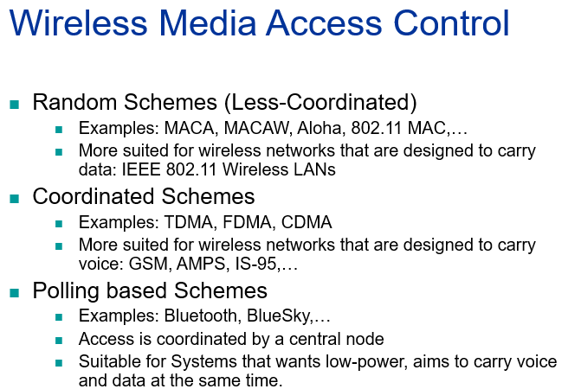

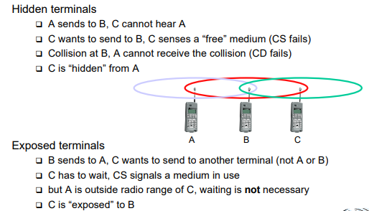

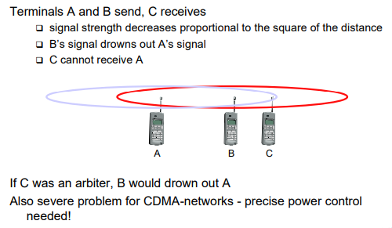

**2) What is Multiplexing? Explain different multiplexing schemes?**

A) **Multiplexing;** Multiplexing is a way of sending multiple signals or streams of information over a communications link at the same time in the form of a single, complex [signal](http://searchnetworking.techtarget.com/definition/signal).

* Process of different users sharing a same medium with minimum or no interference
* Needs guard space
* Guard space was given to prevent the interference between the various signals

Multiplexing in 4 dimensions

* + space (si)
  + time (t)
  + frequency (f)
  + code (c)

**Space division multiplexing;**

* Medium has been shared by various signals
* But each and every signal has differaent orientation
* Enough guard space need to be given
* Wastes lot of band width
* Example old analog telephone system.
* SDMA: Interference happens if senders are too close to each other. Terminals or base stations have to keep a minimum distance.



**Frequency multiplexing;**

* subdivide the frequency dimension into several non-overlapping frequency bands
* Senders using a certain frequency band can use this band continuously. Again, **guard spaces are needed to avoid frequency band overlapping (also** called **adjacent channel interference).**
* This scheme is used for radio stations within the same region, where each radio station has its own frequency
* Interference happens if senders transmit data at the same frequency.

Advantages:

* no dynamic coordination   
  necessary
* works also for analog signals

Disadvantages:

* While radio stations broadcast 24 hours a day, mobile communication typically takes place for only a few minutes at a time.
* Wastes bandwidth
* Inflexible.



**Time division multiplexing;**

* Here a channel is given the whole bandwidth for a certain amount of time.
* all senders use the same frequency but at different points in time
* Again, **guard spaces, which now** represent time gaps, have to separate the different periods when the senders use the medium
* Interference happens if senders transmit data at the same time.



**Code multiplex**



**3) Draw the system architecture of GSM; explain the various components associated with its subsystems.**



GSM is a PLMN (Public Land Mobile Network)

* + several providers setup mobile networks following the GSM standard within each country
  + components
    - MS (mobile station)
    - BS (base station)
    - MSC (mobile switching center)
    - LR (location register)
  + subsystems
    - RSS (radio subsystem): covers all radio aspects
    - NSS (network and switching subsystem): call forwarding, handover, switching
    - OSS (operation subsystem): management of the network

**Radio subsystem**

The Radio Subsystem (RSS) comprises the cellular mobile network up to the switching centers

* Components
  + Base Station Subsystem (BSS):
    - Base Transceiver Station (BTS): radio components including sender, receiver, antenna - if directed antennas are used one BTS can cover several cells
    - Base Station Controller (BSC): switching between BTSs, controlling BTSs, managing of network resources, mapping of radio channels (Um) onto terrestrial channels (A interface)
    - BSS = BSC + sum(BTS) + interconnection
  + Mobile Stations (MS)

**Mobile station:**

Terminal for the use of GSM services

* A mobile station (MS) comprises several functional groups
  + MT (Mobile Terminal):
    - offers common functions used by all services the MS offers
    - corresponds to the network termination (NT) of an ISDN access
    - end-point of the radio interface (Um)
  + SIM (Subscriber Identity Module):
    - personalization of the mobile terminal, stores user parameters
* international mobile equipment identity(IMEI)
* a personal identity number (PIN),
* PIN unblocking key (PUK),

**Base Transfer Station and Base Station Controller:**

Tasks of a BSS are distributed over BSC and BTS

* BTS comprises radio specific functions
* BSC is the switching center for radio channels

**Network and switching subsystem:**

NSS is the main component of the public mobile network GSM

* + switching, mobility management, interconnection to other networks, system control
* Components
  + Mobile Services Switching Center (MSC)  
    controls all connections via a separated network to/from a mobile terminal within the domain of the MSC - several BSC can belong to a MSC
* MSC manages several BSCs in a geographical region. A gateway

MSC (GMSC) has additional connections to other fixed networks, such as PSTN and ISDN.

* Using additional interworking functions (IWF),
* An MSC handles all signaling needed for connection setup, connection release and handover of connections to other MSCs. The standard signaling system No. 7 (SS7) is used for this purpose. SS7
* Features of SS7 are number portability, free phone/toll/collect/credit calls, call forwarding, three-way calling etc

**HLR;**

* This comprises static information, such as the **mobile subscriber ISDN number (MSISDN), subscribed** services (e.g., call forwarding, roaming restrictions, GPRS), and the **international mobile subscriber identity (IMSI).**
* Dynamic information is also needed, e.g., the current **location area (LA) of the MS, the mobile subscriber roaming number (MSRN), the current VLR and MSC**
* As soon as an MS leaves its current LA, the information in the HLR is updated. This information is necessary to localize a user in the worldwide GSM network

**VLR:**

* The VLR associated to each MSC is a dynamic database which stores all important information needed for the MS users currently in the LA that is associated to the MSC (e.g., IMSI,MSISDN, HLR address).
* If a new MS comes into an LA the VLR is responsible for, it copies all relevant information for this user from the HLR

**Operation subsystem:**

* Operation and maintenance center (OMC): The OMC monitors and controls all other network entities via the O interface (SS7 with X.25).
* Typical OMC management functions are traffic monitoring, status reports of networkentities, subscriber and security management, or accounting and billing.
* OMCs use the concept of telecommunication management network(TMN) as standardized by the ITU-T.

**Authentication centre (AuC)**

* **Authentication centre (AuC): As the radio interface and mobile stations** are particularly vulnerable, a separate AuC has been defined to protect user identity and data transmission.
* The AuC contains the algorithms for authentication as well as the keys for encryption and generates the values needed for user authentication in the HLR.
* The AuC may, in fact, be situated in a special protected part of the HLR.

**Equipment identity register**

* **Equipment identity register (EIR): The EIR is a database for all IMEIs, i.e.,** it stores all device identifications registered for this network
* . As MSs are mobile, they can be easily stolen. With a valid SIM, anyone could use the stolen MS. The EIR has a blacklist of stolen (or locked) devices.
* In theory an MS is useless as soon as the owner has reported a theft. Unfortunately, the blacklists of different providers are not usually synchronized and the illegal use of a device in another operator’s network is possible (the reader may speculate as to why this is the case).

The EIR also contains a list of valid IMEIs (white list), and a list of malfunctioning devices (gray list)

1. **With advantages and disadvantages, explain the characteristics of different orbits of satellites**

Four different types of satellite orbits can be identified depending on the shape and diameter of the orbit:

* GEO: geostationary orbit, ca. 36000 km above earth surface
* LEO (Low Earth Orbit): ca. 500 - 1500 km
* MEO (Medium Earth Orbit) or ICO (Intermediate Circular Orbit): ca. 6000 - 20000 km
* HEO (Highly Elliptical Orbit) elliptical orbits



**Geostationary satellites**

Orbit 35,786 km distance to earth surface, orbit in equatorial plane (inclination 0°)

🡺 complete rotation exactly one day, satellite is synchronous to earth rotation

* fix antenna positions, no adjusting necessary
* satellites typically have a large footprint (up to 34% of earth surface!), therefore difficult to reuse frequencies
* bad elevations in areas with latitude above 60° due to fixed position above the equator
* high transmit power needed
* high latency due to long distance (ca. 275 ms)

🡺 not useful for global coverage for small mobile phones and data transmission, typically used for radio and TV transmission

**LEO systems**

Orbit ca. 500 - 1500 km above earth surface

* visibility of a satellite ca. 10 - 40 minutes
* global radio coverage possible
* latency comparable with terrestrial long distance   
  connections, ca. 5 - 10 ms
* smaller footprints, better frequency reuse
* Shorter life time , routing required
* but now handover necessary from one satellite to another
* many satellites necessary for global coverage
* more complex systems due to moving satellites

Examples:

Iridium (start 1998, 66 satellites)

* + Bankruptcy in 2000, deal with US DoD (free use,   
    saving from “deorbiting”)

Globalstar (start 1999, 48 satellites)

* + Not many customers (2001: 44000), low stand-by times for mobiles

**MEO systems:**

Orbit ca. 5000 - 12000 km above earth surface

comparison with LEO systems:

* slower moving satellites
* less satellites needed
* simpler system design
* for many connections no hand-over needed
* higher latency, ca. 70 - 80 ms
* higher sending power needed
* special antennas for small footprints needed

Example:

ICO (Intermediate Circular Orbit, Inmarsat) start ca. 2000

* + Bankruptcy, planned joint ventures with Teledesic, Ellipso – cancelled again, start planned for 2003

1. **With a neat diagram explain the architecture of IEE 802.11 and also discuss the services provided by it.**

**Answer:**

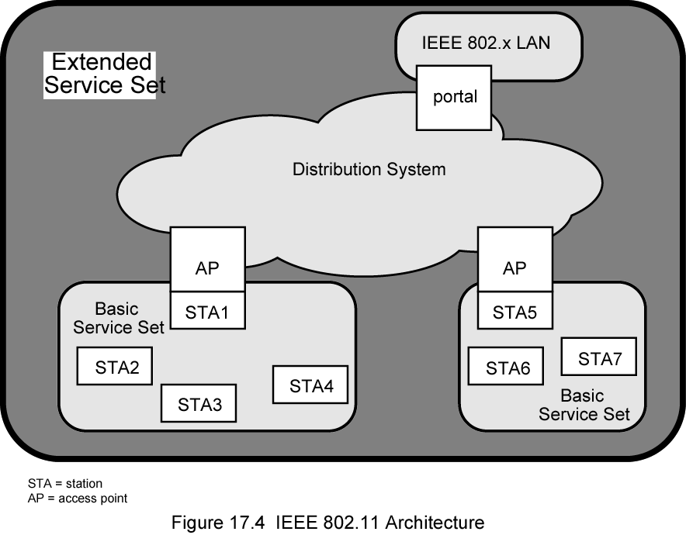 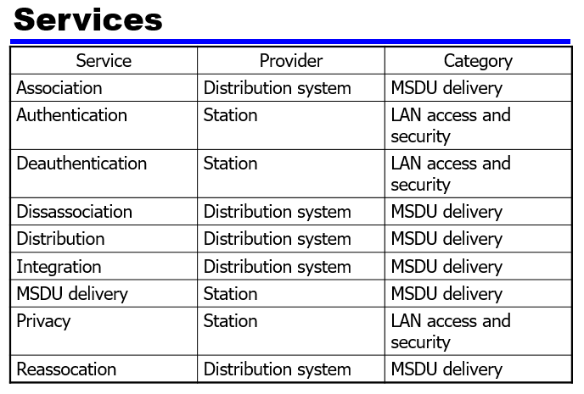

**Categorizing Services**

* Station services implemented in every 802.11 station
* Including AP stations
* Distribution services provided between BSSs
* May be implemented in AP or special-purpose device
* Three services used to control access and confidentiality
* Six services used to support delivery of MAC service data units (MSDUs) between stations
* Block of data passed down from MAC user to MAC layer
* Typically LLC PDU
* If MSDU too large for MAC frame, fragment and transmit in series of frames (see later)

**Distribution of Messages Within a DS**

* Distribution is primary service used by stations to exchange MAC frames when frame must traverse DS
* From station in one BSS to station in another BSS
* Transport of message through DS is beyond scope of 802.11
* If stations within same BSS, distribution service logically goes through single AP of that BSS
* Integration service enables transfer of data between station on 802.11 LAN and one on an integrated 802.x LAN
* Integrated refers to wired LAN physically connected to DS
* Stations may be logically connected to 802.11 LAN via integration service
* Integration service takes care of address translation and media conversion

**Association Related Services**

* Purpose of MAC layer transfer MSDUs between MAC entities
* Fulfilled by distribution service (DS)
* DS requires information about stations within ESS
* Provided by association-related services
* Station must be associated before communicating
* Three transition types of based on mobility
* No transition: Stationary or moves within range of single BSS
* BSS transition: From one BSS to another within same ESS
* Requires addressing capability be able to recognize new location
* ESS transition: From BSS in one ESS to BSS in another ESS
* Only supported in sense that the station can move
* Maintenance of upper-layer connections not guaranteed
* Disruption of service likely

**Station Location**

* DS needs to know where destination station is
* Identity of AP to which message should be delivered
* Station must maintain association with AP within current BSS
* Three services relate to this requirement:
* Association: Establishes initial association between station and AP
* To make identity and address known
* Station must establish association with AP within particular BSS
* AP then communicates information to other APs within ESS
* Reassociation: Transfer established association to another AP
* Allows station to move from one BSS to another
* Disassociation: From either station or AP that association is terminated
* Given before station leaves ESS or shuts
* MAC management facility protects itself against stations that disappear without notification

**Access and Privacy Services - Authentication**

* On wireless LAN, any station within radio range other devices can transmit
* Any station within radio range can receive
* Authentication: Used to establish identity of stations to each other
* Wired LANs assume access to physical connection conveys authority to connect to LAN
* Not valid assumption for wireless LANs
* Connectivity achieved by having properly tuned antenna
* Authentication service used to establish station identity
* 802.11 supports several authentication schemes
* Allows expansion of these schemes
* Does not mandate any particular scheme
* Range from relatively insecure handshaking to public-key encryption schemes
* 802.11 requires mutually acceptable, successful authentication before association

**Access and Privacy Services - Deauthentication and Privacy**

* Deauthentication: Invoked whenever an existing authentication is to be terminated
* Privacy: Used to prevent messages being read by others
* 802.11 provides for optional use of encryption