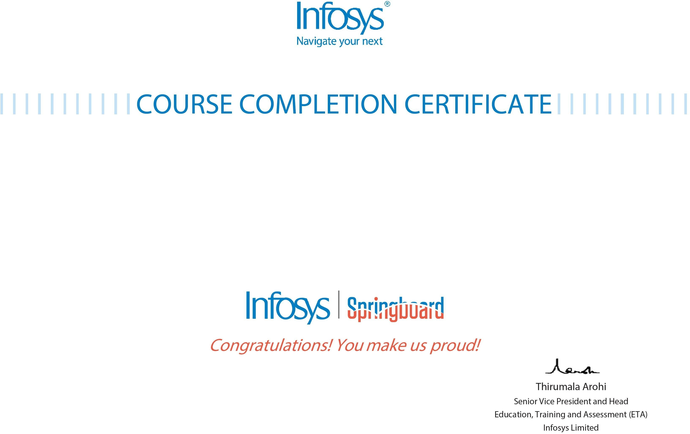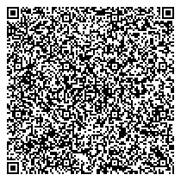

# The certicate is awarded to

A.CHARAN

# for successfully completing the course

Python for Data Science

# on Monday, February 20th 2023

Issued on: Monday, February 20th 2023

This certicate can be veried by scanning the QR code at https://verify.onwingspan.com