DDR3_DMA
Vivado IP Core & Interface Reference
Arty A7-100T | XC7A100T-CSG324-1 | Vivado 2025.2
Block pictures • interface definitions • configurable parameters • address map • integration checks
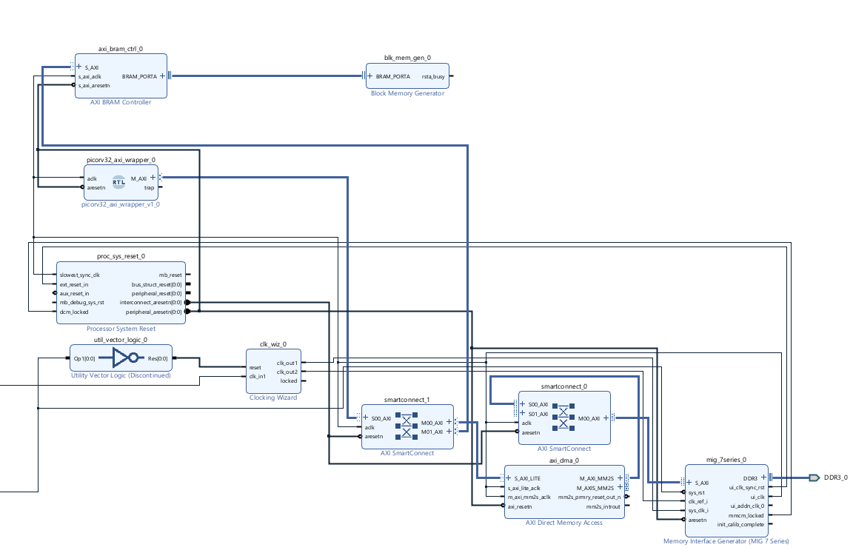
Prepared from the saved Vivado Block Design screenshot, IP inventory, Tcl export and project configuration notes.
Document status: engineering reference snapshot, not a sign-off that the complete DDR3-to-accelerator data path has been functionally tested.

1. Purpose and scope
This document describes the IP and custom RTL blocks assembled for the DDR3_DMA system. For every block, the diagram is followed immediately by its interfaces, current connection, configurable parameters and practical notes for changing the configuration.

1.1 Hardware and project baseline
Item | Current project record
Vivado / Block Design | Vivado 2025.2 / dma_ddr3_system
FPGA target | Digilent Arty A7-100T, XC7A100T-CSG324-1
External memory | On-board DDR3L, 16-bit physical data bus; nominal capacity recorded as 256 MiB
Processor | Custom wrapper around YosysHQ PicoRV32 AXI variant
Main data path | DDR3 → MIG → SmartConnect_0 → AXI DMA MM2S → AXI4-Stream output
Control/local-memory path | PicoRV32 → SmartConnect_1 → DMA S_AXI_LITE and AXI BRAM Controller → Block Memory Generator

1.2 Evidence and configuration labels
Label | Meaning
Captured | Present in the saved Tcl export or Vivado screenshot.
Project note | Recorded in the working design notes, but not exposed by the available Tcl export.
Verify | Conflicting or incomplete evidence; check the current Vivado Customize IP / Address Editor view before relying on it.
Pending | Required for the intended system, but no connected implementation is shown in the saved design snapshot.

1.3 Important scope boundary
The current Block Design includes the DDR3/MIG, DMA, interconnect, PicoRV32 wrapper and local BRAM control path. The accelerator controller, PE array and Global Buffer belong to the larger accelerator architecture, but are not shown as completed Vivado IP blocks in the saved Block Design screenshot/Tcl. The DMA M_AXIS_MM2S stream destination is therefore treated as pending integration.

2. System-level architecture
Figure 1. Saved Vivado Block Design screenshot (1 November 2026). Some signal routes are visually dense; use the interface tables below as the port-level reference.

2.1 Functional paths
Path | Sequence | Role
DMA data read | DDR3 device ⇄ MIG S_AXI ⇄ SmartConnect_0 ⇄ AXI DMA M_AXI_MM2S | Moves data from a DDR3 memory-mapped buffer into the DMA.
Stream output | AXI DMA M_AXIS_MM2S → Global Buffer / stream sink (pending) | Delivers each DMA read as AXI4-Stream beats. This is not an AXI memory-mapped SmartConnect connection.
CPU control | PicoRV32 M_AXI → SmartConnect_1 → AXI DMA S_AXI_LITE | CPU writes DMA source address, control and length registers; reads status.
CPU local memory | PicoRV32 M_AXI → SmartConnect_1 → AXI BRAM Controller → Block Memory Generator | Provides instruction/data storage for the processor, subject to final BRAM map/size verification.
Clock/reset | Clock Wizard + MIG UI clock + Processor System Reset + Utility Vector Logic | Creates the MIG clocks and distributes the synchronized reset domains.

2.2 Address map (saved working configuration)
Target | Base address | Range / high address | Notes
Local BRAM | 0x00000000 | 8 KB recorded | Project notes say the BRAM base was moved to zero. Confirm effective memory capacity; see BRAM warning.
AXI DMA registers | 0x41E00000 | 64 KB | Control register aperture, accessed through S_AXI_LITE.
DDR3 MIG memory | 0x80000000 | 256 MiB / 0x8FFFFFFF | Captured in Tcl export as the MM2S data address region.

Address spaces are not interchangeable: the processor control path reaches the DMA registers and local BRAM. No direct PicoRV32-to-DDR3 path is required by the current design plan; the DMA is the DDR3 data mover.

3. PicoRV32 AXI Wrapper (custom RTL)
The processor block is a custom RTL wrapper around the picorv32_axi module from YosysHQ. It exposes a single AXI4-Lite master interface for memory-mapped access. The CPU is used to configure/control the DMA and access the local BRAM; it is not intended to read DDR3 directly.
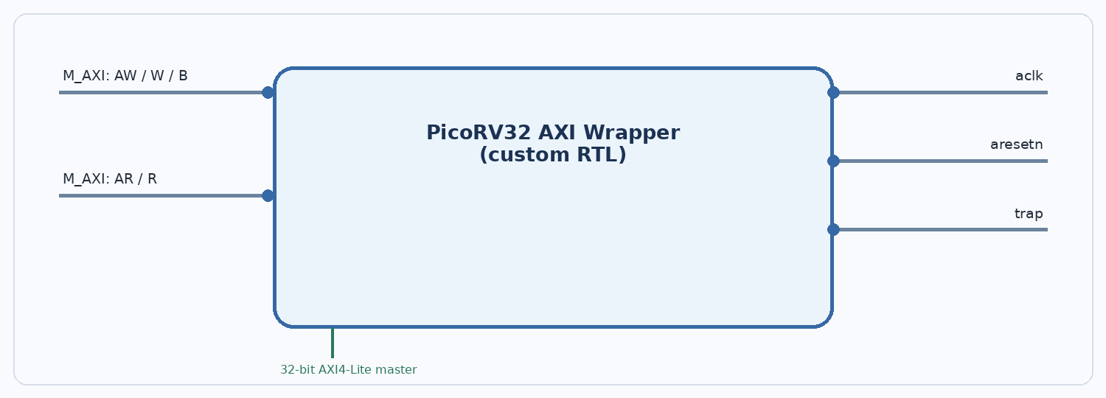
Figure 2. Logical interface view of the project wrapper; the AXI channels are grouped for readability.

Interfaces
Port / interface | Direction at block | Protocol / width | Connection / purpose
M_AXI | Master output | AXI4-Lite; 32-bit address and 32-bit data | Connected to SmartConnect_1/S00_AXI.
M_AXI AW channel | Master output | AWADDR[31:0], AWVALID, AWREADY, AWPROT[2:0] | Write-address channel.
M_AXI W channel | Master output | WDATA[31:0], WSTRB[3:0], WVALID, WREADY | Write-data channel; byte strobes select byte lanes.
M_AXI B channel | Master input | BRESP[1:0], BVALID, BREADY | Write response channel.
M_AXI AR channel | Master output | ARADDR[31:0], ARVALID, ARREADY, ARPROT[2:0] | Read-address channel.
M_AXI R channel | Master input | RDATA[31:0], RRESP[1:0], RVALID, RREADY | Read-data/response channel.
aclk | Input | Single clock | Clocked from MIG ui_clk according to the project notes.
aresetn | Input | Active-low reset | Connected to the peripheral reset domain in the working connection plan.
trap | Output | 1-bit status | Core trap output; useful for firmware fault/debug indication.

Changeable parameters
Parameter | Current value / evidence | What can be changed / design impact
Core variant | picorv32_axi | Selects PicoRV32 with an AXI4-Lite master port; differs from native-memory and Wishbone variants.
PROGADDR_RESET | 0x00000000 (core default / project notes) | Changes firmware start PC. Must match the program memory mapping.
STACKADDR | 0x00002000 (project note) | Sets initial stack pointer to the end of the 8-KB mapped region if that map is correct. Stack grows down; ensure 16-byte alignment.
ISA/performance options | Not fully captured | Underlying core parameters include MUL/DIV, compressed ISA, IRQ, counters, barrel shifter, two-cycle ALU/compare, trace and register options.
Wrapper bus width | 32-bit AXI4-Lite | Changing this requires wrapper and downstream interconnect compatibility; it is not a GUI-only setting.

Connection and design notes
- M_AXI is a control/local-memory master. It is not connected directly to MIG DDR3 in this architecture.
- CPU control path: wrapper M_AXI → SmartConnect_1/S00_AXI.
- The wrapper is custom RTL, so its exact Verilog parameter list and port naming should be checked in picorv32_axi_wrapper.v before editing.
Verify: the wrapper RTL source was not present among the files available for this document. The interface summary is based on the saved Block Design screenshot and project notes, plus the upstream picorv32_axi interface definition.

4. AXI SmartConnect 1 - CPU control and BRAM fabric
SmartConnect_1 is the AXI memory-mapped interconnect between the PicoRV32 master and the two AXI slave targets: AXI DMA control registers and the AXI BRAM Controller. It arbitrates/routes the processor transactions based on the address map.
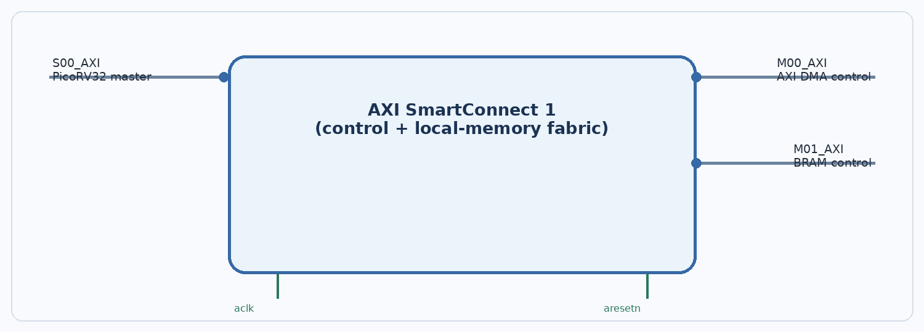
Figure 3. SmartConnect_1 has one slave-side ingress and two master-side egress interfaces in the working connection plan.

Interfaces
Port / interface | Direction at block | Protocol / width | Connection / purpose
S00_AXI | Slave-side ingress | AXI4-Lite master transaction input | Receives the PicoRV32 wrapper M_AXI transactions.
M00_AXI | Master-side egress | AXI4-Lite | Routes to AXI DMA S_AXI_LITE.
M01_AXI | Master-side egress | AXI4-Lite | Routes to AXI BRAM Controller S_AXI.
aclk | Input | AXI clock | Recorded as MIG ui_clk.
aresetn | Input | Active-low interconnect reset | Recorded as proc_sys_reset_0/interconnect_aresetn.

Changeable parameters
Parameter | Current value / evidence | What can be changed / design impact
Number of slave interfaces (NUM_SI) | 1 (project notes / screenshot) | Can be increased for more AXI masters.
Number of master interfaces (NUM_MI) | 2 (project notes / screenshot) | Can be increased for more AXI targets; each output needs address routing.
Number of clocks (NUM_CLKS) | 1 | Can support additional clock domains, but clock conversion/CDC requirements must be planned.
Reset input (HAS_ARESETN) | Enabled | Controls presence of active-low reset.
Strategy | Automatic/default unless overridden | SmartConnect offers area/performance trade-off strategies; choose based on timing/resource goals.
Data/address widths | Derived from connected interfaces | SmartConnect can adapt interface widths where supported; inspect generated interface properties after connection.

Connection and design notes
- M00_AXI is the DMA register-control route; M01_AXI is the local BRAM route.
- Address Editor assignments determine which M_AXI address requests are forwarded to each slave.
- Changing NUM_SI/NUM_MI changes the available ports and may require reconnecting interfaces and rerunning Validate Design.

5. AXI BRAM Controller
The AXI BRAM Controller makes on-chip block RAM accessible to an AXI master. In this design it is a memory-mapped target for PicoRV32 via SmartConnect_1, and it drives one BRAM interface connected to Block Memory Generator.
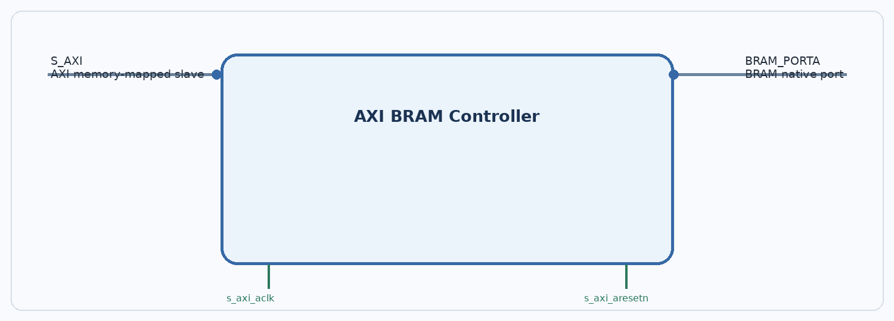
Figure 4. AXI BRAM Controller converts AXI memory-mapped transactions into the BRAM native port signals.

Interfaces
Port / interface | Direction at block | Protocol / width | Connection / purpose
S_AXI | Slave input | AXI4-Lite per working notes; 32-bit data noted | Connected to SmartConnect_1/M01_AXI.
BRAM_PORTA | BRAM-side output/interface | Native BRAM port; data/address/control widths follow IP configuration | Connected to Block Memory Generator/BRAM_PORTA.
s_axi_aclk | Input | AXI clock | Recorded as MIG ui_clk.
s_axi_aresetn | Input | Active-low reset | Recorded in working design notes as peripheral/interconnect reset domain; verify exact pin in current BD.

Changeable parameters
Parameter | Current value / evidence | What can be changed / design impact
AXI protocol mode | AXI4-Lite (working notes; verify GUI) | AXI4-Lite is suitable for register/simple memory transactions; AXI4 mode supports bursts and wider throughput where needed.
AXI data width | 32 bits (working notes) | Choose a supported width compatible with the master and BRAM side.
Number of BRAM interfaces | 1 | Can be increased for more BRAM ports/memories.
BRAM interface mode | External BRAM instance / controller-managed memory | Internal vs external BRAM configuration affects how the memory IP is instantiated/connected.
ECC | Not recorded / assumed off unless enabled | ECC consumes extra logic/storage and changes interface requirements.

Connection and design notes
- The AXI BRAM Controller is the bridge between AXI and BRAM; it is not itself the storage array.
- The connected storage primitive is Block Memory Generator instance blk_mem_gen_0.
- Validate the effective BRAM byte capacity against the Address Editor range before compiling firmware.
Verify: 8-KB address range is recorded in the project notes, while the saved Block Memory Generator setup was described as depth 8192 × 32 bits (= 32 KiB before any ECC/parity overhead). These figures conflict and must be reconciled in Vivado.

6. Block Memory Generator (local BRAM)
The Block Memory Generator configures FPGA block RAM primitives as a memory array. The project notes record a single-port RAM in BRAM Controller mode and a 32-bit memory width. The AXI BRAM Controller supplies the host-facing AXI path.
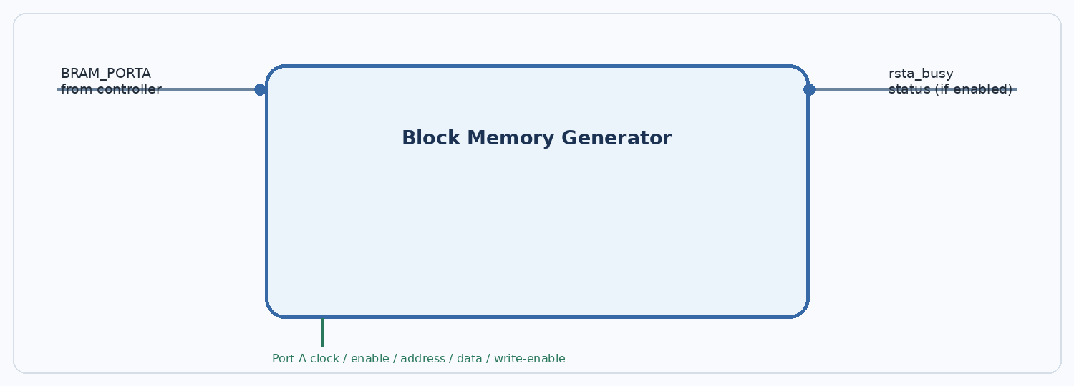
Figure 5. Block Memory Generator is the actual on-chip memory resource behind the AXI BRAM Controller.

Interfaces
Port / interface | Direction at block | Protocol / width | Connection / purpose
BRAM_PORTA | BRAM interface | Port A address, clock, enable, write-enable, data in/out | Connected to AXI BRAM Controller/BRAM_PORTA. In controller mode, Vivado bundles the native signals.
rsta_busy | Status output (if enabled) | Busy indication | Visible on the Block Design screenshot; check whether used by other logic.
Initialization file | Configuration property, not a run-time port | COE/MEM initialization source | Can preload a firmware/test data image during bitstream generation.

Changeable parameters
Parameter | Current value / evidence | What can be changed / design impact
Memory type | Single Port RAM (project note) | Can select Single Port RAM, Simple Dual Port RAM, True Dual Port RAM, ROM, etc., subject to device/IP capabilities.
Operating mode | BRAM Controller mode (project note) | Controls the generator interface assumptions when paired with AXI BRAM Controller.
Write width / read width | 32 bits / 32 bits (project note) | Width can be changed; read/write width ratios are supported within primitive/IP limits.
Write depth / read depth | 8192 words recorded (verify effective generated setting) | Depth is coupled to width and the selected BRAM resources. A 8192 × 32 memory is 262,144 bits = 32 KiB.
Port count | One port recorded | Single, simple-dual or true-dual-port choice determines independent access capability.
Read latency / output register | Not captured | Changing pipeline/output registers affects timing and read latency.
Initialization / byte write / ECC | Not captured | Optional init files, byte enables, parity/ECC and collision behavior are configurable options.

Connection and design notes
- Firmware and local data share the same mapped BRAM target unless the memory map or additional port logic is changed.
- If a second independent client (for example an accelerator) must access the same memory concurrently, plan a dual-port BRAM or an arbitration/port-sharing scheme.
- An address range in Address Editor is a bus-visible aperture; ensure it matches the actual generated storage capacity.
Critical verification: do not assume 8 KB and 8192 × 32-bit are both correct. Check AXI BRAM Controller width/depth and the final Address Editor segment after regenerating output products.

7. AXI DMA - MM2S channel
The AXI DMA performs memory-mapped to stream data movement. The current project is configured for MM2S (memory-mapped to stream); S2MM (stream to memory-mapped) is disabled. Scatter-Gather is disabled, so transfers use direct-register mode: software programs source address and byte length.
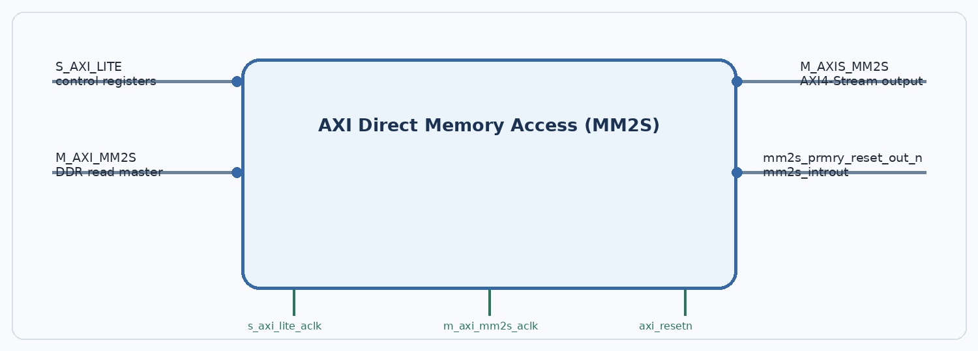
Figure 6. The enabled DMA data path reads DDR3 through M_AXI_MM2S and emits AXI4-Stream on M_AXIS_MM2S.

Interfaces
Port / interface | Direction at block | Protocol / width | Connection / purpose
S_AXI_LITE | Slave input | AXI4-Lite, 32-bit register interface | Connected to SmartConnect_1/M00_AXI; CPU programs/reads DMA registers.
M_AXI_MM2S | Master output | AXI4 memory-mapped read master; 128-bit data width | Connected through SmartConnect_0 to MIG S_AXI.
M_AXIS_MM2S | Master output | AXI4-Stream; TDATA width 128 bits | Intended destination is Global Buffer / stream receiver; no final destination shown in supplied Tcl export.
s_axi_lite_aclk | Input | Control clock | Recorded as MIG ui_clk.
m_axi_mm2s_aclk | Input | MM2S memory/stream clock | Recorded as MIG ui_clk.
axi_resetn | Input | Active-low reset | Reset for DMA logic; recorded from peripheral reset output.
mm2s_prmry_reset_out_n | Output | Active-low reset/status output | Visible in the BD screenshot; confirm whether used by downstream stream logic.
mm2s_introut | Output | Interrupt | Visible in the BD screenshot; processor IRQ integration not shown in the saved notes.

Changeable parameters
Parameter | Current value / evidence | What can be changed / design impact
MM2S channel | Enabled | Can be disabled if not required.
S2MM channel | Disabled (captured in Tcl) | Enable to add stream-to-memory transfers; this creates extra stream and memory-mapped interfaces.
Scatter-Gather | Disabled (captured in Tcl) | Enabling SG adds descriptor fetch/update interfaces and software/descriptor complexity.
Memory-map data width | 128 bits (captured in Tcl) | Supported primary AXI data widths include 32, 64, 128, 256, 512 and 1024 bits, subject to device/IP constraints.
AXI4-Stream TDATA width | 128 bits (captured in Tcl) | Can be selected from supported widths; must match downstream stream endpoint or be adapted.
Address width | 32 bits (project notes) | Controls address reach; must match MIG address map and system address width.
Buffer length width | 14 bits (project notes) | Sets maximum byte-count register range; software must obey configured limit.
Max burst size | 4 noted in working notes; verify GUI | Controls maximum beats per memory burst. Changing this can affect throughput, buffering and interconnect load.
Micro DMA / DRE / control streams | Not confirmed in latest export | Optional features affect resource use, alignment, legal transfer sizes and sideband ports.

Connection and design notes
- 128-bit data width means 16 bytes per accepted beat. It is a datapath width, not a guarantee of 1.6 GB/s sustained bandwidth.
- The DDR3 physical interface is 16 bits wide; MIG adapts between its physical DDR interface and its AXI-side interface.
- M_AXIS_MM2S is AXI4-Stream and must connect to a stream receiver/Global Buffer path. Do not route it through AXI SmartConnect, which is for memory-mapped AXI.
- With SG disabled, the CPU must program the MM2S source address and transfer length for each transfer.
Pending: the stream destination and its TREADY/backpressure behavior must be integrated and tested before claiming an end-to-end DMA-to-Global-Buffer transfer.

8. AXI SmartConnect 0 - DDR memory fabric
SmartConnect_0 carries memory-mapped AXI transactions between DMA read master(s) and the MIG memory controller. Its job is address routing/arbitration and interface adaptation, not AXI4-Stream routing.
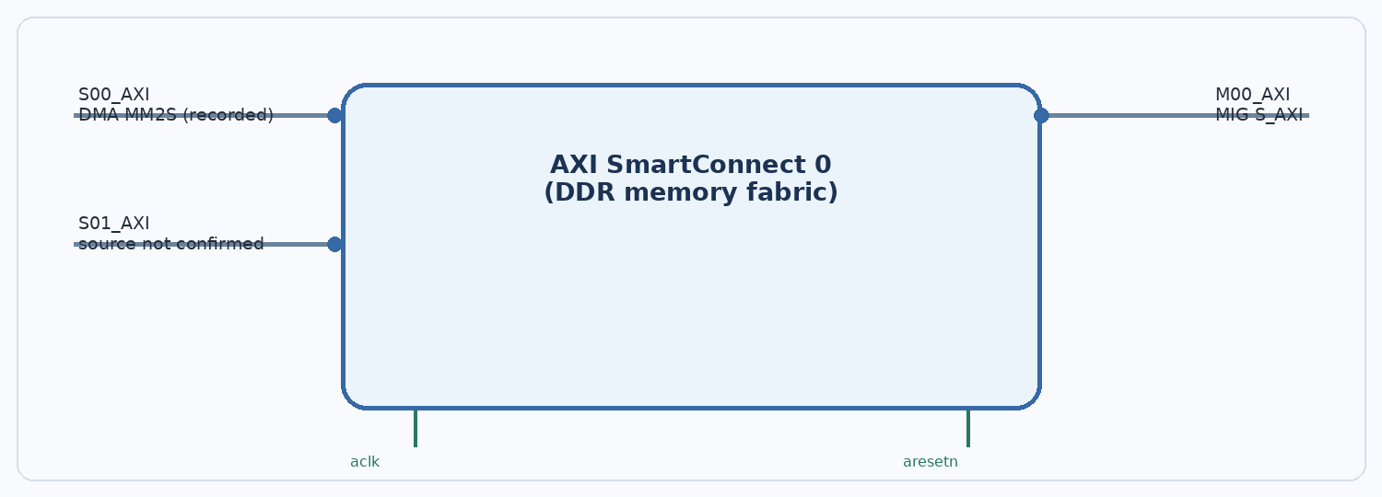
Figure 7. The 1 November Vivado screenshot shows two slave-side ports and one master-side port. The source of S01_AXI is not established from the exported Tcl.

Interfaces
Port / interface | Direction at block | Protocol / width | Connection / purpose
S00_AXI | Slave-side ingress | AXI4 memory-mapped | Recorded connection: AXI DMA M_AXI_MM2S.
S01_AXI | Slave-side ingress | AXI4 memory-mapped | Port visible in 1 Nov screenshot; upstream source not verified.
M00_AXI | Master-side egress | AXI4 memory-mapped | Connected to MIG S_AXI.
aclk | Input | AXI clock | Recorded as MIG ui_clk.
aresetn | Input | Active-low reset | Recorded as proc_sys_reset_0/interconnect_aresetn.

Changeable parameters
Parameter | Current value / evidence | What can be changed / design impact
Number of slave interfaces | Screenshot: 2; older Tcl: 1 | Set to match actual AXI master count. Confirm whether S01_AXI is used or is an unused configured input.
Number of master interfaces | 1 | Add outputs only when more memory targets are required.
Number of clocks | 1 in recorded export | Multi-clock designs require proper clock/reset domain handling.
Reset presence | Active-low aresetn present | Can be configured depending on system reset strategy.
Strategy | Automatic/default unless overridden | Area/performance setting; advanced properties can customize buffering/optimization.

Connection and design notes
- Current target is MIG S_AXI; address mapping must include the DDR3 region at 0x80000000.
- The Tcl export has one SI and one MI, while the saved screenshot shows S00_AXI and S01_AXI. Re-export the current Block Design Tcl and reconcile this difference.
- For the current project plan, PicoRV32 does not need a third direct path to DDR3.
Verify: do not leave a required master disconnected or assume S01_AXI is harmless. Inspect the connection net for S01_AXI in the current Diagram and Address Editor.

9. MIG 7-Series - DDR3 controller and PHY
The Memory Interface Generator (MIG) configures the DDR controller and physical interface for the Arty A7-100T memory. DMA requests reach MIG through SmartConnect_0. MIG handles command scheduling, calibration, timing and the translation between the AXI user interface and external DDR3 pins.
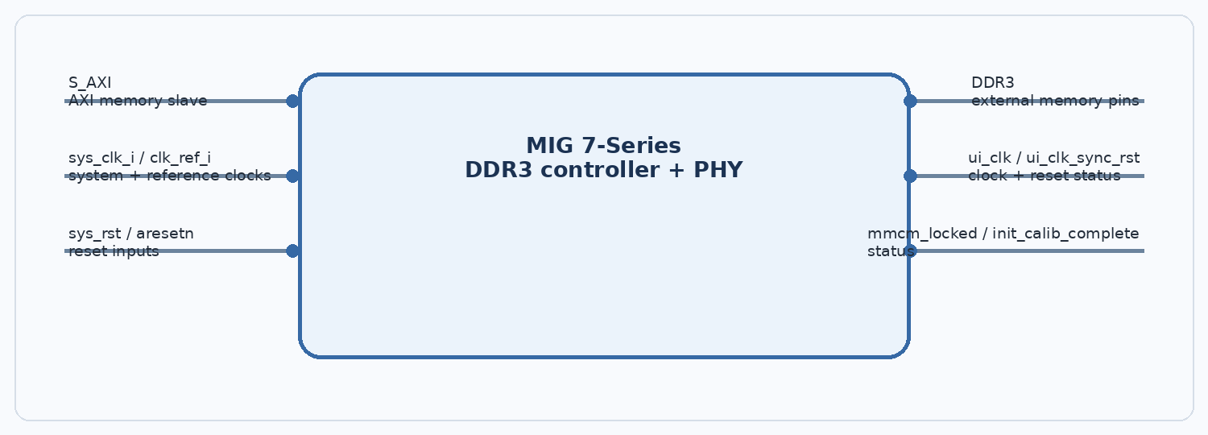
Figure 8. MIG presents an AXI slave interface to the FPGA fabric and implements the board-level DDR3 PHY.

Interfaces
Port / interface | Direction at block | Protocol / width | Connection / purpose
S_AXI | Slave input | AXI4 memory-mapped slave; project notes say 128-bit | Connected to SmartConnect_0/M00_AXI.
DDR3 | External bidirectional interface | DDR3 pins: address, bank, command, clock, DQ, DQS, DM, etc. | Externalized as top-level DDR3_0 and constrained for Arty A7-100T.
sys_clk_i | Input | MIG system clock | Connected to Clocking Wizard clk_out1 in the saved export.
clk_ref_i | Input | MIG reference clock | Connected to Clocking Wizard clk_out2 in the saved export.
sys_rst | Input | MIG system reset | Top-level sys_rst_0 in the export.
aresetn | Input | Active-low AXI/UI reset | Recorded as driven by Processor System Reset peripheral_aresetn; verify polarity/sequence.
ui_clk | Output | MIG user-interface clock | Feeds DMA, SmartConnects, reset synchronizer and, per working notes, PicoRV32/BRAM control.
ui_clk_sync_rst | Output | Synchronous UI reset indication | Connected to proc_sys_reset_0/ext_reset_in in export.
mmcm_locked | Output | Clock-lock status | Connected to proc_sys_reset_0/dcm_locked.
init_calib_complete | Output | DDR initialization/calibration status | Must be high before normal memory traffic is considered ready.

Changeable parameters
Parameter | Current value / evidence | What can be changed / design impact
Memory component | MT41K128M16XX-15E in embedded MIG project | Must match the actual board memory and board preset; exact device suffix should be checked.
Physical data width | 16 bits (captured in inventory / XDC comments) | Set according to the actual DDR memory component and PCB routing.
Memory capacity | 256 MiB (captured in inventory) | Derived from configured memory geometry; verify against the chosen component.
Memory voltage / standard | 1.35 V; SSTL135-related board constraints | Must match DDR3L device and board I/O constraints.
ECC | Disabled (captured in inventory) | ECC changes data path width/storage and adds reporting logic.
Data mask | Enabled (captured in inventory) | DM/DQS/DQ configuration follows the memory component.
PHY ratio | 4:1 (captured in inventory) | A MIG-generated internal timing/PHY configuration; not a free run-time throughput knob.
AXI data width | 128 bits (working design notes) | Must match AXI DMA/interconnect capabilities and MIG AXI configuration.
Clock input mode/frequency | Export says Single-Ended, 99.997 MHz and 3077 ps | Must be checked against the actual selected sys_clk_i source and MIG wizard input-clock setting.

Connection and design notes
- MIG S_AXI is the memory-mapped slave endpoint; AXI DMA is an initiator/master on the other side of SmartConnect_0.
- The physical DDR3 data bus is 16 bits, while the fabric-side AXI data width is recorded as 128 bits. These are different sides of the controller and are not contradictory by themselves.
- Wait for init_calib_complete before issuing functional DDR3 accesses.
- Use the exact Arty A7 MIG preset and its generated XDC/constraints; do not replace pin constraints with guessed values.
High-priority verification: the embedded MIG project records approximately 100 MHz input / 3077 ps, while clk_wiz_0 requests 166.667 MHz on the net connected to sys_clk_i and 200 MHz on clk_ref_i. Re-open MIG customization and generated clock constraints to verify that these values form a valid clocking plan.
Part-name verification: the MIG project records MT41K128M16XX-15E; the supplied XDC header describes MT41K128M16JT-125. Confirm that the selected MIG memory part is the correct Digilent Arty A7-100T component/preset.

10. Clocking Wizard
The Clocking Wizard uses FPGA clock-management resources (MMCM/PLL, as selected by Vivado) to generate clocks for the DDR3 MIG system and reference inputs. The two frequencies recorded in the Tcl are 166.667 MHz and 200 MHz.
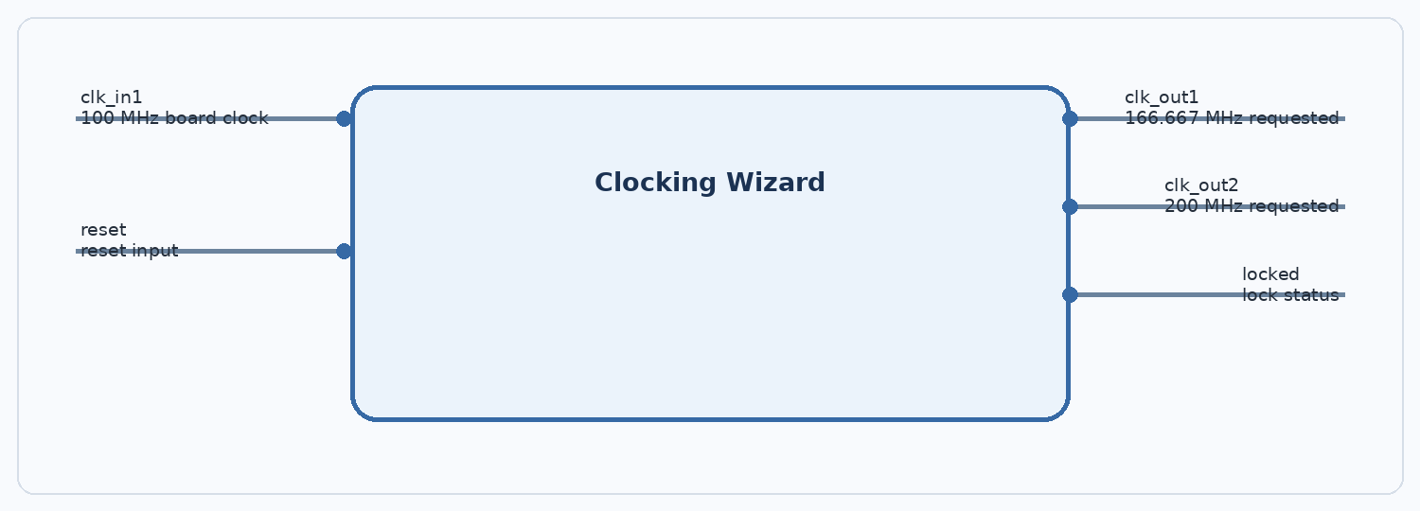
Figure 9. Clocking Wizard generates the two requested clock outputs from the external board clock.

Interfaces
Port / interface | Direction at block | Protocol / width | Connection / purpose
clk_in1 | Input | Single-ended clock | External clk_in1_0 from board oscillator; project notes identify the Arty clock as 100 MHz.
reset | Input | Reset, polarity depends on IP configuration | Driven by Utility Vector Logic NOT output in the saved Tcl.
clk_out1 | Output | Clock, requested 166.667 MHz | Connected to MIG sys_clk_i.
clk_out2 | Output | Clock, requested 200 MHz | Connected to MIG clk_ref_i.
locked | Output | Lock status | Available status signal; ensure reset release sequencing uses a valid lock indicator where intended.

Changeable parameters
Parameter | Current value / evidence | What can be changed / design impact
Input clock frequency | 100 MHz board oscillator (project context) | Must match actual clock source and input port constraint.
Output clock count | 2 (captured in Tcl) | Can add/remove generated clocks within device/IP limits.
Output frequencies | 166.667 MHz and 200 MHz requested | Can change output frequencies subject to MMCM/PLL limits, input frequency and timing.
Phase / duty cycle | Not captured in saved Tcl summary | Can configure phase and duty cycle per output.
Feedback source | Automatic (captured in Tcl) | Automatic/other supported feedback modes depend on the IP configuration.
Primitive / jitter / phase error | MMCM-related values generated by Vivado | Vivado recalculates these when frequencies or primitive settings change.

Connection and design notes
- clk_out1 and clk_out2 are separate nets intended for MIG clock inputs.
- Clocking Wizard reset polarity and external sys_rst_0 polarity must be consistent with the NOT gate and MIG reset input.
- After any frequency change, regenerate output products and re-check timing/clock reports and MIG constraints.
Verify: do not treat the requested frequencies as validated until MIG input-frequency settings, Clocking Wizard output constraints and the board clock constraint agree.

11. Processor System Reset
The Processor System Reset block synchronizes reset behavior to a clock domain and exposes different active-low/high reset outputs for interconnect and peripheral logic. It should release resets only after the relevant clock is stable and external reset conditions are cleared.
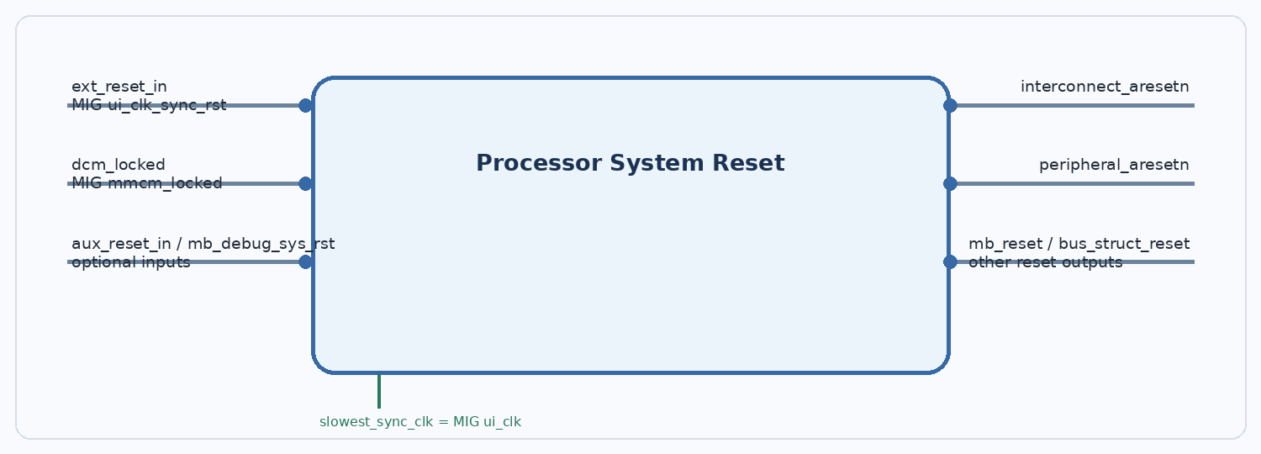
Figure 10. Processor System Reset creates synchronized reset outputs for interconnect and peripheral logic.

Interfaces
Port / interface | Direction at block | Protocol / width | Connection / purpose
slowest_sync_clk | Input | Clock input | Connected to MIG ui_clk.
ext_reset_in | Input | External reset input; polarity configured in IP | Connected to MIG ui_clk_sync_rst in saved export.
dcm_locked | Input | Clock-lock status | Connected to MIG mmcm_locked.
interconnect_aresetn | Output | Active-low reset | Connected to SmartConnect_0 and SmartConnect_1 aresetn.
peripheral_aresetn | Output | Active-low reset | Connected to DMA axi_resetn and MIG aresetn in the saved export; verify MIG reset recommendation.
mb_reset / bus_struct_reset / peripheral_reset | Outputs | Other reset polarities/domains | Present on the IP; only connections visible in the saved design should be treated as active.

Changeable parameters
Parameter | Current value / evidence | What can be changed / design impact
Number of external reset inputs | Default/current not explicitly captured | Adjust if additional reset sources or debug resets are required.
External reset polarity | Not captured in available Tcl summary | Must match sys_rst / ext_reset signal active polarity.
Auxiliary/debug reset options | Not captured | Can be enabled for auxiliary reset and processor debug reset inputs.
Reset output widths | Derived from configured processor/peripheral counts | Impacts output bus widths and port generation.
Clock domain | MIG ui_clk | If a block is moved to another clock domain, use a separate reset synchronizer for that domain.

Connection and design notes
- Interconnect_aresetn and peripheral_aresetn are separate output nets; use each according to the target IP reset requirements.
- The saved connection has the MIG UI reset feeding ext_reset_in while Processor System Reset peripheral_aresetn feeds MIG aresetn. Verify this against MIG documentation and generated design recommendations to avoid an unintended reset dependency.
- Check reset polarity in the Customize IP dialog; the suffix aresetn conventionally denotes active-low.
Verify: reset sequencing and the MIG aresetn connection deserve a dedicated review before hardware bring-up.

12. Utility Vector Logic
The Utility Vector Logic IP provides simple combinational logic. The instance in this design is used to invert the external sys_rst_0 signal before driving Clocking Wizard reset.
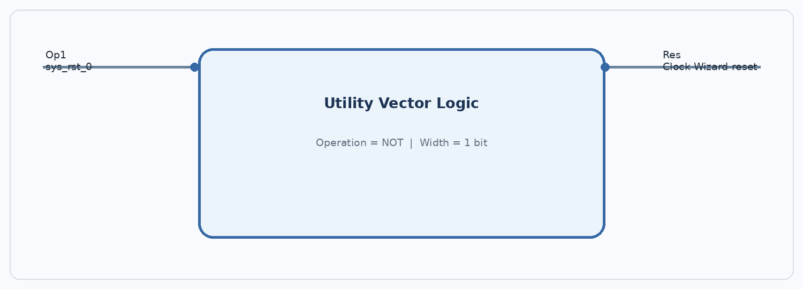
Figure 11. This instance is configured as a one-bit inverter.

Interfaces
Port / interface | Direction at block | Protocol / width | Connection / purpose
Op1 | Input | 1-bit vector | Connected to top-level sys_rst_0.
Res | Output | 1-bit vector | Connected to clk_wiz_0/reset.

Changeable parameters
Parameter | Current value / evidence | What can be changed / design impact
C_OPERATION | NOT (captured in Tcl) | Other supported operations include AND, OR and XOR.
C_SIZE | 1 bit (captured in Tcl) | Sets vector width; can be increased for wider vector logic.
Input count | 2 for binary operations; NOT uses one input | Depends on selected operation.

Connection and design notes
- This block performs only polarity inversion; it does not synchronize or debounce reset.
- Any reset polarity change must be checked together with the Clocking Wizard reset configuration.

13. External ports, address routing and interfaces that are not IP blocks
Top-level port | Direction | Meaning / connection
clk_in1_0 | Input | External board clock into Clocking Wizard clk_in1.
sys_rst_0 | Input | External reset source; also drives MIG sys_rst and Utility Vector Logic Op1.
DDR3_0 | Bidirectional interface | External MIG DDR3 interface. Package pins and I/O standards are defined by board-specific XDC constraints.

13.1 AXI interface distinctions
Interface family | Typical role here | Where it appears
AXI4 memory-mapped | Addressed read/write transactions to memory or registers | DMA M_AXI_MM2S → SmartConnect_0 → MIG S_AXI; also DMA register access is AXI4-Lite.
AXI4-Lite | Lightweight register/control and local memory transactions | PicoRV32 M_AXI → SmartConnect_1 → DMA S_AXI_LITE / AXI BRAM Controller S_AXI.
AXI4-Stream | Unaddressed streaming payload with TDATA/TVALID/TREADY/TLAST | DMA M_AXIS_MM2S output; intended Global Buffer path.
Native BRAM interface | BRAM address, clock, enable, write-enable and data signals | AXI BRAM Controller BRAM_PORTA ↔ Block Memory Generator BRAM_PORTA.

13.2 AXI-Stream connection rule
M_AXIS_MM2S must connect to an AXI4-Stream slave/consumer (for example, a stream-aware Global Buffer wrapper). SmartConnect is not the stream interconnect for this path. The stream endpoint must define how it handles TREADY backpressure, packet end (TLAST), byte qualifiers (TKEEP, if enabled) and reset/clock alignment.

13.3 Global Buffer and accelerator boundary
The Global Buffer, accelerator controller, functions block and PE array appear in the project-level architecture but are not included as completed IP instances in the saved Vivado Block Design screenshot/Tcl supplied for this reference. Their exact ports, widths, depth, banking and handshakes cannot be specified from the current project evidence. They should receive their own interface specification when their RTL is integrated.

14. Configuration checks before synthesis and hardware testing
Check | Required action
Re-export current BD Tcl | The Tcl export must include the latest PicoRV32 wrapper, AXI BRAM Controller, BMG and updated SmartConnect port counts.
Resolve SmartConnect_0 port count | Screenshot shows S00_AXI and S01_AXI, while the Tcl inventory has one SI. Verify the source connected to S01_AXI.
Verify MIG system/reference clocks | Resolve the 99.997 MHz / 3077 ps MIG project data versus Clock Wizard outputs requested at 166.667 MHz and 200 MHz.
Verify MIG memory component | Reconcile MT41K128M16XX-15E in MIG project with the Arty board part notation in the XDC comments.
Verify MIG reset sequence | Confirm reset polarity and sequencing, including why Processor System Reset peripheral_aresetn feeds MIG aresetn.
Resolve BRAM size mismatch | Check whether the effective memory is 8 KB or 32 KB; align BMG depth/width, AXI BRAM Controller settings and Address Editor range.
Connect AXI-Stream destination | Connect DMA M_AXIS_MM2S to the Global Buffer or a temporary AXI-Stream sink for bring-up.
Check processor firmware map | Confirm reset vector 0x00000000, stack pointer 0x00002000, BRAM aperture and program image loading method.
Check DMA control and interrupts | Confirm software register access, MM2S length limits, interrupt handling or polling, and status/error reporting.
Validate MIG calibration | Do not issue test DMA reads until init_calib_complete is asserted.
Run known-pattern memory test | Write/read a deterministic pattern through a valid DDR3 access path, then perform one MM2S transfer and inspect TDATA/TLAST.
Check timing and implementation | Review clock interaction, CDC/reset behavior, timing slack, BRAM use and routing after synthesis/implementation.

14.1 Recommended first functional milestone
Bring up MIG first and verify calibration. Then verify processor access to BRAM and DMA registers. Next use a known DDR3 source buffer and transfer a short block through MM2S into a temporary stream sink. Only after that should the stream connect to the Global Buffer and the double-buffer controller.

15. References and provenance
Project-specific facts in this document are drawn from the saved Vivado Block Design screenshot dated 1 November 2026, dma_ddr3_system_export.tcl, dma_ddr3_system_ip_inventory.txt, the saved Arty A7 DDR3 pinout XDC, and the project configuration notes available in this conversation. Where these sources conflict or omit a parameter, the document marks the item Verify rather than guessing.
AMD PG021: AXI DMA LogiCORE IP Product Guide, v7.1. AXI4/AXI4-Stream datapaths, MM2S/S2MM, direct-register and scatter-gather operation, width options. https://docs.amd.com/r/en-US/pg021_axi_dma
AMD PG247: AXI SmartConnect LogiCORE IP Product Guide. SmartConnect interface counts and configuration parameters. https://docs.amd.com/r/en-US/pg247-smartconnect
AMD UG586: 7 Series Memory Interface Solutions User Guide. MIG customization, AXI slave interface, DDR3 physical interface, clocks, calibration and reset. https://docs.amd.com/r/en-US/ug586_7Series_MIS
AMD PG078: AXI Block RAM Controller Product Guide, v4.1. AXI endpoint to local block RAM. https://docs.amd.com/v/u/en-US/pg078-axi-bram-ctrl
AMD PG058: Block Memory Generator Product Guide, v8.4. BRAM types, port configurations, widths/depths and initialization. https://docs.amd.com/v/u/en-US/pg058-blk-mem-gen
AMD PG065: Clocking Wizard Product Guide, v6.0. Input/output clock configuration, MMCM/PLL and reset/lock ports. https://docs.amd.com/r/en-US/pg065-clk-wiz
AMD PG164: Processor System Reset Module Product Guide, v5.0. Reset synchronization and reset output groups. https://docs.amd.com/v/u/en-US/pg164-proc-sys-reset
AMD UG994: Vivado IP Integrator guide, including Utility Vector Logic and AXI subsystem integration. https://docs.amd.com/r/en-US/ug994-vivado-ip-subsystems
YosysHQ PicoRV32: PicoRV32 source repository and README. Core variants and picorv32_axi AXI4-Lite master interface/parameters. https://github.com/YosysHQ/picorv32

Revision note
Rev 1.0 — 5 November 2026. This is a design reference for the current working state, not an implementation sign-off. Update the current Vivado export and the Verify items when the Block Design changes.

