**Demonstrate React context**

**Component Folder:**

**ComponentA.js:**

import React, {Component} from 'react'

import ComponentB from './ComponentB'

class ComponentA extends Component{

    render(){

     return <><ComponentB/></>

}

}

export default ComponentA

**ComponentB.js:**

import React,{Component} from "react";

import ComponentC from './ComponentC'

class ComponentB extends Component{

    render()

    {

return<ComponentC/>

}

}

export default ComponentB;

**ComponentC.js:**

import React ,{Component} from "react";

import { UserConsumer } from "./UserContext";

class ComponentC extends Component{

    render(){

    return(

        <UserConsumer>{(username) => {

            return <div>Hello{username}</div>

    }

    }

    </UserConsumer>

    )

    }

}

export default ComponentC

**UserContext.js**

import React from "react"

const UserContext=React.createContext('')

const UserProvider=UserContext.Provider

const UserConsumer=UserContext.Consumer

export{UserProvider,UserConsumer}

**App.js:**

import React,{Component} from 'react';

import './App.css';

import ComponentA from './ComponentA'

 import {UserProvider} from "./UserContext";

 class App extends Component{

  render()

  {

    return(

      <div className="App">

      <UserProvider value='Charan'>

          <ComponentA/>

      </UserProvider>

      </div>

    )

  }

}

export default App;

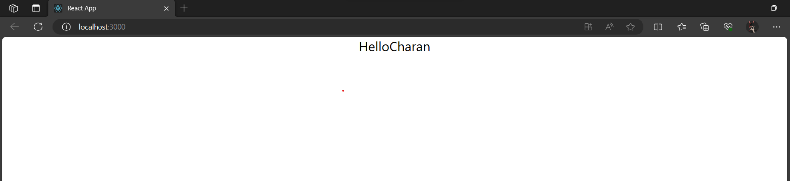**OUTPUT:**