Extension

In this project as extension we have utilize CHACHA20 encryption algorithm which is recently developed and more advanced and lighter than any other algorithm. This algorithm computation performance we have compared with existing ECC algorithm and in both algorithms CHACHA took less time.

SCREEN SHOTS

To run project double click on run.bat file to get below screen

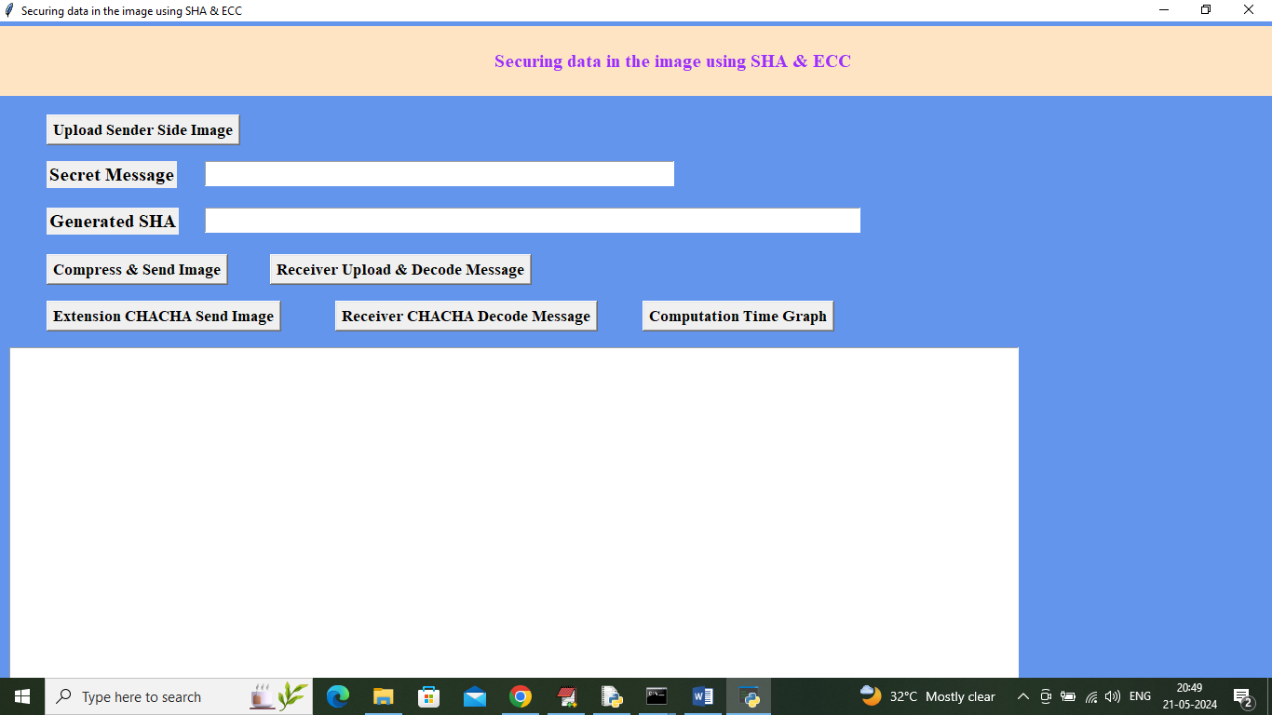

In above screen click on ‘Upload Sender Side Image’ button to upload test image

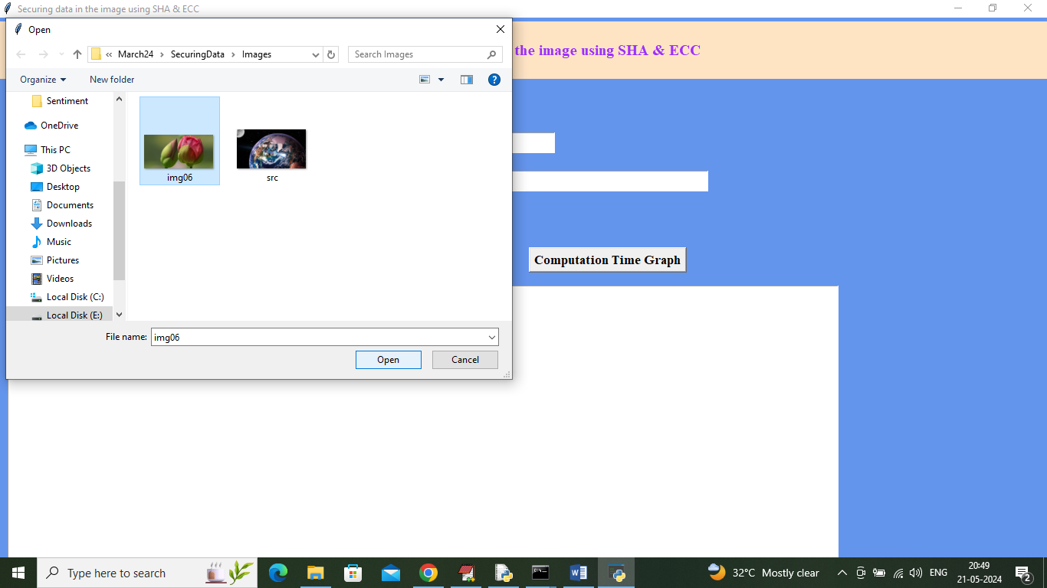

In above screen selecting and uploading test image and then enter some message

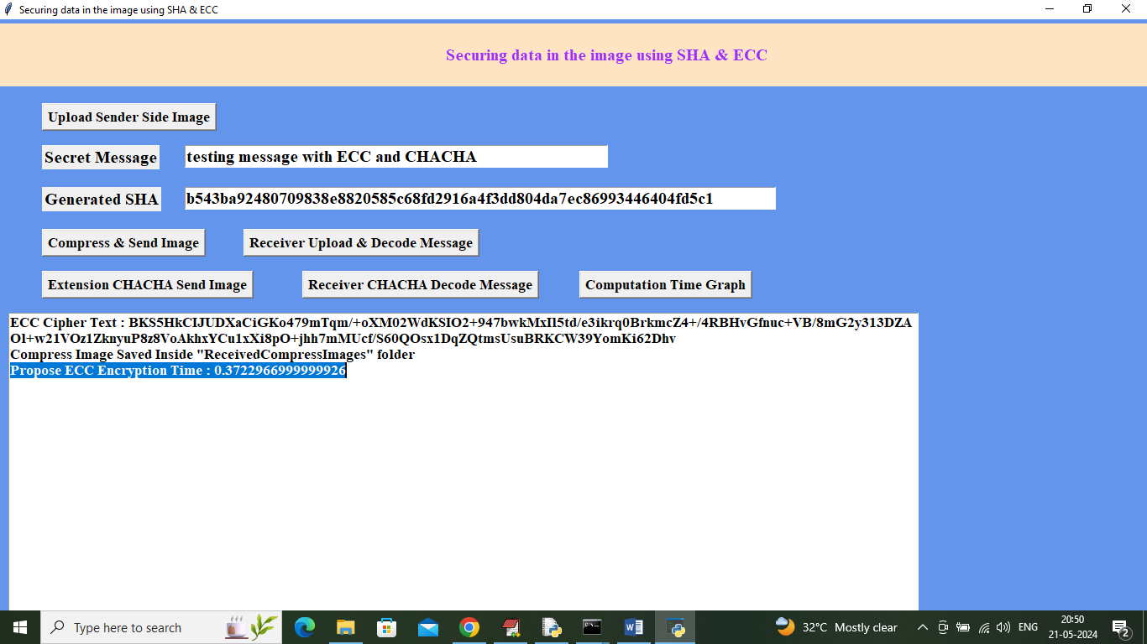

In above screen entered test message as ‘testing message with ECC and CHACHA’ and after clicking on ‘Compress & Send Message’ button then ECC took 0.37 seconds and now click on ‘Receiver Upload & decode Message’ button to decode message with ECC

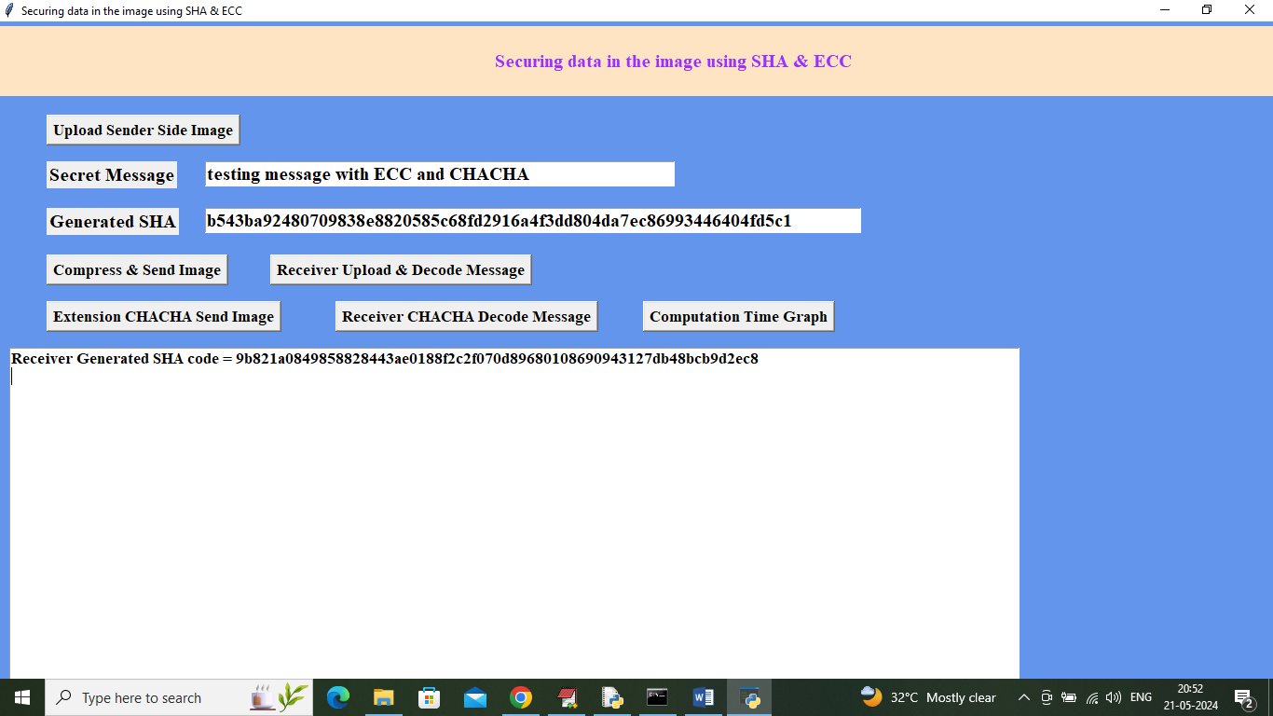

In above screen can see ECC unable to decode and decrypt text when large input message given with 6 to 8 words and this same problem we can overcome with ECC and now I am encrypting message by clicking on ‘Extension CHACHA Send Image’ button

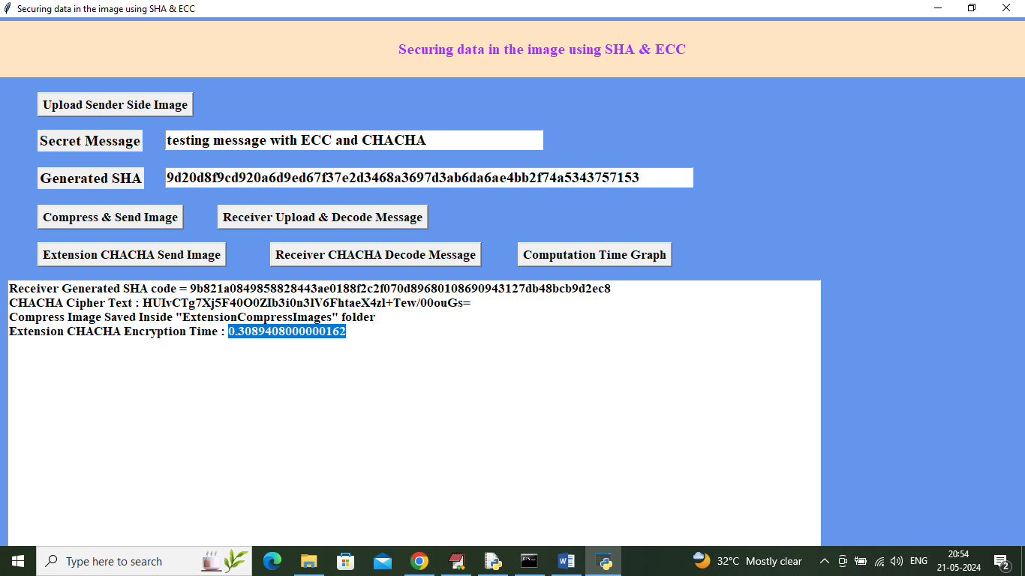

In above screen Extension CHACHA took 0.30 seconds to encrypt message and now click on ‘Receiver CHACHA Decode Message’ button to decode message

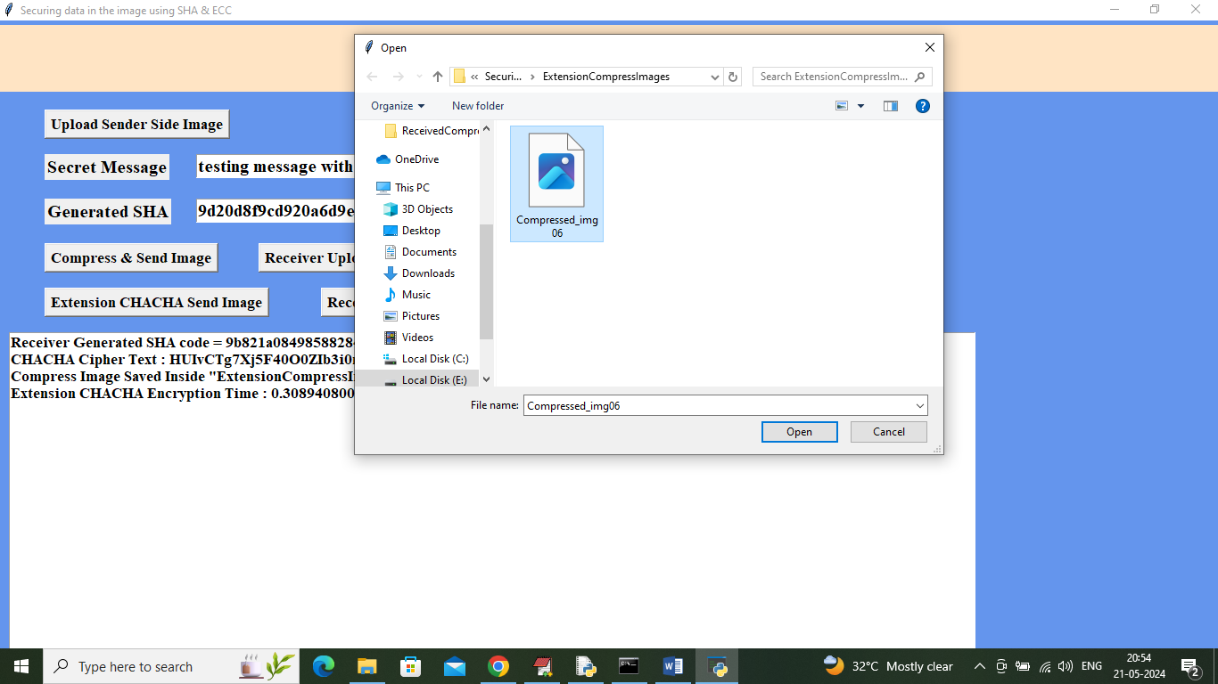

In above screen uploading compressed and encrypted image and after clicking on ‘Open’ button will get below output

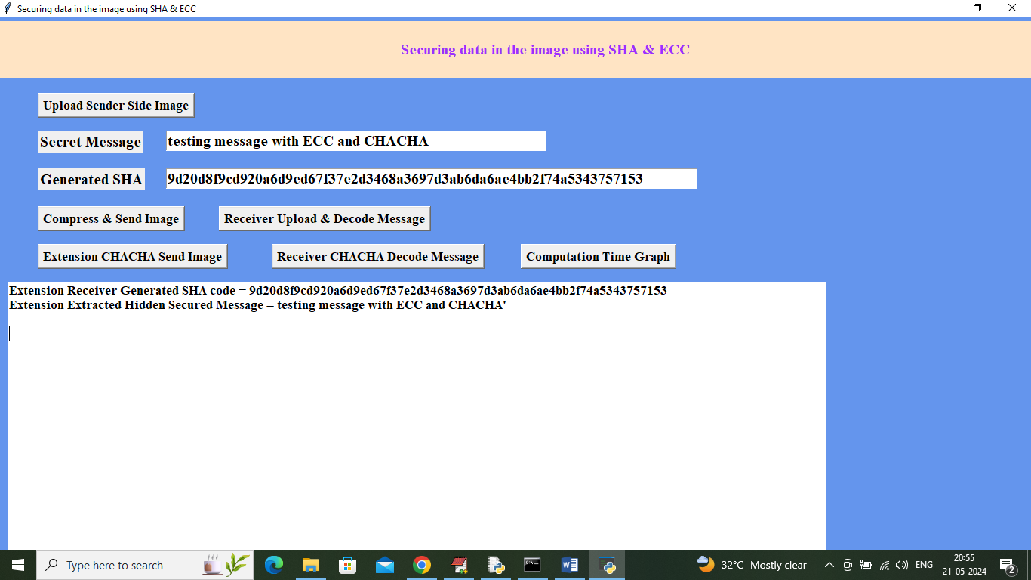

In above screen CHACHA successfully decode large message with 6 to 8 words and now click on ‘Computation Graph’ button to get below graph

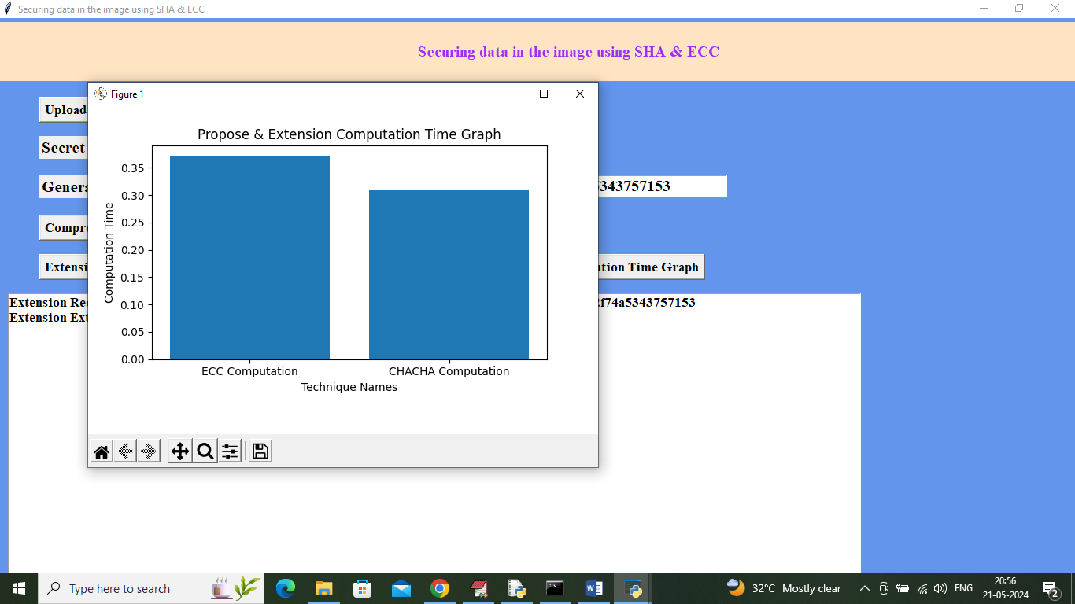

In above graph x-axis represents algorithm names and y-axis represents computation time and in both algorithms extension took less time