**Technology**

**Data Analysis Copilot**

Modern data warehouses can have hundreds to thousands of tables. A simple question like: "What's the average sales cycle by product?" can become a multi-day project. With **Semantic Search**, Edith can find the data tables that are most relevant.

Then, using the state-of-the-art Natural Language **Artificial Intelligence** of **GPT-3**, Edith translates your English questions & instructions into ANSI SQL.

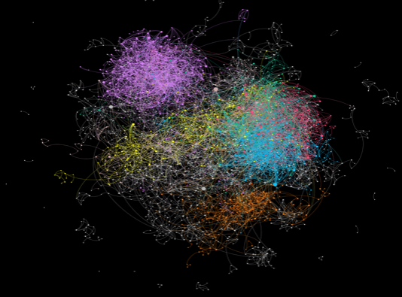

**The AskEdith Algorithm**

**1. Semantic Search**

We take in the plain English question and use a BERT model to search through up to hundreds of tables, surfacing the most relevant ones to answer the question.

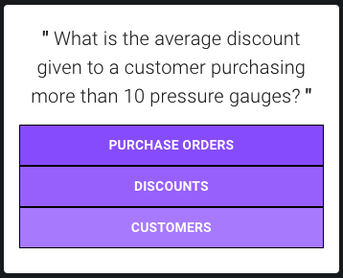

**2. Query Generation**

Using the relevant tables we generate a custom prompt to enable GPT-3 to translate your question into viable SQL.

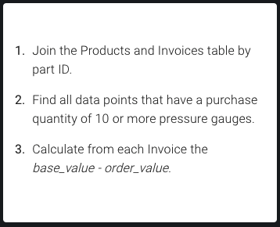

**3. Execution**

Directly execute SQL in your own database or data warehouse.

