**User Documentation**

**Signup Activity**

1. When user open fitness tracker application the first page of Login is opened.

If user already have an account, then user will fill credentials and press Login button.

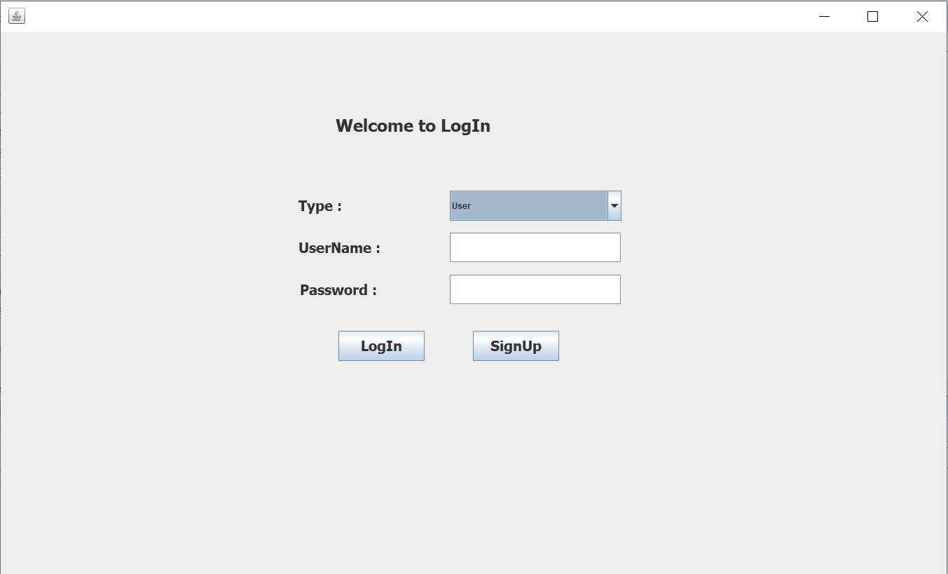

1. A person can Login in application as User, Instructor or Admin. If a person doesn’t have an Account then by clicking on Signup button it goes to signup page to fill the required Information.

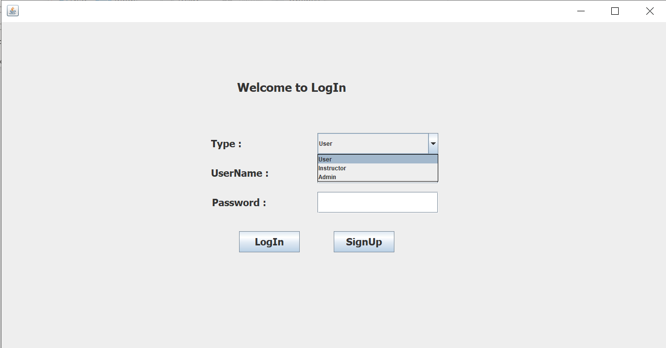

1. If User don’t have an Account, then user will fill signup form and fill required personal information. Note that only user or Instructor can Signup for application.

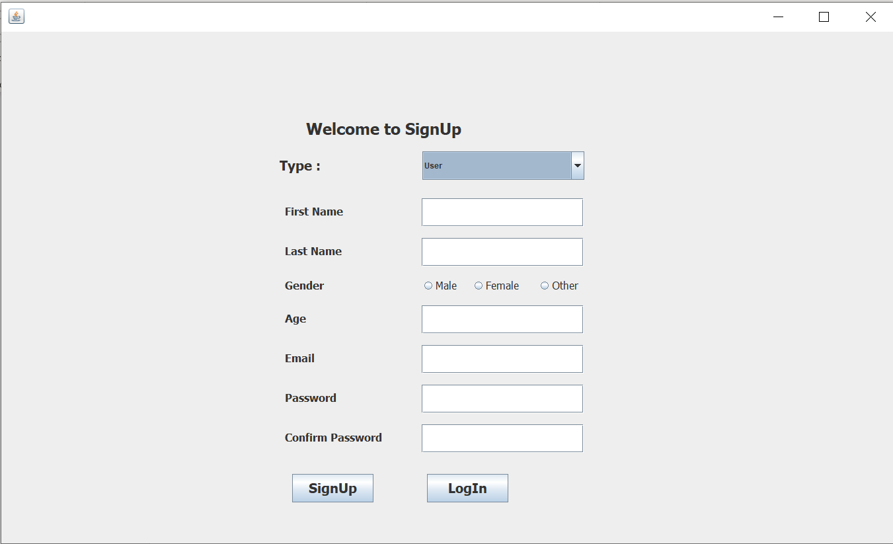

1. While filling the information, the validation on information is performed. if any field is empty that is user didn’t provide information, the error message “One of the required field is empty!”

Will pop up.

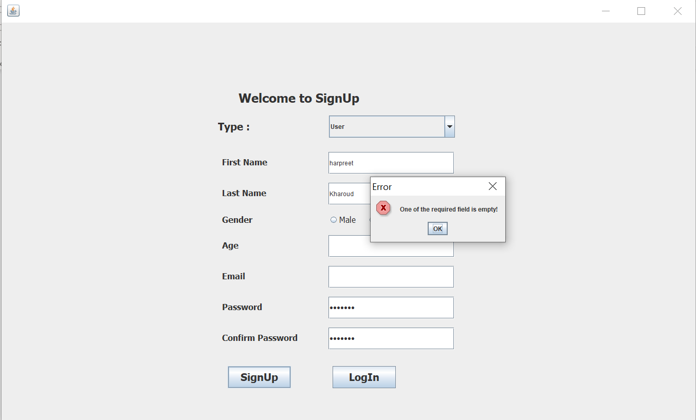

1. If user set password that is less than seven (7) characters, the error message “Password must be greater than 6 character” will popup.

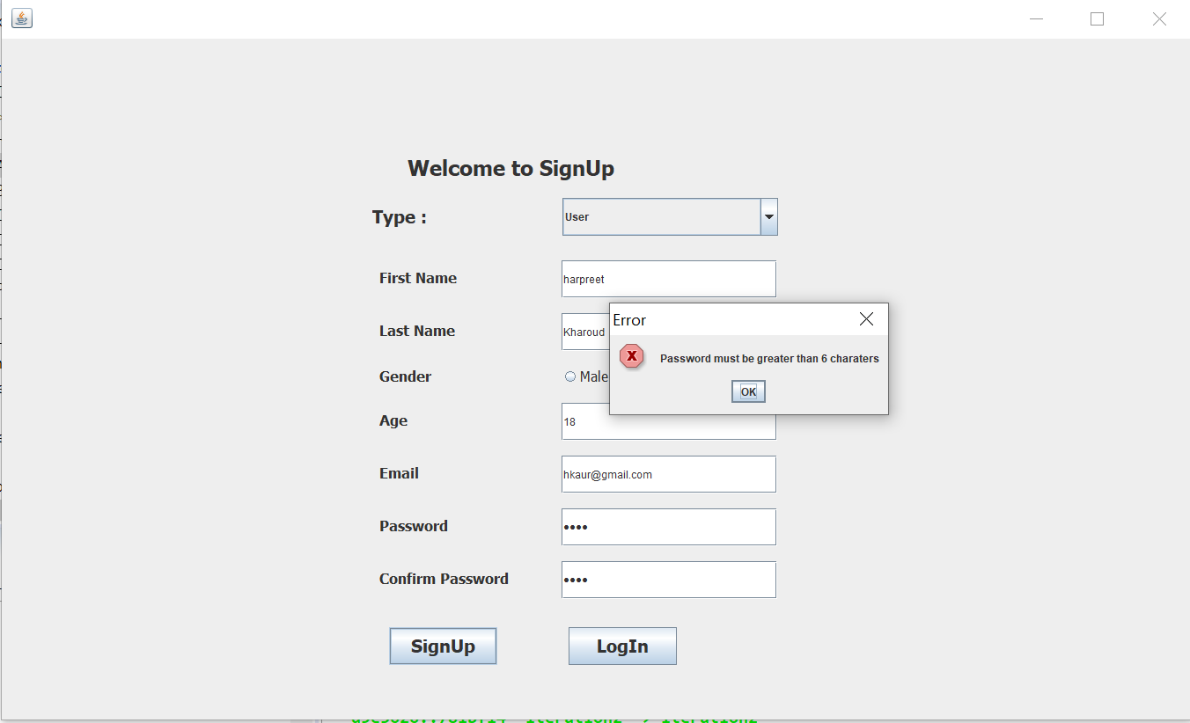

1. If the Password and Confirm password didn’t match, then error message “Password and Confirm Password does not match” will popup.

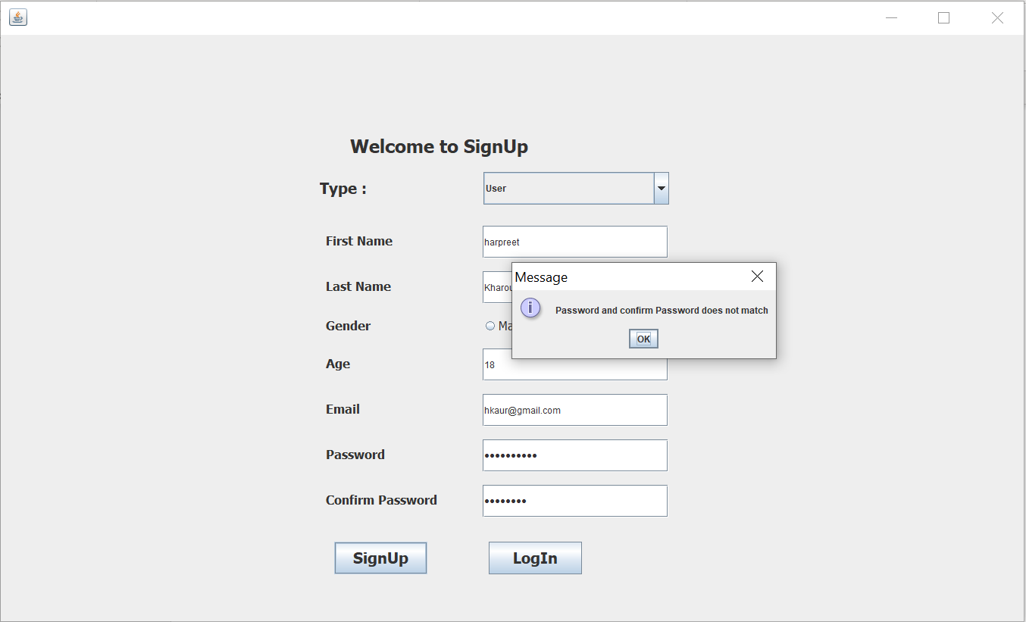

1. After validating all the information, when user press Signup button, the new Account is created showing message “Congrats, User Account Created” and Login page is displayed.

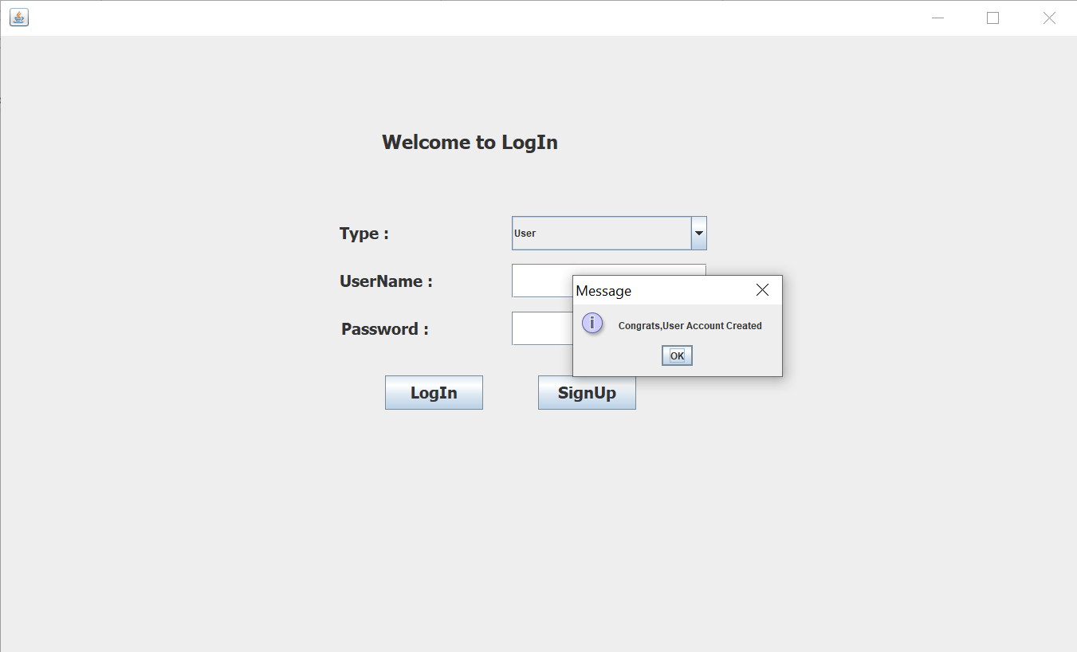

1. After filling the User Name and Password, if it doesn’t match with the username and password provided in the database then the error message “Sorry, Please try Again” will popup.

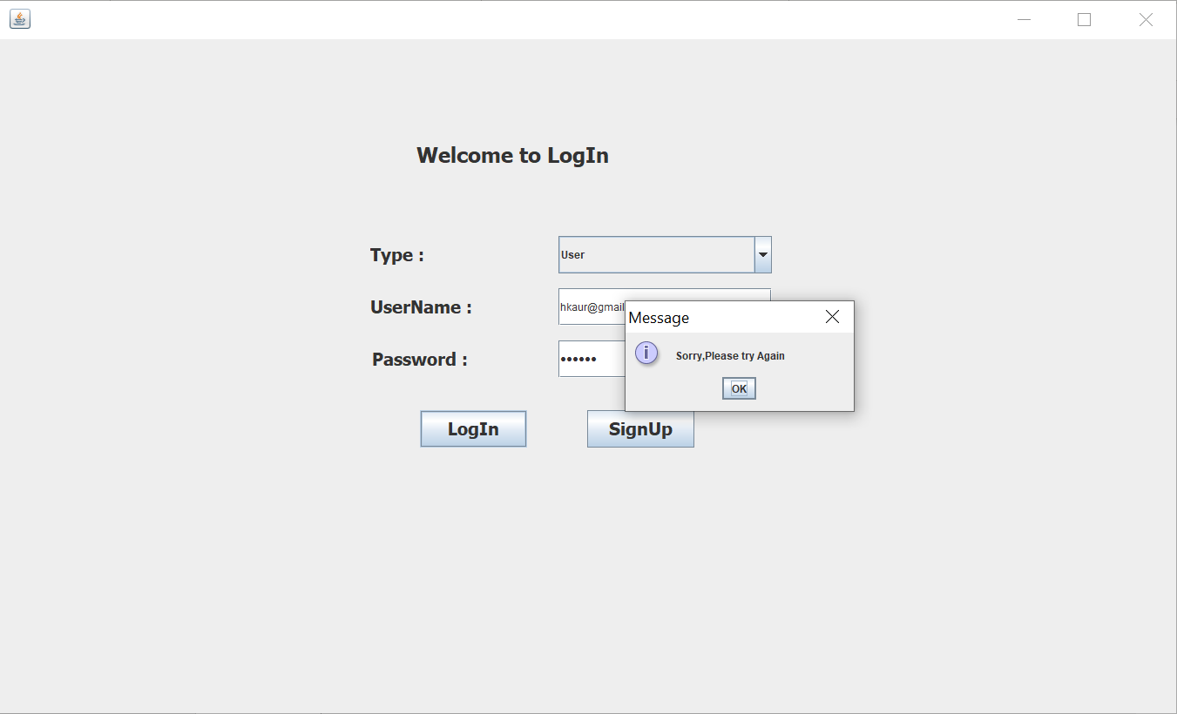

1. After filling the User Name and Password, if it matches with the username and password provided in the database then the user will be logged in and goes to next page.

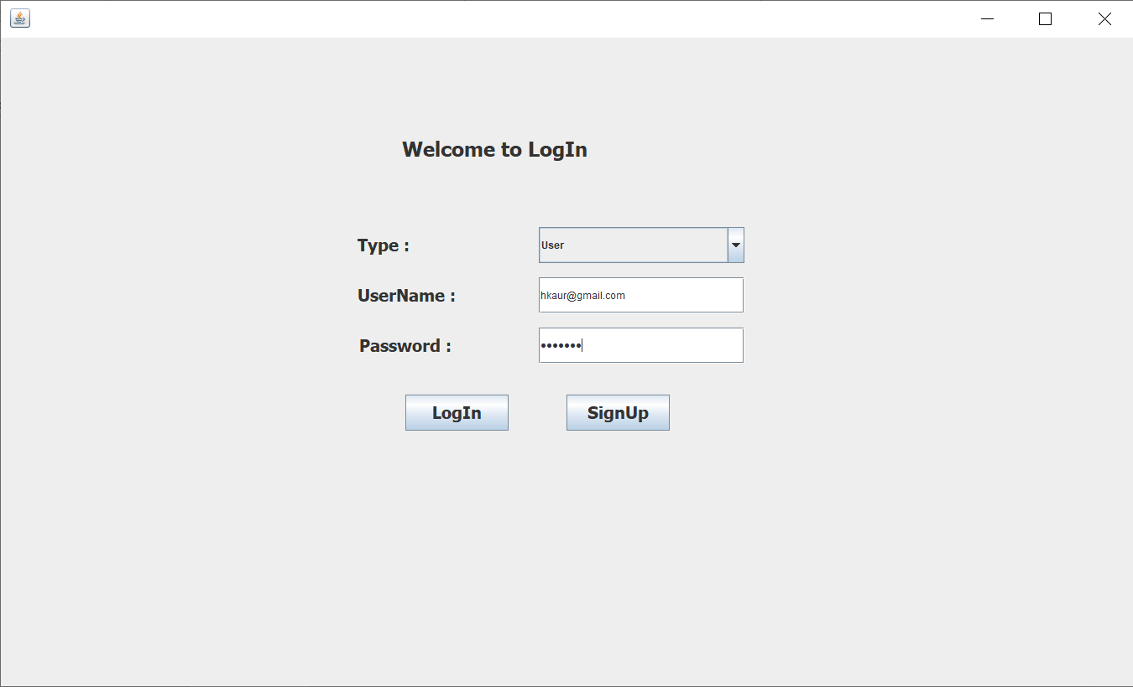

Diet Activity

User can see the list of meals on top table and can add meal to his/her table.

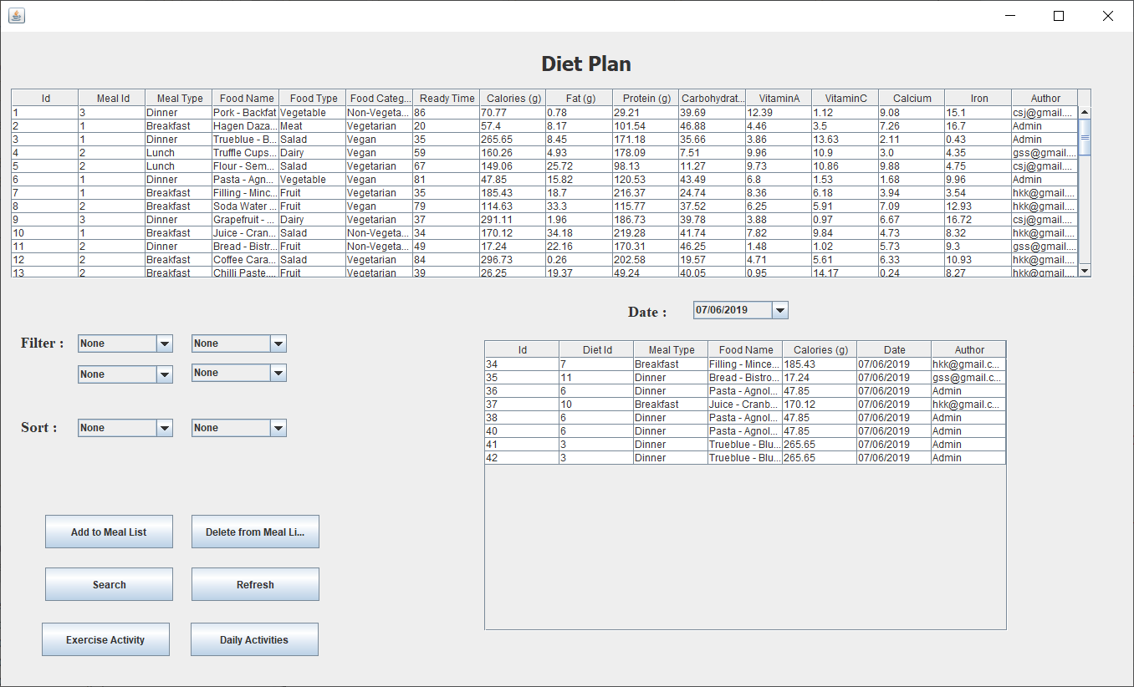

User can Select meal from top and then click on Add to Meal list button and user selected meal will add in user table below.

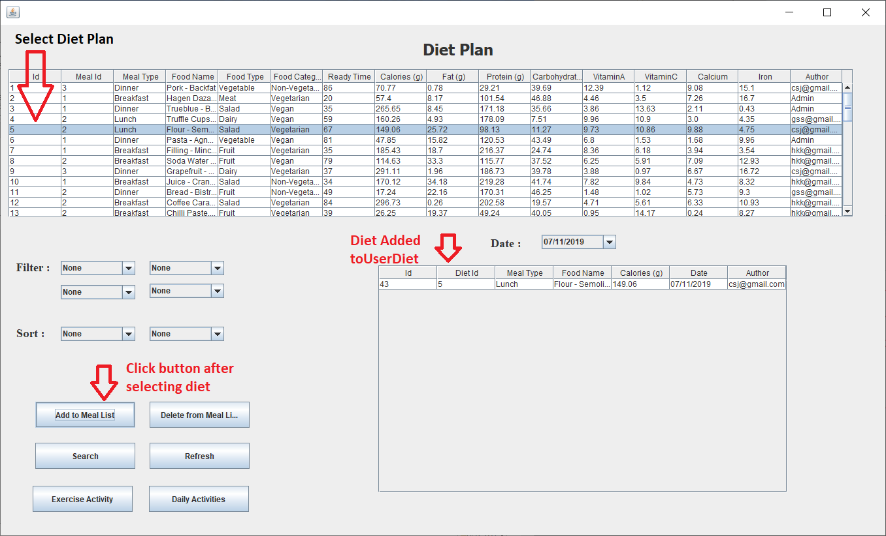

User can Select meal from user Diet table and then click on Delete from Meal list button and user selected meal will delete from user table below.

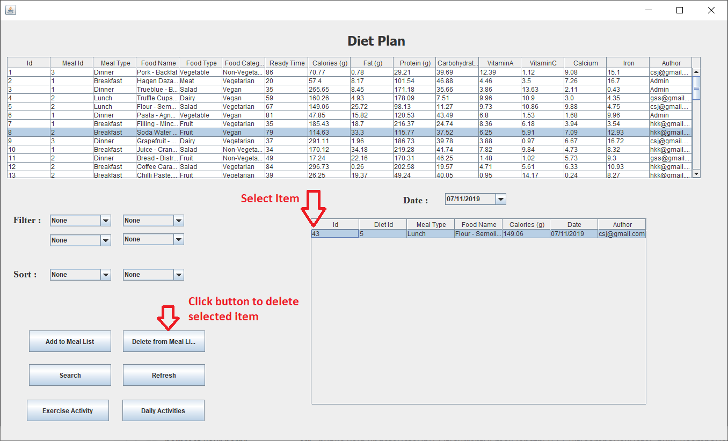

User can filter diet list by selecting food category then click on search button and user will see the filtered list in diet table on top.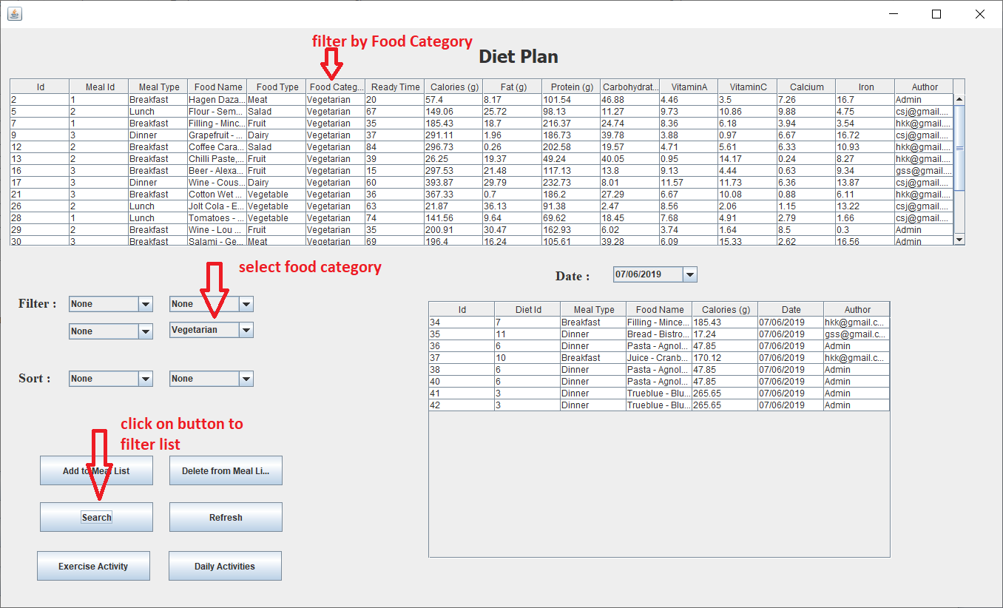

User can filter diet list by selecting food type then click on search button and user will see the filtered list in diet table on top

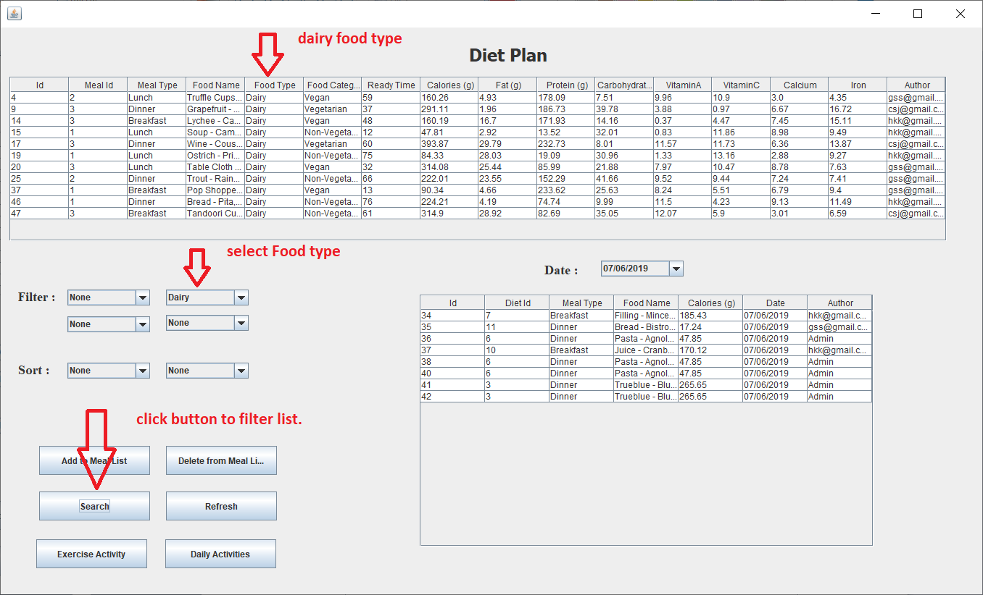

User can filter diet list by selecting meal type then click on search button and user will see the filtered list in diet table on top.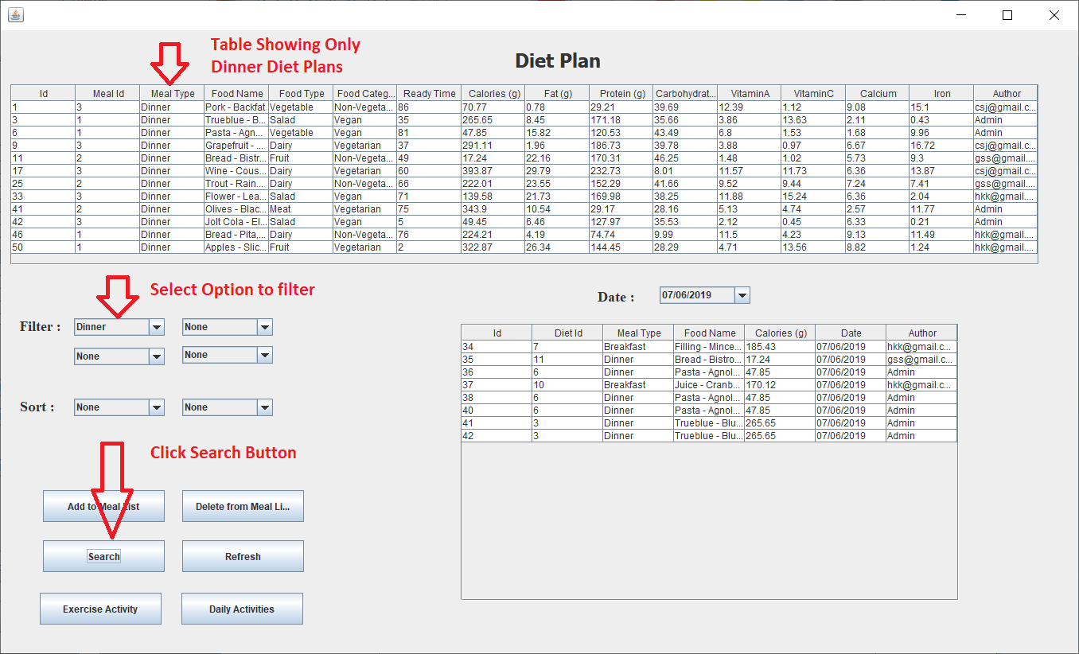

User can filter diet list by selecting author then click on search button and user will see the filtered list in diet table on top

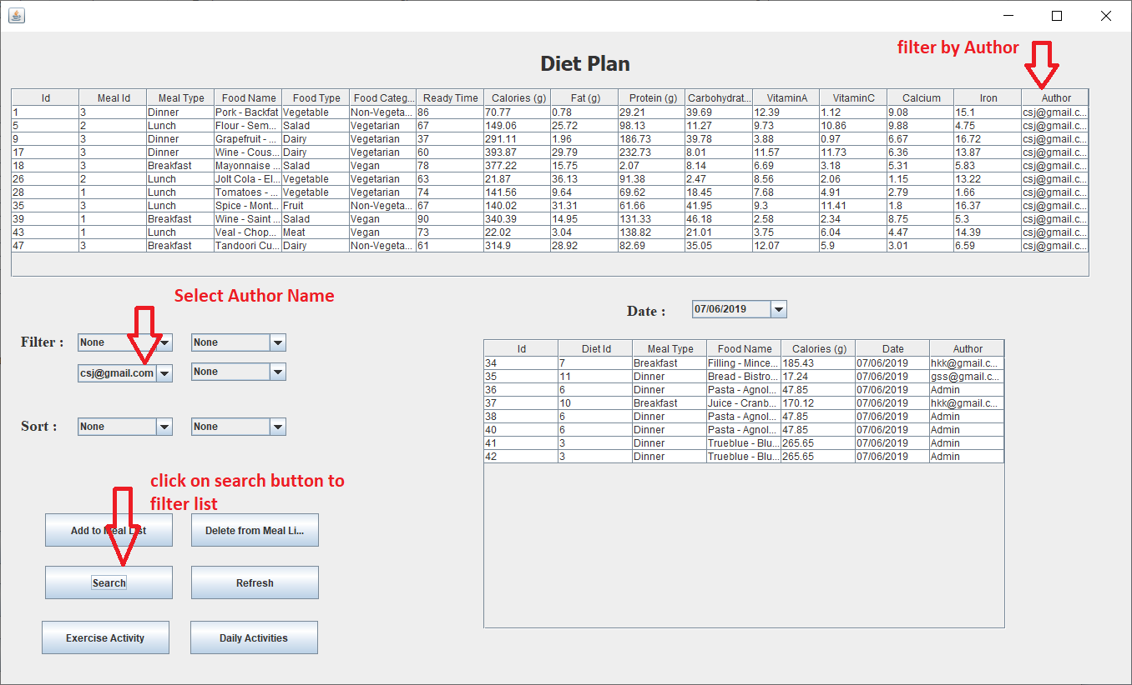

User can check previous added meals by selecting old date from combo box.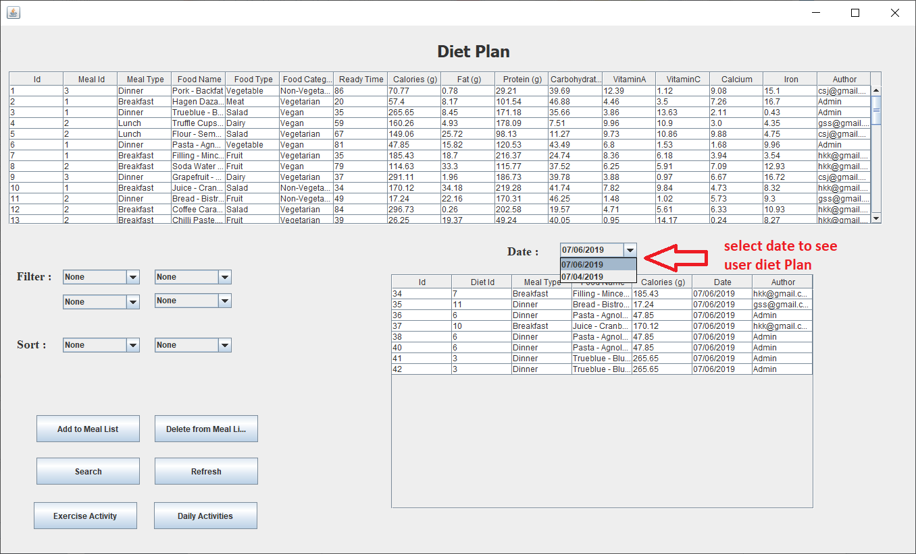

User can go to these activities by click on respective buttons as shown below.

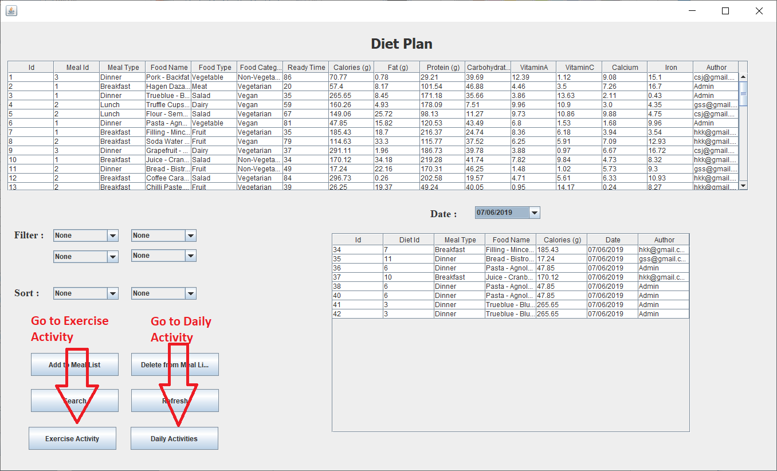

Instructor or admin can add diet by entering following data and then click add button.

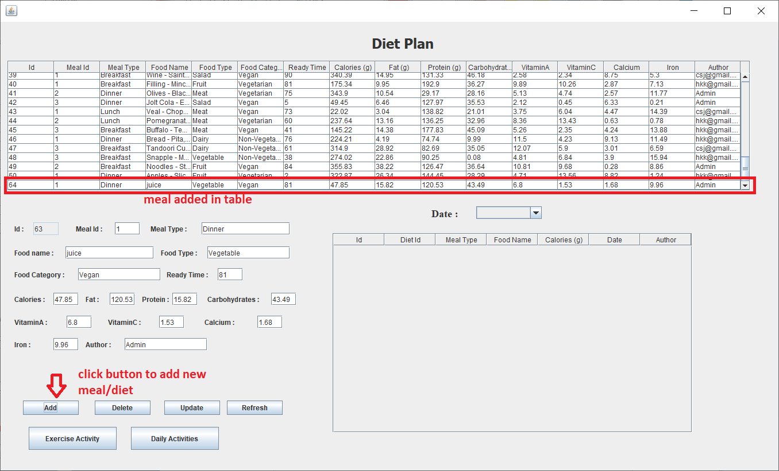

Instructor or admin can update diet by select diet from table and make changes then click update button.

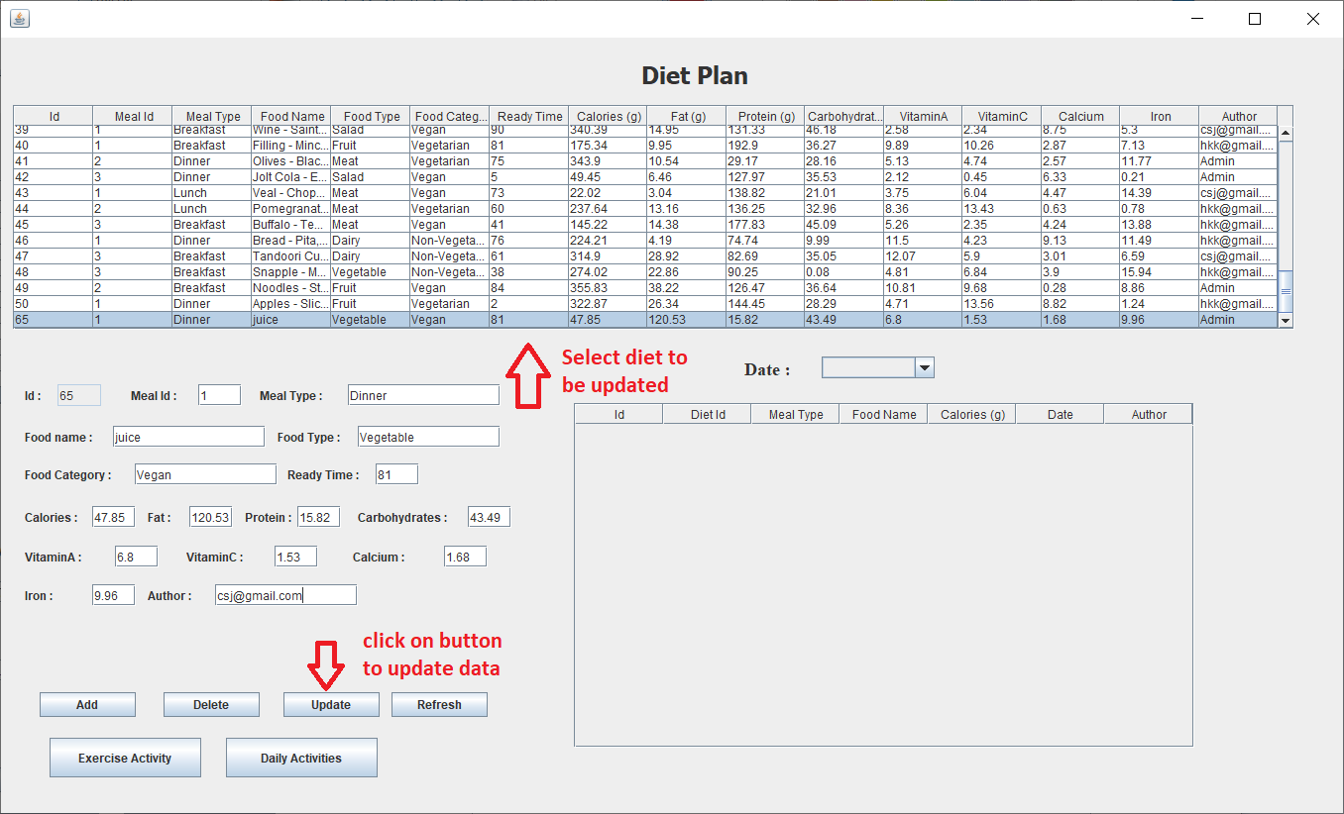

Instructor or admin can delete diet by select diet from table and then click delete button.

