HARYANA CHEMICAL AND PHARMACEUTICALS
PRODUCT PROFILE | Chemical & Pharmaceutical Raw Materials
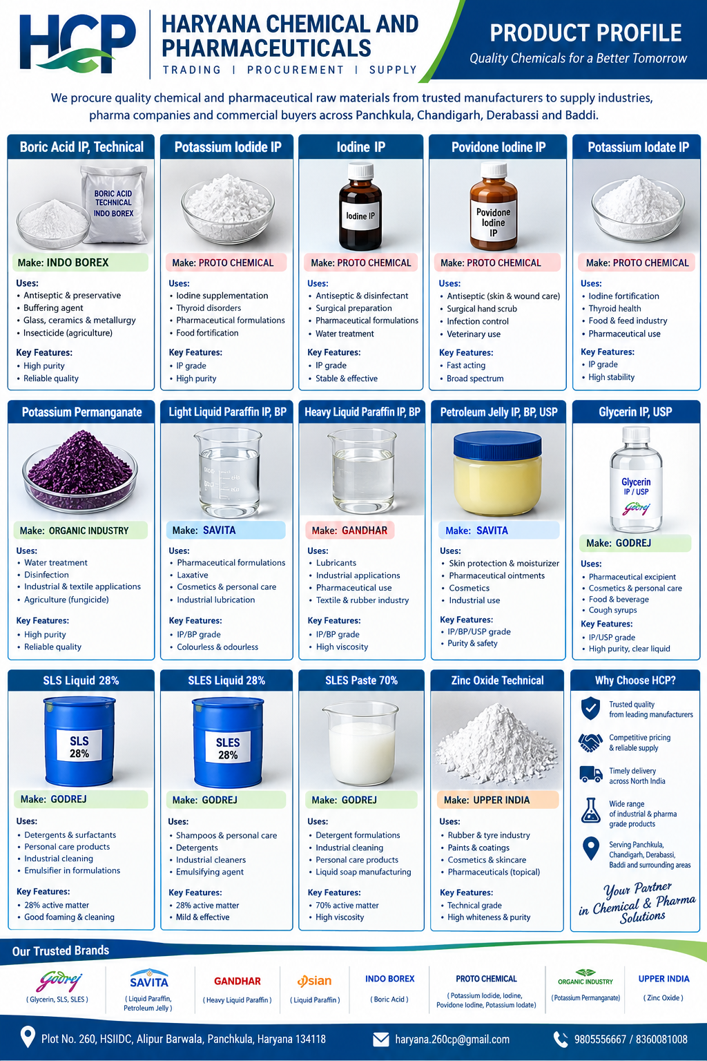
Company Overview
Haryana Chemical and Pharmaceuticals (HCP) is a trading and procurement firm supplying chemical and pharmaceutical raw materials from established manufacturers to industrial, pharmaceutical, personal-care and other commercial buyers. Product supply is subject to availability, applicable grade, specification and documentation.

Product Range, Manufacturers & Uses
The uses below are general application examples, not a guarantee of suitability for every formulation. Always match the product grade and current certificate of analysis (COA) to the buyer's specification.

1. Boric Acid IP
Preferred make(s): Indo Borex
Common uses: Pharmaceutical formulations where permitted by the applicable monograph and approved formulation; other specialised applications depend on grade.
Supply note: IP grade; confirm current pharmacopoeial compliance and COA for each lot.

2. Boric Acid Technical
Preferred make(s): Indo Borex
Common uses: Industrial applications such as glass/ceramics and other technical processes, subject to customer specification.
Supply note: Technical grade; not interchangeable with IP grade.

3. Potassium Iodide IP
Preferred make(s): Proto Chemical
Common uses: Pharmaceutical formulations and iodine-related applications where an IP-grade ingredient is specified.
Supply note: Confirm assay, impurity limits, packaging and COA.

4. Iodine IP
Preferred make(s): Proto Chemical
Common uses: Pharmaceutical and antiseptic-related formulations where the applicable specification permits its use.
Supply note: Handle and store according to supplier SDS and applicable regulations.

5. Povidone Iodine IP
Preferred make(s): Proto Chemical
Common uses: Antiseptic formulations for skin cleansing and wound-care products, when formulated and labelled for that use.
Supply note: Confirm concentration/form, IP compliance and COA.

6. Potassium Iodate IP
Preferred make(s): Proto Chemical
Common uses: Pharmaceutical and iodine-fortification applications where permitted by the relevant specification and regulation.
Supply note: Confirm grade and intended-use requirements.

7. Potassium Permanganate
Preferred make(s): Organic Industry; Black Diamonds
Common uses: Oxidising agent for specified industrial and water-treatment applications; use is subject to local rules and process controls.
Supply note: Strong oxidiser. Keep away from combustible/reducing materials; consult SDS.

8. Light Liquid Paraffin IP/BP
Preferred make(s): Savita; Gandhar; Asian
Common uses: Pharmaceutical, cosmetic and personal-care formulations; other uses depend on the applicable grade.
Supply note: IP/BP grade availability and compliance to be confirmed per batch.

9. Heavy Liquid Paraffin IP/BP
Preferred make(s): Savita; Gandhar; Asian
Common uses: Emollient, ointment and other pharmaceutical/personal-care formulations where the specification calls for heavy liquid paraffin.
Supply note: Confirm viscosity and pharmacopoeial grade.

10. Petroleum Jelly IP/BP/USP
Preferred make(s): Savita; Gandhar; Asian
Common uses: Protective skin-care products, ointments and cosmetic formulations, depending on grade and formulation requirements.
Supply note: Confirm applicable IP/BP/USP specification, colour/odour and COA.

11. Glycerin IP/USP
Preferred make(s): Godrej
Common uses: Pharmaceutical excipient, personal-care and cosmetic formulations, and food-related applications only where the supplied grade and regulations allow.
Supply note: Confirm IP/USP grade, assay, water content and COA.

12. SLS Liquid 28%
Preferred make(s): Godrej
Common uses: Surfactant for selected detergent, cleansing and personal-care formulations, subject to formulation requirements.
Supply note: Confirm exact chemical identity, active matter and specification.

13. SLES Liquid 28%
Preferred make(s): Godrej
Common uses: Surfactant used in shampoos, body washes, liquid soaps and detergents, subject to formulation needs.
Supply note: Confirm active matter, pH, salt content and COA.

14. SLES Paste 70%
Preferred make(s): Godrej
Common uses: Concentrated surfactant for shampoo, liquid soap, detergent and personal-care formulations.
Supply note: Confirm active matter, viscosity, packaging and COA.

15. Zinc Oxide Technical
Preferred make(s): Upper India
Common uses: Technical applications including rubber, ceramics, paints/coatings and other industrial formulations, according to grade.
Supply note: Technical grade; not a substitute for pharmaceutical/cosmetic grade without qualification.

Why HCP
- Procurement and supply support for pharmaceutical and industrial raw materials.
- Multiple manufacturer options across selected product categories.
- Support for specification matching, COA/documentation requests and bulk supply enquiries.
- Serving buyers across Panchkula, Chandigarh, Derabassi, Baddi and surrounding markets.

Contact
Haryana Chemical and Pharmaceuticals (HCP)
Plot No. 260, HSIIDC, Alipur Barwala, Panchkula, Haryana 134118
Email: haryana.260cp@gmail.com
Phone: 9805556667 / 8360081008
Product availability, manufacturer association, grade and specifications should be reconfirmed at the time of enquiry.

