WEB APPLICATION
SECURITY ASSESSMENT
Task 3 — Cybersecurity & Ethical Hacking Internship
Organization | ApexPlanet Software Pvt. Ltd.
Environment | Kali Linux, Apache, MariaDB, DVWA
Assessment type | Controlled local lab exercises
Prepared by | Jetty charan

Scope note: All attack demonstrations are intended for the isolated, authorized training environment. Never test systems without explicit permission.

Contents
- 1. Executive Summary
- 2. Objectives and Scope
- 3. Lab Environment and Methodology
- 4. SQL Injection and Prepared-Statement Mitigation
- 5. Cross-Site Scripting
- 6. CSRF and Token Protection
- 7. LFI/RFI
- 8. Burp Suite Interception and Intruder
- 9. HTTP Security Headers and CSP
- 10. Findings Summary
- 11. Remediation Plan
- 12. Conclusion

1. Executive Summary
This report documents web application security exercises completed in a controlled lab using Kali Linux, Apache, MariaDB and Damn Vulnerable Web Application (DVWA). The exercises explored SQL injection, stored/reflected cross-site scripting, cross-site request forgery, file inclusion, HTTP request manipulation, Intruder fuzzing and HTTP security headers.
The exercises illustrate how unsafe input handling and insecure application settings can expose data or permit unintended behavior. A separate prepared-statement example showed a safer database-query pattern; a standalone CSRF-token demo illustrated request validation; Apache headers were configured and checked locally; Burp Suite was used to modify a login request and run a small payload set.
Important distinction: DVWA is deliberately vulnerable. The CSRF-token file was a separate demonstration, and the SecurityHeaders.com screenshot supplied for this report is for example.com—not the local DVWA instance.

2. Objectives and Scope
- Demonstrate SQL injection and a prepared-statement mitigation.
- Test stored and reflected XSS and review CSP/output encoding.
- Demonstrate a CSRF-style password-change flow and token validation.
- Explore local and remote file inclusion in a controlled lab.
- Use Burp Suite to intercept/modify a login request and run limited Intruder fuzzing.
- Configure and verify HTTP security headers and review an external header scan.
- Document observations, limitations and practical mitigations.
Scope was limited to local DVWA, a locally created RFI test file, and an external SecurityHeaders.com check of example.com. No production application was assessed.

3. Lab Environment and Methodology
Component | Observed configuration
Operating system | Kali Linux
Web server | Apache2; observed active/running
Database | MariaDB client 11.8.6
PHP | PHP 8.4.22 CLI observed
Training app | DVWA at http://127.0.0.1/DVWA/
Proxy/testing tool | Burp Suite
Method | Manual, controlled demonstrations and configuration checks
- Confirm local services and the DVWA training application are available.
- Run exercises only against the authorized lab application or a specifically created local test file.
- Observe and record responses; do not treat lab results as production findings.
- Review mitigations and note whether verification was performed.
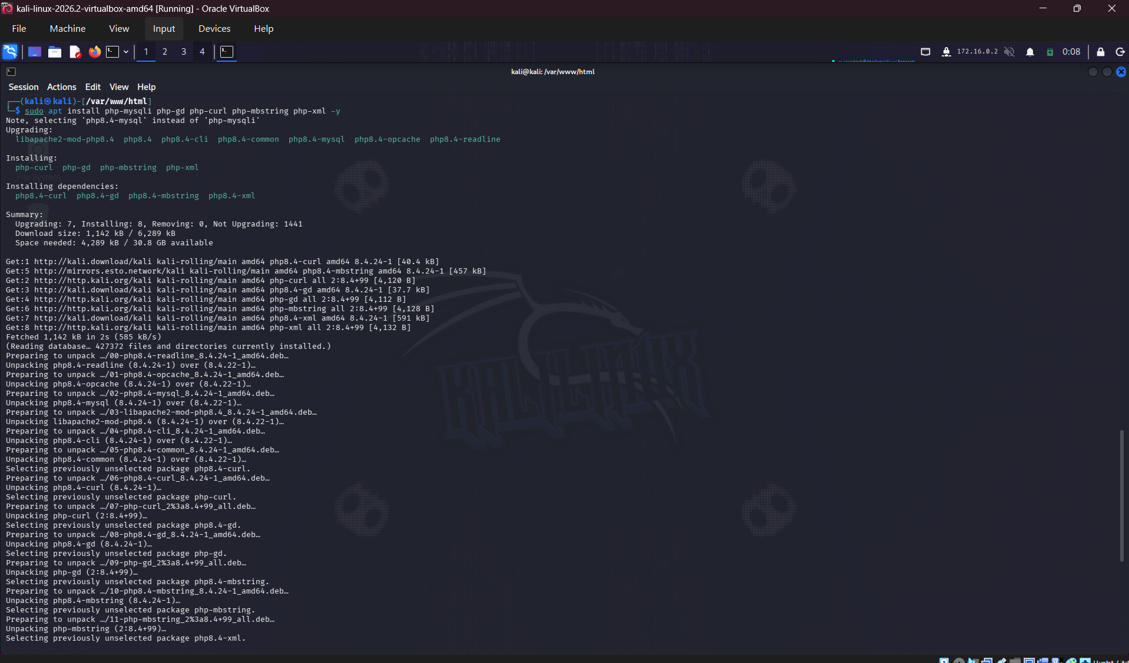
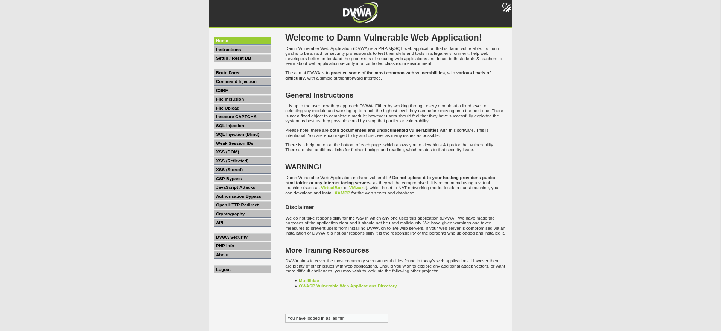

4. SQL Injection and Prepared-Statement Mitigation

4.1 Purpose and risk
SQL injection occurs when untrusted input changes the structure or logic of a database query. Depending on permissions and application design, impact may include unauthorized record retrieval, authentication bypass, or modification/deletion of data.

4.2 Vulnerable lab observation
In the DVWA SQL injection exercise, the payload `1' OR '1'='1' #` was entered in the vulnerable parameter. The response displayed multiple user records instead of only the expected single record. This illustrates how user input can alter query logic in a deliberately vulnerable application.

4.3 Mitigation demonstration
A separate example at `/var/www/html/DVWA/vulnerabilities/sqli/source/prepared_demo.php` used `mysqli_prepare` and `bind_param` to pass the input as data, and `htmlspecialchars` when rendering output. The injection attempt returned a single matching result rather than the broad result set observed in the vulnerable exercise.
- Use parameterized queries for all user-supplied values; do not concatenate input into SQL.
- Validate input against expected type and range, such as a numeric identifier.
- Use a least-privilege database account.
- Return generic errors to users; keep SQL details out of public responses.
- Use context-appropriate output encoding; HTML escaping does not replace query parameterization.
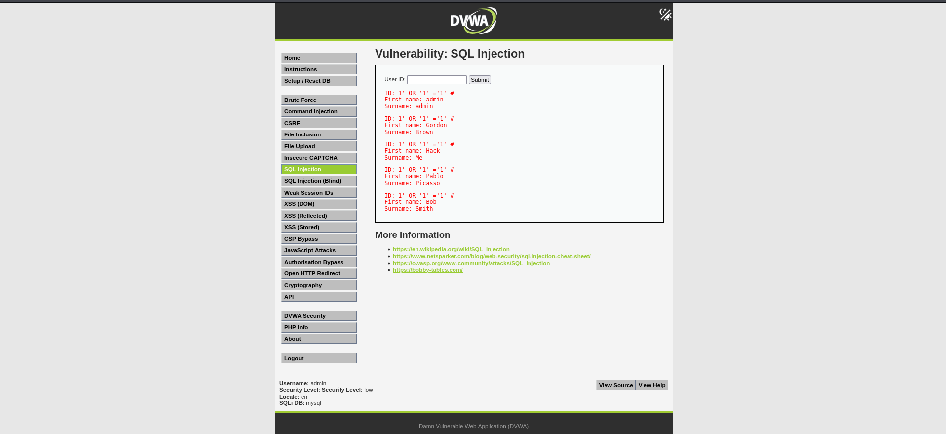
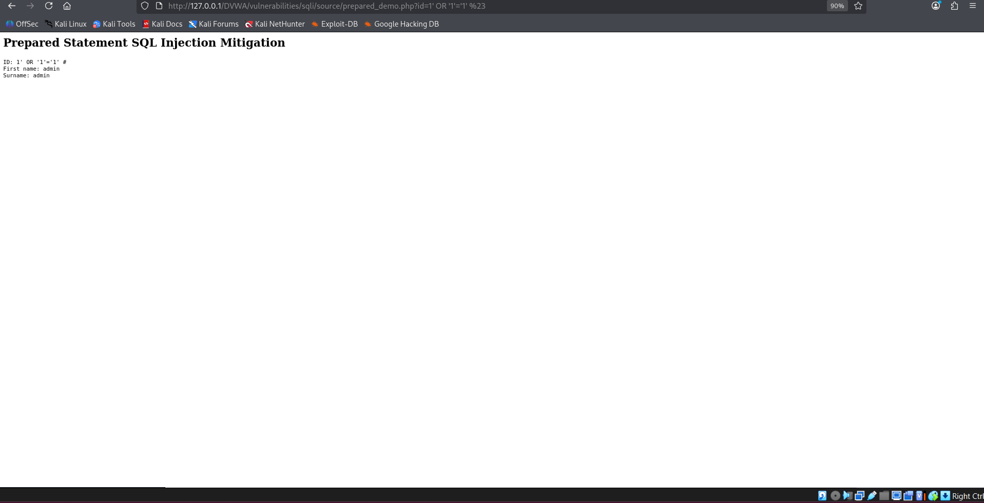

5. Cross-Site Scripting (XSS)

5.1 Concept and observation
XSS occurs when untrusted content is returned to a browser in an executable context. Stored XSS persists content for later viewers; reflected XSS returns content in the immediate response. Both can allow script execution in a victim’s browser depending on the context. Stored and reflected XSS were demonstrated in DVWA, an intentionally vulnerable training application.

5.2 Mitigations
- Apply context-aware output encoding when data is rendered.
- Validate input against business rules, but do not rely on validation alone.
- Avoid unsafe DOM operations such as placing untrusted content in `innerHTML`; prefer safe text APIs.
- Use a restrictive, tested Content Security Policy as defense in depth.
- Set appropriate cookie flags where applicable; these reduce some impact but do not fix XSS itself.
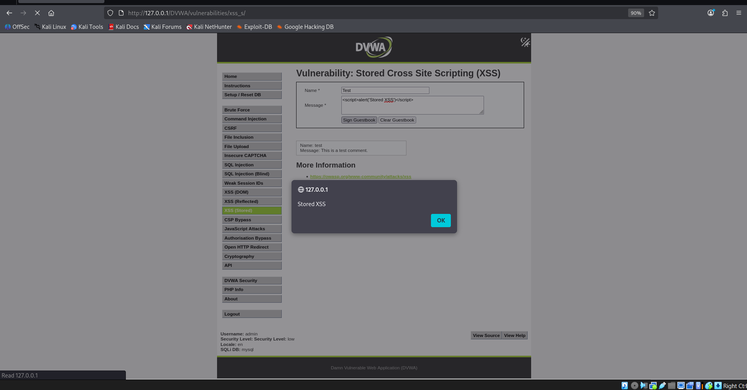
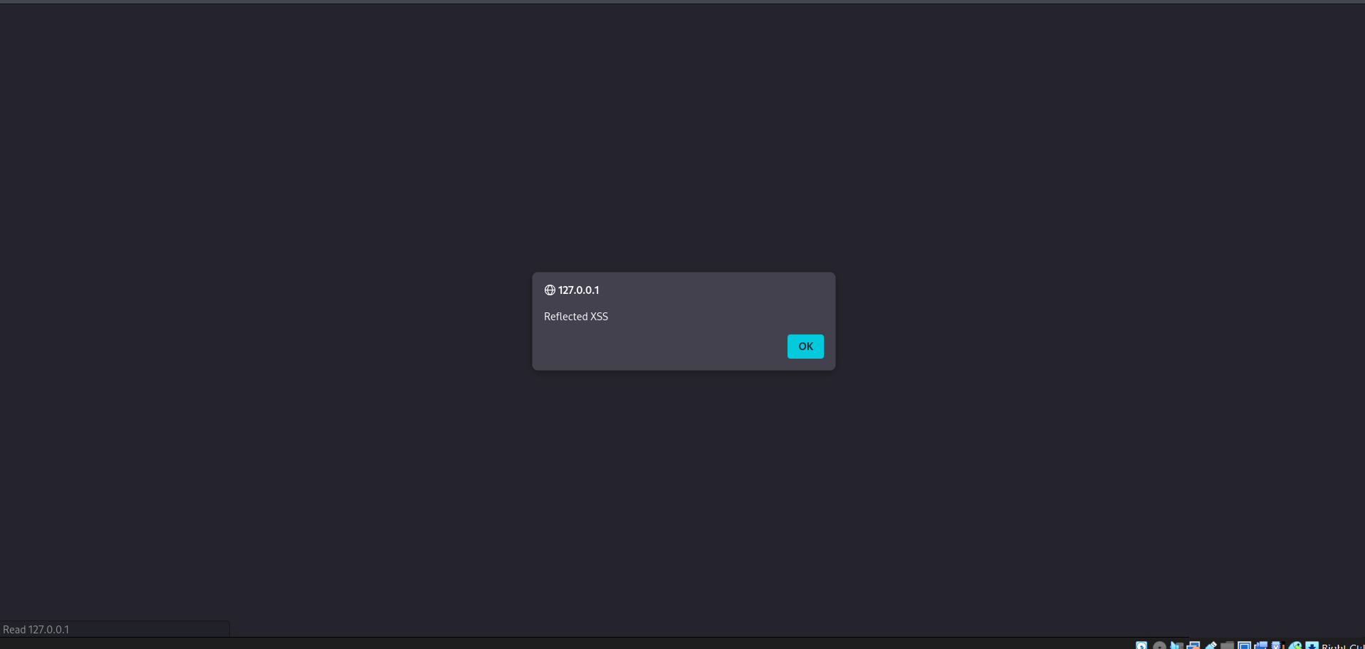

6. CSRF and Token Protection

6.1 Vulnerable workflow
Cross-site request forgery can cause an authenticated browser to submit an unwanted state-changing request. The DVWA low-security password-change exercise was used to demonstrate the vulnerable workflow.

6.2 Token demo and boundary
A separate example at `/var/www/html/csrf_protected.php` demonstrated checking a token before accepting a state-changing action. This was a standalone demonstration, not an integration into DVWA’s own password-change endpoint; therefore it must not be described as having secured that endpoint.

6.3 Recommended controls
- Generate a cryptographically random token, bind it to the user session and validate it server-side on every relevant state-changing request.
- Reject missing, invalid or mismatched tokens.
- Use POST or another appropriate non-safe method for state changes; GET should not change account state.
- Set SameSite cookie attributes as an additional defense, not the only control.
- Consider re-authentication and user notifications for sensitive changes.
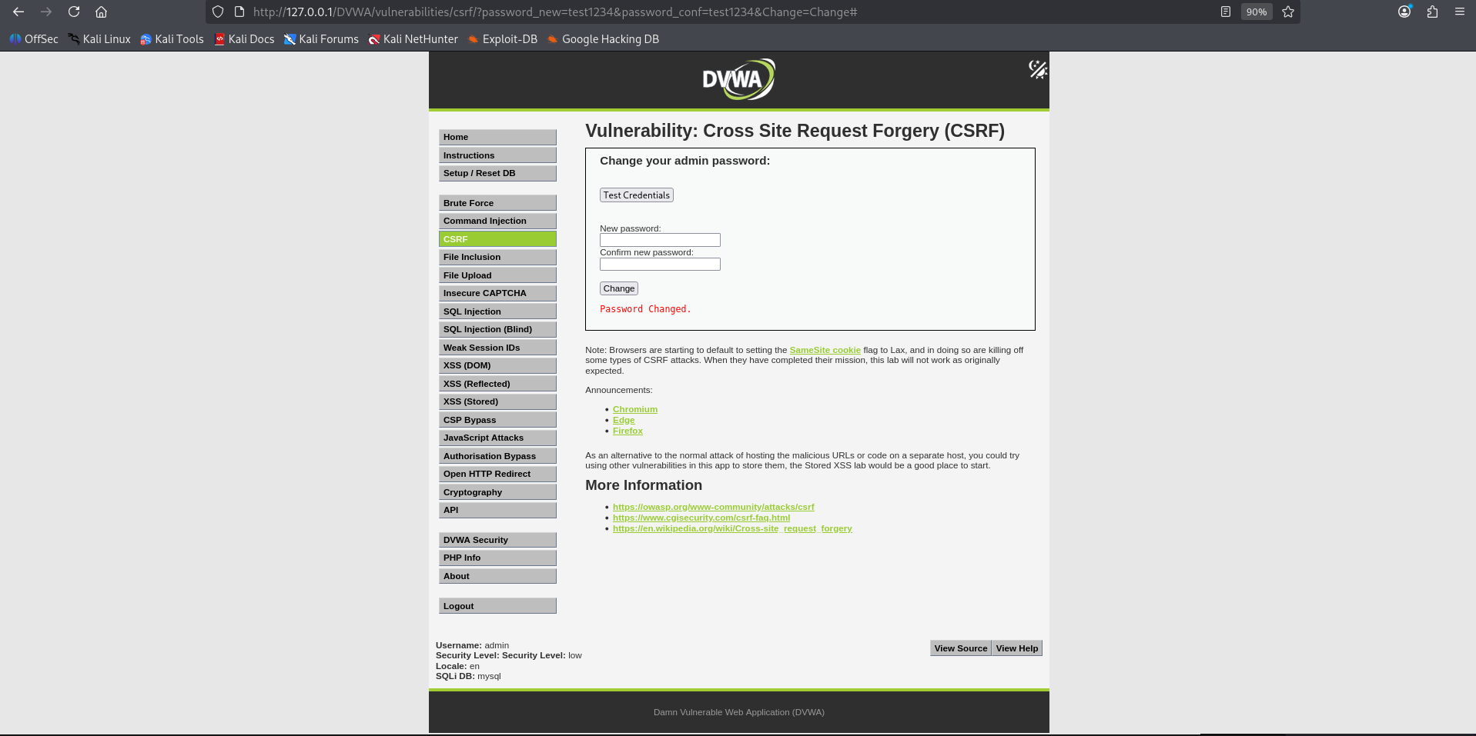
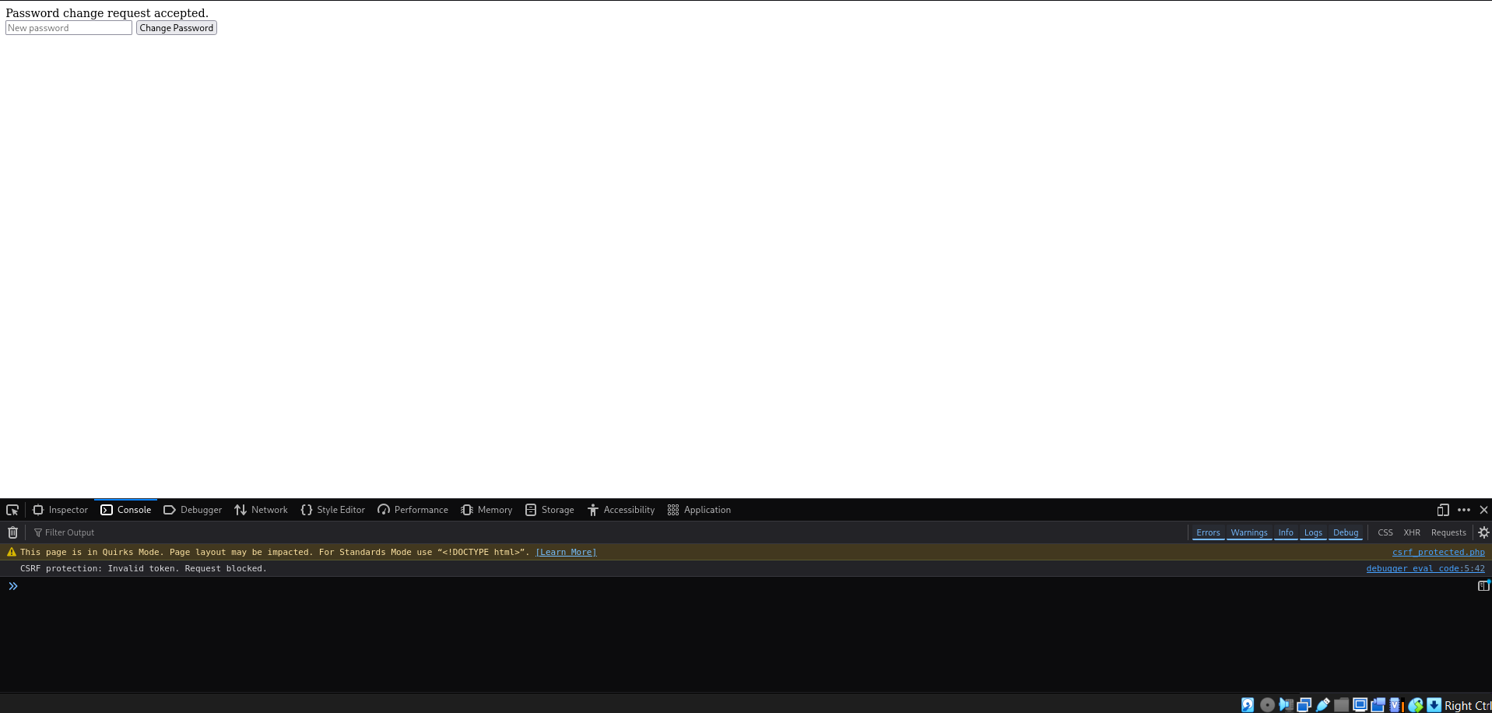

7. Local and Remote File Inclusion (LFI/RFI)

7.1 Local File Inclusion
The DVWA file-inclusion exercise used `/etc/passwd` as the page parameter. The response displayed local account-file content, demonstrating that an unsafe file-path parameter may expose files readable by the web-server process. Impact depends on permissions and configuration.

7.2 Remote File Inclusion
A controlled test file `/var/www/html/rfi-test.php` returned “RFI test successful”. The PHP configuration had `allow_url_include = On`, and a local PHP development server was run on port 8000. The DVWA file-inclusion route was pointed at the local test URL and displayed the message. This was a lab-only setup; remote URL inclusion is unsafe for normal deployment.

7.3 Mitigations
- Avoid accepting arbitrary file paths or URLs; map allowed logical names to fixed server-side paths.
- Canonicalize paths and ensure resolved files remain inside an approved directory.
- Disable `allow_url_include` unless there is a justified, reviewed requirement.
- Run the web server with minimal filesystem permissions and keep secrets out of web-readable directories.
- Avoid displaying raw filesystem errors or file contents to users.
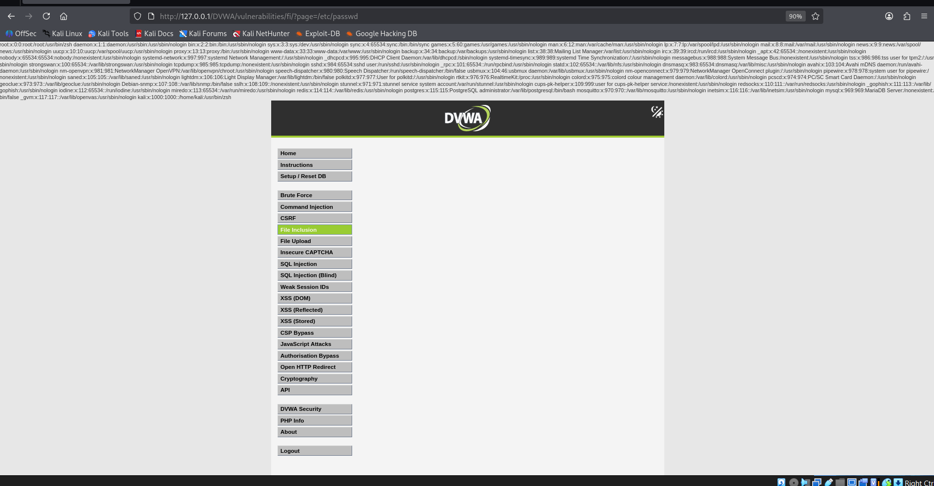
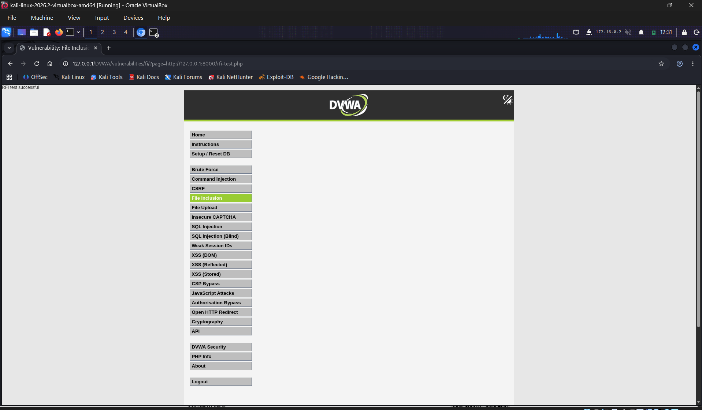

8. Burp Suite: Request Interception and Intruder Fuzzing

8.1 Login request interception
Burp Suite Proxy was used to intercept a DVWA login request. The username was changed to an invalid value and the request forwarded. DVWA returned “Login failed”, confirming the modified request reached the application and the attempted login was rejected. This is evidence of request modification—not a login bypass.
Before sharing evidence, redact passwords, cookies, CSRF tokens and session-related values.
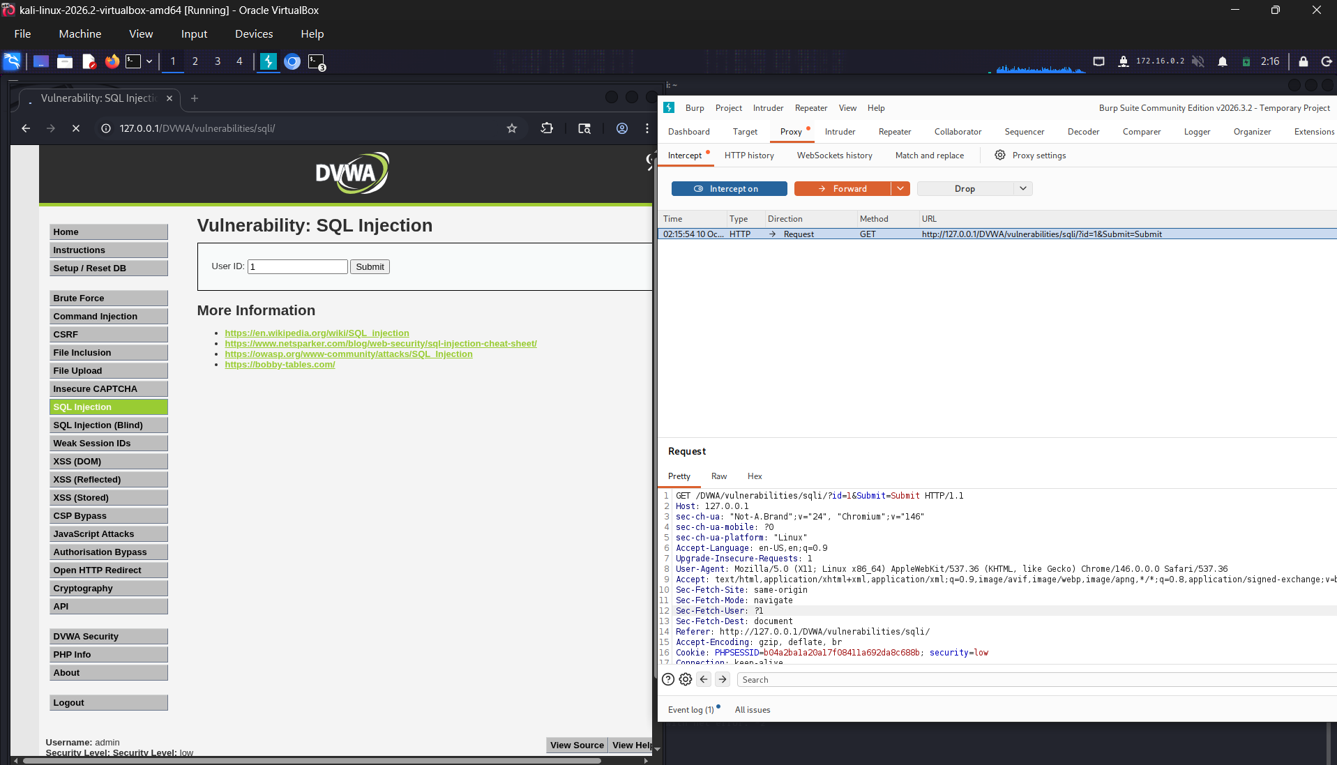

8.2 Intruder fuzzing
A DVWA SQLi GET request was sent to Burp Intruder. The `id` parameter was selected as the payload position, and a small set (1, 2, 3, 4, 5) was sent. Five responses returned HTTP 200, with response lengths around 5038–5045 bytes. Status and length differences alone do not prove a vulnerability; response content must be compared against expected behavior.
- Compare response bodies and relevant markers, not just status or byte length.
- Keep fuzzing limited and controlled in a lab.
- Record parameter, payload, status, response length and interpretation.
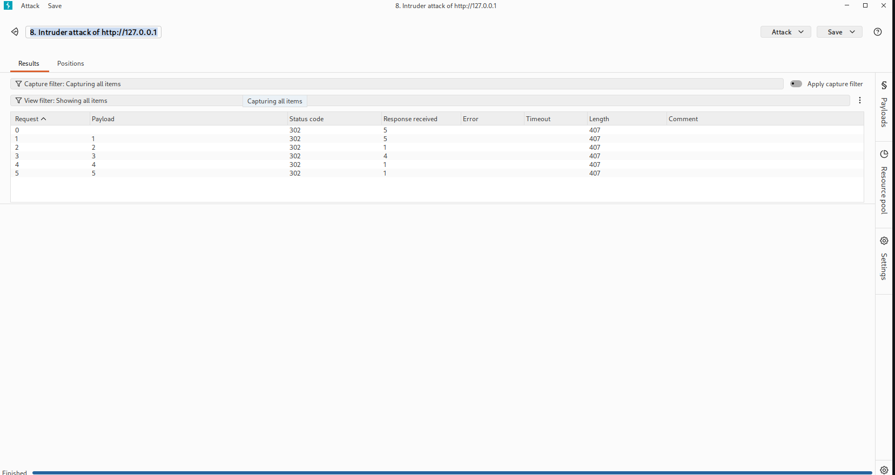

9. HTTP Security Headers and CSP

9.1 Apache configuration and verification
The Apache headers module and security-headers configuration were enabled, and Apache was restarted. `sudo apache2ctl configtest` returned “Syntax OK”; a ServerName warning was noted but did not prevent the syntax test from succeeding. A local curl check confirmed configured headers on the DVWA endpoint.
Header always set Content-Security-Policy "default-src 'self'; script-src 'self'"
Header always set X-Frame-Options "SAMEORIGIN"
Header always set X-Content-Type-Options "nosniff"
Header always set Referrer-Policy "strict-origin-when-cross-origin"
Header always set Permissions-Policy "camera=(), microphone=(), geolocation=()"

9.2 Header purpose and limitations
- CSP restricts permitted resource sources and can reduce XSS impact; test it so legitimate resources are not broken.
- X-Frame-Options: SAMEORIGIN limits framing by other origins in browsers that honor it.
- X-Content-Type-Options: nosniff asks browsers not to infer a different MIME type.
- Referrer-Policy controls how much referrer information is sent.
- Permissions-Policy disables selected browser capabilities in this configuration.
The supplied SecurityHeaders.com screenshot is for `https://example.com` and showed grade F with missing-header findings. It is external-site evidence only and does not measure the local DVWA configuration; local headers were checked separately using curl.
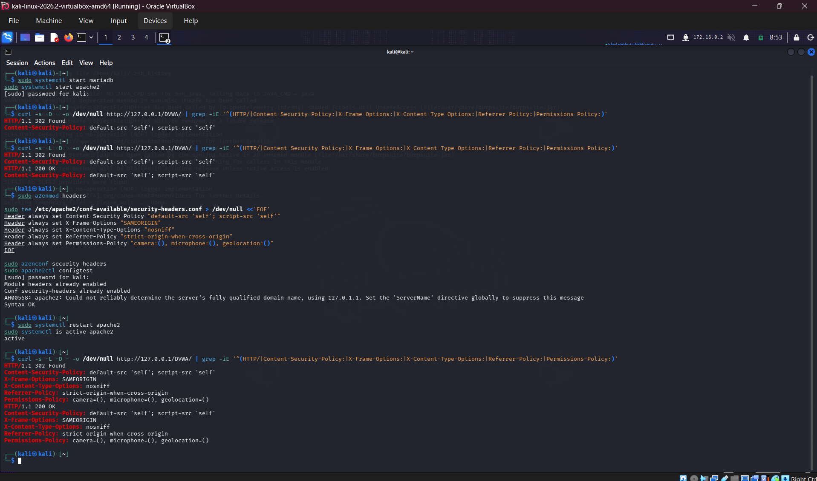
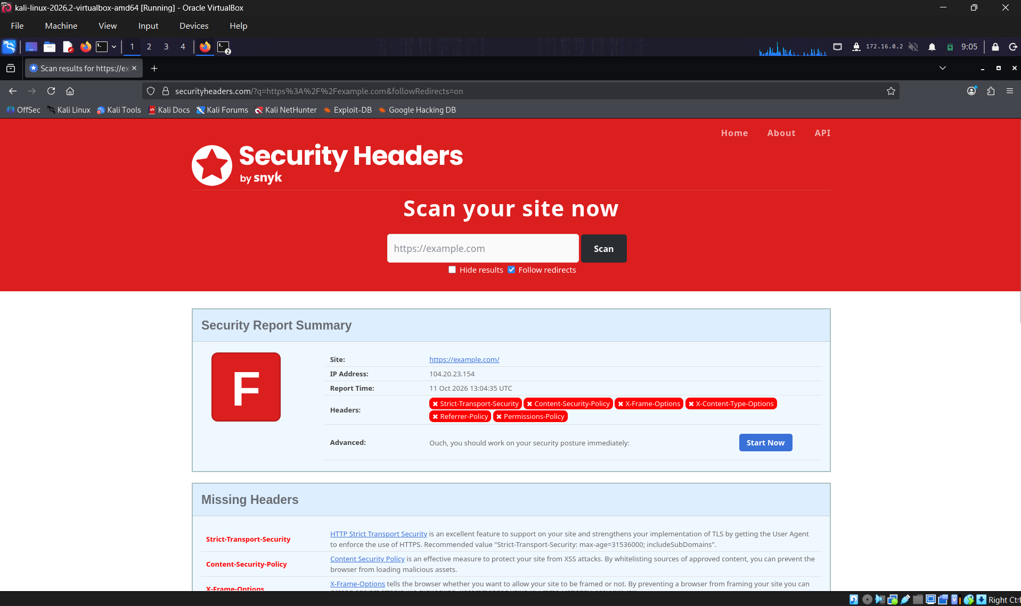

10. Findings Summary and Risk Discussion
Area | Lab observation | Potential production risk | Main mitigation
SQLi | Payload broadened records in DVWA. | Unauthorized data access/query manipulation. | Prepared statements; least privilege.
XSS | Stored and reflected examples in DVWA. | Script execution in a victim browser. | Context-aware output encoding; CSP.
CSRF | Password-change flow and separate token demo. | Unwanted authenticated state changes. | Server-validated session-bound tokens.
LFI | Local account-file content displayed. | Exposure of readable local files. | Allowlisted paths; path restrictions.
RFI | Controlled local test file included. | Remote content/code inclusion depending on setup. | Disable URL inclusion; reject arbitrary URLs.
Burp | Modified login rejected; five Intruder requests returned HTTP 200. | Request manipulation helps test input handling. | Server-side validation; analyze response bodies.
Headers | Local headers configured; external scan was example.com. | Missing browser-side defense-in-depth. | Appropriate, tested security headers.
No formal severity ratings are assigned because this was a deliberately vulnerable training application and no production asset, threat model or business-impact assessment was provided. The table describes potential risk if similar weaknesses existed in a real application.

11. Remediation Plan
- Priority 1 — SQL queries: replace dynamic query construction with parameterized statements and review database access paths.
- Priority 1 — File inclusion: remove user-controlled path/URL inclusion; disable remote URL inclusion and enforce allowlists.
- Priority 1 — XSS: encode output by context, remove unsafe DOM patterns and add regression tests.
- Priority 1 — CSRF: add server-validated session-bound tokens to relevant state-changing requests and test rejection cases.
- Priority 2 — Headers: maintain a tested CSP and suitable security headers; validate against the actual target application and HTTPS deployment.
- Priority 2 — Session data: redact secrets from reports and logs; use secure cookie settings for HTTPS deployments.
- Priority 2 — Verification: retest normal and negative cases and record expected versus actual results.

12. Conclusion
These exercises provided hands-on practice with common web application attack classes and defensive controls. DVWA illustrated unsafe query construction, unsafe output handling and unsafe file inclusion. The prepared-statement example, separate CSRF token demo and Apache headers configuration illustrated mitigation approaches. Burp Suite provided practical experience inspecting and altering HTTP requests.
A result must always be reported with its scope and limitations: the SecurityHeaders.com result belongs to example.com, the CSRF token code was a separate demonstration, and Intruder response lengths alone do not establish exploitability. Production applications require secure defaults, code review and retesting.

