


ITA0330-Mobile Computing
Name: M.Eswarcharan Reg no:192372379
Slot: D Course Name: Mobile Computing

Experiment 2: Mobile Station User Interface Prototype
Aim: To design a user interface prototype for a mobile station considering connectivity and convenience.

Procedure:

- Open Figma and create a new design file.

- Select a smartphone frame from the device templates.

- Design the home screen with a simple layout.
- Add signal strength, battery status, and network connectivity indicators.
- Add call, SMS, contacts, and mobile data icons.
- Apply suitable colors, fonts, and buttons.
- Use Prototype mode to connect the screens and test navigation.

Output:
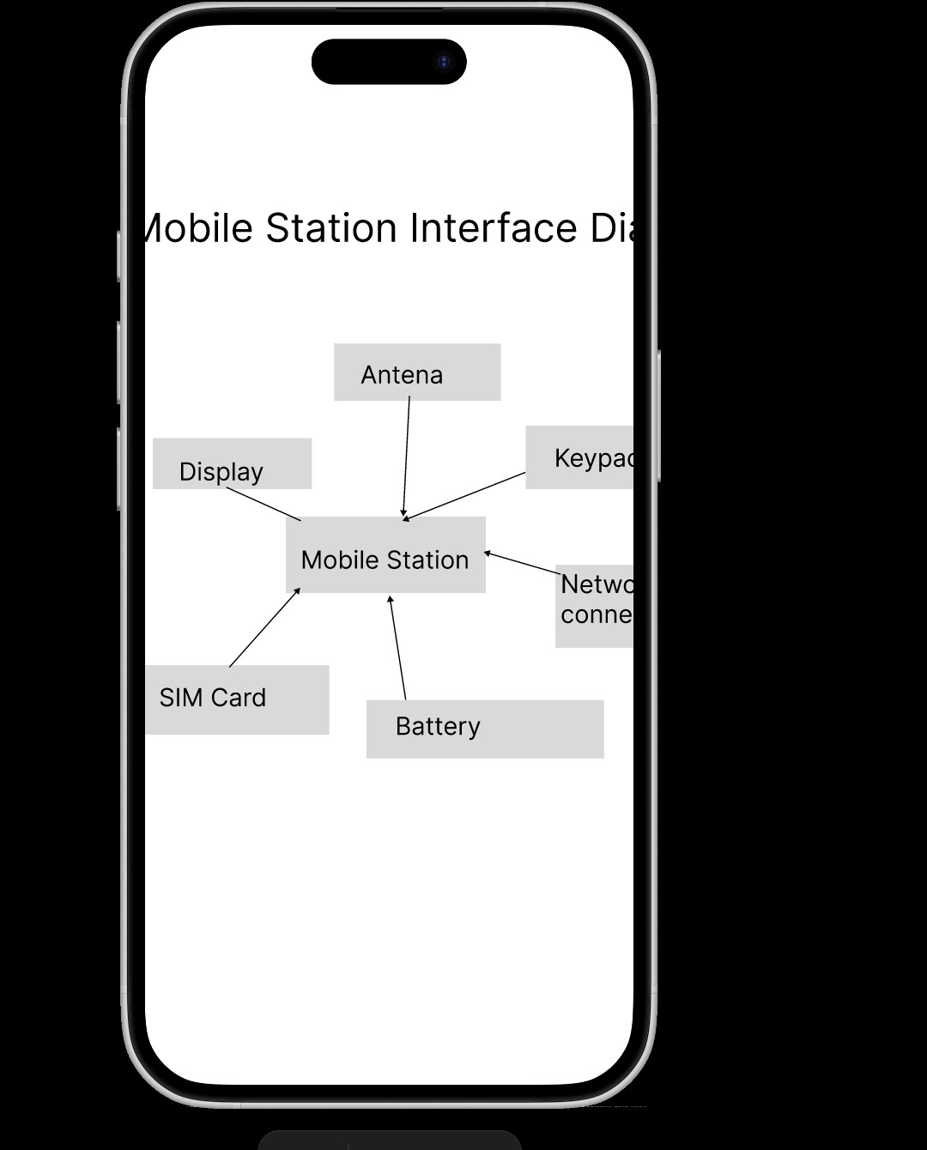

Result: Thus, a mobile station UI prototype with connectivity features and convenient navigation was designed successfully.

