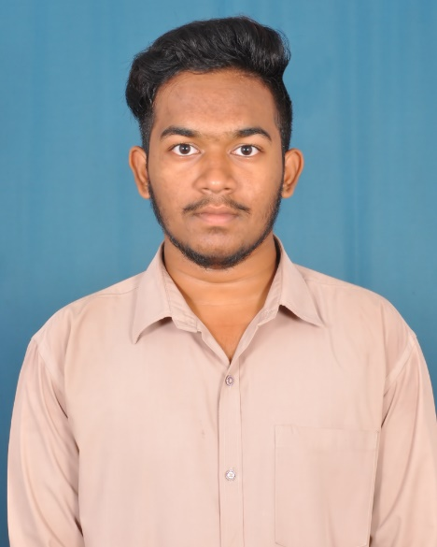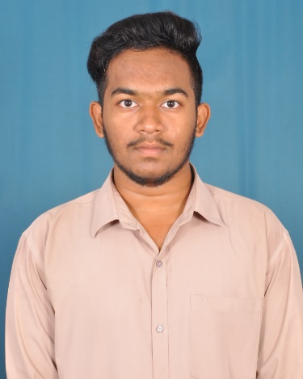

Hindi

English

Telugu

+91 888 3000 330

Charannalli999@gmail.com

The Certification of Fudamentals of digital marketing is achieved in the period of Lockdown.

I have enrolled for the programming langauges(c,c++,python,java) in udemy in the period of Lockdown.

Microsoft Office

Adobe Photoshop

C++

Nalli charan

Travelling

Highly organized and Bachelor of computer science and enghineering pursuing from the Raghu college Vizag.I am able to handle multiple tasks on a daily basis.Full of creativity,Honesty,Hardworking and energetic.

I Have Passed Class 12th from aditya junior college palakoll

Result : 72.40 Percentage

Student

**MY SKILLS**

**EXPERIENCE**

**Google Digital Unlocked**

student

**udemy**

**student**

Akhil.nalli_

**ABOUT ME**

**HOBBIES**

**EDUCATION**

Reading

c

**Class 12th (2017)**

Aditya junior college

I Have Passed Class 10th from j.sikile School Narsapur

Result : 78.83 Percentage

**Class 10th (2015)**

j.sikile.school

cricket

Music

**LANGUAGES**