AIM:
To write a LEX program to identify and print all C keywords present in a C source program.

PSEUDOCODE:
- Start the program.
- Read the C source file.
- Compare each word with the list of C keywords.
- Print each matching keyword.
- Ignore identifiers, whitespace, and other symbols.
- Stop the program.

PROGRAM:

#include <stdio.h>

%}

%%

"auto"|"break"|"case"|"char"|"const"|"continue"|"default"|"do"|"double"|"else"|"enum"|"extern"|"float"|"for"|"goto"|"if"|"int"|"long"|"register"|"return"|"short"|"signed"|"sizeof"|"static"|"struct"|"switch"|"typedef"|"union"|"unsigned"|"void"|"volatile"|"while" {

printf("C keyword: %s\n", yytext);

}

[a-zA-Z_][a-zA-Z0-9_]* { }

[ \t\n]+ { }

. { }

%%

int main(int argc, char *argv[])

{

if (argc > 1) {

yyin = fopen(argv[1], "r");

if (!yyin) return 1;

}

yylex();

return 0;

}

SAMPLE INPUT:

int main()

{

int a;

if (a > 5)

return 0;

}

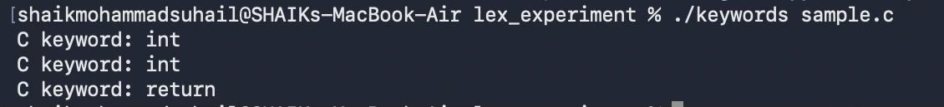
SAMPLE OUTPUT:

RESULT:
The LEX program successfully identifies and prints C keywords present in the source program.

