AIM:
To write a LEX program to remove single-line and multi-line comments from a C program and write the resulting program into another file.

PSEUDOCODE:
- Start the program.
- Open the input C file and output file.
- Read the input file.
- Identify and skip single-line comments beginning with //.
- Identify and skip multi-line comments enclosed in /* and */.
- Copy all remaining characters to the output file.
- Close both files.
- Stop the program.

PROGRAM:

%{
#include <stdio.h>
%}
%x COMMENT
%%
"//"[^\n]* { }
"/*" { BEGIN(COMMENT); }
<COMMENT>"*/" { BEGIN(INITIAL); }
<COMMENT>\n { fputc('\n', yyout); }
<COMMENT>. { }
\n { fputc('\n', yyout); }
. { fputc(yytext[0], yyout); }
%%
int main(int argc, char *argv[])
{
if (argc != 3) {
printf("Usage: %s input.c output.c\n", argv[0]);
return 1;
}

yyin = fopen(argv[1], "r");
yyout = fopen(argv[2], "w");

if (!yyin || !yyout) {
printf("File opening error\n");
return 1;
}

yylex();
fclose(yyin);
fclose(yyout);
return 0;
}

SAMPLE INPUT:

int main()

{

// declare variable

int a = 10;

/* display value */

printf("%d", a);

}

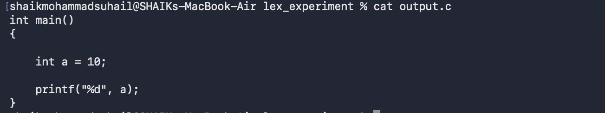
SAMPLE OUTPUT:

RESULT:
The LEX program successfully removes single-line and multi-line comments and writes the resulting C program to a separate output file.

