AIM:
To write a LEX program to identify and print all arithmetic and relational operators present in a C source program.

PSEUDOCODE:
- Start the program.
- Read the C source file.
- Identify arithmetic operators such as +, -, *, /, %, ++, and --.
- Identify relational operators such as <, >, <=, >=, ==, and !=.
- Print each operator with its category.
- Ignore other characters.
- Stop the program.

PROGRAM:

%{
#include <stdio.h>
%}
%%
"++"|"--"|"+"|"-"|"*"|"/"|"%" {
printf("Arithmetic operator: %s\n", yytext);
}
"=="|"!="|"<="|">="|"<"|">" {
printf("Relational operator: %s\n", yytext);
}
[ \t\n]+ { }
. { }
%%
int main(int argc, char *argv[])
{
if (argc > 1) {
yyin = fopen(argv[1], "r");
if (!yyin) return 1;
}
yylex();
return 0;
}

SAMPLE INPUT:

int a, b;

a = 10;

b = a + 5;

if (b > 10)

a++;

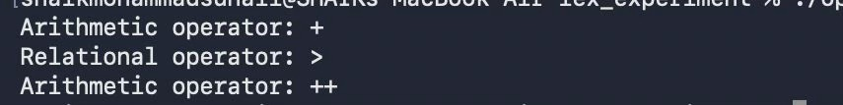
SAMPLE OUTPUT:

RESULT:
The LEX program successfully identifies and prints arithmetic and relational operators present in the C source program.

