AIM:
To write a LEX program to identify and print assignment operators (=, +=, -=, *=, /=) used in a given C program.

PSEUDO CODE:
- Start the program.
- Read the input C program.
- Identify the assignment operators.
- Print the operators found.
- Stop the program.

PROGRAM:

%{

#include <stdio.h>

%}

%%

"+=" { printf("Assignment Operator: +=\n"); }

"-=" { printf("Assignment Operator: -=\n"); }

"*=" { printf("Assignment Operator: *=\n"); }

"/=" { printf("Assignment Operator: /=\n"); }

"=" { printf("Assignment Operator: =\n"); }

.|\n ;

%%

int main()

{

extern FILE *yyin;

yyin = fopen("input.c", "r");

if (yyin == NULL)

{

printf("File not found\n");

return 1;

}

yylex();

fclose(yyin);

return 0;

}

int yywrap()

{

return 1;

}

SAMPLE INPUT:

a = 10;

b += 5;

c *= 2;

d -= 1;

SAMPLE OUTPUT:

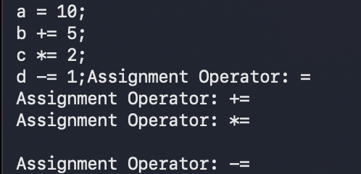

RESULT:
Thus, the LEX program successfully identifies and prints the assignment operators used in the given C program.

