AIM:
To write a LEX program to read a text file and count uppercase and lowercase alphabetic characters.

PSEUDO CODE:
- Start the program.
- Open the input text file.
- Count uppercase characters.
- Count lowercase characters.
- Display both counts.
- Stop the program.

PROGRAM:

%{

#include <stdio.h>

int upper = 0, lower = 0;

%}

%%

[A-Z] { upper++; }

[a-z] { lower++; }

.|\n ;

%%

int main()

{

extern FILE *yyin;

yyin = fopen("input.txt", "r");

if (yyin == NULL)

{

printf("File not found\n");

return 1;

}

yylex();

printf("Uppercase characters = %d\n", upper);

printf("Lowercase characters = %d\n", lower);

fclose(yyin);

return 0;

}

int yywrap()

{

return 1;

}

SAMPLE INPUT :

Hello LEX

World

SAMPLE OUTPUT:

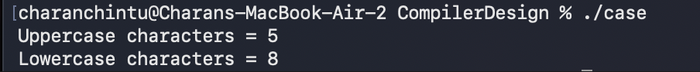

RESULT:
Thus, the LEX program successfully counts the uppercase and lowercase alphabetic characters in the given input file.

