DESIGN AND FABRICATION OF AN
ADJUSTABLE WOODEN PHONE HOLDER STAND
(Base Block · Support Rod · Adjustable Frame Module)
A Mini Project / DIY Fabrication Report
Prepared by
[YOUR NAME]
Register No: [YOUR REGISTER NUMBER]
Department of [YOUR DEPARTMENT]
[YOUR COLLEGE NAME], [CITY]
[MONTH YEAR]

Contents
Abstract
1. Introduction
2. Planning and Design
2.1 Design Requirements
2.2 Concept and Working Principle
2.3 Materials and Tools Required
2.4 Approximate Dimensions
3. Fabrication Procedure (Step-by-Step)
4. Photographs of the Completed Model
5. Video Demonstration
6. Results and Discussion
7. Conclusion

Abstract
This report presents the planning, design and step-by-step fabrication of an adjustable wooden phone holder stand. The stand consists of a solid hardwood base block, a slender support rod fixed into the base, and a frame module at the top with a recess that receives the mobile phone. An adjustable rod mechanism, made of a screw joint and a friction joint, lets the user change the tilt and viewing angle of the frame. The unit is made from hardwood such as oak or teak, joined with wood adhesive and a small metal screw, using simple hand tools. The report covers the design requirements, the materials and tools used, the fabrication procedure, photographs of the completed model, a space for a demonstration video, and the results and conclusions drawn from the build.

1. Introduction
A phone placed flat on a desk is awkward to view, and fixed-angle stands do not suit every user or every surface. This project designs a compact wooden stand whose frame can be tilted and held in position, so the same stand supports video calls, reading, and charging. Building it also gives practice in basic carpentry skills: marking, cutting, drilling, fitting, joining and finishing within a stated tolerance.
Objectives
- Design a stable wooden stand that holds a mobile phone upright at a comfortable viewing angle.
- Provide an adjustable rod mechanism (screw joint with friction joint) so the angle of the frame can be changed and held.
- Fabricate the stand from low-cost, easily available hardwood and adhesive, keeping dimensions within a tolerance of ±1 mm where the blueprint specifies it.
- Document the fabrication process step by step, with a blueprint and photographs, for reproducibility.

2. Planning and Design

2.1 Design Requirements
- A heavy, flat base block so that the stand does not tip when a phone is placed in the frame.
- A straight support rod of fixed diameter, fitted firmly into the base.
- A frame module with a recess (device insertion zone) that holds the phone securely and leaves the screen visible.
- An adjustable connection between the rod and the frame, using a screw joint and a friction joint.
- Overall size small enough for a table or desk, using materials that are cheap, sturdy and easy to work by hand.

2.2 Concept and Working Principle
The design is shown in the blueprint in Fig. 1, which gives the front view, side view and top view along with detail views of the rod mechanism and the frame-rod connection.
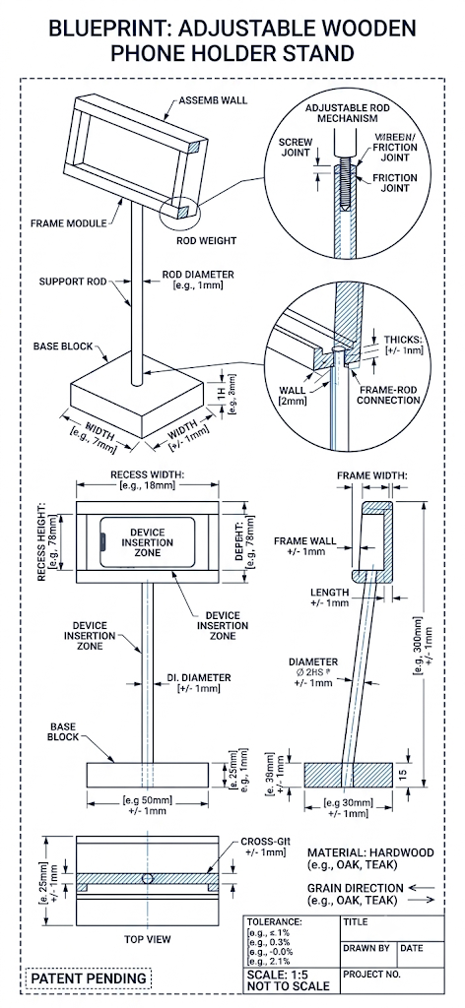
Fig. 1: Blueprint of the Adjustable Wooden Phone Holder Stand
- Base Block — a solid hardwood block that gives weight and stability. A hole drilled at its centre receives the support rod.
- Support Rod — a round hardwood rod that carries the frame. It is fixed in the base and is slightly inclined, as seen in the side view.
- Frame Module — a rectangular frame with a recess (device insertion zone) in which the phone sits. The frame walls and lip keep the phone from slipping out.
- Adjustable Rod Mechanism — a screw joint threads into the rod end, and a friction joint at the frame holds the chosen angle by pressure.
- Grain Direction — the grain of the wood runs along the length of the rod and the frame to resist bending and splitting.

2.3 Materials and Tools Required
The following materials and tools are required for this build:
Material | Approx. Qty / Spec | Purpose
Hardwood plank (oak / teak), ≈ 20 mm thick | 1 piece, ≈ 25 x 15 cm | Base block and frame module
Round wooden rod / dowel | 1 piece, Ø ≈ 10 mm x 300 mm | Support rod
Small metal screw and washer | 1 set (e.g., M4) | Screw joint of the adjustable mechanism
Wood adhesive (e.g., Fevicol/PVA) | As required | Bonding the rod and frame joints
Sandpaper (medium & fine grit) | As required | Smoothing edges and surfaces
Varnish / wood polish | As required | Protective finish
Felt or rubber pads | 4 pieces | Anti-slip pads under the base

Tool | Purpose
Measuring tape / steel rule / pencil | Marking dimensions and cut-lines
Vernier caliper | Checking sizes within ±1 mm tolerance
Hand saw / coping saw | Cutting the base, frame and rod
Electric drill with bits | Drilling the rod hole and screw hole
Chisel & mallet | Cutting the frame recess and squaring corners
Wood file / rasp | Shaping and fitting the joints
Clamps | Holding pieces while the adhesive dries
Sanding block | Finishing edges and surfaces

2.4 Approximate Dimensions
Parameter | Approximate Value
Overall height of the stand | ≈ [300] mm
Base block (L x W x H) | ≈ [120 x 80 x 20] mm
Support rod diameter | ≈ [10] mm
Frame outer size (L x H) | ≈ [160 x 90] mm
Frame width / depth | ≈ [15] mm
Frame wall thickness | ≈ [8] mm
Device recess (slot) width | ≈ [12] mm, to suit a phone with case
General tolerance | ± 1 mm
Note: dimensions are indicative and should be replaced with the actual values measured on your model.

3. Fabrication Procedure (Step-by-Step)
The steps below outline the fabrication sequence. Each step has space for a photograph or diagram of that stage.
Step 1: Marking & Cutting the Pieces
Using the dimensions in Section 2.4, mark the base block, the frame pieces and the support rod on the hardwood with a pencil and ruler. Cut them out with a hand saw or coping saw, keeping the grain along the length of the rod and frame.
[Insert your photo / diagram here]
Fig. 2: Marking and cutting the pieces
Step 2: Drilling the Rod Hole in the Base Block
Mark the centre of the base block and drill a hole of the rod diameter (≈ 10 mm) to a shallow depth, so that the rod sits firmly. Drill slowly and keep the drill straight, or tilted at the intended angle if the rod is inclined.
[Insert your photo / diagram here]
Fig. 3: Drilling the rod hole in the base
Step 3: Making the Frame Module
Assemble the frame from the cut pieces, or cut it from a single block, and chisel out the recess for the phone. Check the recess against the phone and its case, and keep the frame wall and recess width within ±1 mm of the marked size.
[Insert your photo / diagram here]
Fig. 4: Making the frame and the device recess
Step 4: Fitting the Adjustable Rod Mechanism
Drill a pilot hole at the upper end of the rod and fit the screw joint. Fit the friction joint at the frame connection so that the frame can be turned and then holds its position under light pressure from the screw.
[Insert your photo / diagram here]
Fig. 5: Screw joint and friction joint
Step 5: Assembling the Stand
Apply wood adhesive to the lower end of the rod and press it into the base hole. Clamp and hold it upright until the adhesive is fully dry, then attach the frame module to the rod through the adjustable joint.
[Insert your photo / diagram here]
Fig. 6: Assembling base, rod and frame
Step 6: Sanding, Cleaning & Finishing
Sand all edges and surfaces with medium and then fine sandpaper to remove roughness and splinters, then wipe the stand clean. Apply varnish or wood polish, and fix felt pads under the base.
[Insert your photo / diagram here]
Fig. 7: Sanding and finishing

4. Photographs of the Completed Model
The completed stand was photographed from multiple views: the front view showing the frame and device recess, the side view showing the inclined rod, and the top view of the base.
[Insert Front View photograph]
Fig. 8: Front View
[Insert Side View photograph]
Fig. 9: Side View — Adjustable Rod and Frame
[Insert Top / Base View photograph]
Fig. 10: Top View — Base Block

5. Video Demonstration
A short video demonstrating the fabrication process and/or the working of the stand can be viewed at the link below.
Video Link: [PASTE YOUR VIDEO LINK HERE]

6. Results and Discussion
On visual inspection, the completed model achieves the intended functions:
- The frame recess holds a mobile phone upright, with the screen clearly visible.
- The adjustable rod mechanism allows the viewing angle to be changed and held in position.
- The heavy base block keeps the stand stable and prevents tipping.
- The stand is compact and portable and is built from low-cost wood and adhesive.
Advantages
- Adjustable viewing angle in a simple wooden design.
- Simple hand-tool fabrication — no specialised machinery required.
- Low material cost; easy to repair or modify.
Limitations & Scope for Improvement
- A slender wooden rod may flex under a heavy phone or tablet; a thicker rod or metal insert would improve strength.
- The friction joint may loosen with repeated adjustment; a wing nut or spring washer could be added.
- Varnish or polish protects the wood from moisture, and rubber pads inside the recess would prevent scratches on the phone.
- [Add any other observation from your own build.]

7. Conclusion
The planning and fabrication of an adjustable wooden phone holder stand, with a base block, support rod and adjustable frame module, was completed successfully. The design requirements in Section 2.1 were met: the stand holds a phone upright, its viewing angle can be adjusted through the rod mechanism, and it is built from low-cost hardwood and adhesive. The step-by-step procedure in Section 3 documents the build for reproducibility, and the observations in Section 6 confirm that the intended functions are achieved in the finished model.

