# Ram charan

# 125-batch

# 6304335587

# LIFE CYCLE MANAGEMENT

* Create S3 bucket

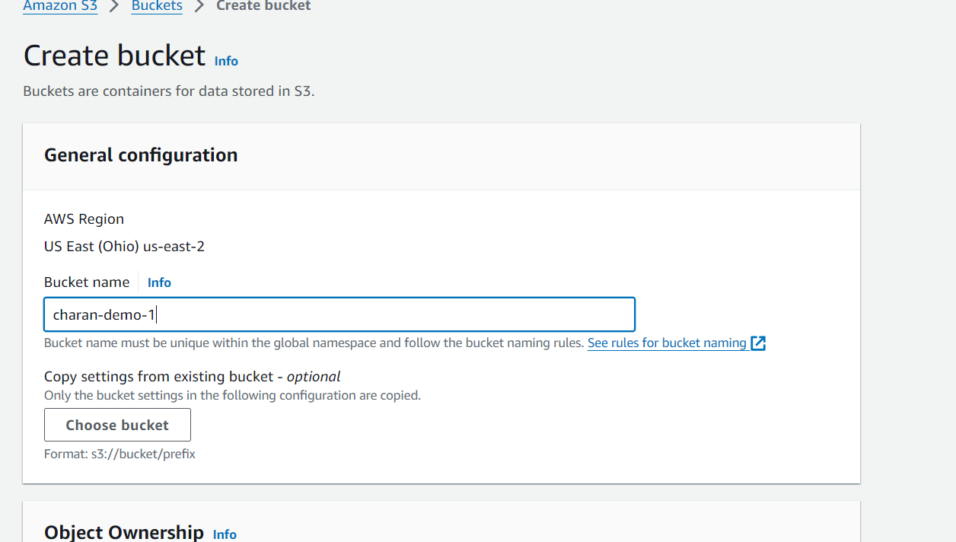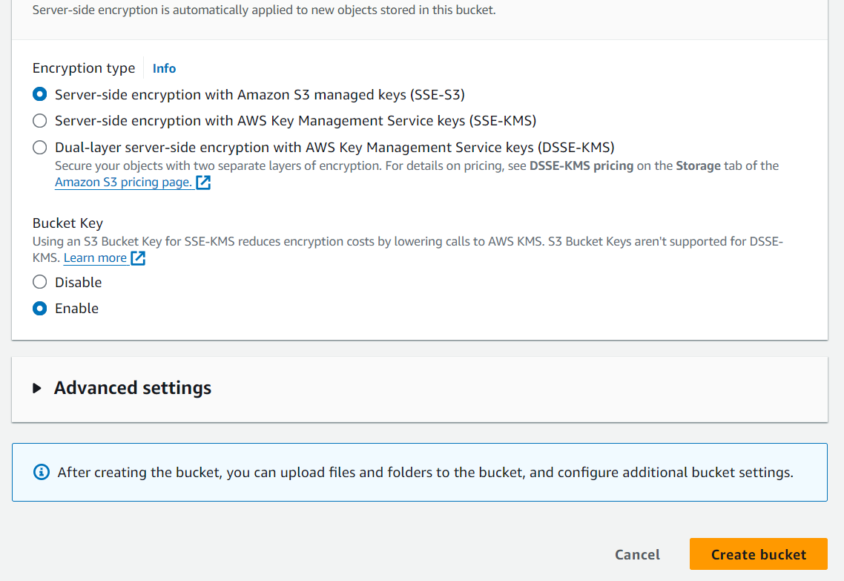

* Open S3 bucket and upload a file in the bucket

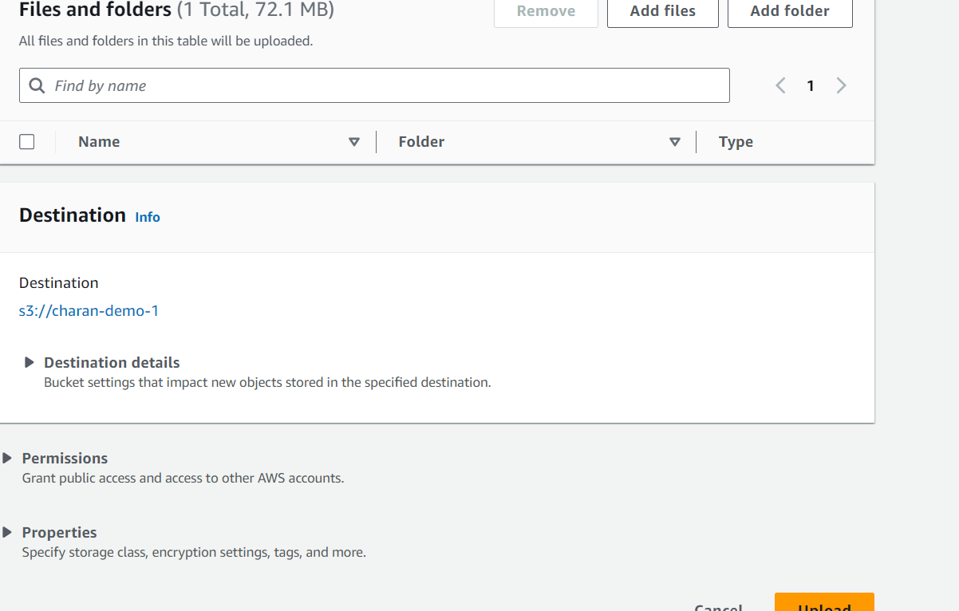

* After uploading to management inside the bucket
* Click on create Life cycle rules

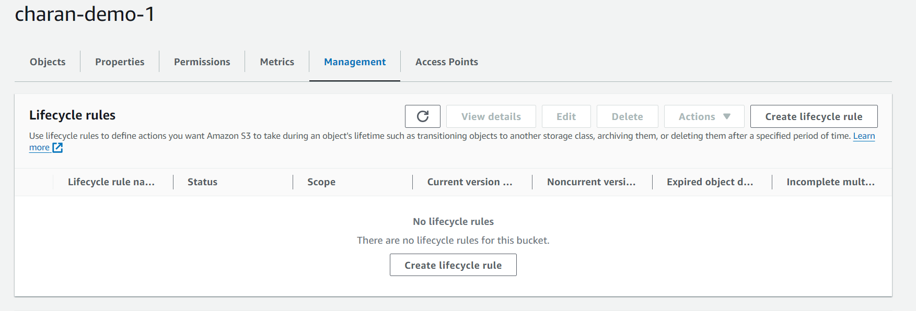

* Create Lifecycle rule name
* Choose a rule scope
* Apply to all objects in the bucket
* Acknowledge that this will apply to all objects

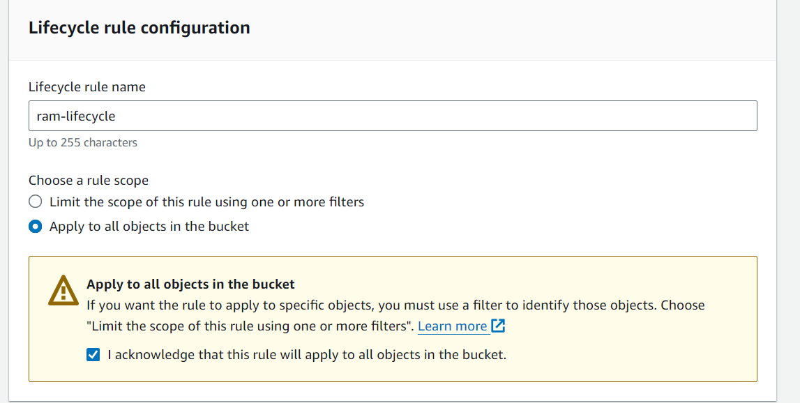

* **Lifecycle rule actions**
* Select move current versions of objects between storage classes

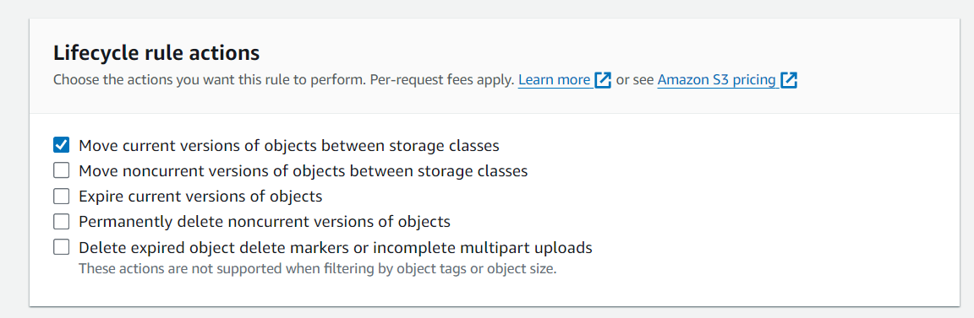

* **Transition current versions of objects between storage classes**

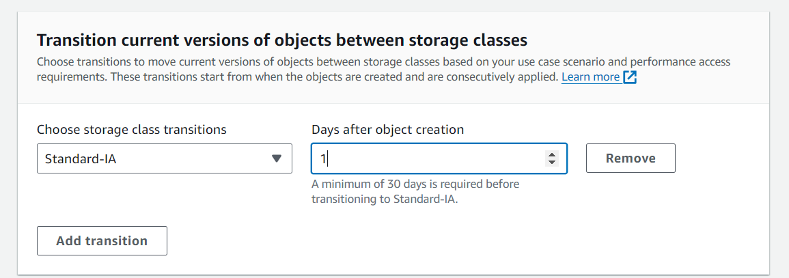

* Standard-IA should be minimum of 30 days
* Intelligent-Tiering should more than 30 days off standard-IA
* One Zone-IA should be more than 30 days off Intelligent-Tiering
* Glacier Flexible Retrieval should be more than 30 days off One-Zone-IA
* Glacier Deep Archive should be more than 90 days off Glacier Flexible Retrieval 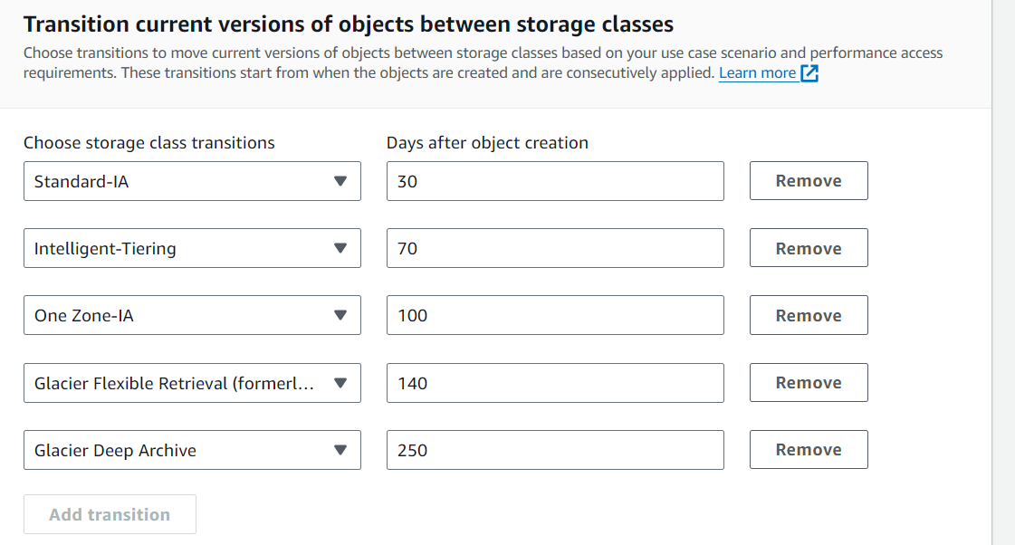
* Review transition and expiration actions

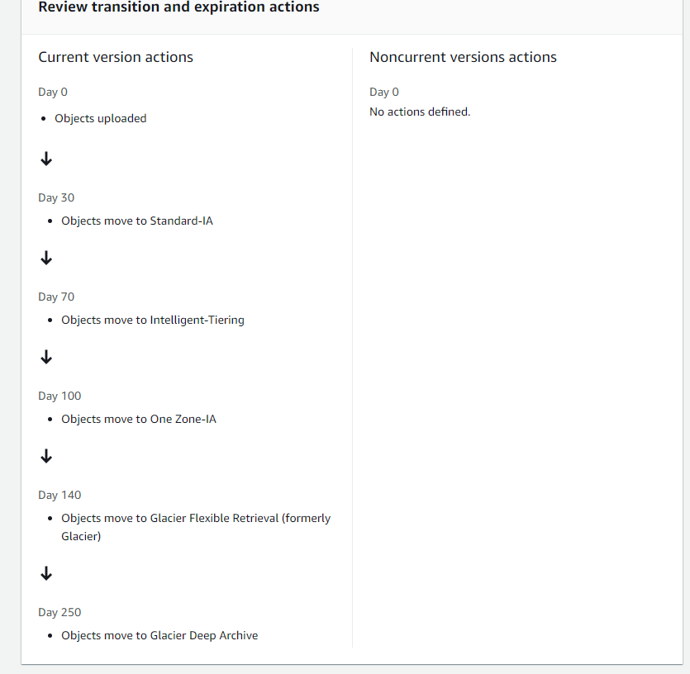

* Finally create rules

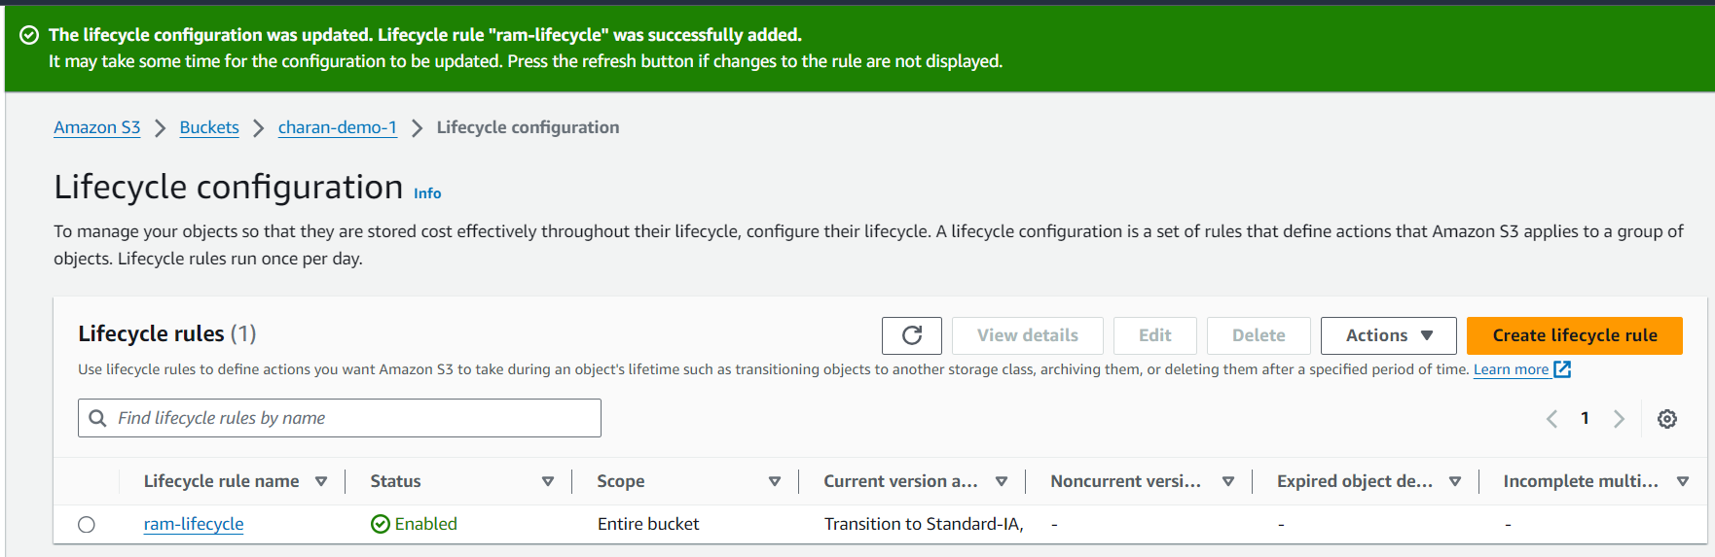

* Rules and review transitions & expiration actions
* After creating life cycle rule

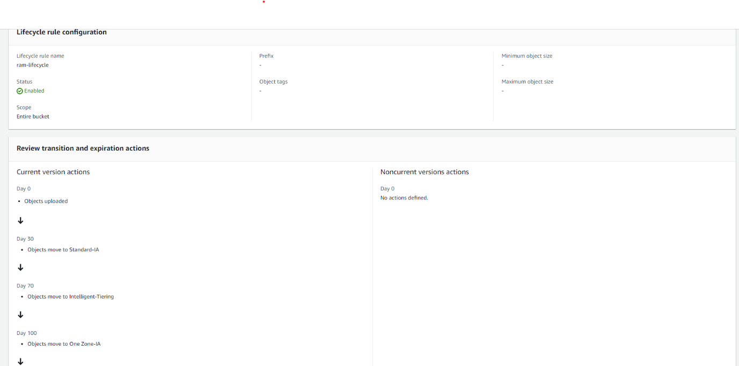

* ----------------END-----------------