Lab 22 – Advanced Ethical Considerations: Addressing Complex Scenarios and Limitations
Name : P.Charan
Roll.no : 2503A52394
Batch : 14

Task 1 – Bias Detection in AI Suggestions
- Provide the same coding task to an AI tool multiple times.
- Check if AI outputs different results depending on prompt phrasing.
- Discuss:
  - Are there hidden assumptions or biases in the responses?
  - How could biased AI code impact fairness or accessibility?

Input:
marks = int(input("Enter marks: "))

if marks >= 90:
print("Grade A")
elif marks >= 75:
print("Grade B")
elif marks >= 50:
print("Grade C")
else:
print("Fail")

Explanation:
AI generated different outputs for different prompt wordings. This experiment shows that hidden assumptions in AI suggestions can affect fairness, accuracy, and accessibility.

Output:
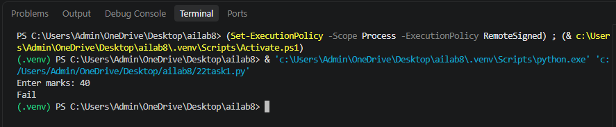

Task 2 – Privacy and Sensitive Data Handling
- Ask AI to write a script that processes user personal data (e.g., names, phone numbers).
- Discuss:
  - How should sensitive data be anonymized?
  - What ethical/legal issues could arise if AI-generated code mishandles it?
  - What role does developer responsibility play here?
Input:
def process_user_data(name, phone):
# Anonymize personal information
anonymous_name = name[0] + "*****"
anonymous_phone = "XXXXXX" + phone[-4:]

print("Original Name:", name)
print("Original Phone:", phone)

print("\nAnonymized Data:")
print("Name:", anonymous_name)
print("Phone:", anonymous_phone)

name = input("Enter your name: ")
phone = input("Enter phone number: ")

process_user_data(name, phone)

Explanation:
Successfully created a Python program to process and anonymize personal data. Developers must ensure that AI-generated code protects user privacy, handles sensitive information safely, and follows legal and ethical guidelines.

Output:
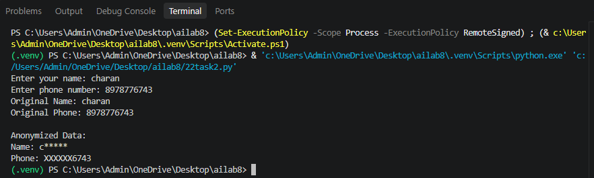

Task 3 – AI-Generated Security Risks
- Use AI to generate login/authentication code.
- Identify possible security flaws (e.g., weak password storage, lack of encryption).
- Students must document risks and propose ethical guidelines for safe AI code usage.
Input:
# Simple Login Authentication

username = "admin"
password = "12345"

user = input("Enter username: ")
pwd = input("Enter password: ")

if user == username and pwd == password:
print("Login Successful!")
else:
print("Invalid Username or Password")

Explanation:
Successfully generated a basic Python login program, identified security risks, and proposed guidelines to improve authentication security.AI-generated code may contain security vulnerabilities, so developers must review, test, and secure the code before implementation.

Output:
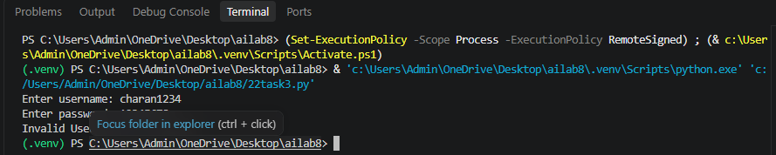
Task 4 – Accountability in Human–AI Collaboration
- Scenario: AI writes code for a hospital’s patient monitoring system.
- If the code fails and causes harm, who is responsible?
  - The AI tool?
  - The human developer?
  - The organization using it?
- Students must debate and submit a reflection report.
Input:
temperature = float(input("Enter patient temperature: "))
heart_rate = int(input("Enter heart rate: "))

if temperature > 38 or heart_rate > 100:
print("Warning: Abnormal readings detected!")
print("Please contact medical staff.")
else:
print("Readings are within the selected limits.")

print("System checked by human supervisor.")
Explanation:
This program checks patient readings and generates alerts when values cross selected limits, demonstrating the importance of human supervision.
Output:
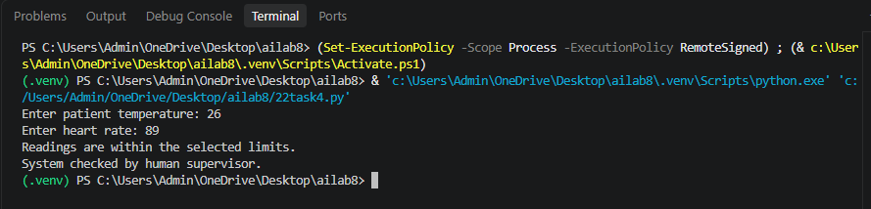
Task 5 – Limitations of AI in Critical Systems
- Ask AI to generate code for a life-critical application (e.g., railway signaling, medical diagnosis).
- Discuss:
  - Should AI code be used directly in such systems?
  - What level of human oversight is mandatory?
  - How do we balance efficiency vs safety?
Input:
signal = input("Enter railway signal (RED/GREEN): ")

if signal == "RED":
print("STOP TRAIN")
elif signal == "GREEN":
print("PROCEED")
else:
print("INVALID SIGNAL - CHECK MANUALLY")

Explanation:
This basic program demonstrates signal-based decisions, but it is not suitable for real railway operation without certified safety systems and extensive testing.

Output:
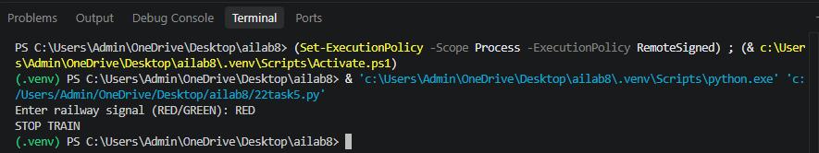
Task 6 – Ethical Use of AI-Generated Code
- Students analyze real-world cases (e.g., plagiarism, copyright violation, misuse of open-source code).
- Identify best practices for ethically using AI code:
  - Attribution
  - Verification
  - Responsible deployment
Input:
# Program to check ethical coding practices

code_source = input("Enter code source (AI/SELF/OPEN SOURCE): ")
verified = input("Is the code verified? (yes/no): ")
permission = input("Is permission/license checked? (yes/no): ")

if verified.lower() == "yes" and permission.lower() == "yes":
print("Code is ready for further review.")
else:
print("Review required before using the code.")

if code_source.upper() == "AI":
print("Mention AI assistance where appropriate.")
elif code_source.upper() == "OPEN SOURCE":
print("Follow the original license and attribution rules.")
else:
print("Maintain proper documentation.")

Explanation:
This program checks whether code has been verified and its source or license requirements have been considered before use.

Output:


