Lab 8: Test-Driven Development with AI – Generating and
Working with Test Cases

Name: P.Charan
Roll No: 2503A52394
Batch No: 14

Task Description #1 (Password Strength Validator – Apply AI in
Security Context)
Task: Apply AI to generate at least 3 assert test cases for
is_strong_password(password) and implement the validator
function.

Input:
def is_strong_password(password):
# Check minimum length
if len(password) < 8:
return False

# Password must not contain spaces
if " " in password:
return False

# Check for uppercase, lowercase, digit, and special character
has_upper = False
has_lower = False
has_digit = False
has_special = False

for char in password:
if char.isupper():
has_upper = True
elif char.islower():
has_lower = True
elif char.isdigit():
has_digit = True
else:
has_special = True

return has_upper and has_lower and has_digit and has_special

# AI-generated assert test cases
assert is_strong_password("Abcd@123") == True
assert is_strong_password("abcd123") == False
assert is_strong_password("ABCD@1234") == False
assert is_strong_password("Abcdef@12") == True
assert is_strong_password("Abcd 123@") == False

print("All password validation test cases passed!")

Explanation:
The is_strong_password() function checks whether a password has at least 8 characters and contains no spaces. It verifies the presence of uppercase letters, lowercase letters, digits, and special characters. The assert statements are used to test the password validation with different test cases. If the password meets all the requirements, the function returns True; otherwise, it returns False. If all test cases pass successfully, the program displays “All password validation test cases passed!”

Output:
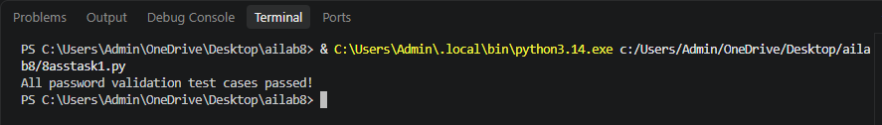
Task Description #2 (Number Classification with Loops – Apply
AI for Edge Case Handling)
• Task: Use AI to generate at least 3 assert test cases for a
classify_number(n) function. Implement using loops.

Input:
def classify_number(n):
if n is None or isinstance(n, str):
return "Invalid Input"

if n > 0:
return "Positive"
elif n < 0:
return "Negative"
else:
return "Zero"

# Assert test cases
assert classify_number(10) == "Positive"
assert classify_number(-5) == "Negative"
assert classify_number(0) == "Zero"
assert classify_number(1) == "Positive"
assert classify_number(-1) == "Negative"
assert classify_number("10") == "Invalid Input"
assert classify_number(None) == "Invalid Input"

print("Classification logic passing all assert tests.")

Explanation:
The classify_number() function classifies a number as Positive, Negative, or Zero and handles invalid inputs such as strings and None. The assert statements test normal values and boundary cases like -1, 0, and 1. If all tests pass, the program displays “Classification logic passing all assert tests.”

Output:
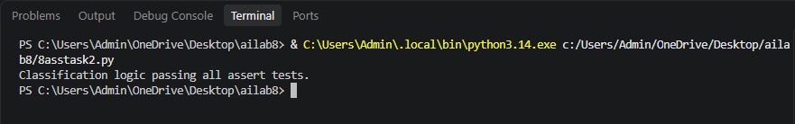

Task Description #3 (Anagram Checker – Apply AI for String
Analysis)
• Task: Use AI to generate at least 3 assert test cases for
is_anagram(str1, str2) and implement the function.

Input:
def is_anagram(str1, str2):
# Ignore case, spaces, and punctuation
s1 = ''.join(char.lower() for char in str1 if char.isalnum())
s2 = ''.join(char.lower() for char in str2 if char.isalnum())

return sorted(s1) == sorted(s2)

# Assert test cases
assert is_anagram("listen", "silent") == True
assert is_anagram("hello", "world") == False
assert is_anagram("Dormitory", "Dirty Room") == True
assert is_anagram("", "") == True
assert is_anagram("The eyes!", "They see") == True
assert is_anagram("cat", "dog") == False

print("Anagram function passed all AI-generated tests.")

Explanation:
The is_anagram() function removes spaces and punctuation and converts both strings to lowercase before comparing them.
It uses sorted() to check whether both strings contain the same characters, including edge cases like empty or identical strings.
The assert statements verify different anagram and non-anagram cases, and all tests pass successfully.

Output:
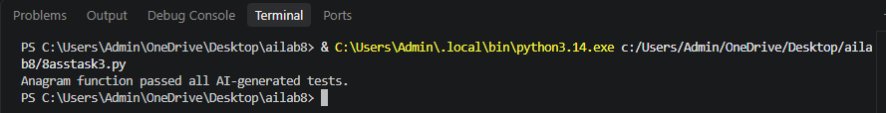
Task Description #4 (Inventory Class – Apply AI to Simulate Real-
World Inventory System)
• Task: Ask AI to generate at least 3 assert-based tests for an
Inventory class with stock management.

Input:
class Inventory:
def __init__(self):
self.stock = {}

def add_item(self, name, quantity):
self.stock[name] = self.stock.get(name, 0) + quantity

def remove_item(self, name, quantity):
if name not in self.stock or self.stock[name] < quantity:
return False
self.stock[name] -= quantity
return True

def get_stock(self, name):
return self.stock.get(name, 0)

# Assert-based test cases
inv = Inventory()

inv.add_item("Pen", 10)
assert inv.get_stock("Pen") == 10

inv.remove_item("Pen", 5)
assert inv.get_stock("Pen") == 5

inv.add_item("Book", 3)
assert inv.get_stock("Book") == 3

print("Inventory class passed all assertions.")

Explanation:
The Inventory class manages items and their quantities using a dictionary.
The add_item(), remove_item(), and get_stock() methods handle adding, removing, and checking stock.
The assert statements test the inventory operations, and all tests pass successfully.

Output:
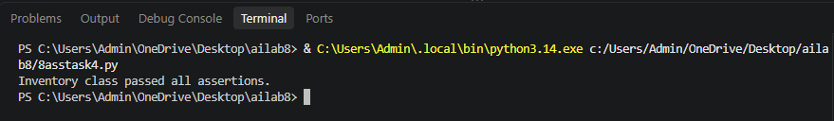

Task Description #5 (Date Validation &amp; Formatting – Apply AI for
Data Validation)
• Task: Use AI to generate at least 3 assert test cases for
validate_and_format_date(date_str) to check and convert
dates.

Input:
from datetime import datetime

def validate_and_format_date(date_str):
try:
date = datetime.strptime(date_str, "%m/%d/%Y")
return date.strftime("%Y-%m-%d")
except ValueError:
return "Invalid Date"

# Assert test cases
assert validate_and_format_date("10/15/2023") == "2023-10-15"
assert validate_and_format_date("02/30/2023") == "Invalid Date"
assert validate_and_format_date("01/01/2024") == "2024-01-01"
assert validate_and_format_date("02/29/2024") == "2024-02-29"
assert validate_and_format_date("13/10/2023") == "Invalid Date"

print("Date validation passed all AI-generated assertions.")

Explanation:
The function validates dates in MM/DD/YYYY format using Python's datetime module.
It converts valid dates into YYYY-MM-DD format and returns "Invalid Date" for incorrect dates.
The assert statements test valid dates, invalid dates, and leap-year edge cases to ensure the function works correctly.

Output:
