Deliverable 5: Object Relational Mapping

By: Team

( Brogan Young , Victor Elujinmi, Charan Ramachandra, Tristan McIntosh)

CSCI 4050

Dr. Eman Saleh

October 20, 2020

# INTRODUCTION

The following document is intended to map the objects and relationships between them for our online bookstore system. First will be the class diagrams, which will show the different attributes of each class and the methods they use to interact with each other, as well as the relationships between the classes themselves. These will include inheritance, association, multiplicity, and composition. After that will be the Entity Relationship Schema, which will help us further explore these attributes and relationships. The ERD will help us identify primary keys, which are unique identifying attributes of a class object that differentiate between the objects of that class. This schema will also help show which attributes of which classes directly relate to the other classes, and which methods they use to do so, these being called foreign keys. We will map out the relationships here, and from this generate the database dictionary, which is a dictionary of different aspects of the database. This includes what is in the database, who is allowed to access which information, and where the database if physically stored, among other things. This will show how things are meant to run on a very deep level that the customer should never know and/or see. Ultimately, this document is here to visualize the classes in the online bookstore system. This allows us to look at some of the different layers of the bookstore system, so that when it is implemented it is possible to see how it came together. Also, the visualization of the classes helps us initially set up the database and helps remind us how everything is connected when we start to build everything.

**Class Diagram**

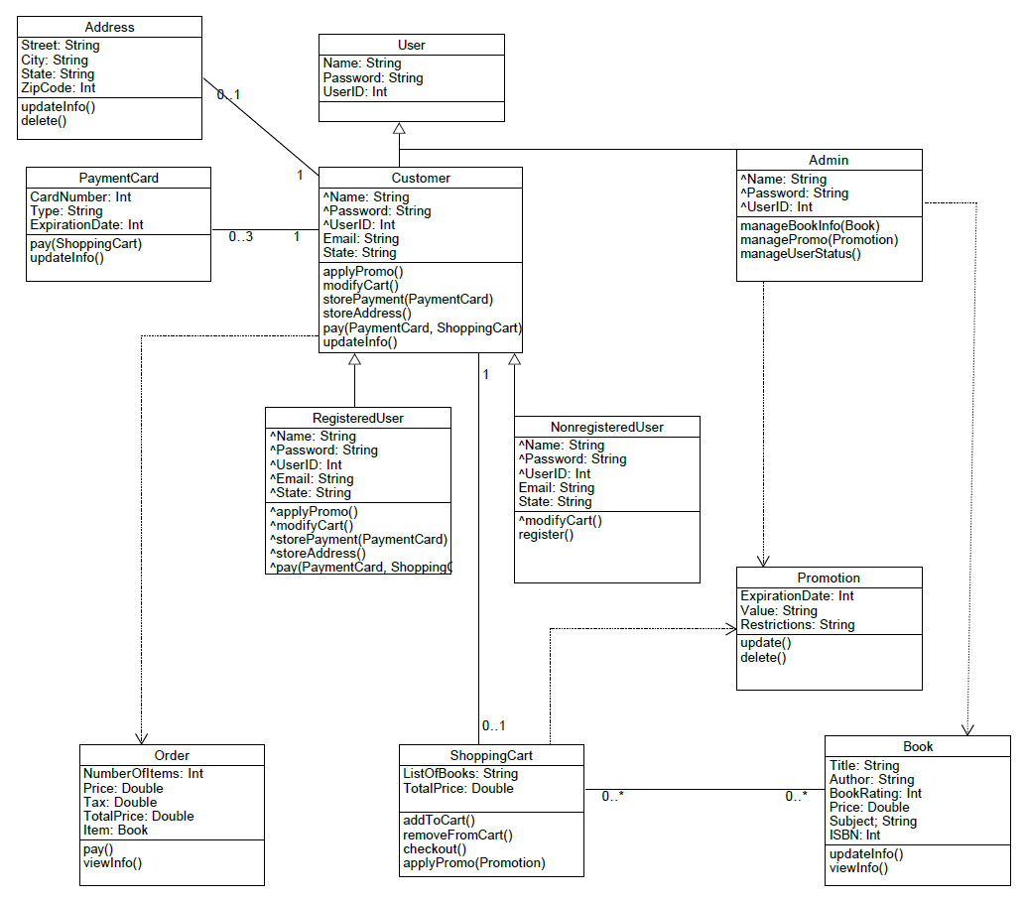

**Entity Relationship Diagram (ERD)**

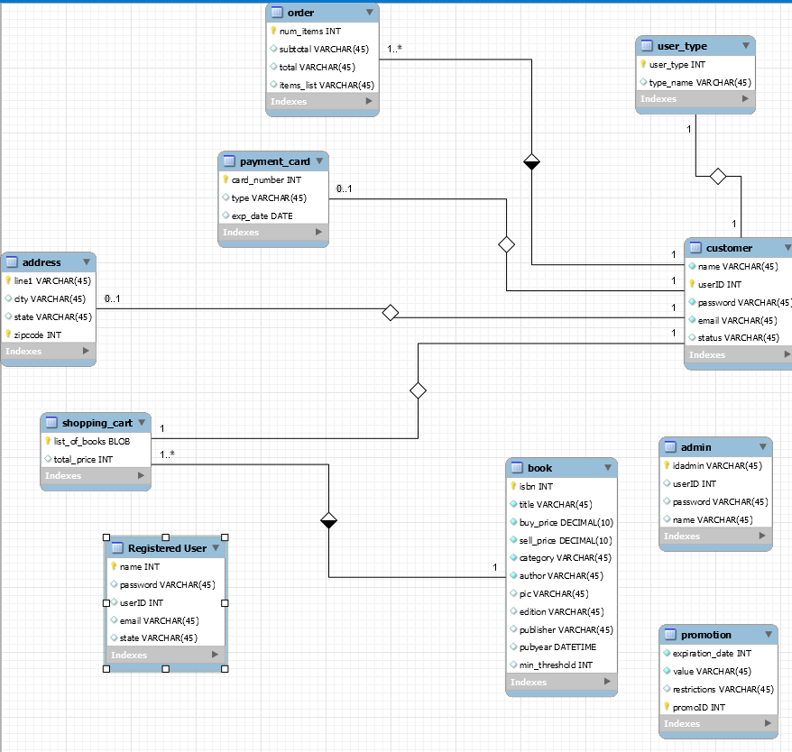

**Database Dictionary**

**Schema Report for database: mydb**

Table List

* book
* promotion
* shopping_cart
* customer
* order
* admin
* address
* user_type
* payment_card
* Registered User

|  |  |  |  |  |  |  |
| --- | --- | --- | --- | --- | --- | --- |
| **Table: book** | | | | | | |
| Table Comments |  | | | | | |
| Columns | | | | | | |
| **Name** | **Data Type** | **Nullable** | **PK** | **FK** | **Default** | **Comment** |
| isbn | INT | Yes | Yes | No |  |  |
| title | VARCHAR(45) | Yes | No | No |  |  |
| buy_price | DECIMAL(10) | Yes | No | No |  |  |
| sell_price | DECIMAL(10) | Yes | No | No |  |  |
| category | VARCHAR(45) | Yes | No | No |  |  |
| author | VARCHAR(45) | Yes | No | No |  |  |
| pic | VARCHAR(45) | No | No | No |  |  |
| edition | VARCHAR(45) | No | No | No |  |  |
| publisher | VARCHAR(45) | No | No | No |  |  |
| pubyear | DATETIME | No | No | No |  |  |
| min_threshold | INT | No | No | No |  |  |

Table List

|  |  |  |  |  |  |  |
| --- | --- | --- | --- | --- | --- | --- |
| **Table: promotion** | | | | | | |
| Table Comments |  | | | | | |
| Columns | | | | | | |
| **Name** | **Data Type** | **Nullable** | **PK** | **FK** | **Default** | **Comment** |
| expiration_date | INT | Yes | No | No |  |  |
| value | VARCHAR(45) | Yes | No | No |  |  |
| restrictions | VARCHAR(45) | No | No | No |  |  |
| promoID | INT | Yes | Yes | No |  |  |

Table List

|  |  |  |  |  |  |  |
| --- | --- | --- | --- | --- | --- | --- |
| **Table: shopping_cart** | | | | | | |
| Table Comments |  | | | | | |
| Columns | | | | | | |
| **Name** | **Data Type** | **Nullable** | **PK** | **FK** | **Default** | **Comment** |
| list_of_books | BLOB | Yes | Yes | No |  |  |
| total_price | INT | No | No | No |  |  |

Table List

|  |  |  |  |  |  |  |
| --- | --- | --- | --- | --- | --- | --- |
| **Table: customer** | | | | | | |
| Table Comments |  | | | | | |
| Columns | | | | | | |
| **Name** | **Data Type** | **Nullable** | **PK** | **FK** | **Default** | **Comment** |
| name | VARCHAR(45) | Yes | No | No |  |  |
| userID | INT | Yes | Yes | No |  |  |
| password | VARCHAR(45) | Yes | No | No |  |  |
| email | VARCHAR(45) | Yes | No | No |  |  |
| status | VARCHAR(45) | No | No | No |  |  |

Table List

|  |  |  |  |  |  |  |
| --- | --- | --- | --- | --- | --- | --- |
| **Table: order** | | | | | | |
| Table Comments |  | | | | | |
| Columns | | | | | | |
| **Name** | **Data Type** | **Nullable** | **PK** | **FK** | **Default** | **Comment** |
| num_items | INT | Yes | Yes | No |  |  |
| subtotal | VARCHAR(45) | No | No | No |  |  |
| total | VARCHAR(45) | No | No | No |  |  |
| items_list | VARCHAR(45) | No | No | No |  |  |

Table List

|  |  |  |  |  |  |  |
| --- | --- | --- | --- | --- | --- | --- |
| **Table: admin** | | | | | | |
| Table Comments |  | | | | | |
| Columns | | | | | | |
| **Name** | **Data Type** | **Nullable** | **PK** | **FK** | **Default** | **Comment** |
| idadmin | VARCHAR(45) | Yes | Yes | No |  |  |
| userID | INT | No | No | No |  |  |
| password | VARCHAR(45) | No | No | No |  |  |
| name | VARCHAR(45) | No | No | No |  |  |

Table List

|  |  |  |  |  |  |  |
| --- | --- | --- | --- | --- | --- | --- |
| **Table: address** | | | | | | |
| Table Comments |  | | | | | |
| Columns | | | | | | |
| **Name** | **Data Type** | **Nullable** | **PK** | **FK** | **Default** | **Comment** |
| line1 | VARCHAR(45) | Yes | Yes | No |  |  |
| city | VARCHAR(45) | No | No | No |  |  |
| state | VARCHAR(45) | No | No | No |  |  |
| zipcode | INT | Yes | Yes | No |  |  |

Table List

|  |  |  |  |  |  |  |
| --- | --- | --- | --- | --- | --- | --- |
| **Table: user_type** | | | | | | |
| Table Comments |  | | | | | |
| Columns | | | | | | |
| **Name** | **Data Type** | **Nullable** | **PK** | **FK** | **Default** | **Comment** |
| user_type | INT | Yes | Yes | No |  |  |
| type_name | VARCHAR(45) | No | No | No |  |  |

Table List

|  |  |  |  |  |  |  |
| --- | --- | --- | --- | --- | --- | --- |
| **Table: payment_card** | | | | | | |
| Table Comments |  | | | | | |
| Columns | | | | | | |
| **Name** | **Data Type** | **Nullable** | **PK** | **FK** | **Default** | **Comment** |
| card_number | INT | Yes | Yes | No |  |  |
| type | VARCHAR(45) | No | No | No |  |  |
| exp_date | DATE | No | No | No |  |  |

Table List

|  |  |  |  |  |  |  |
| --- | --- | --- | --- | --- | --- | --- |
| **Table: Registered User** | | | | | | |
| Table Comments |  | | | | | |
| Columns | | | | | | |
| **Name** | **Data Type** | **Nullable** | **PK** | **FK** | **Default** | **Comment** |
| name | INT | Yes | Yes | No |  |  |
| password | VARCHAR(45) | No | No | No |  |  |
| userID | INT | No | No | No |  |  |
| email | VARCHAR(45) | No | No | No |  |  |
| state | VARCHAR(45) | No | No | No |  |  |

Table List