AGILE:- It is a SDLC methodology to develope a product in

company. It uses Spiral + RAD methods in developement, ie devide and develope parallel.

It this process Roles of persons :

1)Business Analyst.(BA)

2)Developer (DEV)

3)Quality Analyst.(QA)

4)Architecture (Arch.)

-----------------------

1)Epic: End client/customer provides all his requirements to BA. BA prepares the document (known as EPIC). Which contains functional and technical requirements. It is like a reference book to product/project. We need to develop only points provided in document(not more or less) This document needs a final review by End Client and approval by Product Owner.

2)Epic Conversion:- Epic will be devided into 2 parts initially. Those are

>i)Highe level Design/Document

>ii)Low level Design/Document

HLDs are constructed for End User(for product understand and usage) and LLDs are done for Programmer View.

-----------------------------

3)Scrum Team:- To develop the product Owner creates a Team with DEV,BA,QA & Arch with MASTER and Leads.

----------------------------

4)Story creations: A story is a part of project, It can be a module/sub module/task/sub task. A story can

be combination of modules/tasks also.

\*)Size and limits of Stories are defined by BAs.

\*)Each story Contains "Acceptance Criteria" ie what to implement for given story in point by point to Dev/QA/Arch given by BA.

-------------------------

5)Story points Calculations:

Time taken to develope a story is known as "Efforts Estimations". These are guess values(Not exact) given by team members.

1 Story point = 8 Hours

0.5 Story point = 4 Hours

\*)ex: Story-8560 needs 4.5 story points total time (hours)is:36

---------------------------

6)Sprint Planning:- "For a period of time what stories we need to implement" is decided in a meeting. ie known as Sprint Planning. A sprint is known as milestone/small release/targets. In this meeting BA explains about story to all others. They should understand and provide efforts for those.

\*)A sprint can be planned for 10 days,15 days, 1 month... (based on company & project)

\*)At a time we can not plan for all stories. for example, in our project we have 100 stories and we

planned as below:

> Sprint-1 (Story 1 to 12) for 15 days.

> Sprint-2 (Story 13 to 32) for 25 days.

> Unplanned stories comes under product backlogs (Story 33 to 100).

> In Sprint-1 we planed for for 12 Stories, but only 10 are finished after 15 days then, 2 will be moved to Product backlogs.

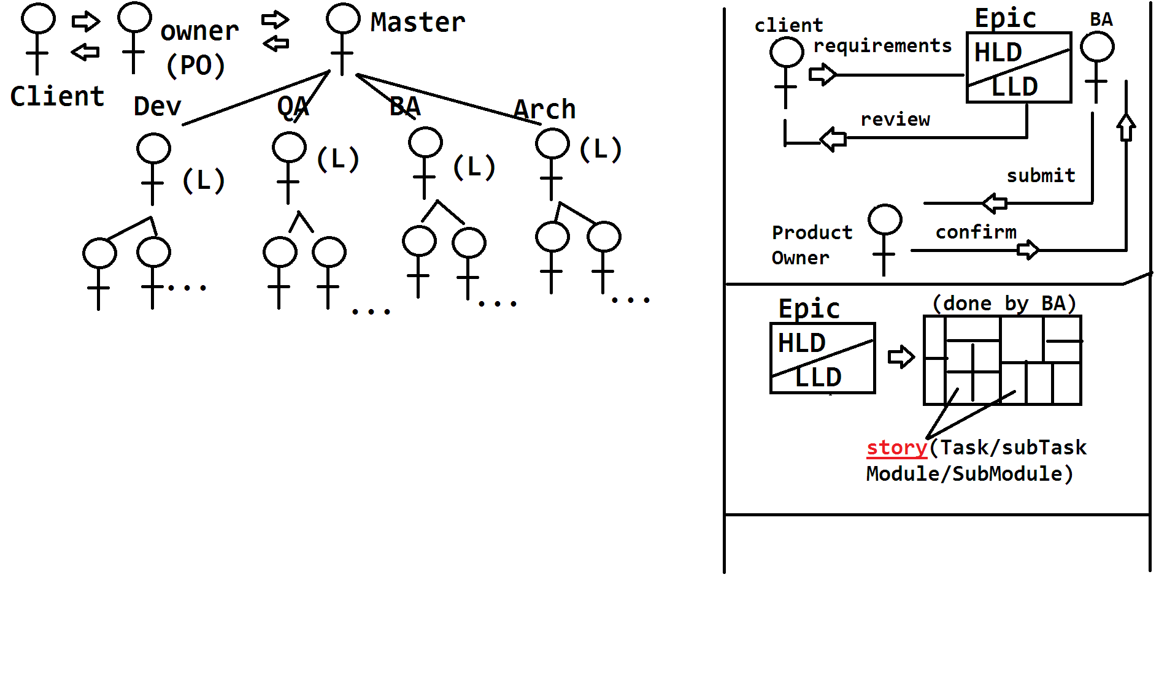

\*)Sprint Evalutation:-

---------------------

From Day-1 coding/implementation is started by developer.

\*)To implement any story dev has to code and Test from his side. To represent work status of a story, we follow Story life cycle. Shown as below,

(possible values are: Open->In Progress->Resolved ->Closed or Re-Open)

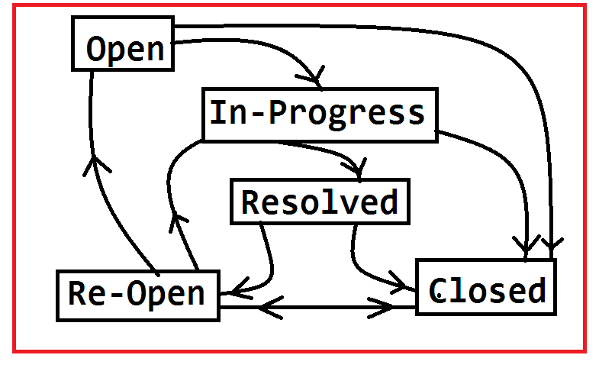

.............

\*)Open: Every developer gets story in Open Status, which indicates ready to start (ready for coding)

\*)In-Progress: Which indicates story is under implementation (ie coding is started)

\*)Resolved: Indicates Coding and UnitTesting is done. Code is available in Repository (ex: GIT).

\*)Closed: Once Testing done by QA and working fine, then story status will be Closed.

\*)Re-Open : If code contains Bugs,then story is not complete which will be converted to Re-Open and QA creates a BUG with below priority levels.

1)Blocker: Unable to do any process.

2)Critical: High level problem (But not stoping complete process)

3)Major: Normal/Medium problem (Stoping in one way/ otherpossible processing ways are available)

4)Minor: Small problem or occurs very rare.

5)Tirvial: Ignorable problem. not makes any problem in process.

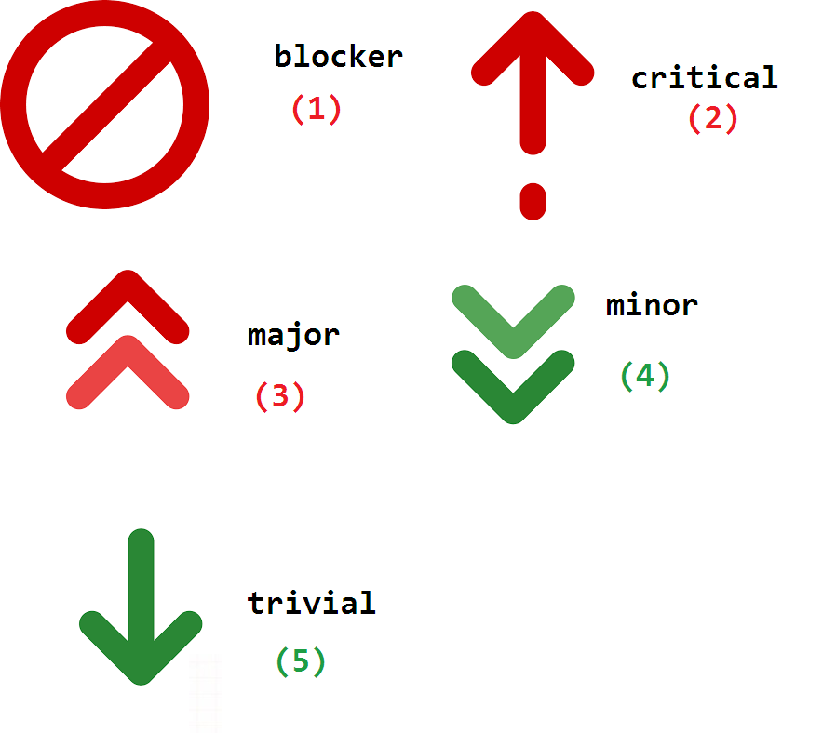

-------------

\*)Bug/Defect Life cycle:- While developing a story, it may contain problems (bug) or it is incomplete then QA identifies the bug and reports to Developer. ex: Bug-32( Critical): Email is not sending while vendor registration. Attached to Story-54(Vendor Registration).

\*)Developer checks bug and validates , if valid starts finxing else reject the bug.

\*)Life Cycle :-

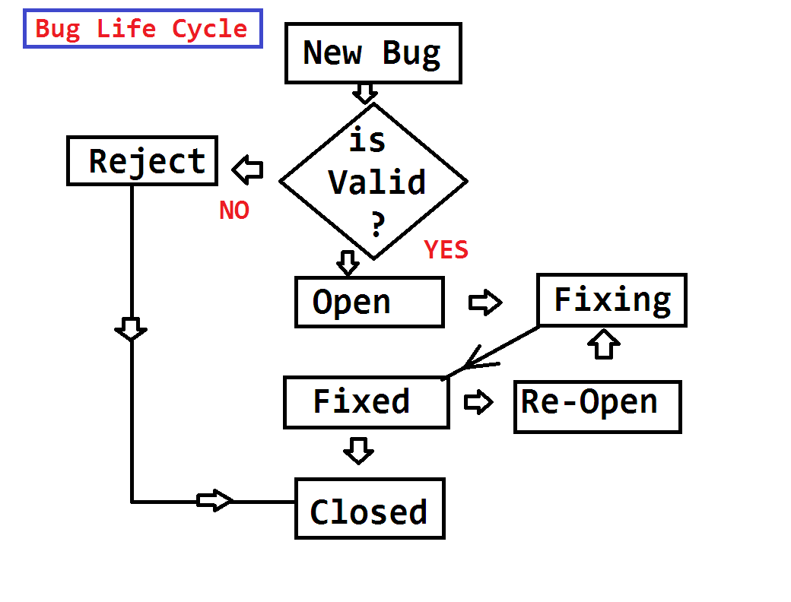

\*)BurnDown Chart:-

This is a global chart, constructed to represent status of the sprint/Sprints. UptoDate what % of work done is shown by this chart. If one story is finished, then it shows -value ex: -3.25 points. At end all stories should be finished. +ve value indicates Work is re-opened.

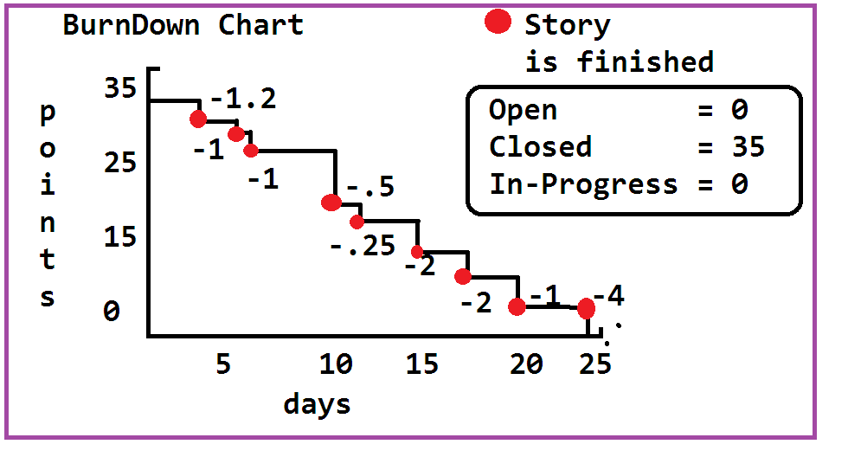

\*)Scrum Meetings:-

On Starting Sprint, every day we need to provide status updates to Scrum Master. For this every day meeting is taken by master mostly 15-20 mins. ex: 10:45 to 11:00 AM. some times 3:00 to 3:25 PM. In this meeting we need to tell "what we did yester day, what we will do today and tomorrow".

