

FINAL REPORT OF WEB DEVELOPMENT OF

INTERNET BANKING

SUBMITTED BY:

K Charan(11701131)

V Sairaj(11706658)

K Shiva Krishna Reddy

(11701132)

**INTRODUCTION**

**Online banking**, also known as **internet banking**, is an electronic payment system that enables customers of a bank or other financial institution to conduct a range of financial transactions through the financial institution's website. The online banking system will typically connect to or be part of the core banking system operated by a bank and is in contrast to branch banking which was the traditional way customers accessed banking services.

"A Internet corporation is a temporary network of independent company’s suppliers, customers by information technology to share skills, costs, and access to one another's markets. This corporate model is fluid and flexible- a group of collaborators that quickly unite to exploit a specific opportunity. Once the opportunity is met, the venture will, more often than not, disband. In the concept's purest form, each company that links up with others to create a Internet corporation contributes only what it regards as its core competencies. Technology plays a central role in the development of the Internet corporation. Teams of people in different companies work together, concurrently rather than sequentially, via computer networks in real time." 16 The Internet corporation to be a 'must have' road map for every corporation that will soon find itself, its members and most importantly, its customers, living, working and shopping in a Internet world.

There are five basic dimensions that organizations can virtually organize and each dimension is a continuum from physical to virtual.

• Location

• Organizational interfaces or boundaries

• Organizational processes

• Organizational structures

• Products / services

CONCEPT OF INTERNET BANKING:

The concept of virtualization play a vital role to transform banking industry from paper banking to paperless banking which will majorly benefit the customers of banking industry.

Internet Banking works as a milestone to achieve the customer satisfaction towards the services provided by commercial banks. Internet Banking is a type of banking which allowed customers to access their financial and banking services via internet world wide web. It’s called a Internet Banking because a Internet bank has no boundaries of brick and mortar and exists only on the internet. With cybercafés and kiosks springing up in different cities, access to the Internet Banking is going to be easy.

Internet Banking is a development of computer banking format that is rapidly growing in popularity. It is not restricted to a specific computer, as there is no need for the customer to have any financial software program installed on the computer in order to conduct banking over the internet. Instead of establishing a direct link between the customer’s own pc and the bank via a modem, the World Wide Web is used as a distribution and communication channel to the bank.

This implies that Internet Banking may be cost-efficient and a convenient banking format for many customers. It can be expected to generate its main benefits from retail services such as short-term lending, deposits, cash management including card payments, pre-scheduled payments for electricity, insurance, housing, etc. In those cases, traditional manual operations within the bank are being replaced by online ones performed by the customers themselves.

TECHNOLOGY USED

* HTML
* CSS
* JAVASCRIPT

LOGIN PAGE

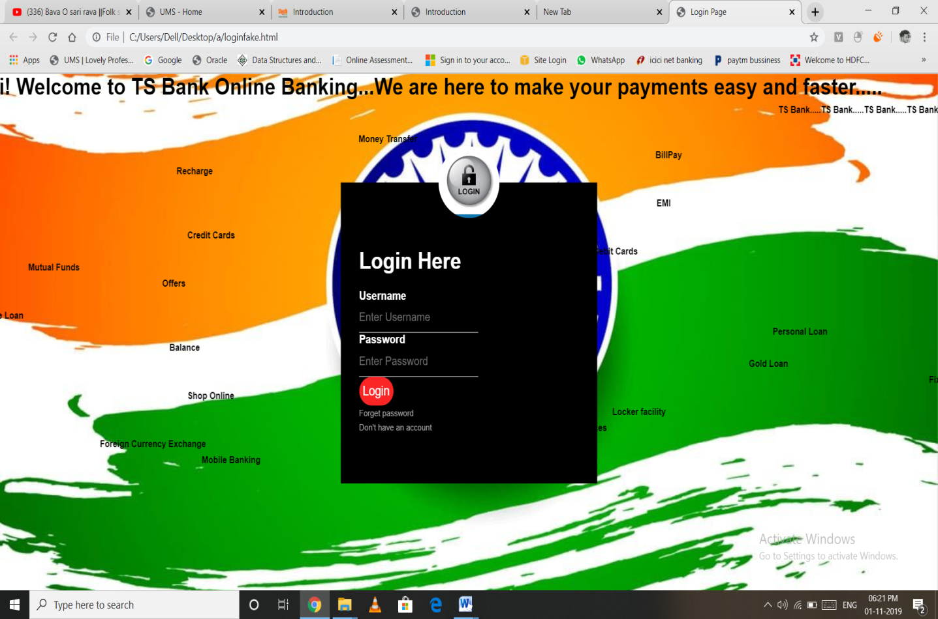

HOME PAGE

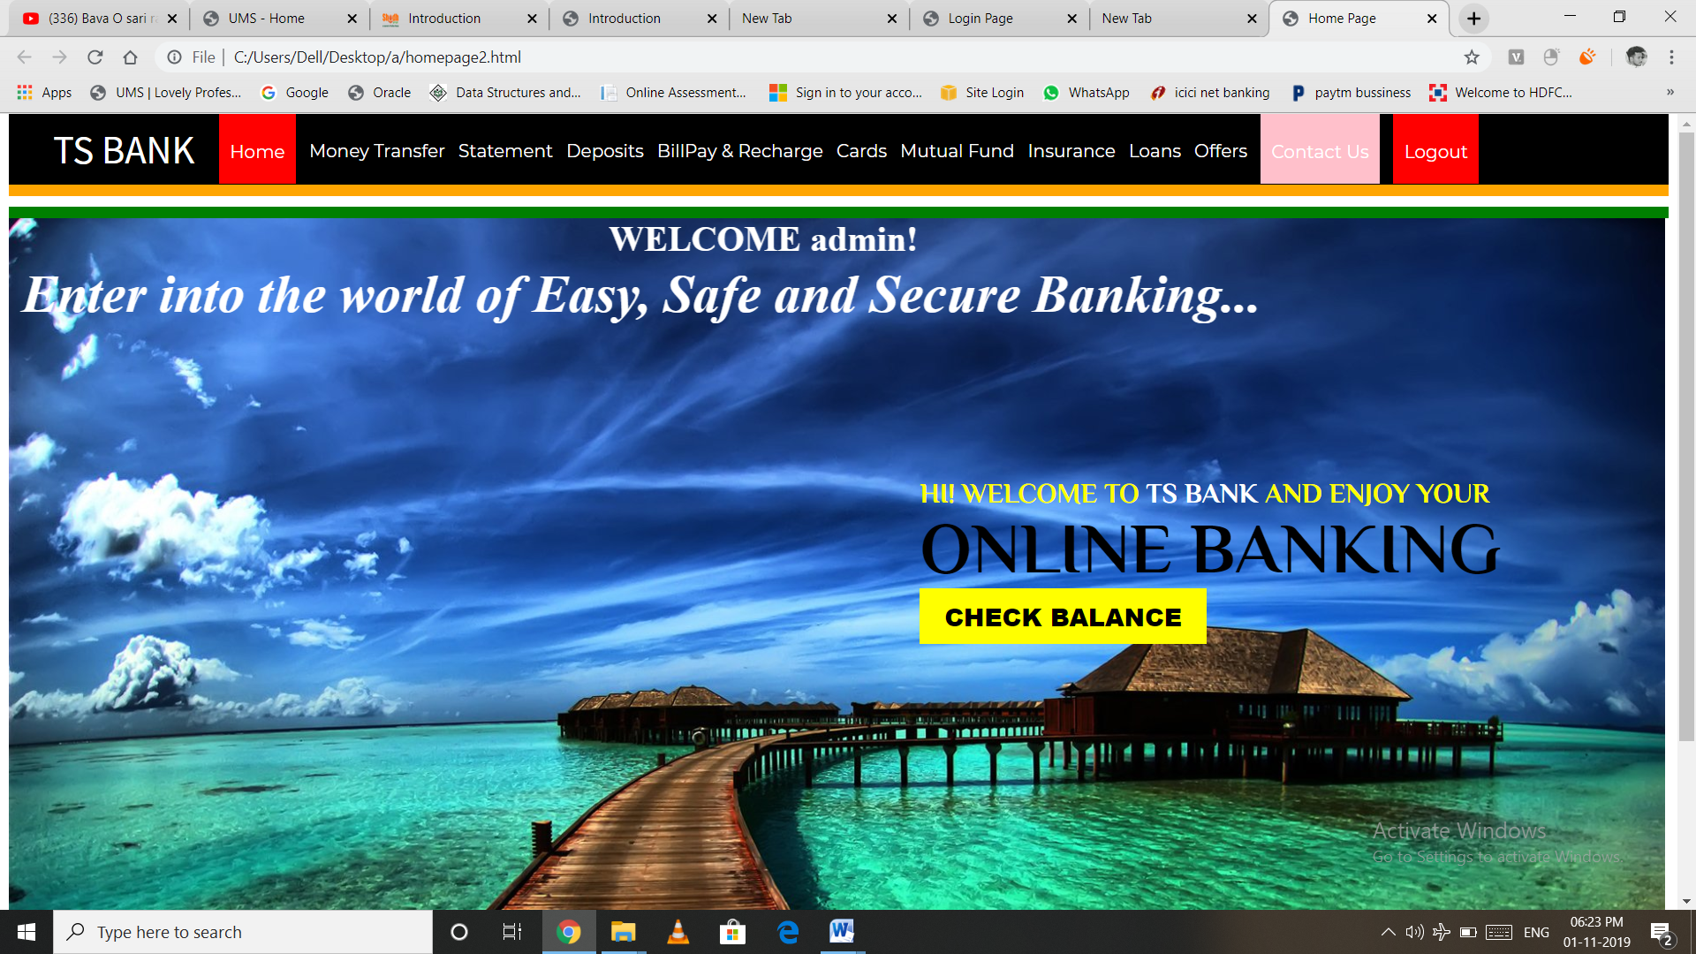

MONEY TRANSFER

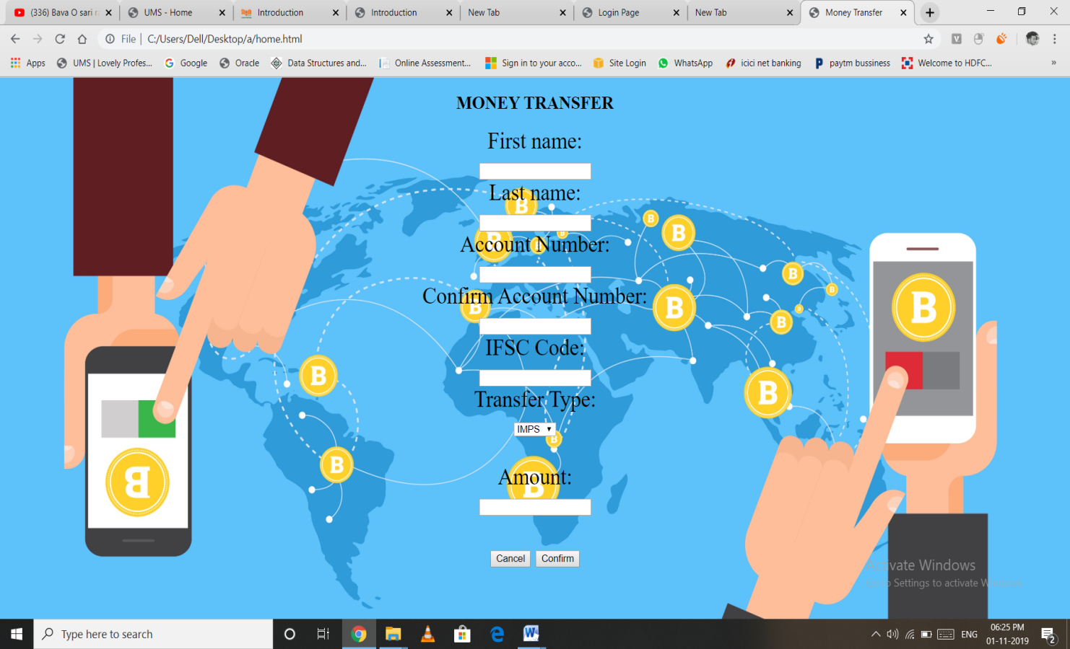

TYPES OF INTERNET BANKING:

Banking industry is continuously increasing their product day by day, by which banks are transfering from real to Internet very speedily. Banks divided Internet Banking products into 3 types based on the levels of access granted

This type of banking provides general purpose information like interest rates, branch location, bank products and their features, loan and deposit calculations are provided in the banks website. There exist facilities for downloading various types of application forms. The communication is normally done through e-mail. There is no interaction between the customer and bank's application system. No identification of the customer is done. In this system, there is no possibility of any unauthorized person getting into production systems of the bank through internet

ELECRTRONIC INFORMATION TRANSFER SYSTEM:

In this type of banking the system provides customer-specific information in the form of account balances, transaction details, and statement of accounts. The information is still largely of the 'read only' format. Identification and authentication of the customer is through password. The information is fetched from the bank's application system either in batch mode or off-line. The application systems cannot directly access through the internet.

This system allows bi-directional capabilities. Transactions can be submitted by the customer for online update. This system requires high degree of security and control. In this environment, web server and application systems are linked over secure infrastructure. It covering Computerization, Networking and secure payment gateway.

Internet Banking, ATM, Phone Banking, Mobile Banking, Smart Cards, are the types of fully electronics transactional system. Internet Banking: Tremendous growth of Internet during the mid- nineties prompted banks to utilize Internet as a medium for offering banking services. Internet Banking involves consumers using the internet to access their bank account and to undertake banking transactions. At the basic level, Internet banking can mean the setting up of web page by bank to give information about its product and services. At an advance level, it involves provision of facilities such as accessing accounts, fund transfer, and buying financial products or services online. This is called “transactional” online banking. There are two ways to offer of Internet banking. First, an existing bank with physical offices can establish a website and offer Internet banking in addition to its traditional delivery channels. Second, a bank may be established as a “branchless, Internet only or Internet bank” without any physical branch

ADVENTAGES:

Benefits of Internet Banking Advantages previously held by large financial institutions have shrunk considerably. The internet has level led the playing field and afforded open access to customers in the global marketplace. Internet Banking is a costeffective delivery channel for financial institutions. Consumers are embracing the many benefits of Internet Banking. Access to one's accounts at anytime and from any location via the World Wide Web is a convenience unknown a short time ago. Thus, a bank's Internet presence transforms from 'brochure ware' status to 'Internet banking' status once the bank goes through a technology integration effort to enable the customer to access information about his or her specific account relationship.

The six primary drivers of Internet Banking includes, in order of primacy are: • Improve customer access

• Facilitate the offering of more services

• Increase customer loyalty

• Attract new customers

• Provide services offered by competitors

• Reduce customer attrition

**Disadvantages:**

* If Internet connection fails, this system won’t work.
* All e-banking websites related data will be stored in one place.

**Software Requirements:**

* Windows 7 or higher
* Microsoft SQL Server 2008
* Visual Studio 2010

**Hardware Components:**

* Processor –Core i3
* Hard Disk – 160 GB
* Memory – 1GB RAM
* Monitor