ASSIGNMENT 7
DVWA Installation + Vulnerability Discovery

Step 1 - DVWA Installation
Installed DVWA on Kali using apt and started service.
Commands:
sudo apt update sudo apt install dvwa sudo dvwa-start
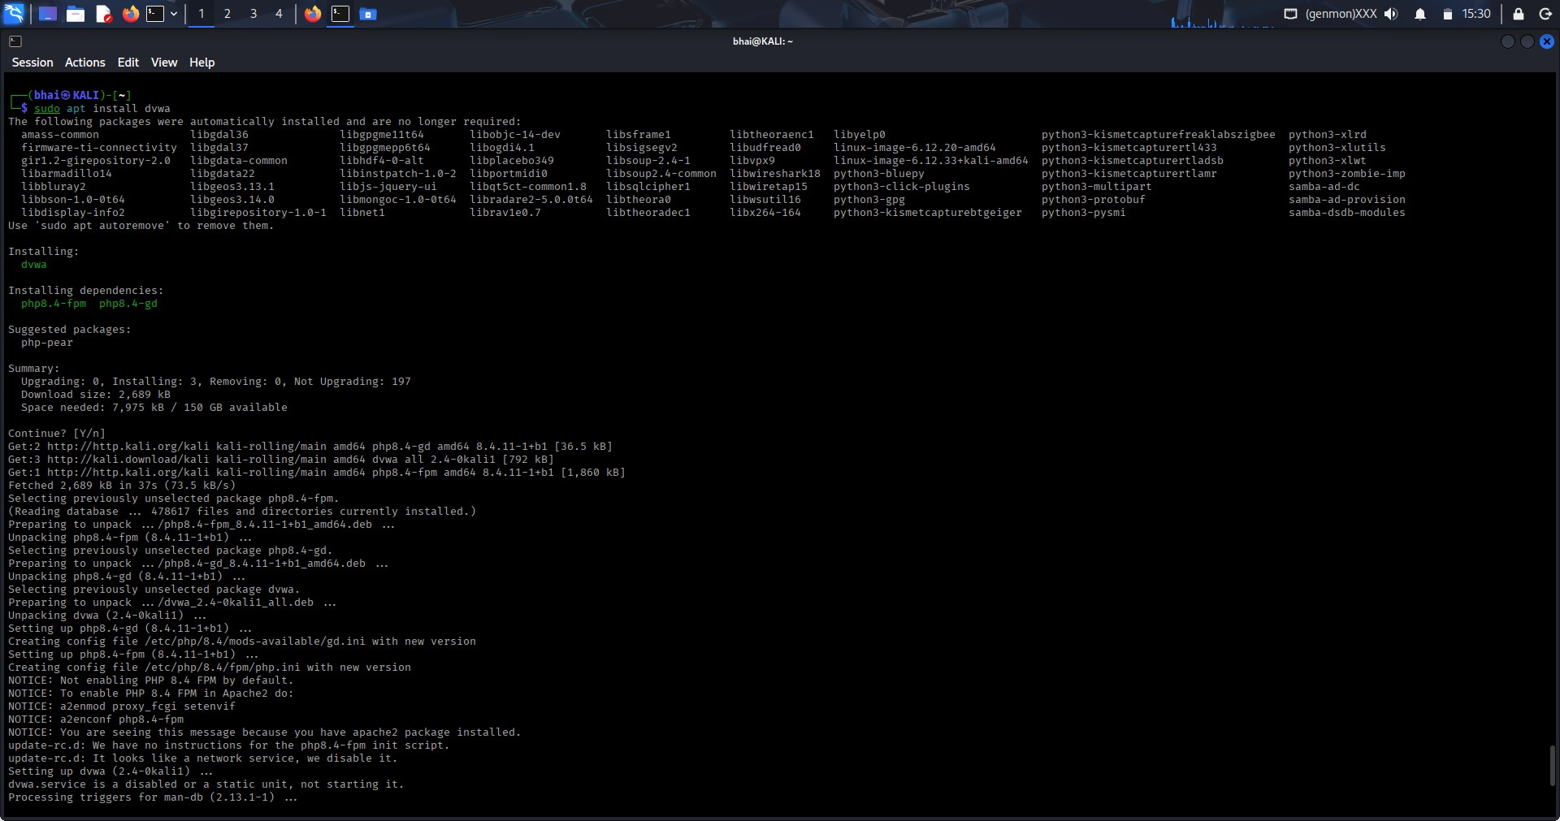
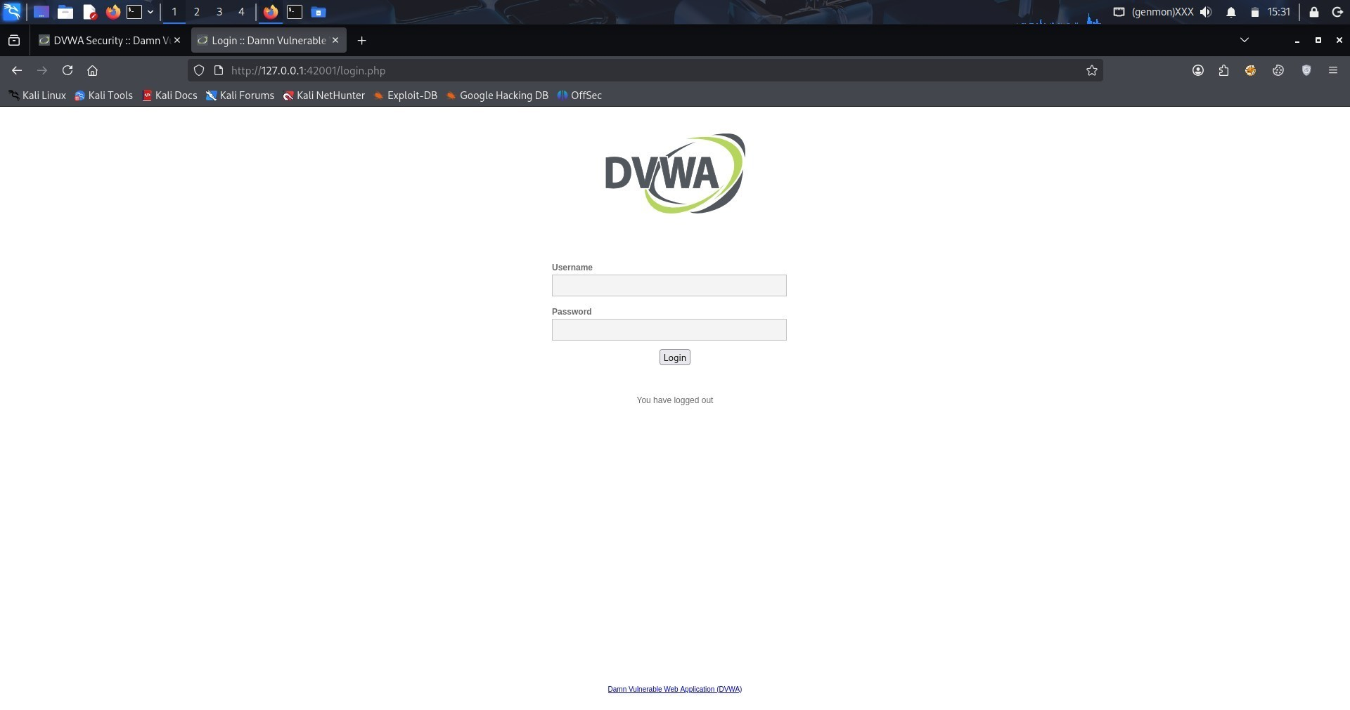
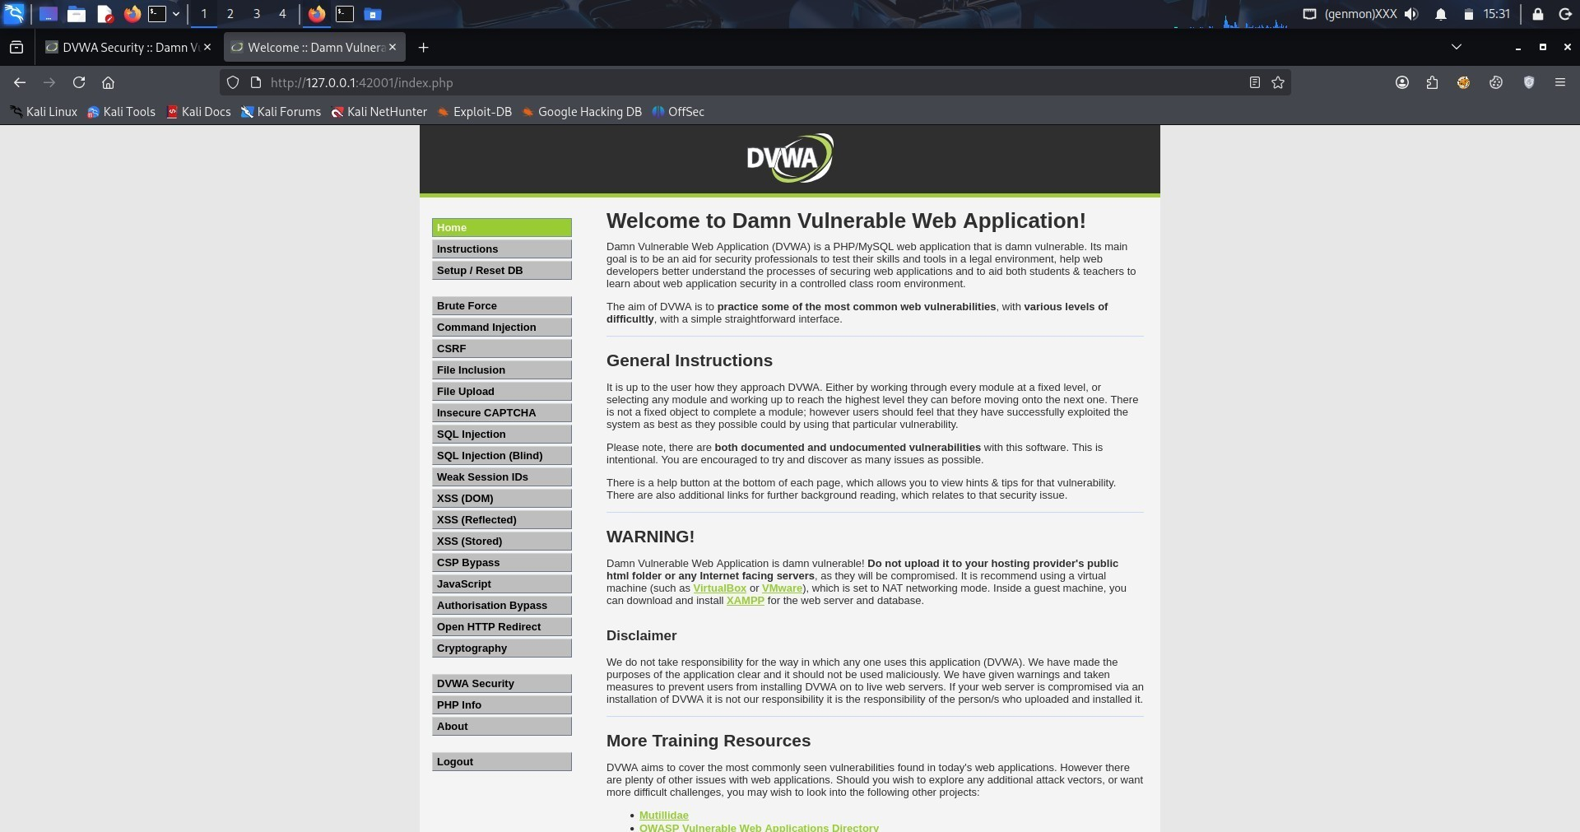

Step 2 - Security Levels
Changed DVWA security to Low → Medium → High and tested again.
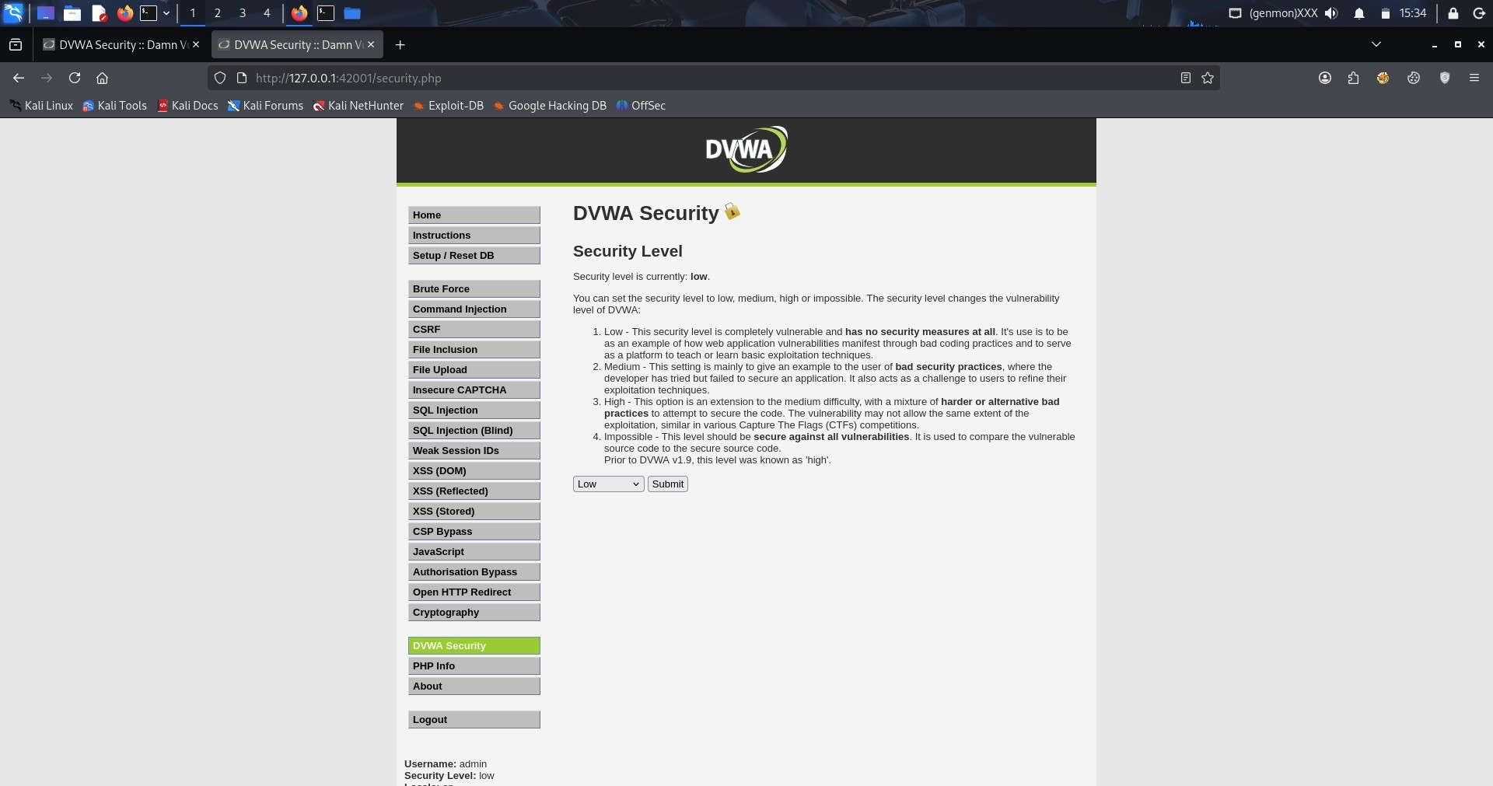

Step 3 - Vulnerability Tests

1. SQL Injection
Performed basic SQL injection to bypass login and extract DB info.
Payloads:
1' OR '1'='1
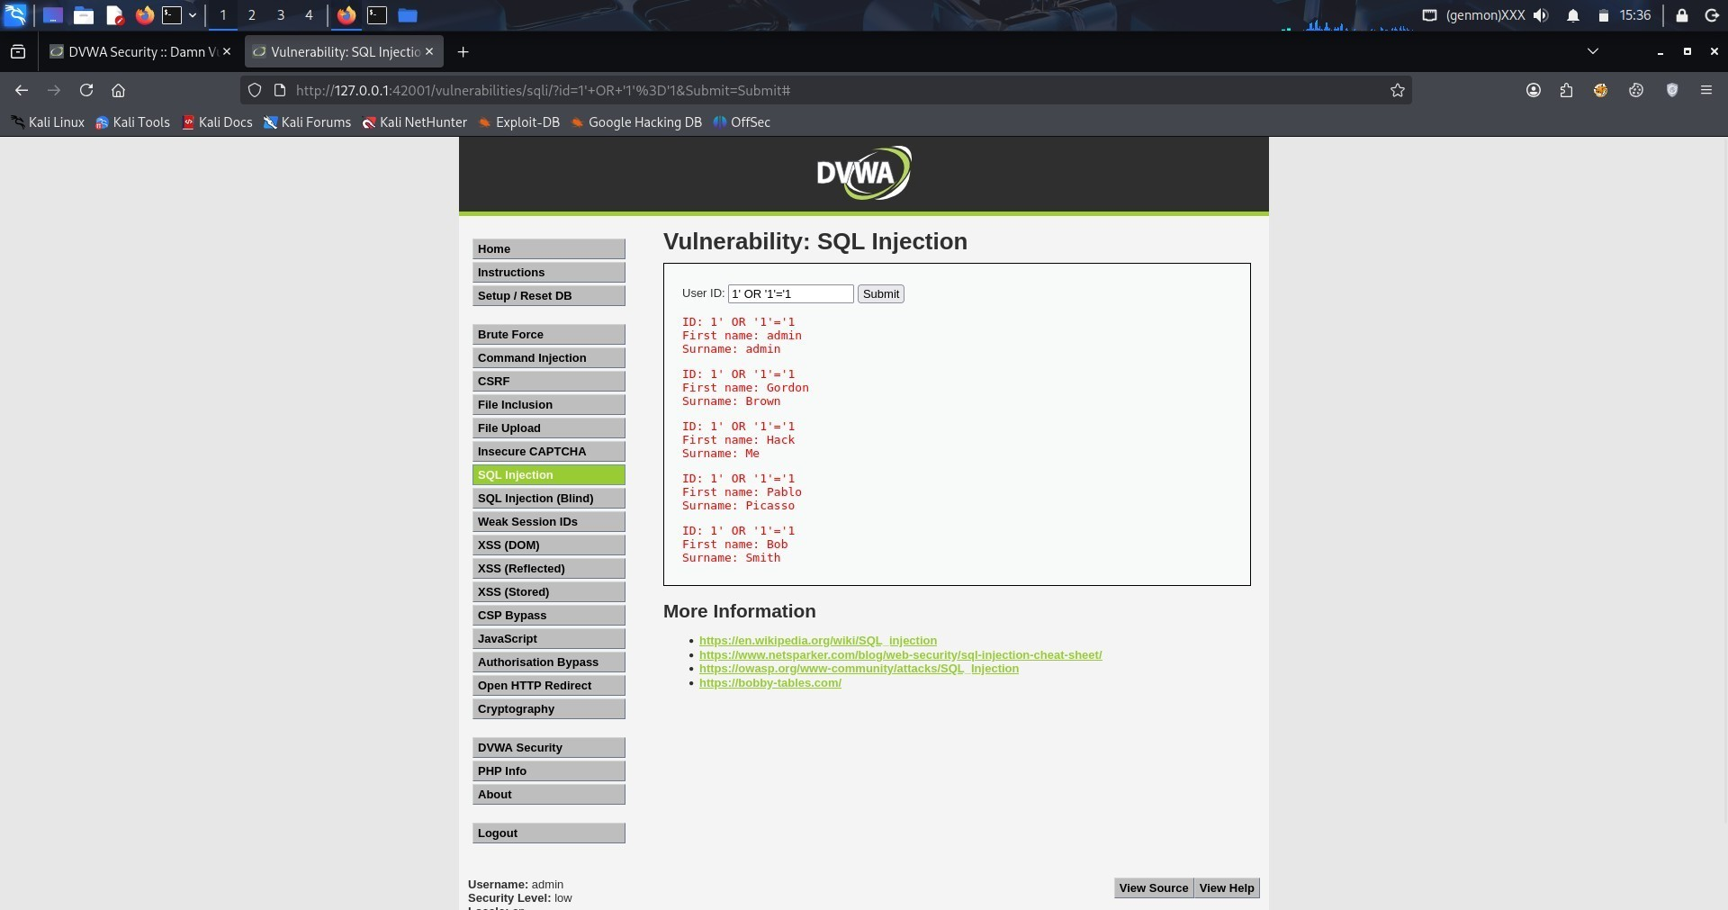

2. Cross-Site Scripting (XSS)
Injected JavaScript to confirm reflected and stored XSS.
Payloads:
<h1>vikram<h1>
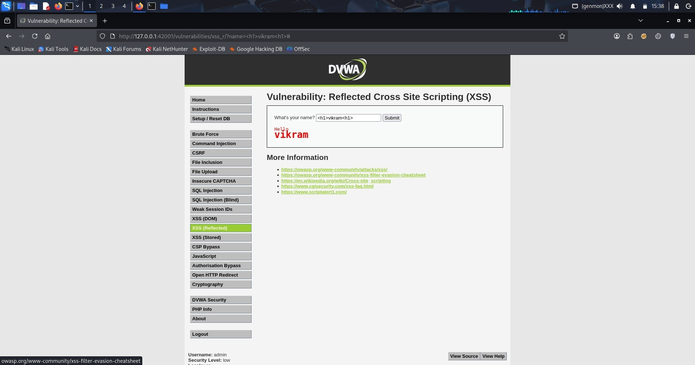
<script>alert(1)</script>
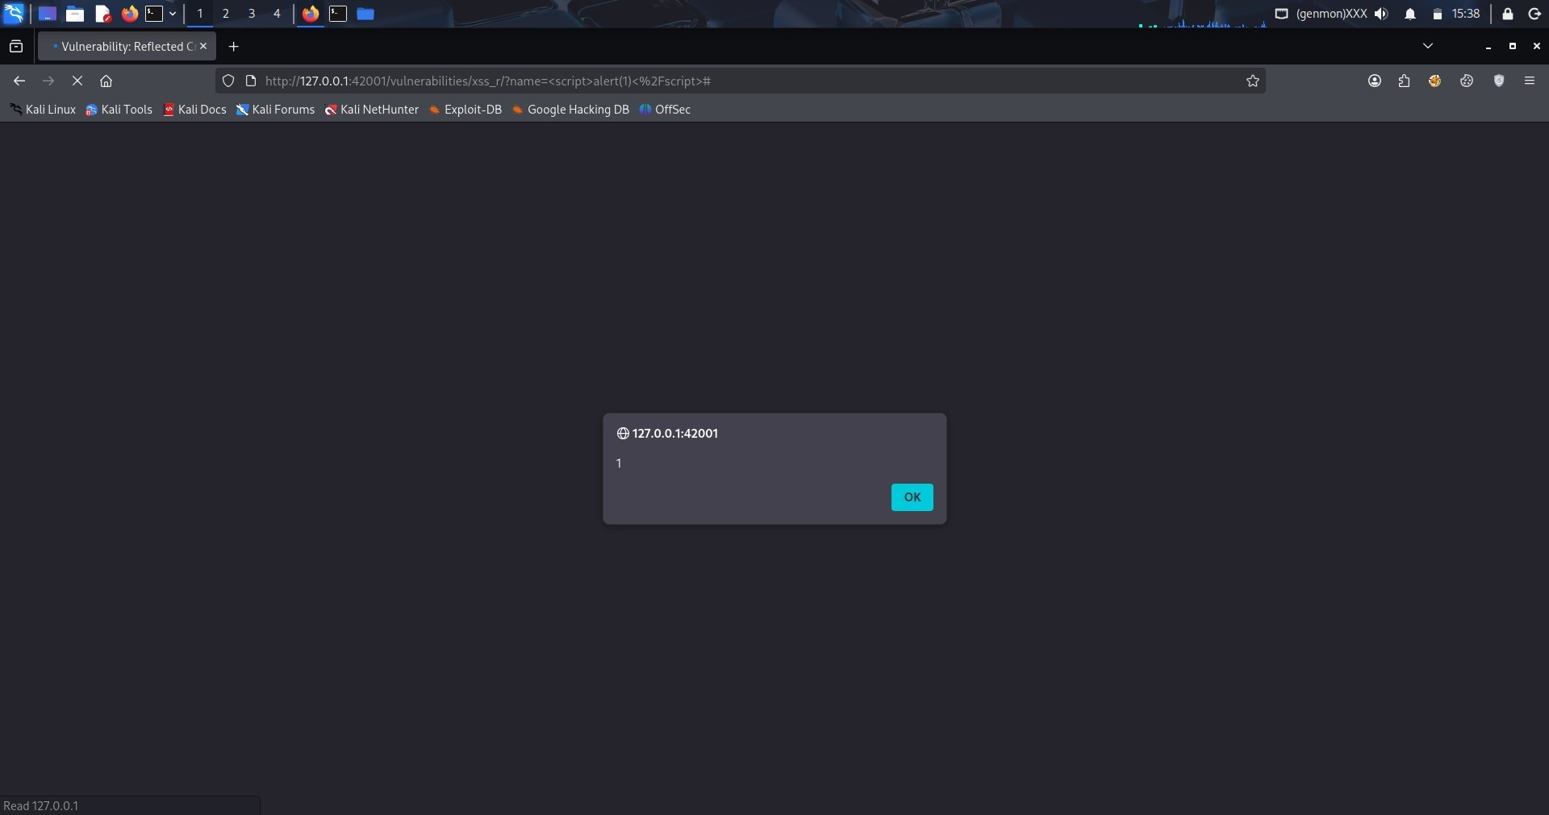

3. Command Injection
Executed system commands via vulnerable parameter.
Payloads:
127.0.0.1; ls
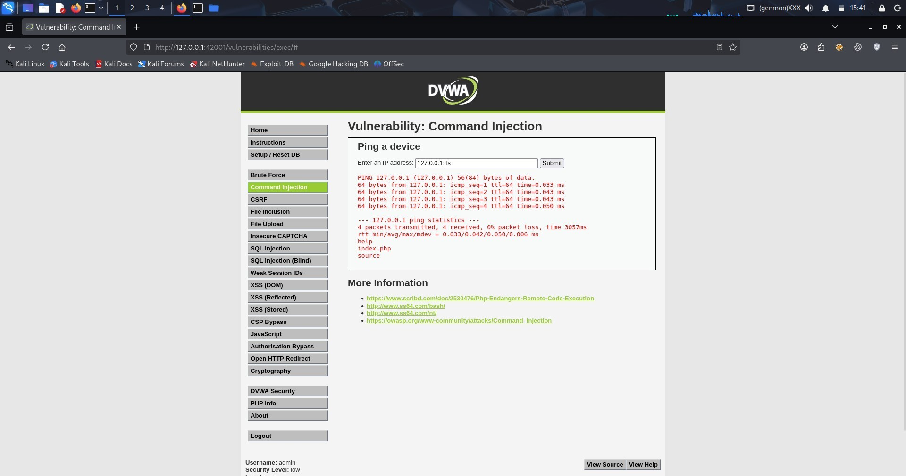

4. File Upload Vulnerability
Uploaded test PHP file by bypassing file extension filters.
Payload:
<?php echo "test"; ?>
Rename as: shell.php.jpg
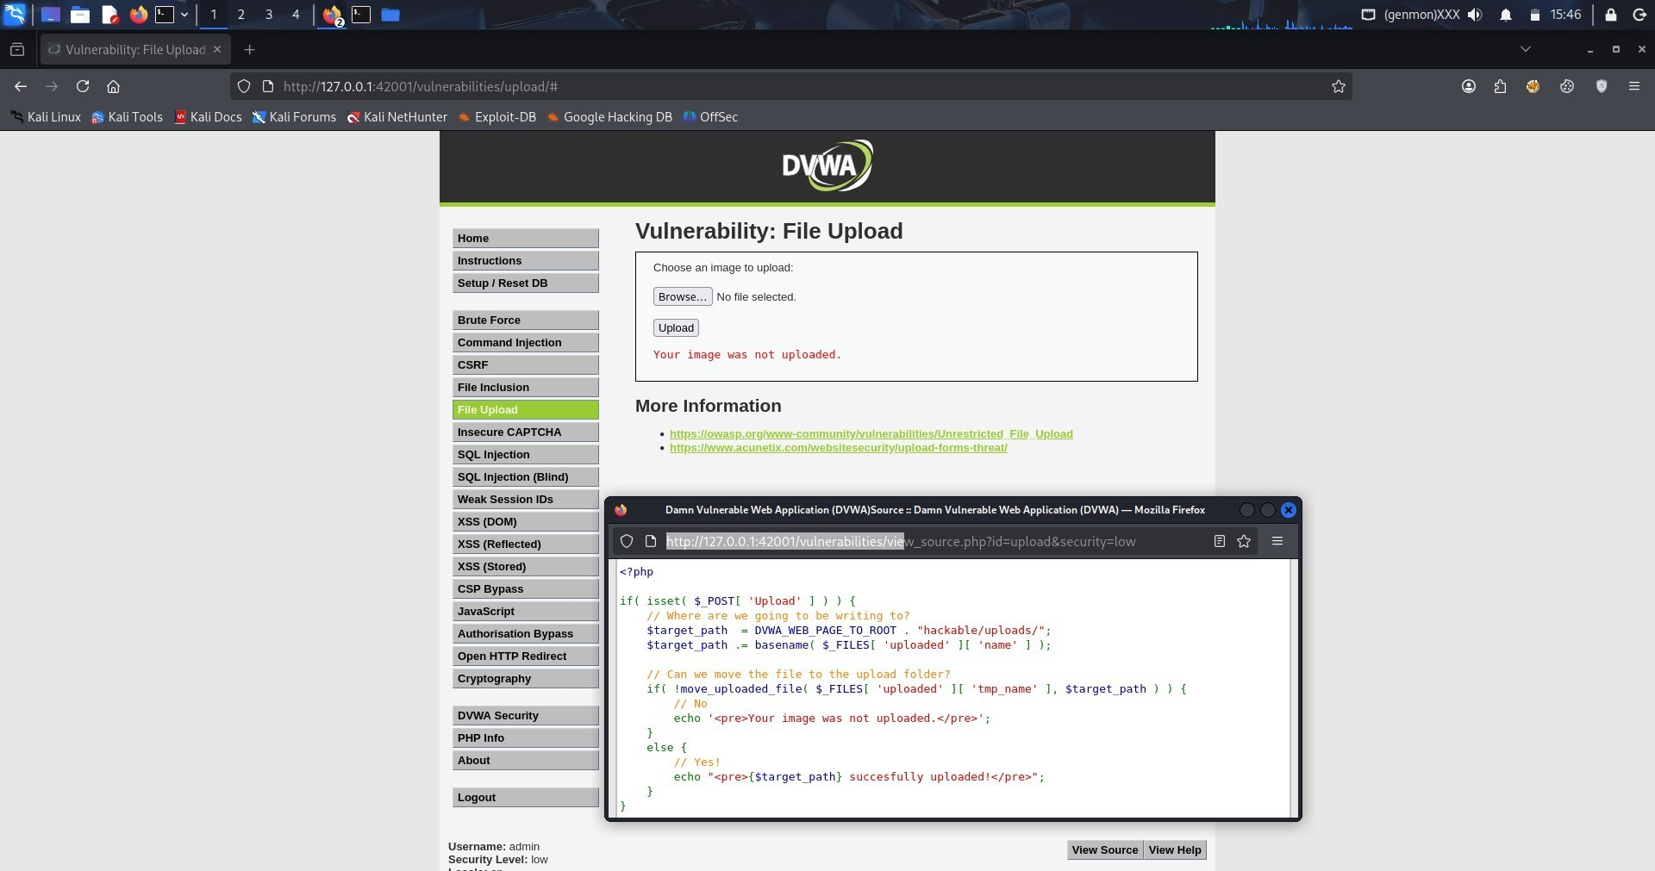

5. IDOR (Insecure Direct Object Reference)
Accessed other user info by modifying ID value.(performed on THM) URL Test:
?id=10
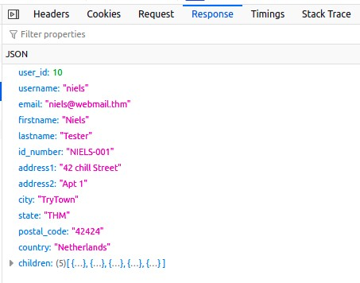

6. Security Misconfigurations / Headers
Checked missing security headers using curl.
Command:
curl -I http://localhost/dvwa
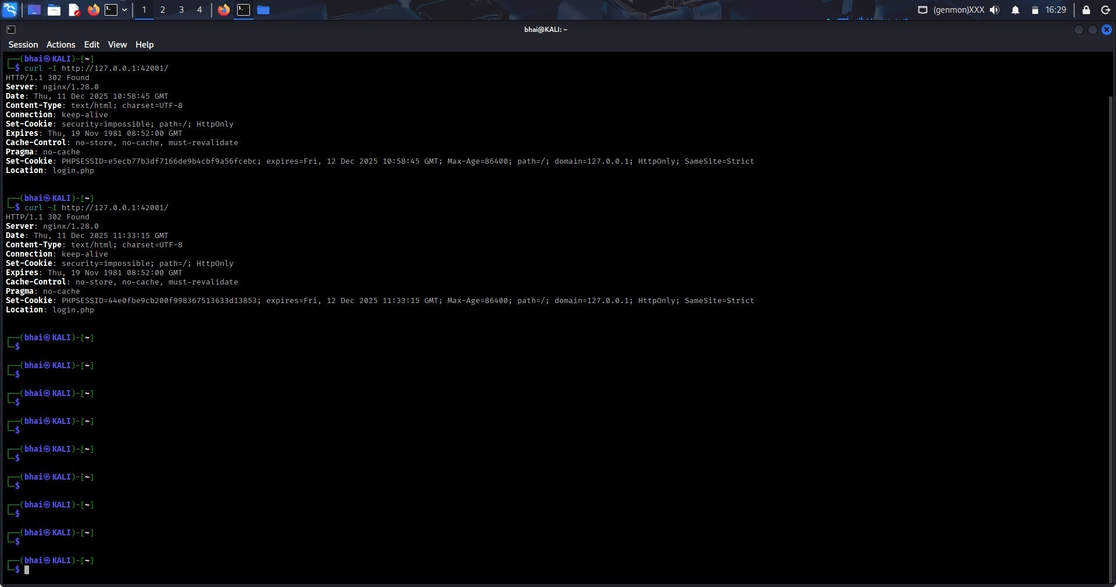

7. Sensitive Info in Source / JS
Viewed page source to identify exposed info.
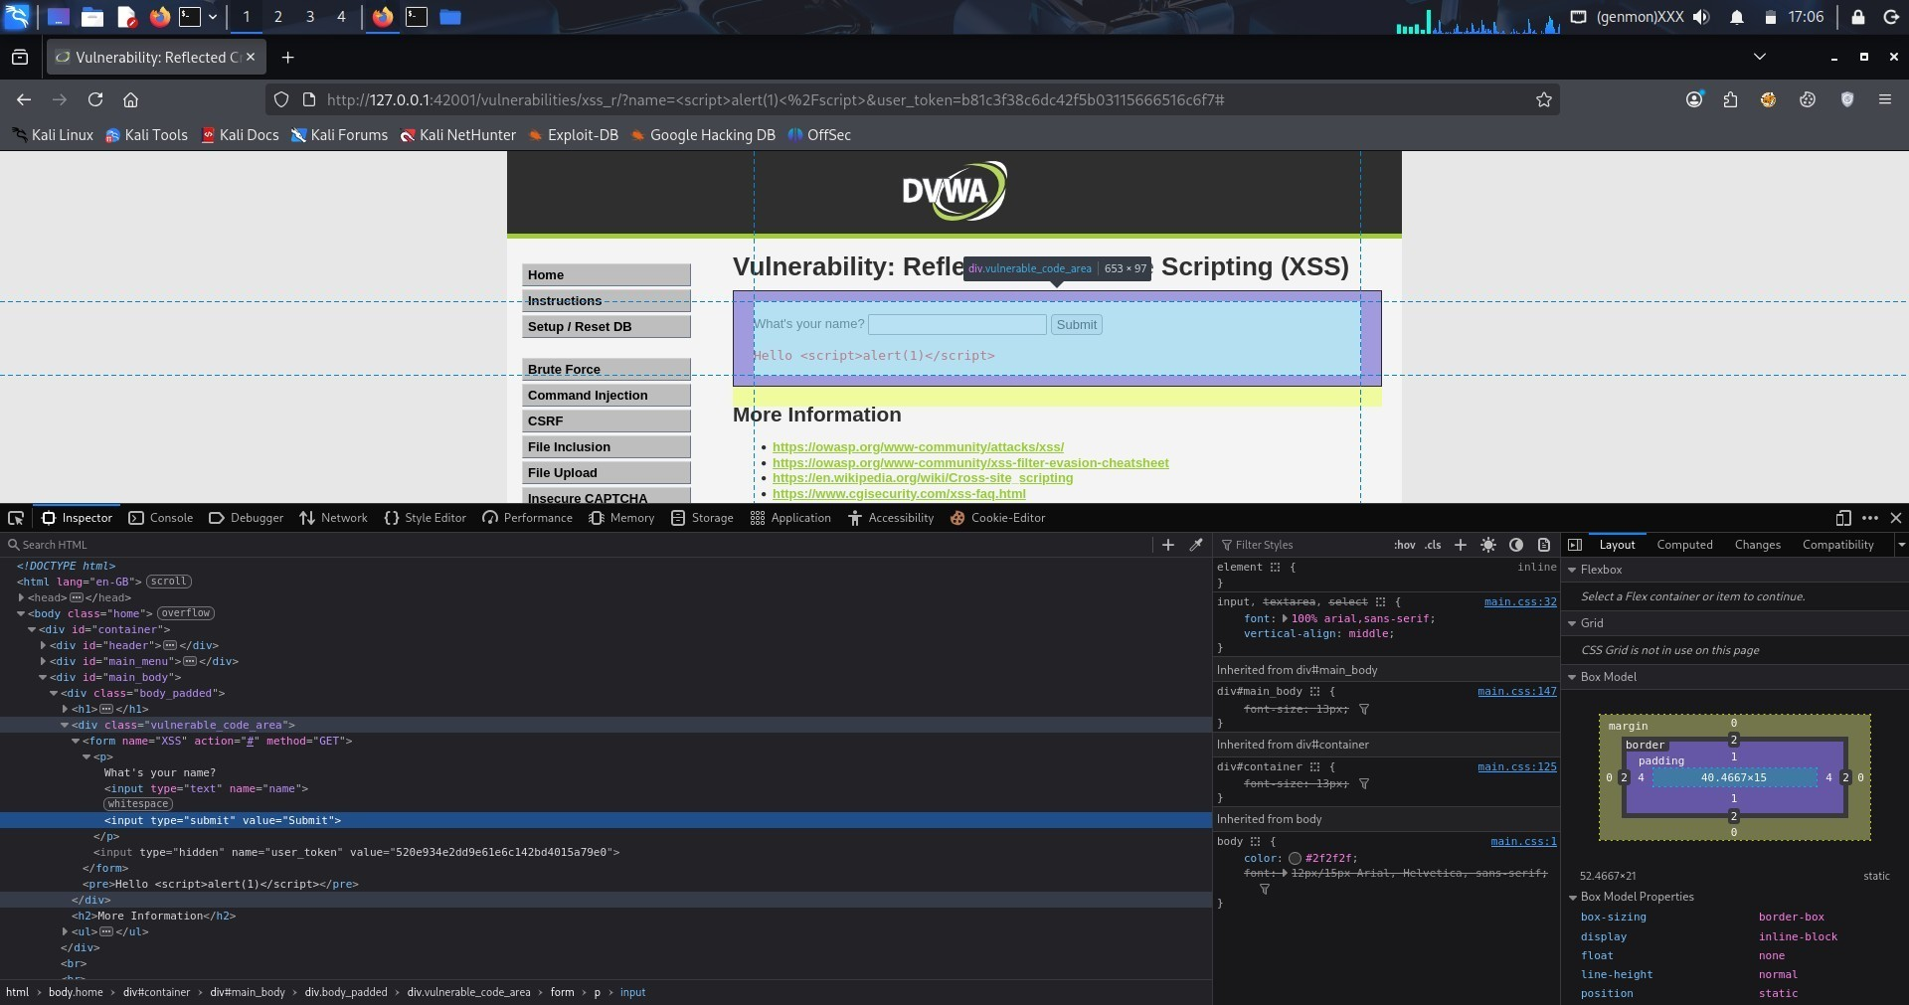

8. Session Management Issues
Verified insecure cookies and missing flags.
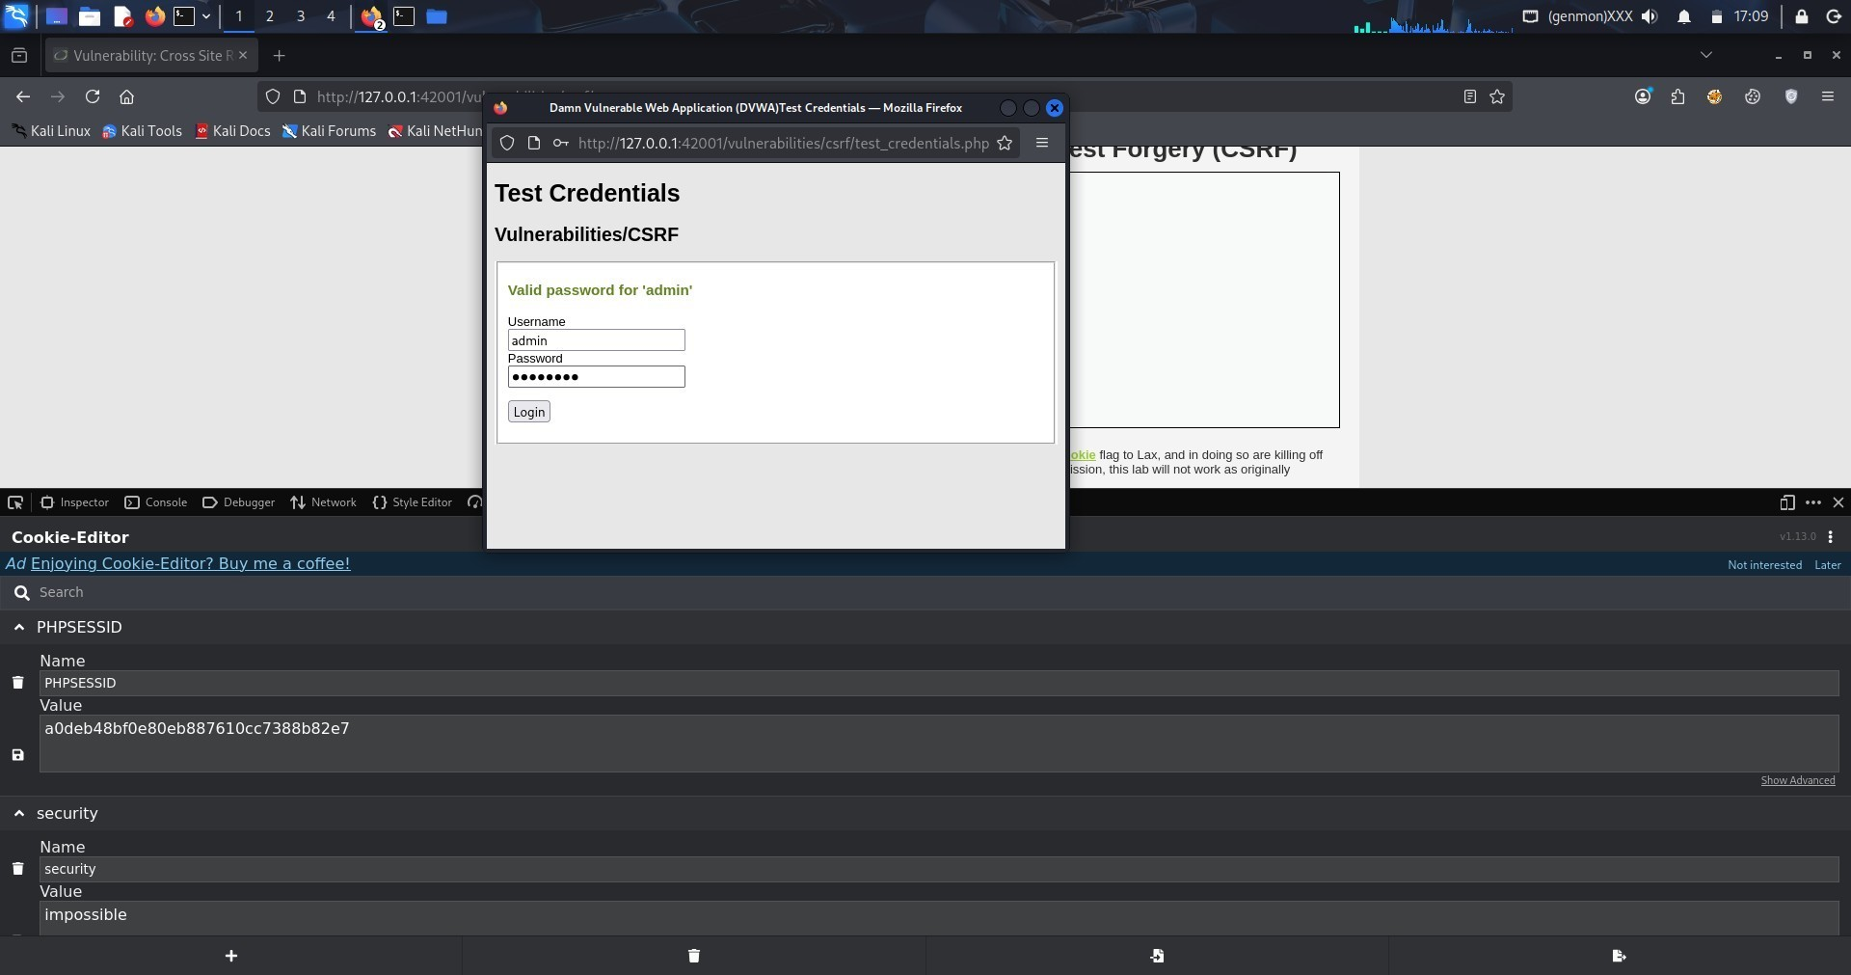

Step 4 - Light Automation

Nikto Scan
Scanned server for misconfigurations.
Command:
nikto -h http://localhost/dvwa
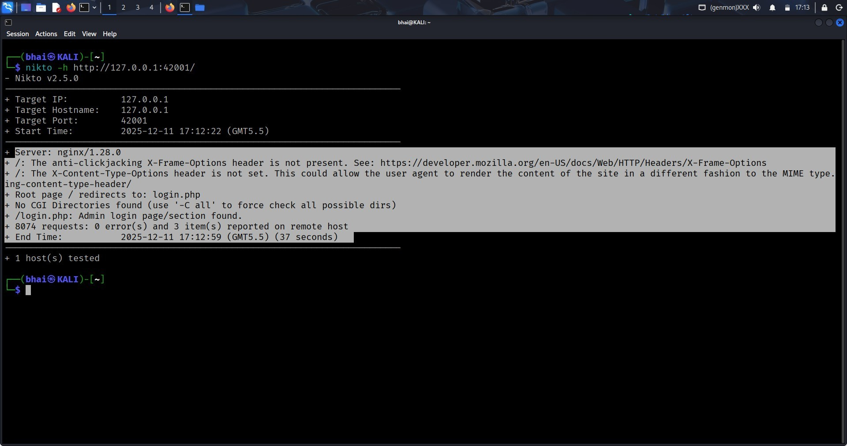

WhatWeb Fingerprinting
Identified technologies running on DVWA.
Command:
whatweb http://localhost/dvwa
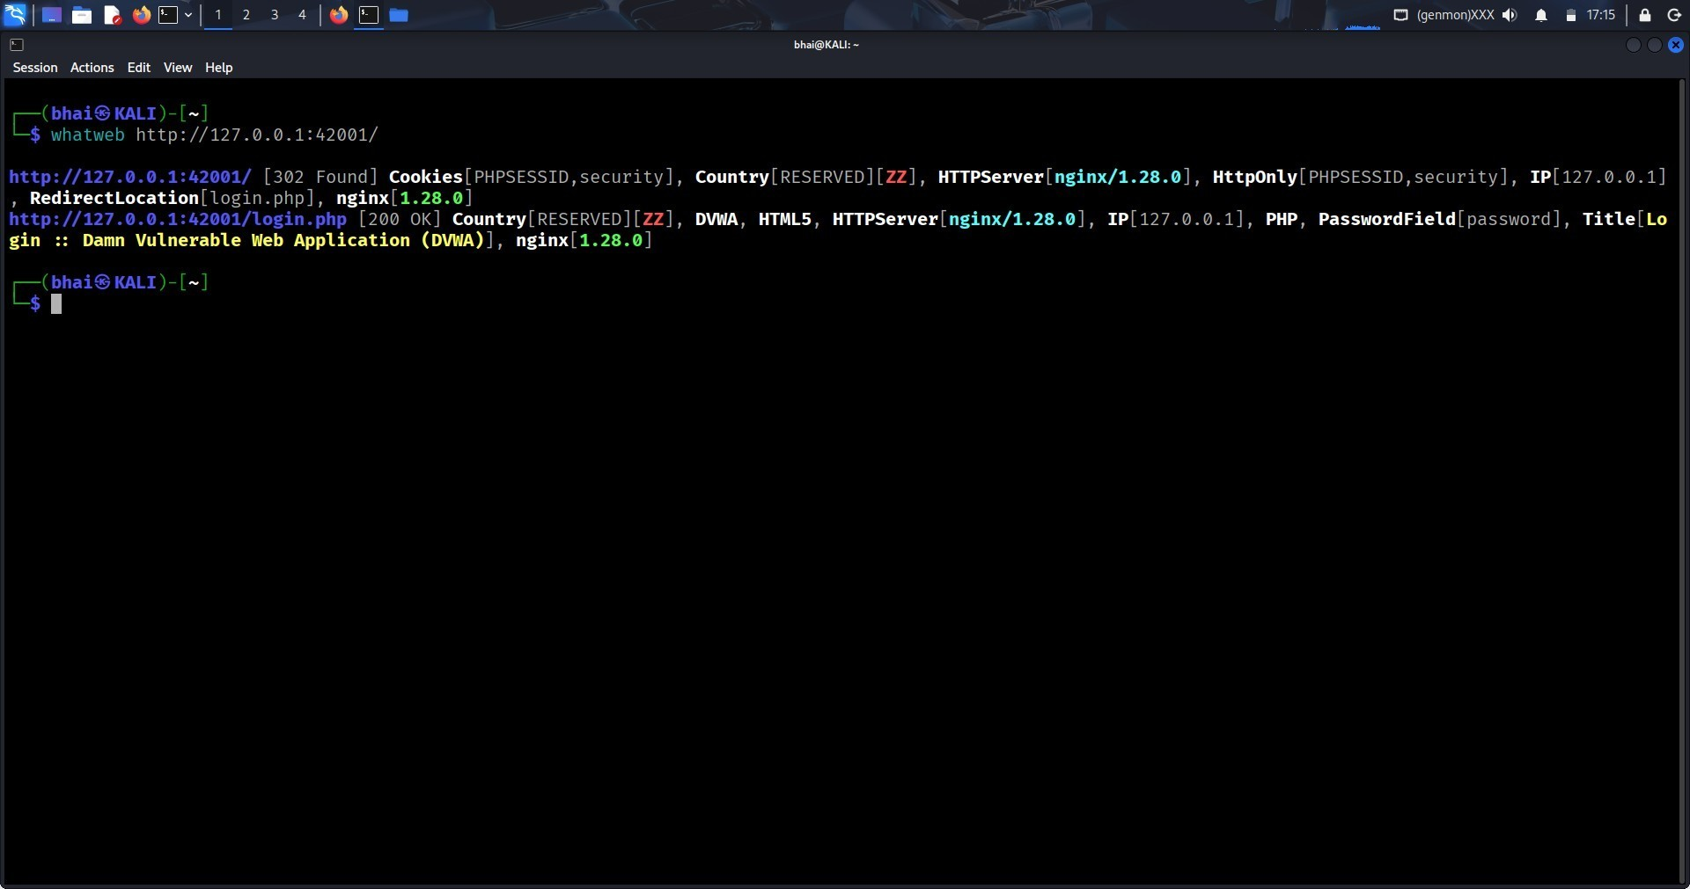

DIRB Directory Scan
Enumerated hidden directories and files.
Command:
dirb http://localhost/dvwa
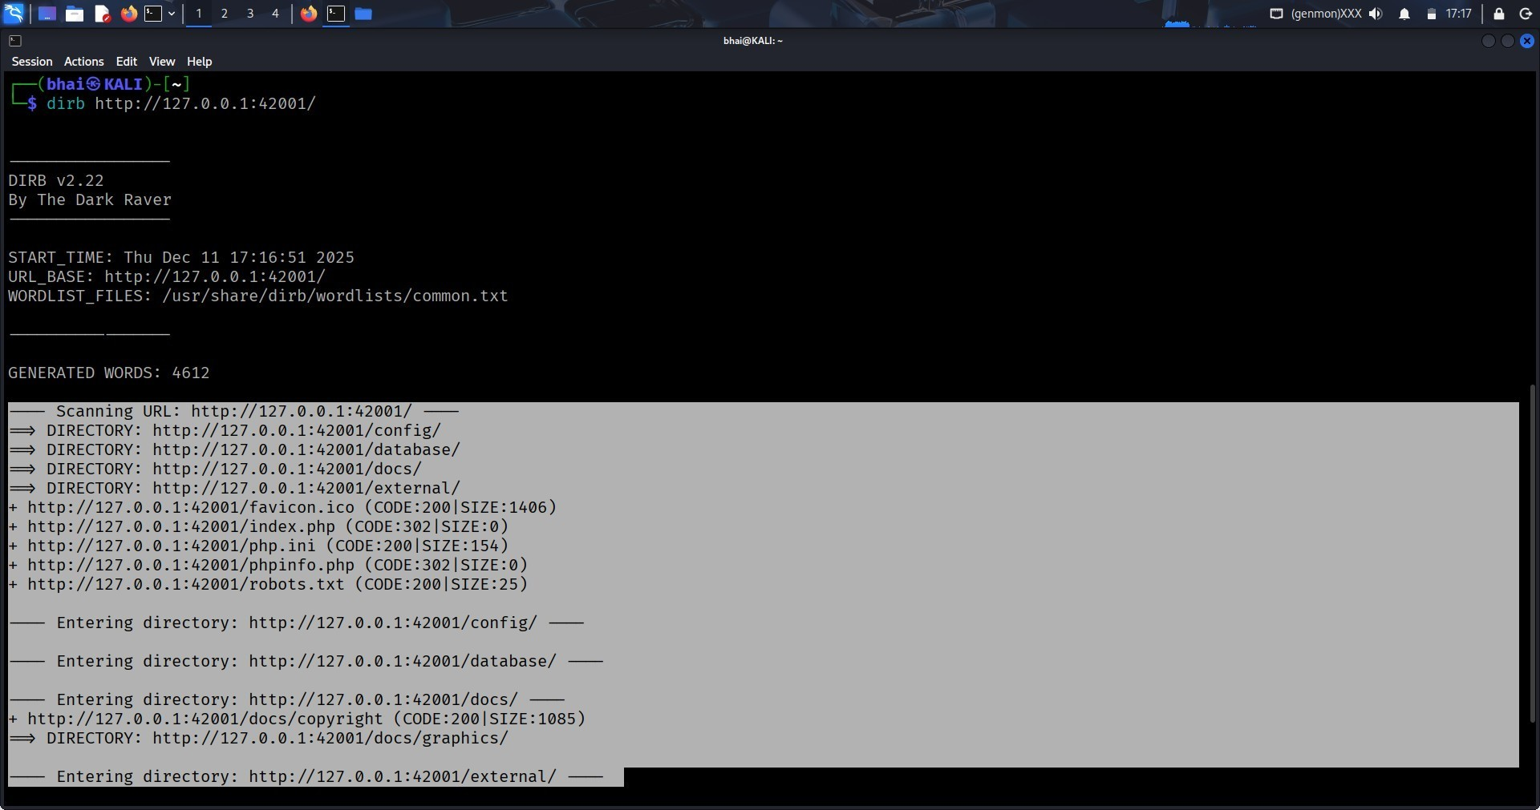

Nuclei Scan
Ran templates for common misconfigurations.
Command:
nuclei -u http://localhost/dvwa

