Assignment –2-Passive Recon using linkx commands .
- Using command Whois on skillhorizon.
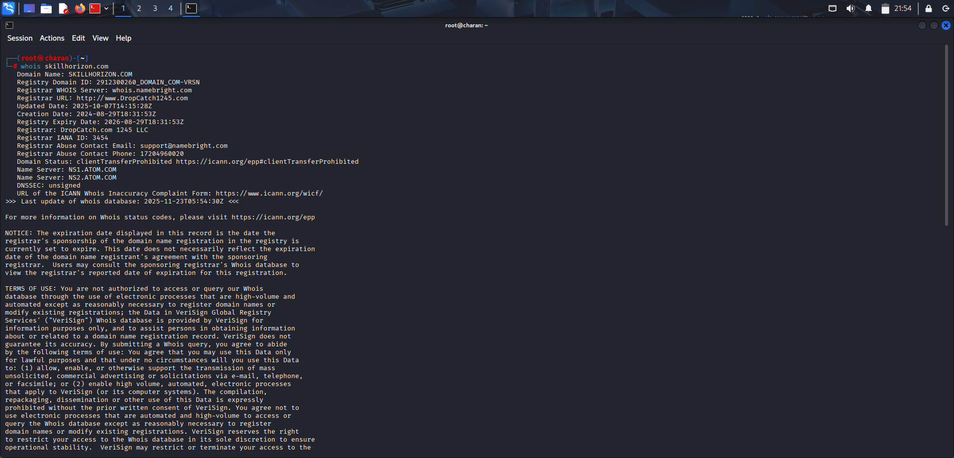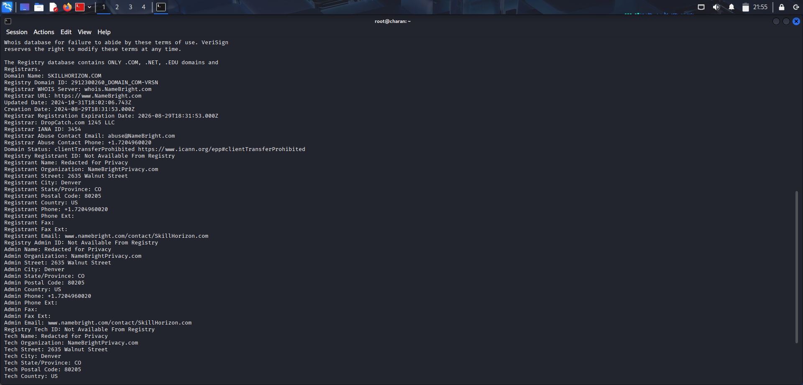
Information gathered:

Domain name: skillhorizon.com

Registrar:Dropcatch.com

Created on 2024-08-29
Updated on 2024-10-31

Expiration on 2026-08-29

Registrant: Namebrightprivacy.com

2)using command Subfinder
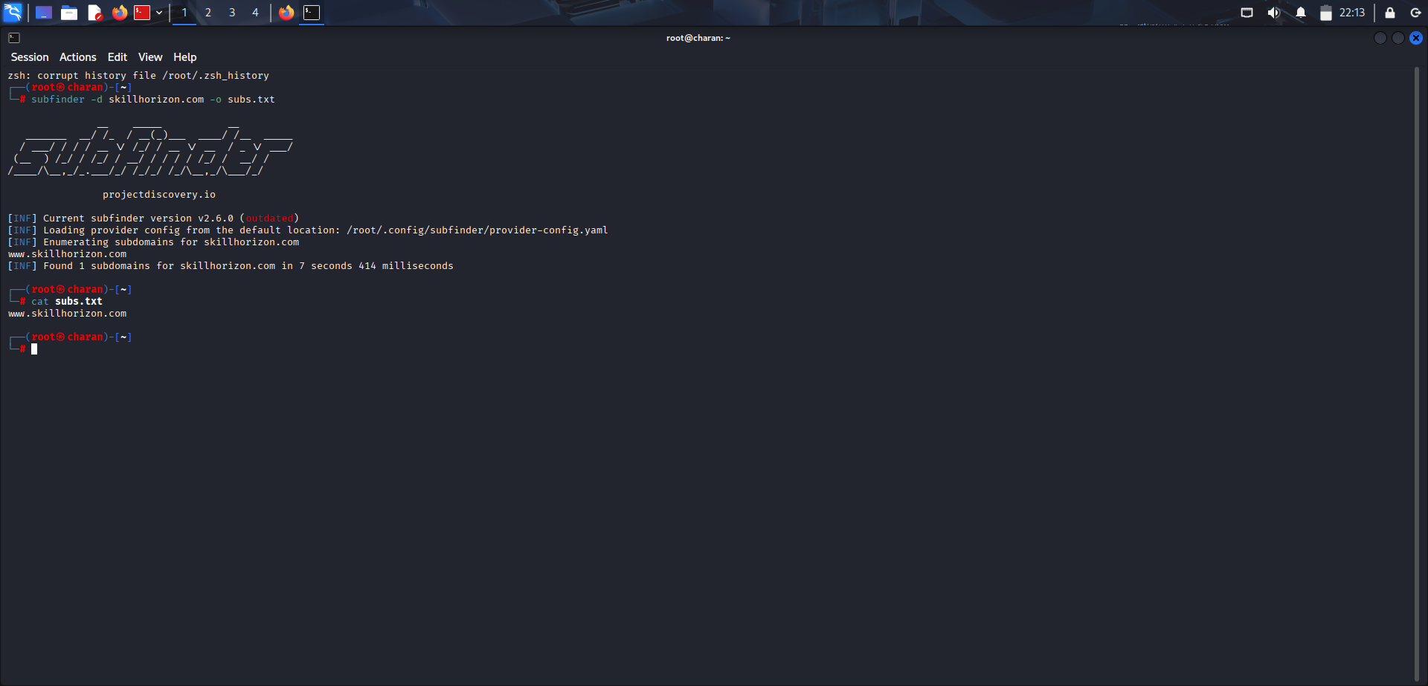

- theharvester
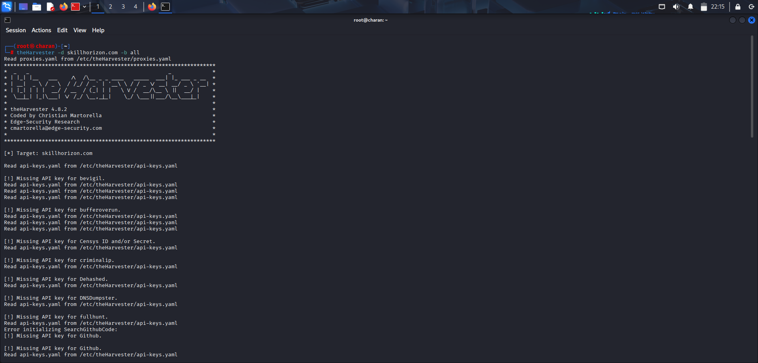
Missing/No records found related to api key information or email address.

4)exfittool
No files found

5) GoogleDorking
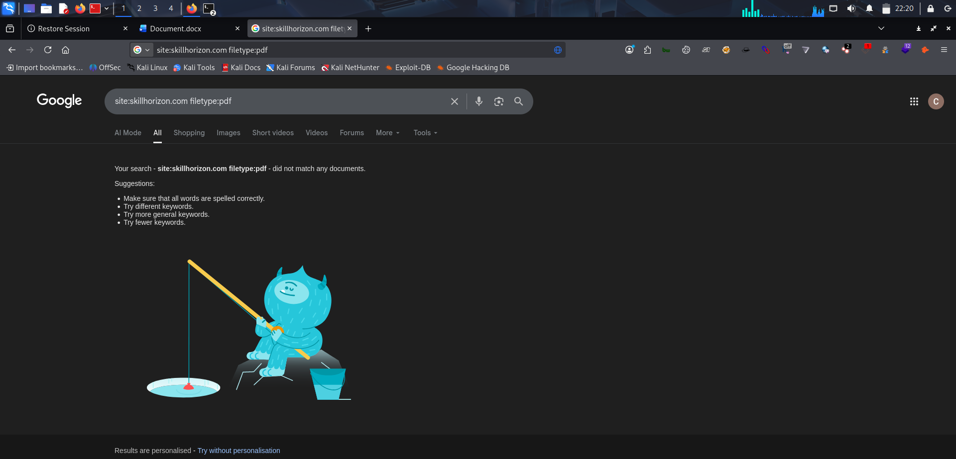
6)OSINT
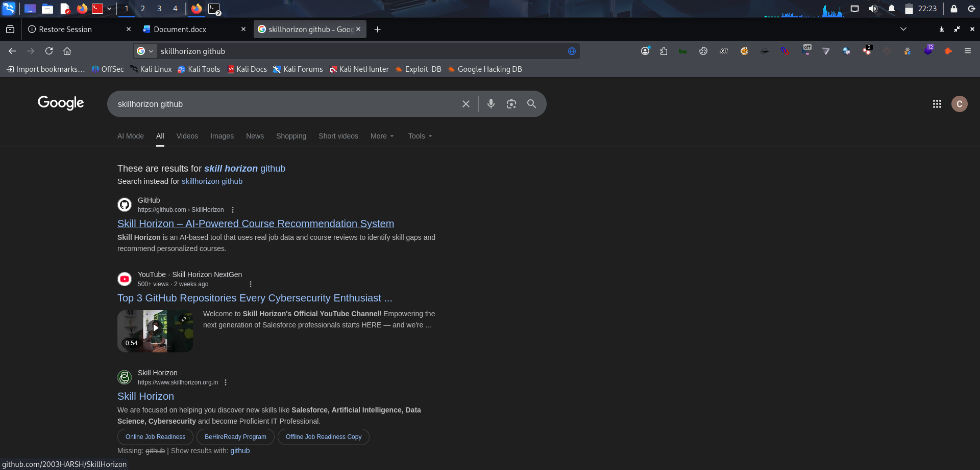
7)Waybackurls (urls found)
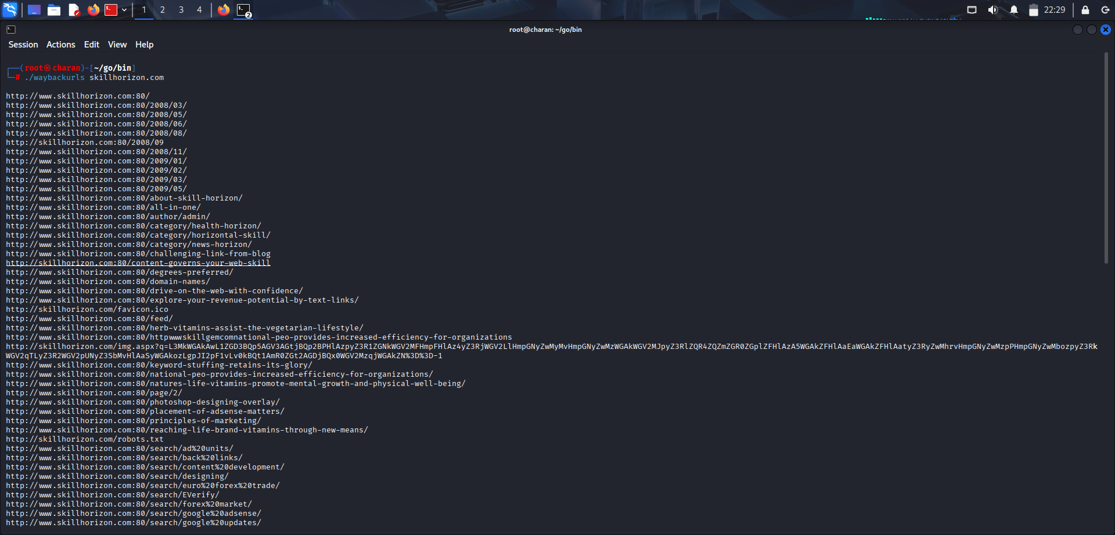
8) jsleaks (No Host found0
