Project:5
Research Project
Common Vulnerabilities Across Real Web Applications File Upload Vulnerability

Objective
The objectives of this research project were:
- To study the File Upload vulnerability in DVWA
- To research real-world CVEs related to insecure file upload
- To understand how attackers exploited these vulnerabilities
___________________________________________________________________________

File Upload Vulnerability Overview
File Upload vulnerabilities occur when a web application allows users to upload files without proper validation. If file type, content, or execution permissions are not restricted, attackers can upload malicious files such as web shells or scripts.
In DVWA, the File Upload module demonstrates how an attacker can upload a malicious PHP file and execute commands on the server.

Real-World Case 1: CVE-2018-9206 (Drupal File Upload)

Description
CVE-2018-9206 affected the Drupal content management system. The vulnerability allowed attackers to upload malicious files due to improper validation of file types.

Exploitation Method
Attackers uploaded files with double extensions such as .php.jpg, which bypassed file extension checks. The server executed the PHP code inside the uploaded file.
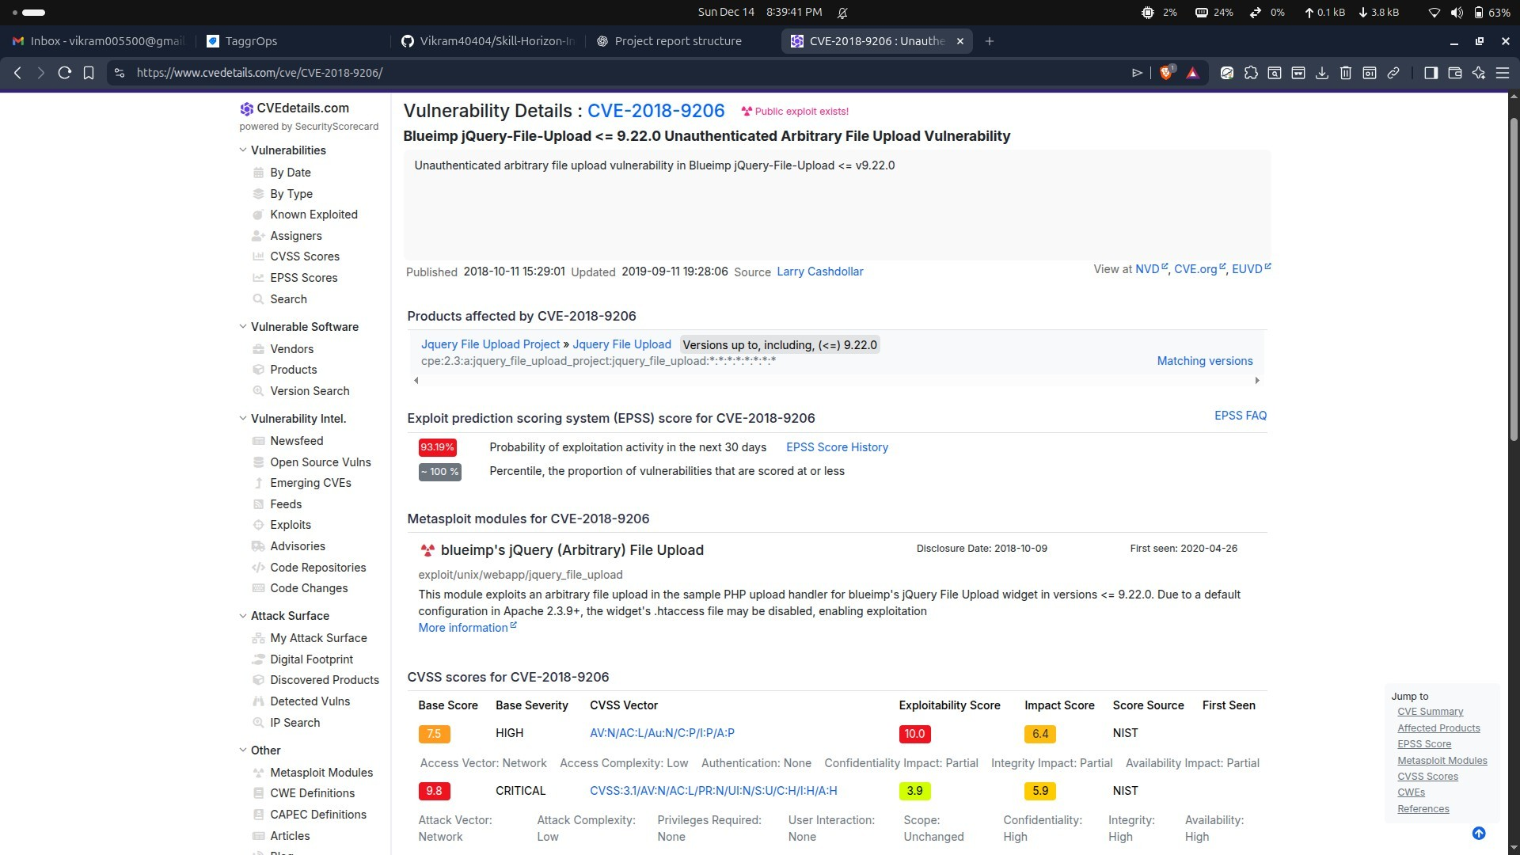
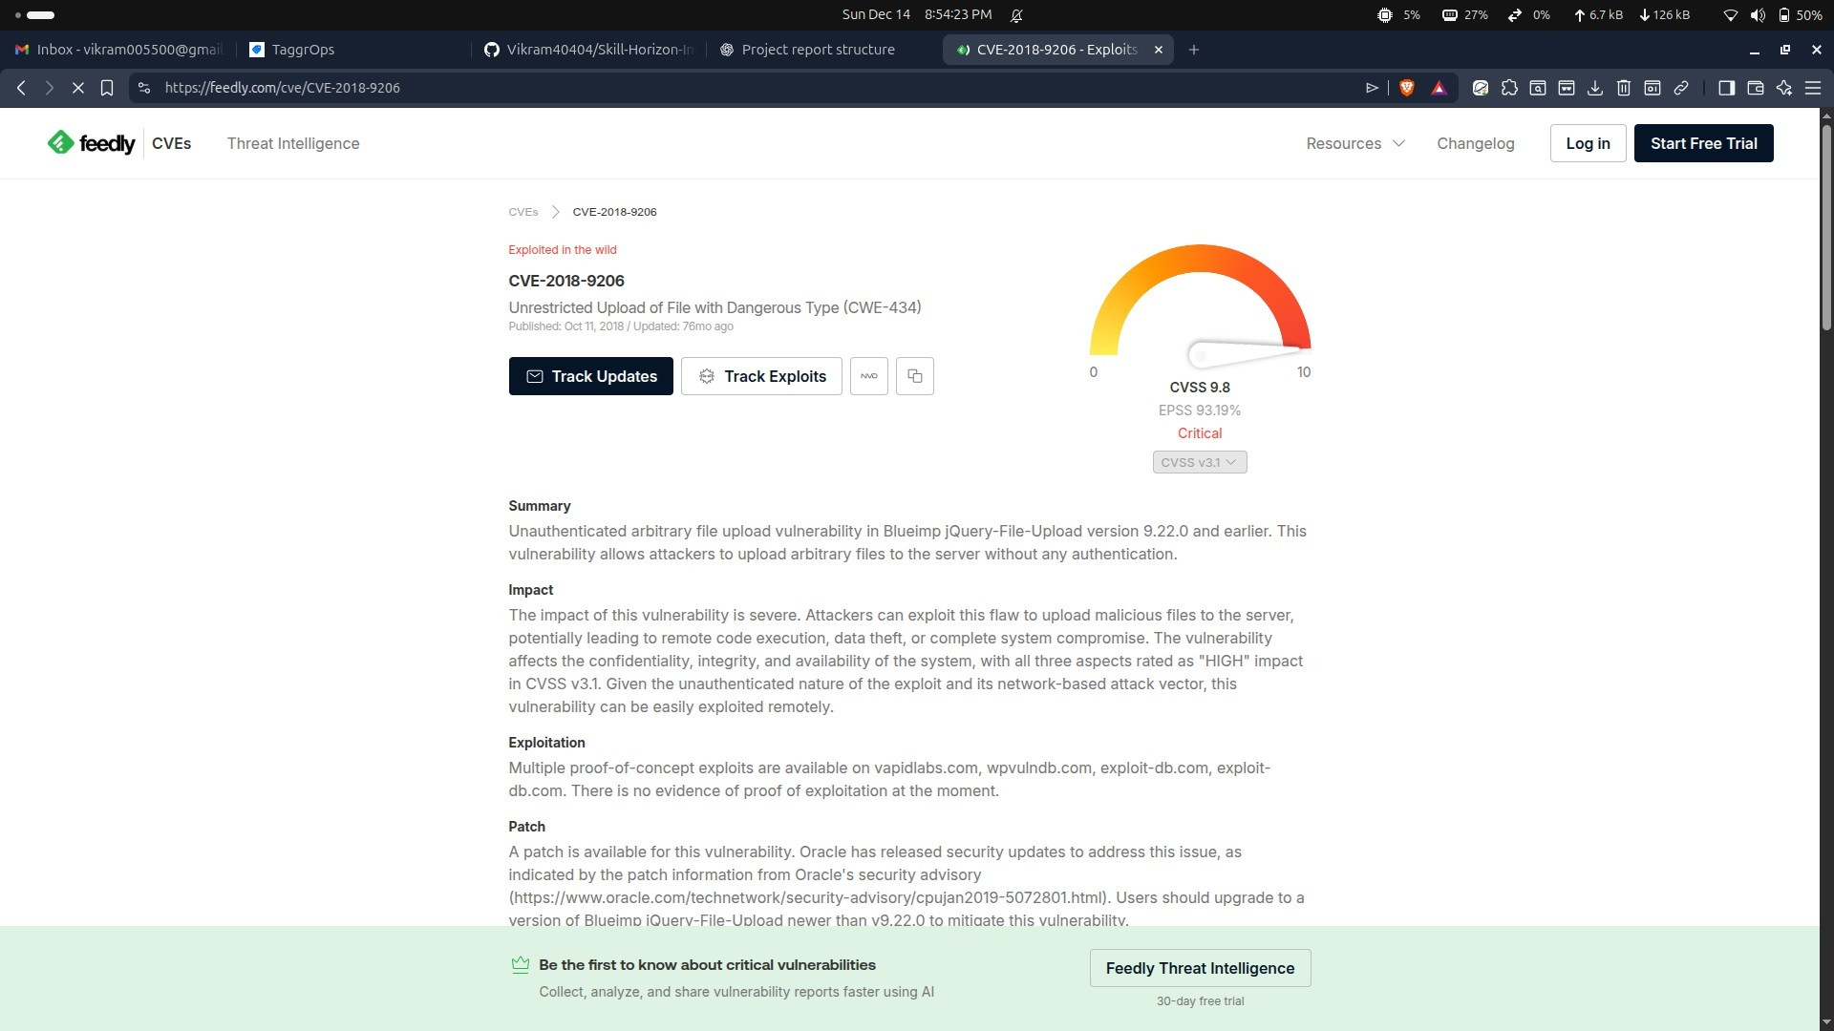

Impact
- Remote code execution on the server
- Full website compromise
- Data theft and defacement

Fix and Mitigation
- Strict file extension and MIME type validation
- Disabling execution permissions on upload directories
- Security patches released by Drupal

Real-World Case 2: CVE-2016-10033 (PHPMailer File Upload Abuse)

Description
CVE-2016-10033 was found in PHPMailer, a popular PHP library. Improper input handling allowed attackers to upload and execute malicious files indirectly through email attachments.

Exploitation Method
Attackers used crafted inputs to inject malicious commands and upload files to the server, leading to remote code execution.
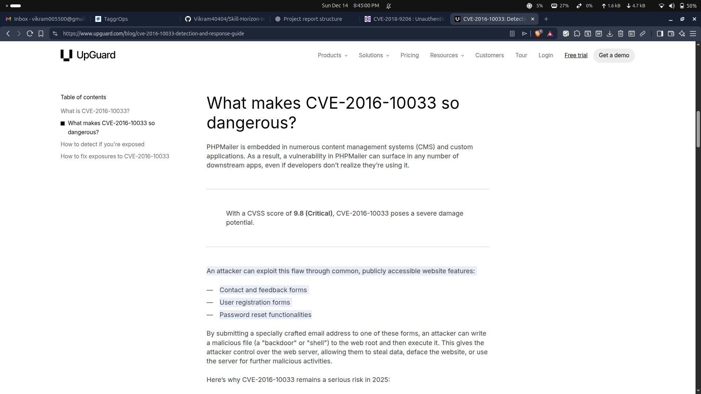
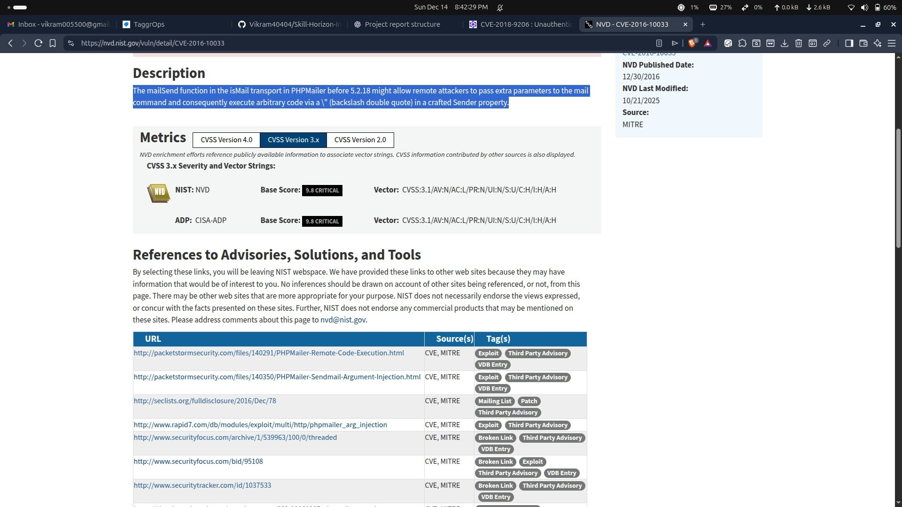

Impact
- Server takeover
- Spam campaigns using compromised servers
- Widespread exploitation across many websites

Fix and Mitigation
- Input validation improvements
- Secure handling of file attachments
- Updated PHPMailer versions released

Real world Case 3- Exploit-DB ID: 42033 (Joomla SQL Injection)Example 1:
A SQL Injection vulnerability was discovered in Joomla components where user input was directly passed into database queries.

Exploitation Method
Attackers manipulated URL parameters to inject SQL queries, allowing them to extract database information or bypass authentication.
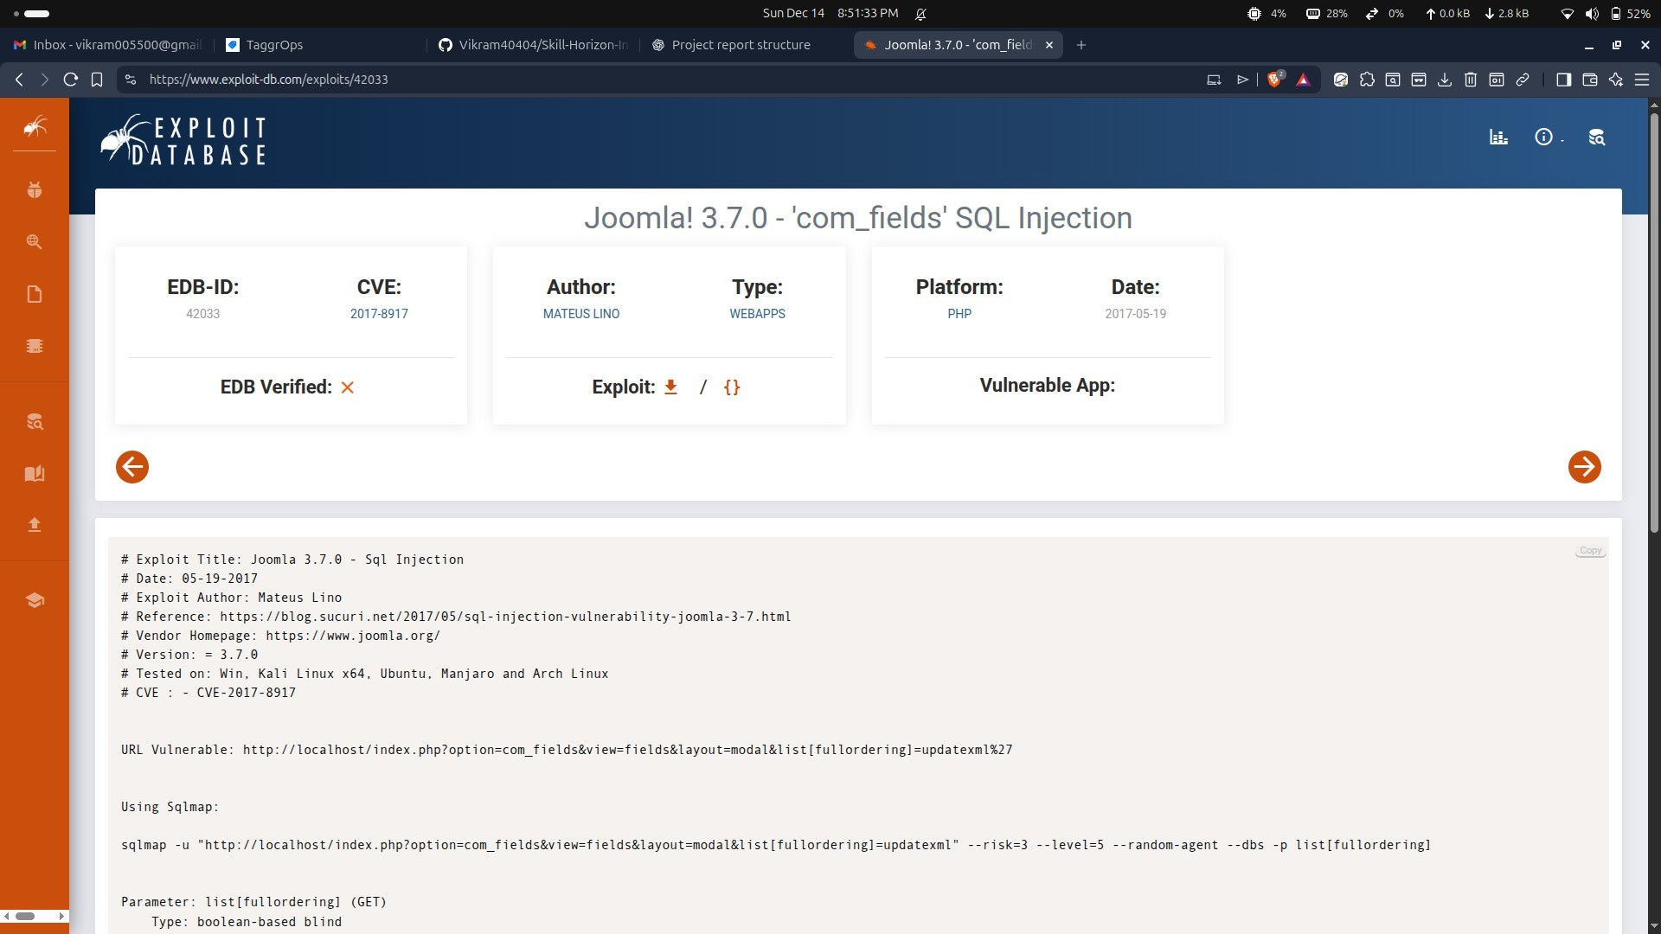
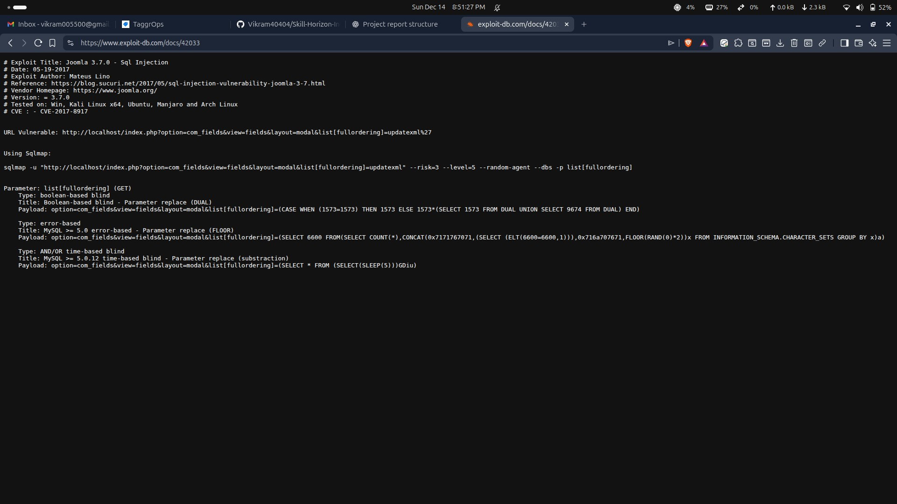

Impact
- Database data leakage
- Admin account takeover
- Full website compromise Fix
- Input validation
- Parameterized queries
- Joomla security patch

Comparison with DVWA File Upload Vulnerability
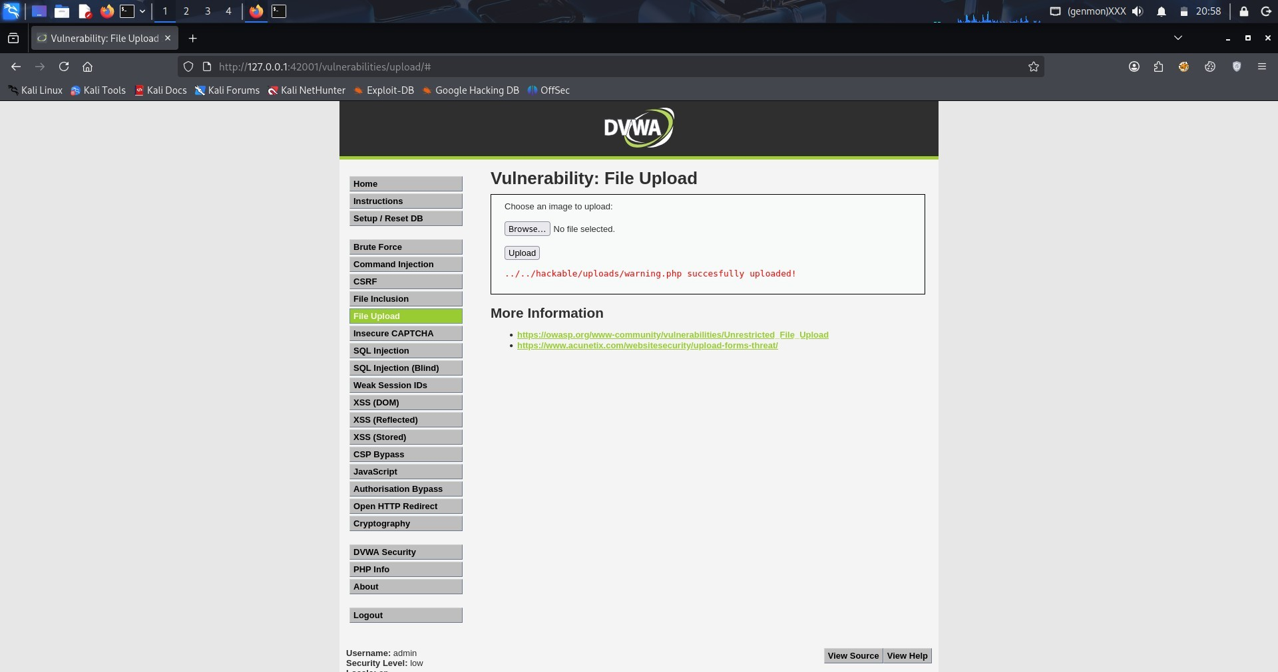
The File Upload vulnerability in DVWA closely resembles real-world issues. In DVWA, insufficient validation allows uploading executable files, similar to how attackers bypassed checks in real applications.
Both DVWA and real-world cases show that relying only on file extensions is not enough. Proper validation, permissions, and server configuration are required to prevent exploitation.

Lessons Learned
- File Upload vulnerabilities are highly dangerous
- Simple validation checks are easy to bypass
- Upload directories should never allow execution
- Real-world attacks often use the same techniques shown in DVWA
- Secure configuration is as important as secure coding

Conclusion
This research project demonstrates that vulnerabilities studied in DVWA are directly relevant to real-world web application security. File Upload vulnerabilities have led to severe security incidents, including server compromise and data breaches.

Learning Outcomes
- Understanding of File Upload vulnerabilities
- Awareness of real-world CVEs and incidents
- Ability to link DVWA learning with real attacks

