Project:4
Build Own Vulnerable Web Application
PHP SQL Injection Demonstration
This project focuses on building a simple vulnerable PHP web application to understand how SQL Injection occurs, how it can be exploited, and how it can be prevented using secure coding practices.

Objective
The objectives of this project were:
- To design a simple PHP-based login page
- To intentionally introduce an SQL Injection vulnerability
- To demonstrate how the vulnerability can be exploited
- To fix the vulnerability using secure coding techniques
- To compare vulnerable and secure implementations

Technology Used
- PHP
- MySQL
- PHP Built-in Development Server
- Kali Linux
- Web Browser

Application Design Overview
A basic login system was developed using PHP and MySQL. The application accepts a username and password from the user and validates them against records stored in a database.
Two versions of the application were created:
- A vulnerable version without input validation
- A secure version using prepared statements

Vulnerable Application Implementation
The vulnerable login page directly concatenates user input into an SQL query. No validation or sanitization is performed before executing the query.
This insecure practice makes the application vulnerable to SQL Injection attacks.

Vulnerable PHP Code
File name: login_vulnerable.php
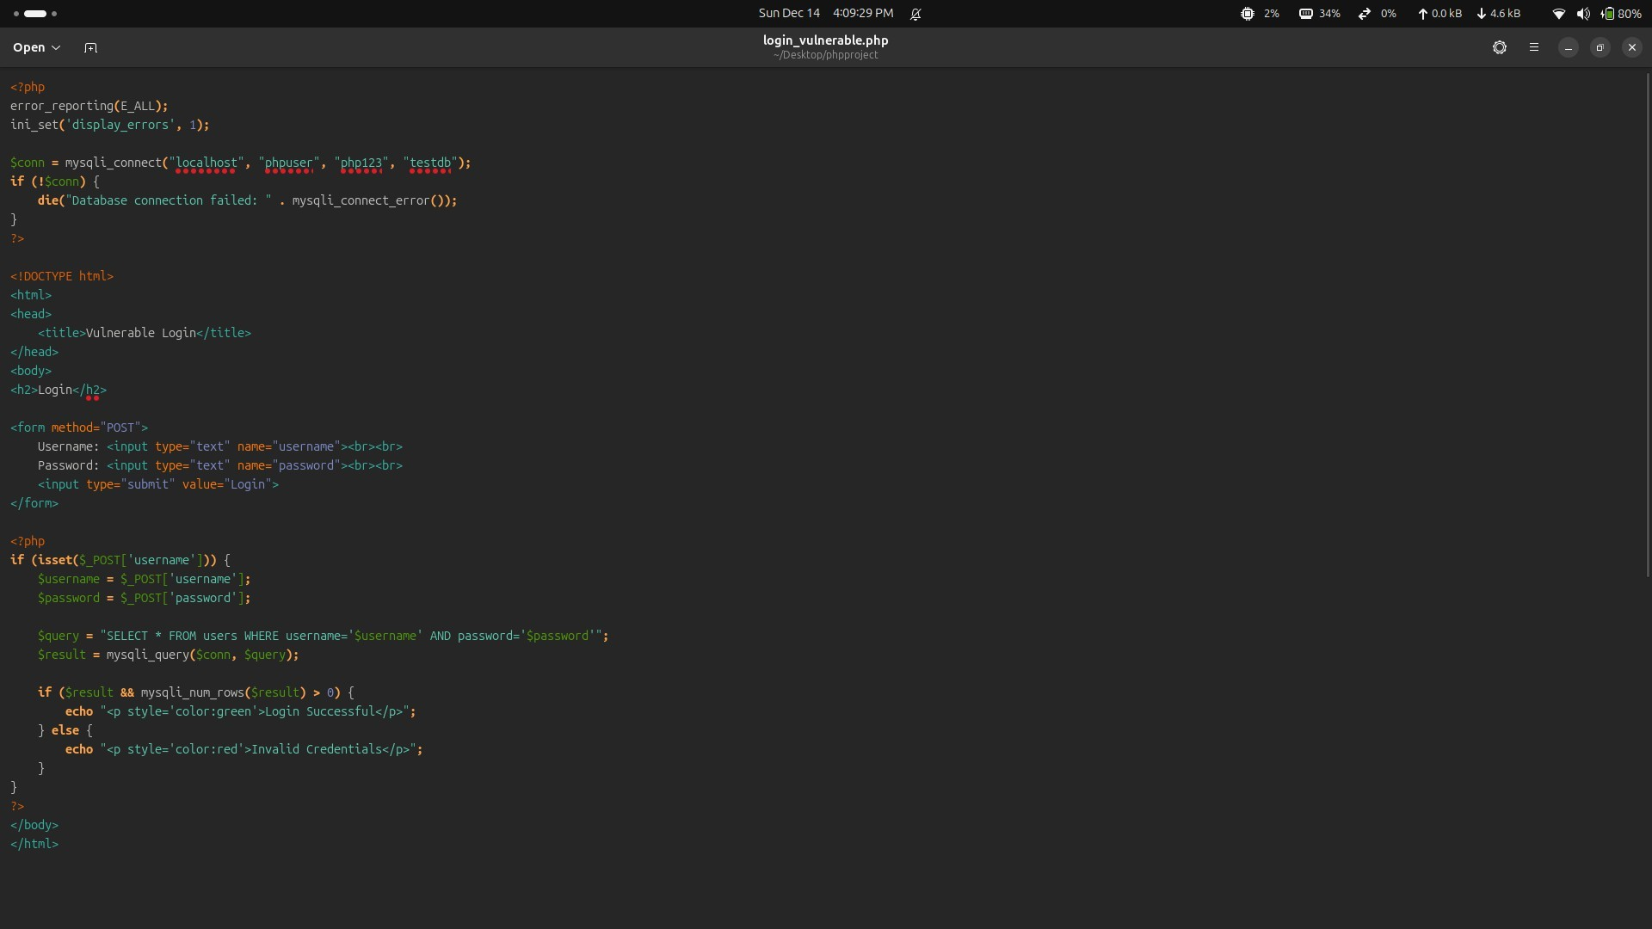
The vulnerable code constructs SQL queries using raw user input, allowing attackers to manipulate the query logic.

Exploitation of the Vulnerability
The SQL Injection vulnerability was exploited by entering a crafted payload in the username field.
Payload used: ' OR '1'='1' --
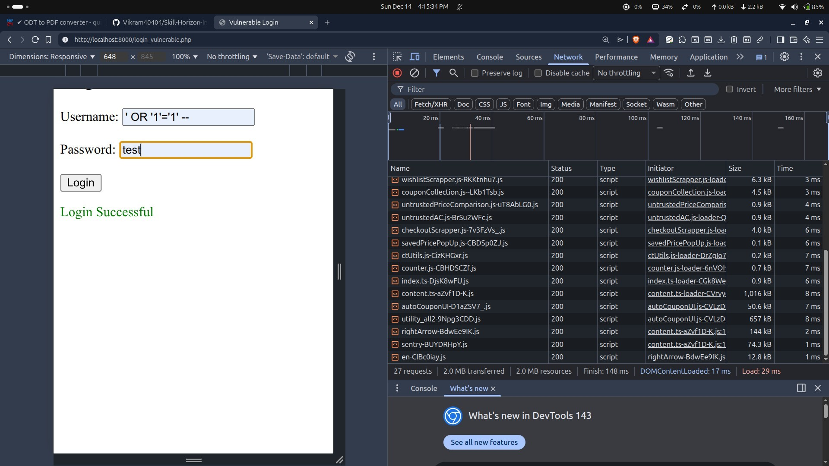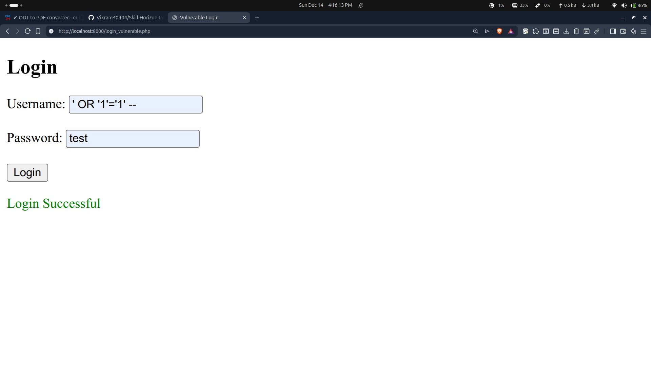
Observation:
- The SQL comment bypassed the password condition
- Authentication was successfully bypassed
- Login was granted without valid credentials
This confirms the presence of an SQL Injection vulnerability.

Secure Application Implementation
To fix the vulnerability, prepared statements were implemented. Prepared statements separate SQL code from user-supplied data, ensuring that input cannot alter query structure.
This approach follows secure coding best practices.

Secure PHP Code
File name: login_secure.php
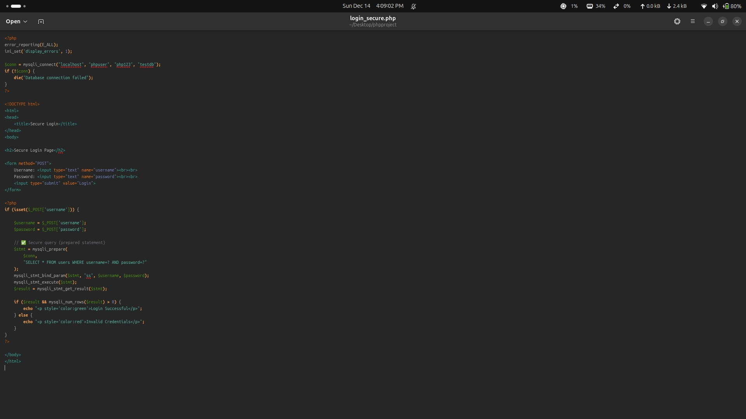
The secure version uses parameterized queries to safely handle user input and prevent SQL Injection attacks.

Verification of Fix
The same SQL Injection payload used on the vulnerable version was tested against the secure version.
Payload tested: ' OR '1'='1' --
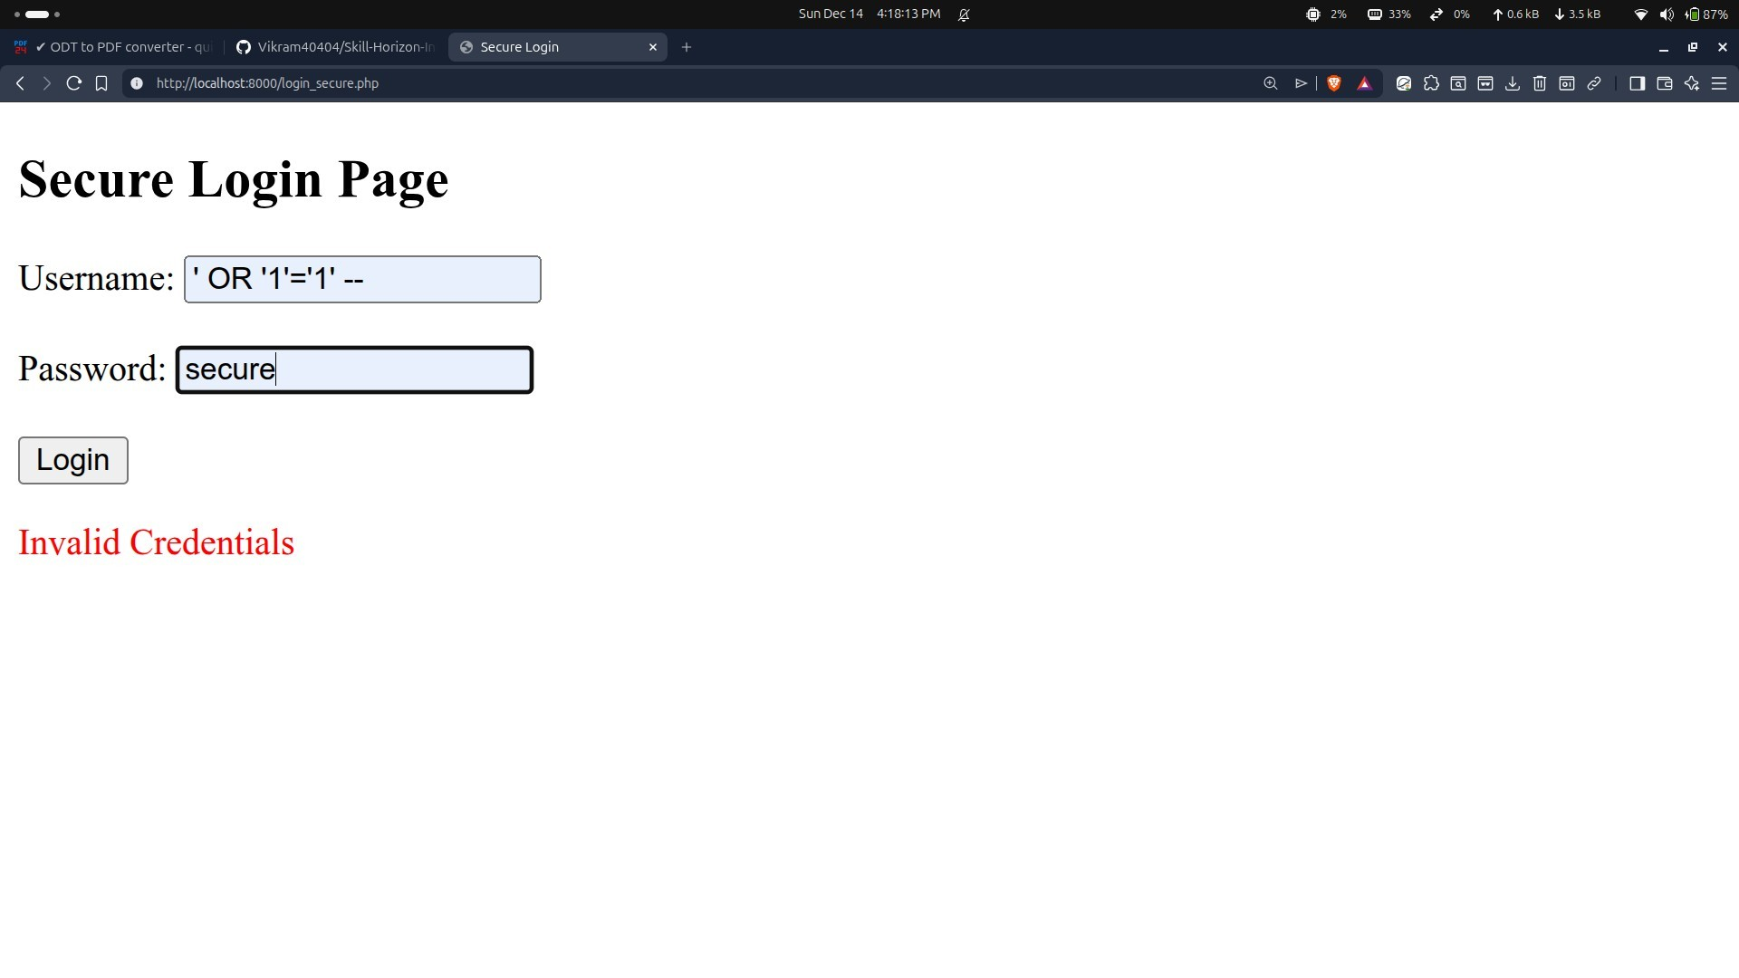
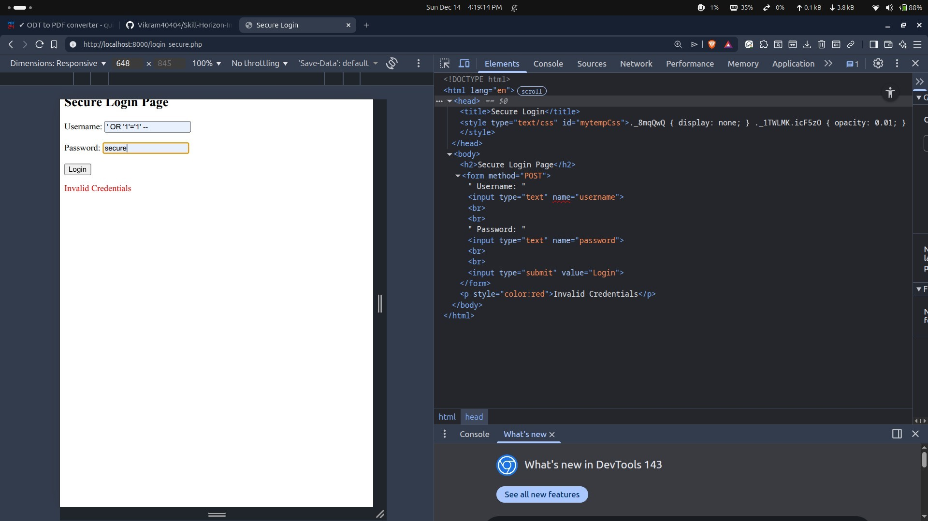
Observation:
- The payload was treated as plain text
- Authentication bypass was not possible
- Login failed as expected
This confirms that the vulnerability was successfully mitigated.

Comparison of Vulnerable and Secure Versions
- The vulnerable version allows direct manipulation of SQL queries
- The secure version strictly separates input data from SQL logic
- SQL Injection works in the vulnerable version but fails in the secure version
- Prepared statements effectively eliminate the attack vector

Conclusion
This project demonstrated how insecure coding practices can introduce critical vulnerabilities into web applications. A simple login page was shown to be vulnerable to SQL Injection due to improper handling of user input.

Learning Outcomes
- Understanding how SQL Injection vulnerabilities occur
- Practical experience in exploiting and fixing vulnerabilities
- Knowledge of secure database access using prepared statements

