1) u(n+2) = 3u(n+1) - 2u(n)

u(n+2)-3u(n+1) + 2u(n)=0

2) (E2-3E+2)un=0;

E2 - 2E - E + 2=0

E(E-2)-(E-2)=0

(E-1)(E-2)=0

Un=A(1) +B(2)n

3) A +B =0 🡪 u1=0

A +2B=1 🡪u2=1

-------

-B=-1 ->B=1

A=-1

Un=-1(1) + 1(2)n

4) TRIAL AND ERROR with the equation u(n+2)-3u(n+1) + 2u(n)=0

8) 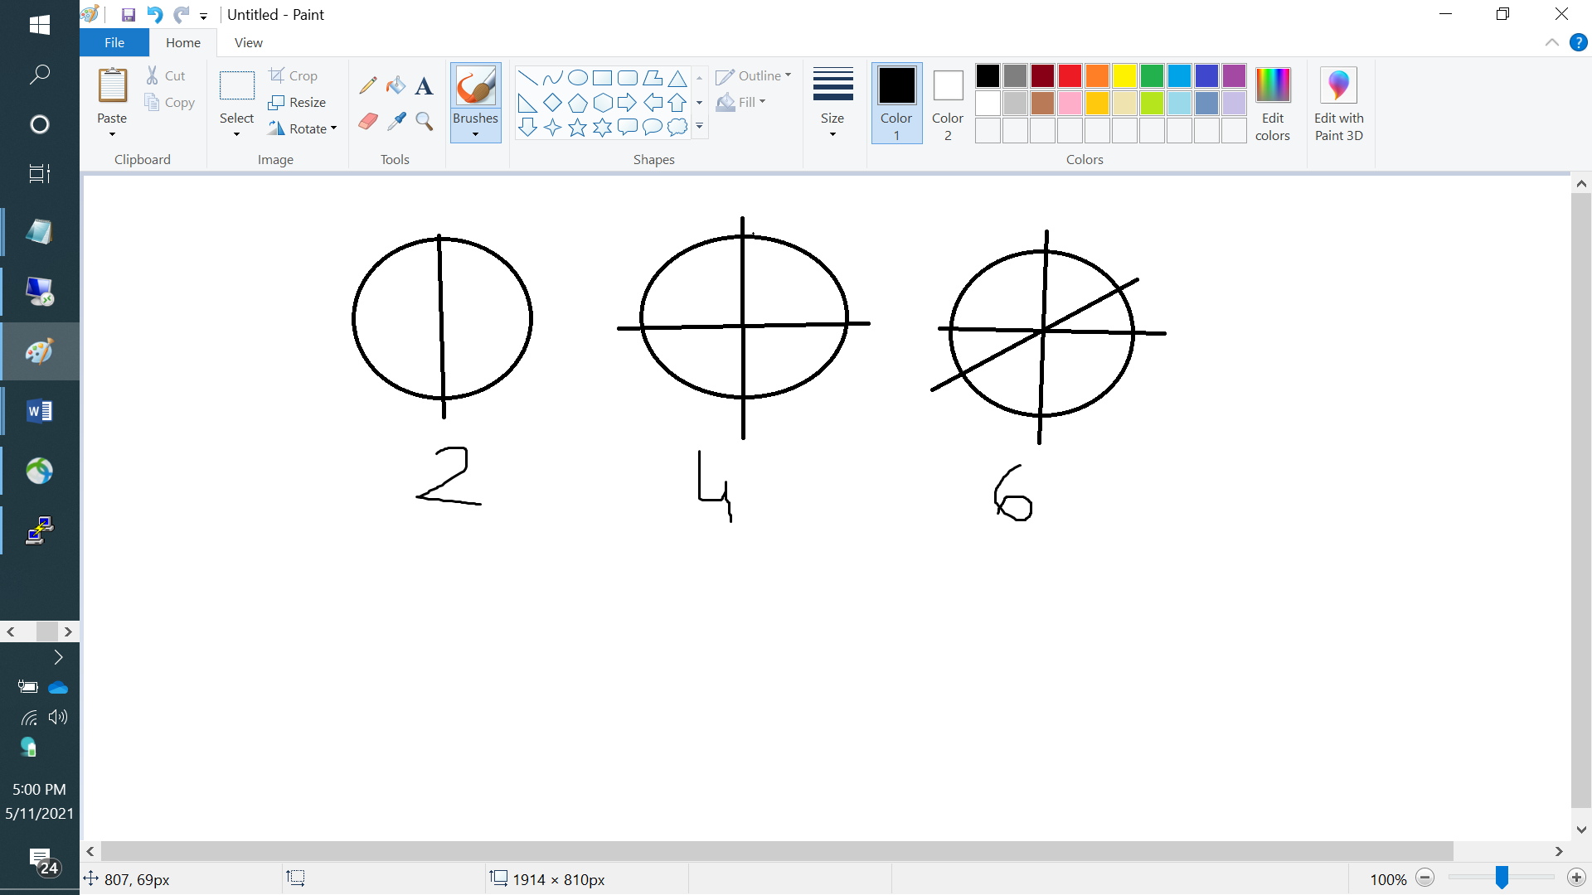

7) check the options with sequence: 2, 4, 6, 8, …

6) check the format in 7th answer

5) check the options with sequence: 2, 4, 6, 8, …

12)

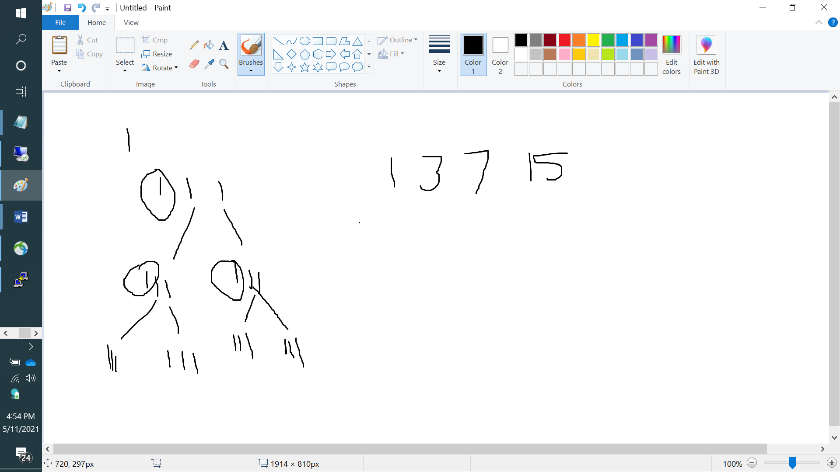

11) checking the options with the sequence: 1, 3, 7, 15

10) check the format in 11th answer

9) check the options with sequence: 1, 3, 7, 15