3D-Chromatin-Aware Genomic Foundation Model
A complete project report in plain machine-learning terms

B.Tech Mini Project · 23CS7552 · Batch 19
VR Siddhartha Engineering College, Department of Computer Science and Engineering

P. Charan Sai (238W1A5447) · G. Karthik (248W5A5404) · P. Sanath (238W1A5446)
Guide: Mrs. K. Divya Kothapali, Assistant Professor

Report generated 26 August 2026

How to read this document
This report deliberately avoids all biology vocabulary. Everything is described as what it actually is to the model: files, arrays, matrices, tokens, features and losses. A translation table is provided at the end for anyone who needs to map the plain descriptions back onto the domain terms used in the literature. Every number quoted came from a command that was actually run and is stored in the project repository.

1. What this project is, in one page
The setup is an ordinary self-supervised language-model experiment with one non-standard ingredient.
The ordinary part.
We have a very long string, about 138 million characters, drawn from an alphabet of 4 symbols plus one 'unknown' symbol. We cut it into fixed-length windows, mask out 15 percent of the tokens in each window, and train a neural network to predict the masked tokens from their surroundings. This is standard masked language modelling. The loss is cross-entropy per token, measured in bits. Because there are 4 real symbols, a model that guesses uniformly at random scores exactly 2.000 bits. Anything below 2.000 means the model has learned something about the string.
The non-standard part.
For every position in the string we also have a second input: a vector of 8 numbers, derived from a completely different data source. These 8 numbers describe how that region of the string relates to other regions physically far away from it in index order. This second input is available at training time and is genuinely extra information: it cannot be computed from the character sequence alone.
The research question.
Does giving the model this second input, in a specific architectural way, make it a better language model than an otherwise identical model that does not get it, when both are given the same number of parameters and the same amount of compute?
Why the 'specific architectural way' matters.
Two published systems already combine these two data sources, but both do it after the language model has finished training: they attach a second module on top of frozen, already-learned representations. This project instead injects the second input into the recurrence itself, so it shapes representation learning while it happens. As far as the literature review found, no published model does that. The novelty is the placement of the conditioning, not the data or the architecture family.
The honest headline result.
On the loss, the answer is no. The model with the extra input scored 0.0020 bits worse than the one without it, and run-to-run noise is 0.0025 bits, so the difference is inside the noise floor and points the wrong way. On a secondary measurement — whether the extra information is recoverable from the network's internal states — the answer is a weak yes. The project then measured why the main result came out flat, and that measurement is arguably the most useful thing it produced.

2. The data: where it comes from and what it actually is
Everything comes from two public files. Nothing was generated, simulated or collected by us. Both are free to download and are permanently archived with stable identifiers.

2.1 Input 1 — the sequence file
Property | Value
What it is | A plain text file containing one very long string
Length | 138,394,717 characters
Alphabet | 4 symbols (A, C, G, T) plus 'N' meaning unknown
Source | Ensembl, public FTP, release 113
Reference build | GRCh38 (a versioned, citable snapshot)
Size on disk | About 40 MB compressed
Preprocessing | Each character mapped to an integer id: the 4 symbols to 2–5, unknown to 6, plus a padding id 0 and a mask id 1
Result | A 1-D integer array. One character equals one token — no sub-word tokenisation, no vocabulary learning

Note on tokenisation.
Many models in this area learn a sub-word vocabulary. This project deliberately does not: one character is one token. That keeps the alignment with the second input exact and makes the uniform-random loss floor exactly 2.000 bits, which is a convenient sanity check. The cost is that windows are long, because 32,768 tokens covers only 32,768 characters.

2.2 Input 2 — the pairwise-similarity file
This is the interesting one and the reason the project exists.
The file stores a large sparse symmetric matrix. Row i, column j holds a number saying how often positions i and j were observed to be physically close to one another in the sample being measured — even when i and j are millions of characters apart in index order. It is, in effect, a measured adjacency matrix over the string, capturing long-range relationships that the character sequence alone does not reveal.
Property | Value
What it is | A sparse symmetric matrix in a multi-resolution container format
Matrix size | 27,679 × 27,679 at the resolution used
File size | 27 GB
Downloaded? | NO. Read over HTTP range requests, so only the needed slices cross the network
Source | 4D Nucleome public data portal, experiment set 4DNES3JX38V5
Underlying study | Rao et al., 2014 — a widely used public reference dataset
Sample | One sample, one cell type (GM12878). The matrix is sample-specific; the sequence file is not
Resolution | One matrix index covers 5,000 string positions ('a bin')

From matrix to 8 features.
The full matrix is far too large to feed into a network, and most of it is empty. Two reductions are applied. First, only the near-diagonal band is kept: pairs closer than 2 million positions apart. Second, each bin's row is summarised into 8 hand-designed scalar features — these are engineered, not learned. Each feature is then standardised to mean 0 and variance 1 across the whole string.
# | Feature (plain description)
1–3 | Three 'boundary strength' scores at three different scales: how sharply the similarity pattern changes when you cross this bin. High value means this position separates two distinct blocks
4 | Directional asymmetry over a 2-million window: does this bin associate more with what precedes it or what follows it
5 | Log of total local similarity mass: how densely connected this region is overall
6 | Fraction of that mass lying upstream rather than downstream
7 | Ratio of short-range to long-range similarity
8 | First principal component of the correlation matrix at coarse resolution — a single number placing each bin into one of two large-scale groupings

Two of these features (4 and 6) are directional, which matters for data augmentation: when a window is reversed as an augmentation, those two must flip sign while the other six do not. Getting that wrong is a documented failure mode in the project's spec.

2.3 Validation of the second input
Because the 8 features are hand-engineered, they could easily be computed wrongly. Two of them were checked against independent public files produced by other groups using different software:
- Boundary-strength feature vs an independent published track: correlation 0.9969
- Grouping feature (#8) vs an independent published track: correlation 0.9759
These are close to 1.0, which is the evidence that the feature extractor is correct.

2.4 Windowing and splitting
Step | Detail
Window length | 32,768 tokens (later changed to 65,536; see Section 8)
Overlap | 50 percent on the training split only; none on validation or test
Rejection rule 1 | Drop a window if more than 10 percent of its characters are unknown
Rejection rule 2 | Drop a window if fewer than 50 percent of its positions have valid feature values
Split method | Three CONTIGUOUS blocks by index position, with a 1-million-position buffer between them — not a random shuffle
Split sizes | train 5,422 / validation 274 / test 243 windows
Unique data | About 89 million characters of non-overlapping training material

Why contiguous blocks and not a random split.
Neighbouring windows overlap and are highly correlated. A random split would put nearly identical windows in both train and validation, which leaks. Contiguous blocks with a buffer avoid the obvious version of that. Section 7 explains why this is still not sufficient.
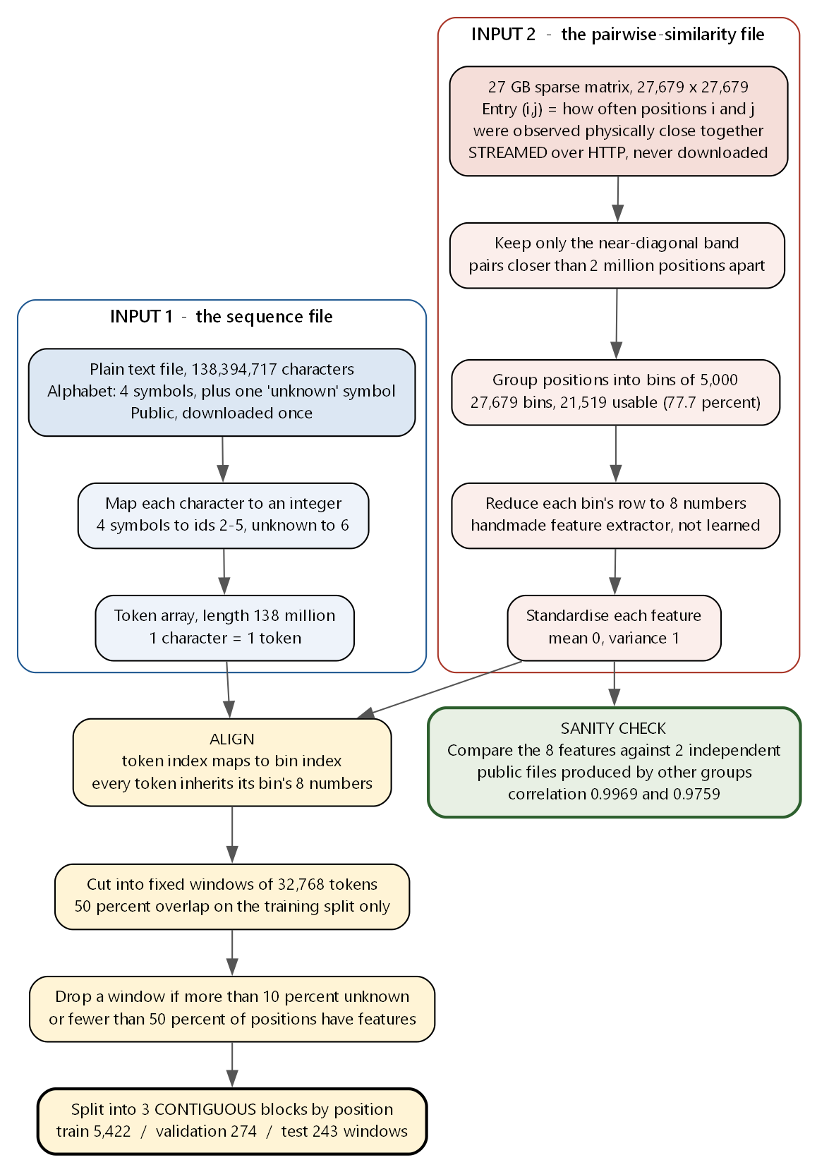
Figure 1 — The full data pipeline. Two independent public files are reduced, aligned by position, cut into windows and split into contiguous blocks.

3. The model and the single modification

3.1 The backbone
The network is a bidirectional state-space model — the same architecture family as Mamba, arranged so that each layer reads the sequence in both directions. This family was chosen over a Transformer for one practical reason: cost grows linearly with sequence length rather than quadratically, and the windows here are tens of thousands of tokens long.
Hyper-parameter | Value
Layers | 16, bidirectional
Hidden width (d_model) | 256
State size | 16
Expansion factor | 2
Baseline parameters | 7,725,312
Precision | float32 throughout, no mixed precision
Masking | 15 percent of tokens; of those, 80 percent replaced by a mask token, 10 percent by a random token, 10 percent left unchanged
Loss | Cross-entropy in bits, computed only over the 4 real symbols

Scale context.
7.7 million parameters sounds small, but the closest published reference model — Caduceus, ICML 2024, the standard bidirectional state-space model for this data type — uses the same width, the same depth and 7.73 million parameters. This project is at the same scale as its nearest peer. The real gap is not parameter count but training volume: that reference model was trained on the full string with 131,072-token windows for 50,000 steps at roughly 1 million tokens per step, about 50 billion tokens. This project trained for 2,000 steps at 262,144 tokens per step, about 0.52 billion tokens — roughly 100 times less.

3.2 The modification
Inside a state-space layer there is a per-position scalar, conventionally called Δ (delta), that controls how quickly the layer's internal state decays as it moves along the sequence. Small Δ means information persists over a long span; large Δ means it decays fast. Normally Δ is computed from the layer's own input alone.
The modification is one line: add a learned linear projection of the second input to Δ before the softplus that keeps it positive.
delta = softplus( dt_proj(x) + W_dstruct(s) )
where s is a 2-dimensional compression of the 8 features, produced by a small encoder (8 → 16 → 2). Two design choices make this experimentally clean:
- W_dstruct is initialised to exactly zero. At step 0 the modified model is numerically identical to the baseline. Anything that develops afterwards was learned, not built in.
- The whole addition costs 33,042 extra parameters, +0.43 percent. The pre-agreed budget was 5 percent, so the comparison is genuinely at matched capacity.
In plain terms: the second input is allowed to tell each layer, at each position, 'remember longer here' or 'forget faster here'.

3.3 A bug found along the way that is worth reporting on its own
The maximum memory span a layer can express is 1 divided by the smallest allowed value of Δ. The reference implementation of this architecture family sets that floor to 1e-3, which caps the memory span at exactly 1,000 tokens — before a single gradient step is taken. Measured value: 999.5.
For windows of 32,768 tokens that cap is severe and entirely invisible unless you look for it. Fixing it costs three constants and zero parameters. After the fix, the median learned memory span rose from 14.2 to 434.7 tokens, and the fraction of layer directions able to reach long spans went from 0 out of 32 to 32 out of 32.
Any model in this architecture family inherits this default. That makes it a small, transferable, independently useful finding.
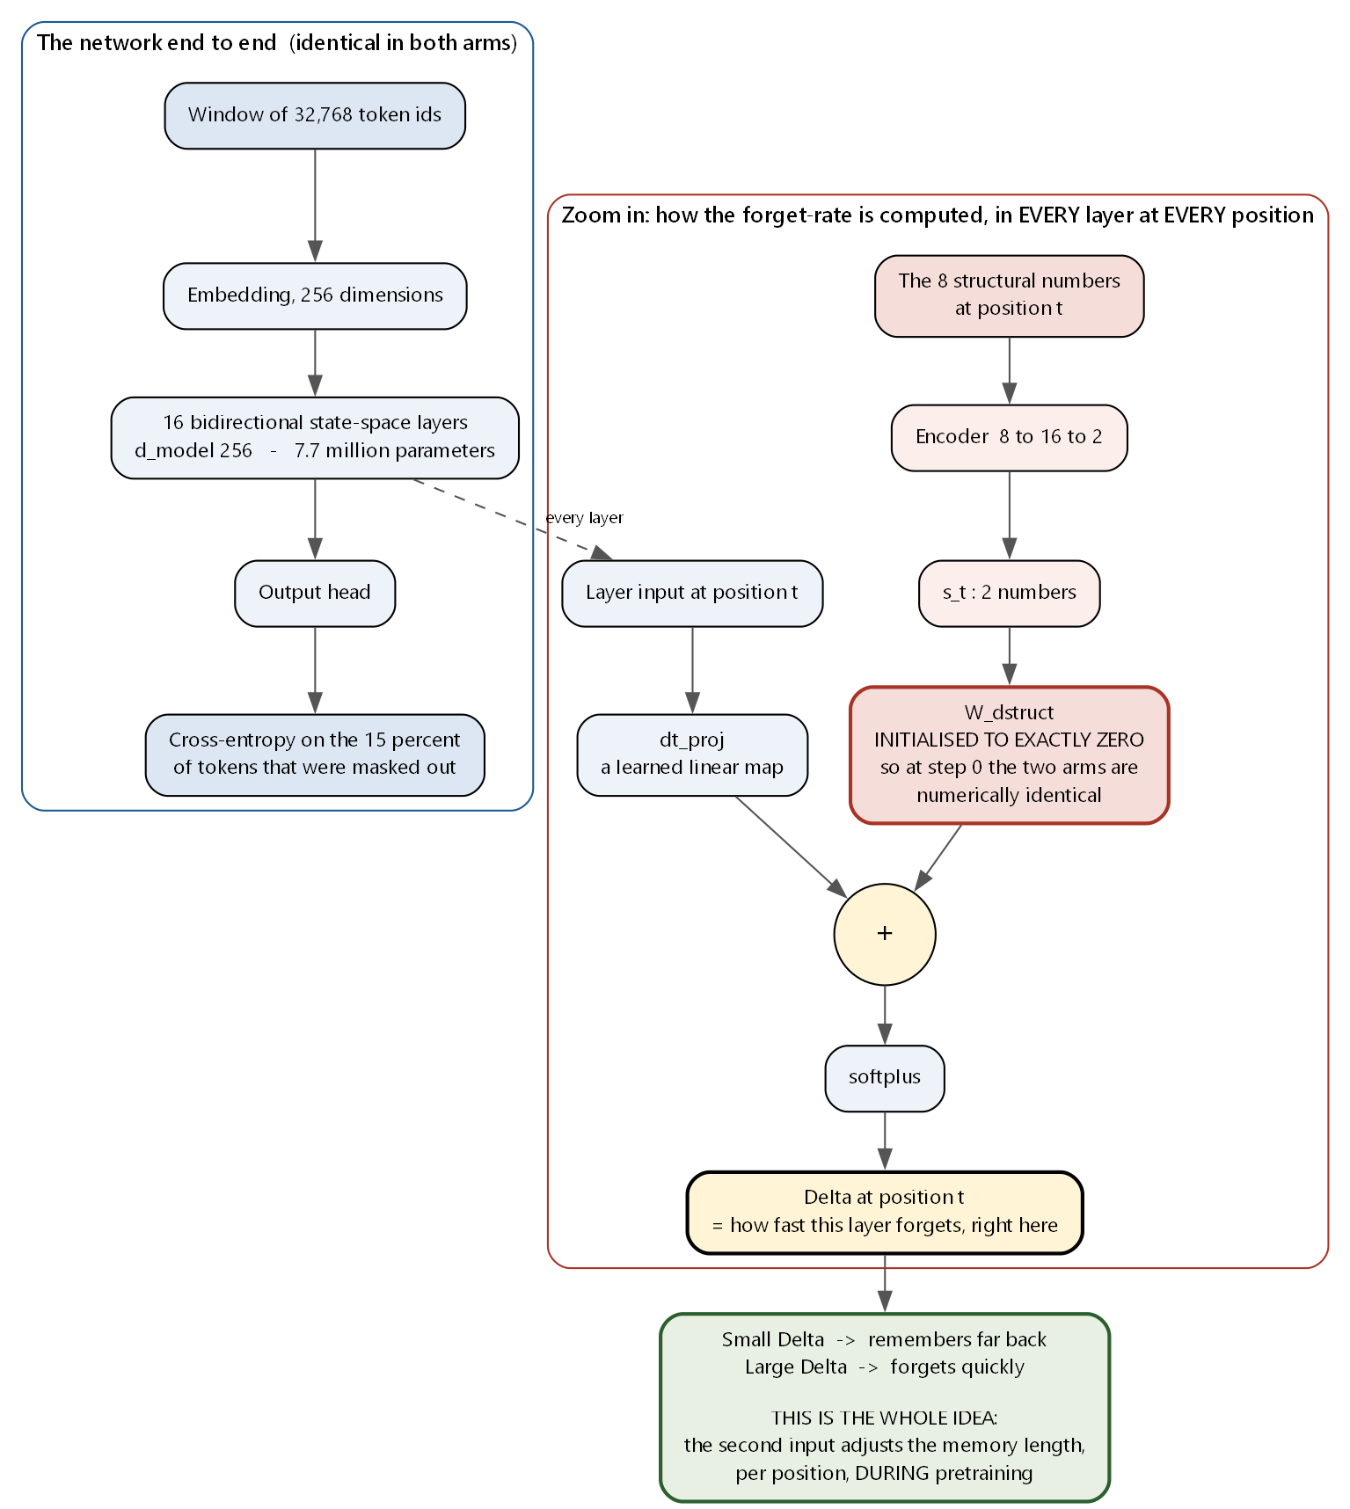
Figure 2 — The network, and a zoom into the one modified computation. The second input adjusts the per-position forget-rate during pretraining.

4. How the comparison was run
The experiment compares two arms that differ in exactly one respect.
 | Arm A — baseline | Arm B — structural
Second input | Not used | Used, via Δ
Parameters | 7,725,312 | 7,758,354 (+0.43%)
Data | Identical | Identical
Optimiser, schedule, steps | Identical | Identical
Seeds | 3 | 3
Steps | 2,000 | 2,000
Throughput | 5.30 s/step | 6.13 s/step (+16%)

4.1 Two different questions, two different measurements
A point the project treats as central: 'does the model use the extra input' and 'does the extra input help' are separate questions, and a single loss number cannot answer both. They were measured separately, and the criteria were written down before the numbers existed.
- Benefit — held-out cross-entropy. Does the second input make the model a better predictor? Threshold agreed in advance: an improvement must exceed 2 standard deviations of seed noise, which is 0.0050 bits.
- Reliance — control swaps. Take a trained model, retrain nothing, and replace the second input at test time with something corrupted. If the output barely changes, the model is ignoring it.
- Recoverability — linear probe. Fit a ridge regression from the network's hidden states to the 8 features. Critically, the second input is withheld (set to zeros) at probe time, so the model cannot simply copy its own input forward.

4.2 The five controls
Control | What is substituted | Alternative explanation it removes
S0 | All zeros | Baseline for 'input removed entirely'
S1 | Values shuffled across all bins | Primary reliance probe
S2 | Values shifted along the sequence | 'Any smooth extra channel would help'
S3 | Values regenerated from index distance alone | 'The information is just index distance'
S4 | Values replaced by 8 features computable from the characters | 'The information is already in the sequence'

The controls draw from a fixed random seed that is deliberately different from the training seeds, so that every training run sees the same corrupted input. Otherwise seed variance and shuffle variance would be confounded.
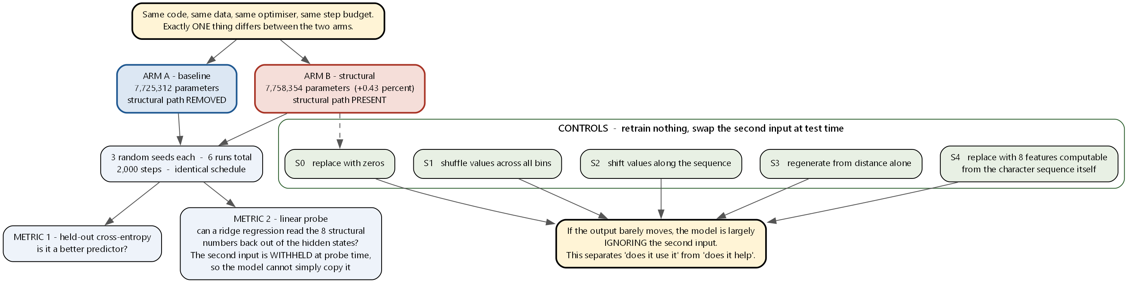
Figure 3 — Experimental design. One variable differs between arms; three seeds each; five test-time controls separate usage from benefit.

5. Results

5.1 The main result — no benefit
Arm | Held-out loss (bits/token) | Median memory span
Baseline, 3 seeds | 1.5197 ± 0.0025 | 434.7
Structural, 3 seeds | 1.5217 ± 0.0045 | 487.3

Per seed the structural arm scored 1.5266 / 1.5177 / 1.5209 against the baseline's 1.5196 / 1.5172 / 1.5223. The difference is +0.0020 bits — worse, not better — against a required threshold of 0.0050 and a noise level of 0.0025. An exact two-sided permutation test gives p = 0.600.
An important limitation of the test itself: with 3 runs against 3 runs there are only 20 possible arrangements, so the smallest p-value obtainable is 2/20 = 0.100. Statistical significance at the 0.05 level was unreachable by design. This is a design flaw in the experiment, not a property of the data.
Every structural run did end up with a longer memory span than every baseline run (+52.6 tokens). Memory lengthened; prediction did not improve.

5.2 Reliance — the input is used, but barely
Control | Loss change | Output divergence | Relative to S0
S0 zeros | +0.0000 | 2.539e-05 | 1.00
S1 shuffled | +0.0001 | 6.334e-05 | 2.49
S2 shifted | +0.0001 | 5.528e-05 | 2.18
S3 distance-matched | +0.0001 | 6.827e-05 | 2.69
S4 sequence-matched | +0.0000 | 2.874e-05 | 1.13

Read this way: corrupting the second input does change the output, so the model is not ignoring it — but the change is about 0.05 percent of the size of the ordinary training signal. Also note the ordering. The divergence tracks how far the substituted values sit from the true ones, which shows the input reaches the output, not that the model understands its meaning.
A separate diagnostic quantified how much the second input actually moves Δ compared with the ordinary sequence-driven term. The threshold for calling the pathway inert was agreed in advance at 0.05. Measured: 0.0004, 0.0002, 0.0002. Inert in all three runs.

5.3 The one place the arms separate
The linear probe was run in a form that removes window identity, leaving only within-window variation — precisely the component the mechanism was designed to affect. Correlation between predicted and true values on held-out data:
Arm | Seed 0 | Seed 1 | Seed 2
Structural | +0.0254 | +0.0303 | +0.0255
Baseline | +0.0134 | +0.0146 | +0.0221

Every structural run beats every baseline run. That is the most extreme arrangement possible at 3 versus 3, and it reaches the permutation floor of p = 0.100. It is on exactly the quantity the mechanism targets, and it reproduces across seeds.
Two caveats that must always be quoted alongside it.
First, both arms score below a floor built from simple local character statistics (+0.0802). Ordinary character composition predicts the target better than either trained model does, so this is a relative advantage between two weak predictors, not absolute competence. Second, the other two probe targets show nothing: one is negative for every run and the other overlaps between arms.

6. Why the main result came out flat — the most useful finding
Rather than leaving the null unexplained, the project measured its cause.
Define a simple quantity: of all the variance in the second input across the whole string, what fraction exists inside a single window, as opposed to being differences between windows? Call it keep.
Measured value: keep = 0.0573.
Only 5.7 percent of the second input's variance lives inside a window. The other 94 percent is variation from one window to the next. The features are defined on bins of 5,000 positions, so a 32,768-token window spans only about 6.6 bins — the input is close to a constant inside any given window.
The mechanism modifies a per-position value. It can therefore only act on that 5.7 percent. This is a complete account of the flat result that does not require the idea to be wrong — the experiment simply gave it almost nothing to work with.

6.1 Does a wider window fix it?
This was measured directly, with no model involved — just the features:
Window (tokens) | Bins spanned | keep | Variance between windows
8,192 | 1.6 | 0.0092 | 99.1 %
16,384 | 3.3 | 0.0318 | 96.8 %
32,768 | 6.6 | 0.0490 | 95.1 %
65,536 | 13.1 | 0.1099 | 89.0 %
131,072 | 26.2 | 0.2117 | 78.8 %
262,144 | 52.4 | 0.3499 | 65.0 %
524,288 | 104.9 | 0.4932 | 50.7 %

Widening helps but does not solve it.
At double the original width, 89 percent of the variance is still between windows. Even at sixteen times the width — far beyond what fits in the available memory — half of it still is. The honest statement is that a per-position conditioning mechanism addresses the smaller share of the available signal at every window width reachable on this hardware. This table must always be shown alongside any claim that the window was the problem.

6.2 Two conclusions the project retracted
Two claims that appeared in an earlier version of the project record were withdrawn after re-analysis of the stored numbers. They are recorded here because retractions are part of an honest report.
- 'The pathway is inactive early in the network and active only in the last four layers.' Withdrawn. The metric was a ratio, and it rose late only because its denominator collapsed. In absolute terms the pathway is 2–4 times weaker in the supposedly active band than in the supposedly inactive one.
- 'The pathway produces a near-constant offset across positions.' Withdrawn. Early layers vary with position proportionally as much as late ones. It produces a small position-varying signal, not a constant bias.
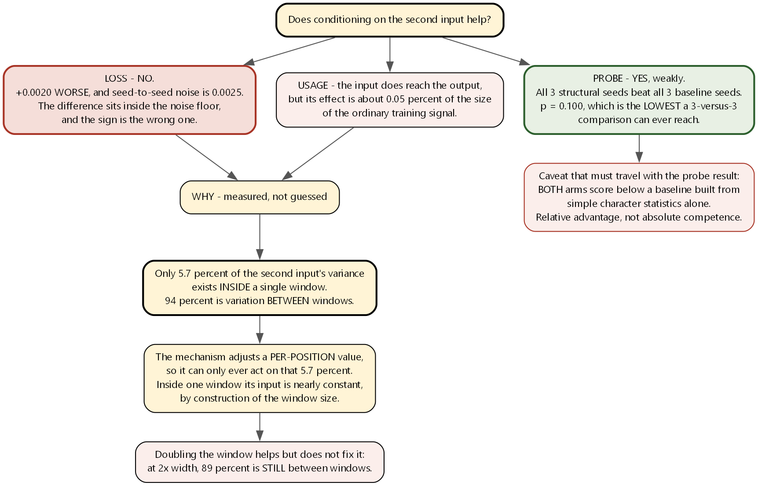
Figure 4 — Results and their measured explanation.

7. Known weaknesses
These are stated plainly because a reviewer will find them anyway.
# | Weakness | Status
1 | Not converged. Validation loss was still falling at step 2,000. A null result from an under-trained model is weak evidence. | Open
2 | Under-powered. Three runs per arm caps the achievable p-value at 0.100. Five per arm, or six paired, is the minimum that permits p < 0.05. | Open
3 | Unpaired initialisation. The modified model creates extra modules, which consumes random numbers, so same-seed runs of the two arms did not actually start from the same weights. | Fixed in code, not yet used in a run
4 | Uncontrolled data ordering. Resuming after an interruption did not restore the data loader position, and runs were interrupted an unrecorded number of times. | Open
5 | Split leakage. Train, validation and test are three blocks of the SAME string. The second input is correlated over very long ranges, so held-out feature values leak far more than held-out characters do — and the leak favours the structural arm. | Open, highest priority
6 | Scale. One string, one sample, roughly 3 passes over the data, about 1 percent of the reference model's training volume. | Open

Weakness 5 deserves emphasis.
It is the one that biases toward a positive result rather than away from it, which makes it the one a reviewer will attack first. Fixing it requires evaluating on material the model has never seen — a genuinely separate string, not a distant block of the same one.

8. Current status and what happens next
Stage | State
Literature review | Done
Data pipeline | Done and validated
Mechanism design | Done and specified
Baseline training | Done, twice — the first version failed the memory-span check
Modified-arm training | Done at the original window size; controls and diagnostics run
Evaluation | Diagnostics complete; no downstream benchmark numbers yet
Write-up | In progress

8.1 Changes already made but not yet exercised
- Window doubled from 32,768 to 65,536 tokens; dataset index rebuilt (2,713 train / 137 validation / 122 test windows). Nothing has been trained at this size yet.
- Paired initialisation implemented and verified: 275 of 275 tensors bitwise identical between the two arms at the same seed.
- Gradient checkpointing repaired — it had never worked, because a required submodule was never imported and the flag defaults to off, so the fault was invisible for the entire project.
- Periodic checkpoint retention added, so later diagnostics get a trajectory rather than a single end point.

8.2 The ordered plan
Phase | Work | Needs GPU?
A | Close out the statistical re-analysis of the existing runs | No — done
B | Build a multi-string dataset with splits across different strings (fixes weakness 5); test a finer feature resolution; acquire a second sample | No
C | Wire one standard public benchmark so the model has a comparable number; design a cross-sample evaluation | No
D | Retrain both arms: wider window, more steps, 5 or 6 seeds per arm | Yes
E | Confirmation tests on genuinely held-out material | No
F | Write up | No

Most of the remaining value needs no GPU.
Phases B, C, E and F are all CPU and network work. The GPU is currently blocked by two infrastructure problems unrelated to this code: a driver-library mismatch that makes the memory allocator fail under contention from other users, and a 10-minute idle timeout that terminates all processes. Both are being addressed with the cluster administrator.

8.3 What the final paper can honestly claim
Not 'our method outperforms the baseline'. The defensible claim is:
Conditioning pretraining on this second input changes what the learned representations encode about it, at no cost to language-modelling performance — and we quantify exactly how much of the available signal a per-position conditioning mechanism can reach at each window width.
Supported by three measured components: the mechanism is genuinely novel in its placement; the memory-span bug is a small transferable contribution to anyone using this architecture family; and the null result is diagnosed rather than merely reported.

9. Translation table
For mapping this document back onto the vocabulary used in the literature.
Plain term used here | Domain term in the literature
The long string, 4-symbol alphabet | The genome / DNA sequence
One character | One base pair (bp)
The sequence file | Reference genome FASTA, GRCh38
Position index | Genomic coordinate
The pairwise-similarity matrix | Hi-C contact matrix
Matrix entry (i,j) | Contact frequency between two loci
Bin of 5,000 positions | 5 kb bin
The 8 numbers per bin | The structural feature vector, φ
Boundary-strength features (1–3) | Insulation scores at 100 kb / 250 kb / 500 kb
Directional asymmetry (4) | Directionality index, 2 Mb
Two large-scale groupings (8) | A/B compartments, PC1
A dense block on the diagonal | A topologically associating domain (TAD)
One sample / cell type | GM12878 cell line
Public data portal | 4D Nucleome (4DN)
The one long string used | Chromosome 9
Reversal augmentation | Reverse-complement augmentation
Per-position forget-rate, Δ | The SSM timescale / discretisation step
Bits per token | Bits per nucleotide (bits/nt)
The two prior systems | CHROME (graph attention on frozen embeddings) and Evo2HiC (contrastive embedding alignment)
Nearest reference model | Caduceus (bidirectional Mamba, ICML 2024)

Every quantitative statement in this report is reproducible from files stored in the project repository: run configurations, per-run metrics, diagnostic outputs and a dated change log recording each result and each retraction.

