Survey on Existing Technologies in Real Time data of Public Transportation System

-------------------------------------------------------------------------------------------------------------------------------
- Abstract

The adoption of location and information based technologies into vehicles, infrastructure, traffic management and traveler information services have shown dramatic improvements in the safe, and efficient mobility of people and freight in USA, European nations, China and Canada.This document focuses on how Real Time Passenger Information (RTPI) systems are used in different places of the world for the improvement of transportation system.

- Introduction

With increase in vehicles it is a call for shift in the demand for mobility from cars to collective means of transport. Hence, public transport performance is a key issue. Bus systems are recognized as essential component of efficient urban transport, providing a flexible and sustainable mode of transport .Taking these into account it is important to attract bus transport to all sectors of community.

It can also be named as Intelligent Transport Systems (ITS) with real time bus schedule as one of its type with following features

- GPS or Mobile Radio enabled in-vehicle navigation systems

- Real time schedule board at every bus stop

- Advanced Intelligent Transport Systems (AITS) like displays informing about change of routes due to traffic jams, congestions, accidents near bus stop or displays in the runways.

- Advanced Public Transportation Systems (APTS): Providing real time information to passengers
and for the buses in providing priority of passage to buses at signalized intersections

- Advanced Rural Transportation Systems (ARTS) provide information about remote road and other transportation systems. Examples include automated road and weather conditions reporting and directional information. This type of information is valuable to motorists travelling to remote or rural areas. This has been widely implemented in the United States and will be a valuable asset to countries like India, where rural areas are widely distributed.

- Basic Components of the system

Traffic Management Center:

Traffic Management Center (TMC) is the hub of transportation where data from different sources are collected and sent to Information Service Provider for dicision making, management and public.
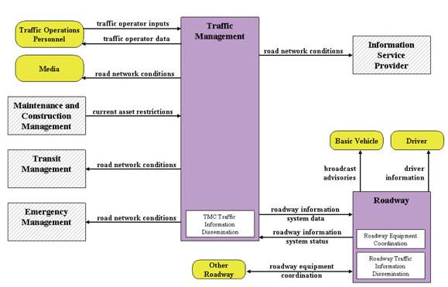

Figure 1: Schematic of the workings of a TMC [4]

Data Acquisition:

The idea of the Real-Time Data Capture and management is the active acquisition and systematic provision of integrated, multi-source data to enhance current operational practices and transform future surface transportation systems management [12].
Figure shows how data is captured from multiple sources and managed
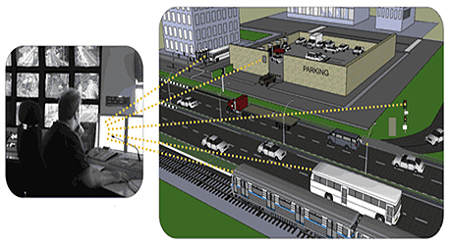

Figure 2: Real Time Data Capture [5]

- Existing Technologies in different Countries

USA:
As per North America public transportation [1] in addition to a website and posted information at stations that provide passengers with information about all modes within the MBTA, including the schedule on Ferries, there are a number of mobile applications that have been built (by independent developers) to provide location and schedule information. Real-time, land-based transit information is available through these applications

The adoption of location and information based technologies into vehicles, infrastructure, traffic management and traveler information services have shown dramatic improvements in the safe, and efficient mobility of people and freight in USA

One of the first online bus tracking systems, BusView, was developed by Daniel Dailey and others [13]. Google Transit, which was started as a Google Labs project in December 2005, is now directly integrated into the Google[11].Ride on real time an android app developed for residents of Montgomery county RideTime utilizes real-time data to help you determine bus departure times for more than 6,500 stops throughout UTA’s service district.

China:
Bus Rapid Transit corridor in Guangzhou, China [8] is known for sustainable transport serving on an average of 805,000 passengers per day and won the International sustainable transportation in 2013 because of remarkably new bus transit system.

Nottingham City Transport, England
A Tait TM8235 mobile radio is installed on each bus to allow for an on-board information system to be integrated into the radio network. The radios are linked to the INIT on-board COPILOT via MAP27 interface allowing drivers to control the radio and parts of the AVL system with one tool[9].

With the AVL data supplied via the TDMA channel, NCT control room staff is able to receive current information and forewarn drivers of potential delays. Passengers will also be updated with accurate information at the stop via the 'real time' (RTPI) signage and on the buses with the 'next stop' signage. In addition, historical data can be collected to illustrate trends of delays and provide genuine insight into time-table scheduling.

Madrid:
An advanced AVMS system has been implemented in 40 buses in 6 bus lines connecting Majadahonda and Moncloa interchange station, from September 2011 to February 2012. These buses have been equipped with such AVMS systems, including screens on board and audio information system. Four time information displays (with audio system) on bus stops in Majadahonda, plus one more with a Bluetooth device to download the information on next bus arrivals have been implemented. One more screen has been installed in Moncloa interchange to give next departures and breakdowns or delays. In addition a specific webpage has been developed to provide real time information to the users. A SMS system has been also deployed to get information about the next bus arrivals and incidents/ breakdowns on the whole transport network.[7]

Canada:
The #98 B-Line uses automated vehicle location (AVL) technology, enabling the operating company to identify the precise location of buses at any point in time using a Global Positioning System (GPS). This was the first application within Vancouver. Once the computer on board the bus calculates where
the bus is, the information is then sent electronically to the transit control center, where the exact location of the bus is mapped. The AVL technology is accurate within 3 meters (10 ft) when a bus is stopped and within a city block when the bus is moving [6].

- Conclusion

The Survey indicate the importance of providing bus services of high quality. For this end the use of ITS appear to be a key factor .Most of the deterrent factors such as waiting time at stops, delays, uncertainty, payment time and lack of information for connecting with other services are clearly reduced .Hence, the image of Public Transport became more competitive in relation with other modes, particularly cars. It produces environmental benefits because level of occupancy of buses is raised and the number of car trips reduced. In conclusion, it is very advisable to invest in a better bus fleet equipped with RTPI systems both on-board and at bus stops and terminals.

- References

[1].http://onlinepubs.trb.org/onlinepubs/tcrp/tcrp_syn_102.pdf
[2] http://www.rtig.org.uk/web/Aboutus/tabid/59/Default.aspx
[3] http://coeut.iitm.ac.in/ITS_synthesis.pdf
[4]. A Report to the ITS Standards Community ITS Standards Testing Program By Battelle
Memorial Institute for US Department of Transportation (USDOT), Chapter 2.
[5]http://www.its.dot.gov/data_capture/data_capture.htm
[6]http://onlinepubs.trb.org/onlinepubs/tcrp/tcrp90v1_cs/Vancouver.pdf
[7]http://www.tsi.lv/Research/Conference/RelStat_12/Procceding/Plennary_Session_Monzon_OK.pdf
[8]http://sustainablecitiescollective.com/urban-sense/125111/putting-rapid-bus-transit-cities
[9]http://www.taitradio.com/industries-and-solutions/industries/transport/clients/nottingham-city-transport
[10]http://www.ssatp.org/sites/ssatp/files/publications/Toolkits/ITS%20Toolkit%20content/case-studies/dublin-ireland.html
[11]http://busview.org/busview_launch.jsp
[12]http://www.its.dot.gov/data_capture/data_capture.htm#sthash.TcSONMcr.dpuf

