**GARBAGE CLASSIFYING SYSTEM**

A PROJECT REPORT

***Submitted by***

BL.EN.U4AIE19007 APOORVA.M

BL.EN.U4AIE19041 TANUJ.M

BL.EN.U4AIE19068 AISHWARYA.V

***in partial fulfilment for the award of the degree***

***0f***

**BACHELOR OF TECHNOLOGY**

IN

ARTIFICIAL INTELLIGENCE ENGINEERING



AMRITA SCHOOL OF ENGINEERING, BANGALORE

AMRITA VISHWA VIDYAPEETHAM

**BANGALORE 560 035**

#### **TABLE OF CONTENTS**

**CHAPTER 1:** INTRODUCTION **.….……………….………….…3**

**CHAPTER 2:** SYSTEM DESIGN **…………………….….……….4**

**CHAPTER 3:** IMPLEMENTATION**………………..…………….12**

**CHAPTER 4:** RESULTS**………………………………………….13**

**CHAPTER 5:** CONCLUSIONANDFUTURE SCOPE**.…………28**

**CHAPTER 6:** REFERENCES**………………………...……….….28**

**CHAPTER 1: INTRODUCTION**

Recycling is necessary for a sustainable society. The current recycling process requires recycling facilities to sort garbage by hand and use a series of large filters to separate out more defined objects. Consumers also can be confused about how to determine the correct way to dispose of a large variety of materials used in packaging. Our motivation was to find an automatic method for sorting trash. This has the potential to make processing plants more efficient and help reduce waste, as it is not always the case that the employees sort everything with 100% accuracy. This will not only have positive environmental effects but also beneficial economic effects.

In order to mimic a stream of materials at a recycling plant or a consumer taking an image of a material to identify it, our classification problem involves receiving images of a single object and classifying it into a recycling material type. The input to our pipeline are images in which a single object is present on a clean white background. We then use CNN to classify the image into six categories of garbage classes. By using computer vision, we can predict the category of garbage that an object belongs to, based on just an image.

#### A computer vision approach to classifying garbage into recycling categories could be an efficient way to process waste. The objective of this project is to take images of a single piece of recycling or garbage and classify it into six classes consisting of glass, paper, metal, plastic, cardboard, and trash. We also create a dataset that contains around 400-500 images for each class, which was hand collected. The models used is a convolutional neural network (CNN).

**CHAPTER 2: SYSTEM DESIGN**

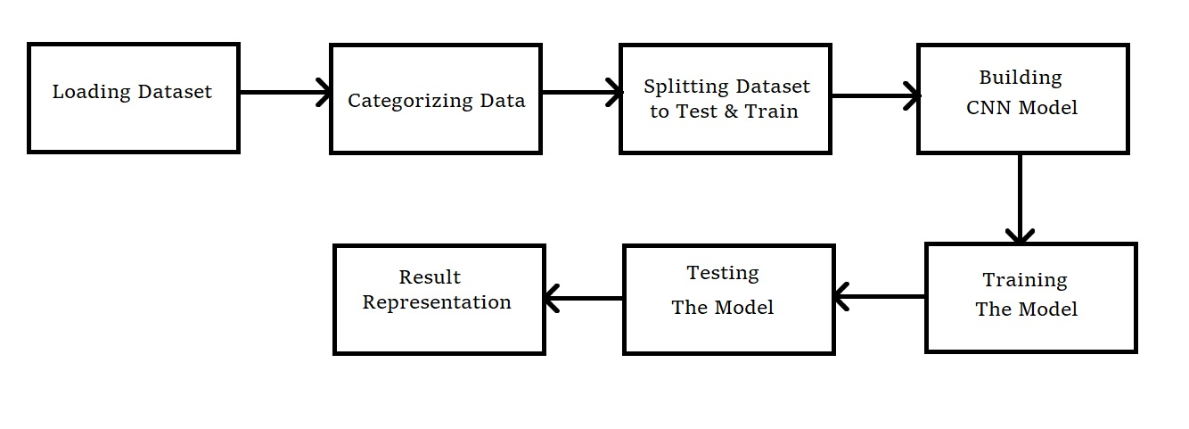

**Figure 2: System Design of our model**

**CHAPTER 3: IMPLEMENTATION**

**3.1 Dataset and data collection:**

The data acquisition process was done by hand by us because there are no publicly available datasets pertaining to garbage materials. Originally, we were using the Flickr Material Database and images from Google Images. However, these images do not accurately represent the state of recycled goods after more research on recycling plants and the state of recycled goods. For example, the images in the Flickr Material Database present materials in a pristine and undamaged state. This is unlikely in recycled materials treated as waste because they are dirty, ruffled, crumpled, etc. Therefore, we hand collected our own dataset of images, which we plan on making a public dataset. The dataset contains images of recycled objects across six classes with about 400-500 images each (besides the ”trash” class which only has about 100 images), totalling about 2,400 images. The data acquisition process involved using a white posterboard as a background and taking pictures of trash and recycling around Stanford, our homes, and our relatives’ homes. The lighting and pose for each photo is not the same, which introduces variation in the dataset. The figures below show example images from the six classes.

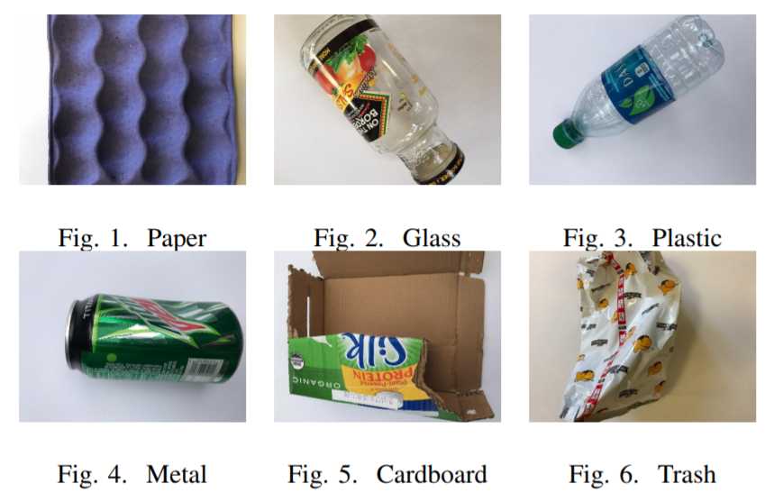

Data augmentation techniques were performed on each image because of the small size of each class. These techniques included random rotation of the image, random brightness control of the image, random translation of the image, random scaling of the image, and random shearing of the image. These image transformations were chosen to account for the different orientations of recycled material and to maximize the dataset size. We also performed mean subtraction and normalization.

**3.2 Convolutional Neural Network (CNN)**

We use the Torch7 framework for Lua to construct our CNN. We implemented an eleven layer CNN that is very similar to Alex Net. Our network is smaller than Alex Net (using 3 4 of the amount of filters for some convolutional layers) because of computational constraints.

Layer 0: Input image of size 256x256

Layer 1: Convolution with 96 filters, size 11x11, stride 4, padding 2

Layer 2: Max-Pooling with a size 3x3 filter, stride 2

Layer 3: Convolution with 192 filters, size 5x5, stride 1, padding 2

Layer 4: Max-Pooling with a size 3x3 filter, stride 2

Layer 5: Convolution with 288 filters, size 3x3, stride 1, padding 1

Layer 6: Convolution with 288 filters, size 3x3, stride 1, padding 1

Layer 7: Convolution with 192 filters, size 3x3, stride 1, padding 1

Layer 8: Max-Pooling with a size 3x3, stride 2

Layer 9: Fully Connected with 4096 neurons

Layer 10: Fully Connected with 4096 neurons

Layer 11: Fully Connected with 5 neurons

Result: Non-normalized log softmax scores, 5 classes

The CNN was trained with a train/val/test split of 70/13/17, an image size of 256x256, 60 epochs, a batch size of 32, a learning rate of 5e-8, 5e-1 weight decay every 5 epochs, an L2 regularization strength of 7.5e-2, and Kaiming weight initialization [6]. We did not use the same hyperparameters that AlexNet used because of the differing tasks at hand (ImageNet contains about 1.3 million images). Many hyperparameters were experimented with and these were the ultimate hyperparameters we ended up with. We encountered trouble training the neural network, as it would not learn. We chose to omit the ”trash” class images because there were only about 1/5 of the images compared to the other classes because they would create an imbalance in the dataset.

**CHAPTER 4: RESULTS**

As stated in the implementation section, we had trouble with training the network. The network seemed to not learn that easily .We saw the same problem of the network not learning on earlier attempts at training the network with a variety of hyperparameters. Previously, we used an image size of 384x384, batch size of 50, and no weight initialization beyond random. Thus, we reduced the image size to reduce complexity, reduced the batch size to be more appropriate for the dataset size, and used a weight initialization technique to improve learning. We believe that the CNN’s inability to learn is related to the hyperparameters being suboptimal, as the loss is erratic and would indicate that the learning rate may be too aggressive, which would cause it to fluctuate up and down, and not decrease at a consistent rate. The same applies for the training and validation accuracy not increasing and also exhibiting erratic behaviour.

Neural networks require a substantial amount of time to train and tune to achieve optimal performance. Based on previous research results with neural networks, they have a higher ceiling for potential. We gained more respect for all of the publicly available datasets. The dataset collection was extremely tedious and at times dirty. We attempted to maximize the data we had through augmentation. Along with that, more thorough hyperparameter search was performed.

Finally, we were able make the model achieve an accuracy of about 80% after tuning the hyperparameters.

Given below are the prediction results of the test images along with their individual probabilities across the 6 classes. Along with that 2 graphs : Training vs Validation accuracy and Training vs Validation loss have been plotted.

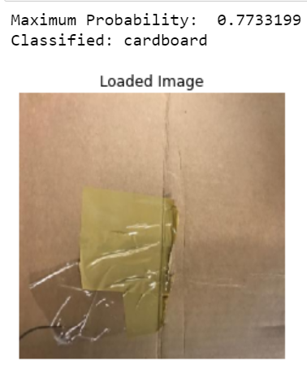

**Fig: Classification result of Test image 1**

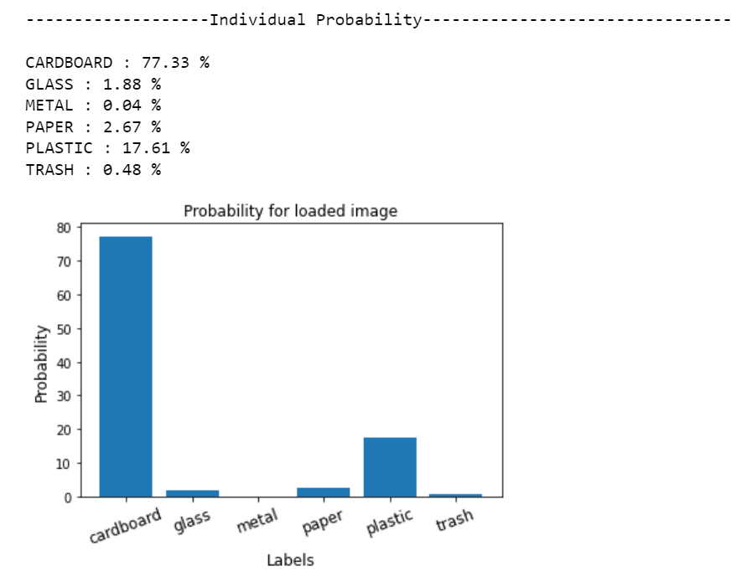

**Fig: Plotting individual probabilities - Test Image 1**

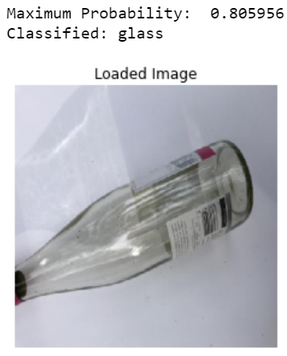

**Fig: Classification result of Test image 2**

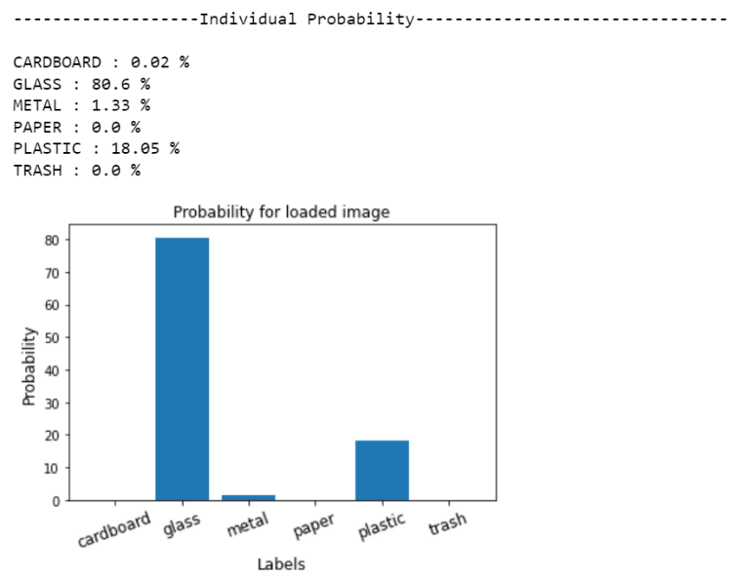

**Fig: Plotting individual probabilities - Test Image 2**

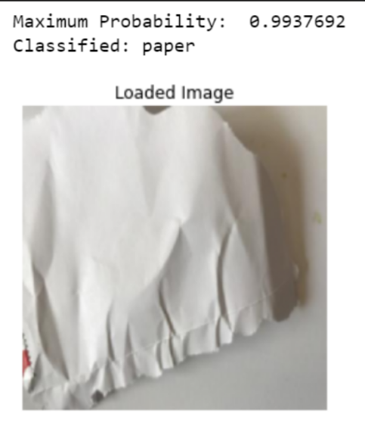

**Fig: Classification result of Test image 3**

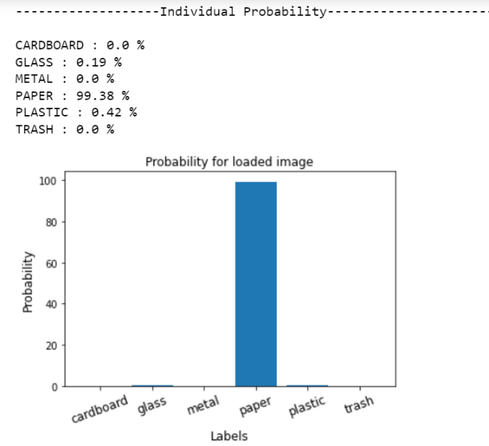

**Fig: Plotting individual probabilities - Test Image 3**

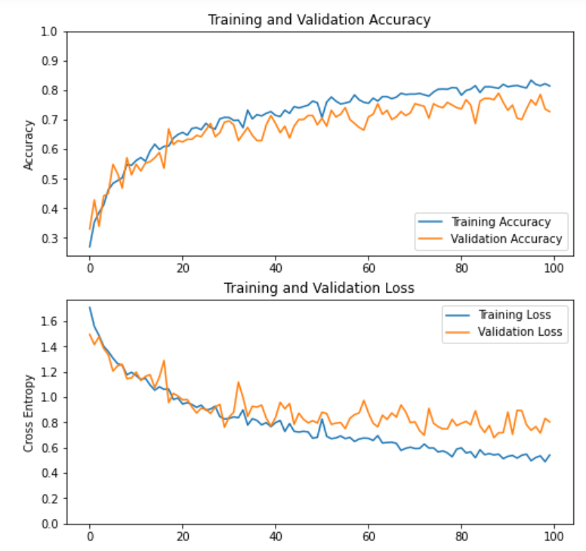

**Fig: Graphical representation of accuracy and loss**

**CHAPTER 5: CONCLUSION AND FUTURE SCOPE**

The classification of trash into various recycling categories is possible through machine learning and computer vision algorithms. One of the biggest pain points is the wide varieties of data (i.e. any object can be classified into one of the waste or recycling categories). Therefore, to create a more accurate system, there needs to be a large and continuously growing data source.

Primarily, we want to continue working on the CNN to figure out ways to further improve its accuracy. Furthermore, we would like to extend this project to identify and classify multiple objects from a single image or video. This could help recycling facilities more by processing a stream of recycling rather than single objects. Another important addition could be multiple object detection and classification. This would improve large scale classification of recycling materials. Finally, we want to continue expanding our dataset by adding more photos, especially in the trash class, and more classes, and then finally releasing it.

**CHAPTER 6: REFERENCES**

1. Hoornweg, Daniel, BhadaTata, et al. Environment: Waste production must peak this century, Nature, 502(7473), 615-7 (2013)

2. Y. LeCun, B. Boser, J. S. Denker, D. Henderson, et al. Backpropagation applied to handwritten zip code recognition. Neural computation, vol.1,no.4, pp. 541– 551 (1989).

3. Brinez L J C, Rengifo A, Escobar M. Automatic waste classification using computer vision as an application in colombian high schools, Networked and Electronic Media. IET, 10 (5)-10 (5) (2017)

4. Sudha S, Vidhyalakshmi M, Pavithra K, et al. An automatic classification method for environment: Friendly waste segregation using deep learning, Technological Innovations in ICT for Agriculture and Rural Development. IEEE, 65-70 (2016)

5. Erhan D, Szegedy C, Toshev A, et al. Scalable Object Detection Using Deep Neural Networks, 3(4), 2155- 2162 (2013)

6. R. B. Girshick, J. Donahue, T. Darrell, and J. Malik. Rich feature hierarchies for accurate object detection and semantic segmentation, In CVPR, pages 580–587, (2014)

7. Mittal G, Yagnik K B, Garg M, et al. SpotGarbage:smartphone app to detect garbage using deep learning, ACM International Joint Conference on Pervasive and Ubiquitous Computing. ACM, 940- 945 (2016)